**Systematic temperature monitoring systems,**

**Using 30DTR at Health Facility Level**

March 15, 2015

Acronyms 3

Executive summary 3

Introduction 5

Purpose of this guidance note 5

1. Plan and prepare 7

1.1 Redefine/review cold chain policies linking data to action 8

1.1.1 Define key performance indicators 8

1.1.2 Review standard operating procedures 8

1.2 Engage with the different stakeholders 9

1.3. Budget and funding 11

1.4. Cost benefit analysis 12

1.5 Define realistic timeframe 13

2. Choose products and technologies 15

2.1. 30DTR products 15

2.2. Technology: from data to action 17

2.2.1. How to report the information 17

2.2.2. Case study 1: Data collection by technical teams in Mali 18

2.2.3. Case study 2: SMS coding in Laos 18

2.2.4 Generic characteristics 20

3. Order and procure 22

3.1. Ordering process 22

3.2 Arrival process 22

3.3. Storage process 23

3.4. Disposal and replenishment 23

4. Train and validate standard operating procedures 24

4.1. Training and capacity development strategy 24

4.1.1. Required skills for health workers 24

4.1.2. Required skills for supervisors and Health Managers 25

4.2. Training materials and protocols 25

5. Deploy and implement 27

5.1 Dispatching and recording in inventory 27

5.2 When to activate the devices 27

5.3 Placement of device in the refrigerator 28

5.4 Full deployment or phased scale-up approach 29

6. Monitor and evaluate: Device + system + responsibility = success 31

6.1. Monitor 31

6.1.1 Key performance indicators 31

6.1.2 Quality assurance 31

6.2. Review and evaluation 33

List of Annexes 35

Acronyms

30DTR 30-day temperature recorder

C Celsius

CCEO Cold Chain Executive Officer

CSB Centre de Santé de Base

CSR corporate social responsibility

DHIS2 District Health Information System 2

EPI Expanded Programme on Immunization

EVM Effective Vaccine Management

GPRS general packet radio service

GPS global positioning system

HMIS Health Management Information System

HSS Health System Strengthening

KPI key performance indicators

LMIS Logistics Management and Information System

MPSC Medical Products Supply Centre

NGO non-governmental organization

NIP National Immunization Programme

PCV pneumococcal conjugate vaccine

PDF portable document format

PQS Performance, Quality and Safety

RTM remote temperature monitoring

SMART specific, measurable, achievable, realistic and time-bound

SMS short messaging system

SIP standard implementation procedure

SOP standard operating procedure

TMC temperature monitoring control

UNICEF United Nations Children’s Fund

USB universal serial bus

WHO World Health Organization

Acknowledgements

The following individuals have contributed to the production of the document and their inputs are acknowledged with sincere gratitude: Mike Brison (CHAI), Paul Colrain (WHO), Dmitri Davydov (UNICEF), Ranjit Dhiman (consultant), Peter Drury (consultant), Claire Frijs-Madsen (consultant), Markku Toryalai Hart (consultant), Denis Maire (WHO), Mercy Mvundura (PATH), Abu Obeida Eltayeb (UNICEF), Joe Pett (consultant), Wendy Prosser (VillageReach), Ticky Raubenheimer (consultant), Benjamin Schreiber (UNICEF)

Executive summary

There is evidence that many incidents of vaccine freezing remain undetected and can result in potency loss of vaccines. With the knowledge that at least 70% of the value of vaccines now being procured by UNICEF represents freeze-sensitive vaccines, more stringent temperature monitoring is required given the value at risk.

The WHO Vaccine Management Handbook, How to monitor temperatures in the vaccine supply chain (July 2015) indicates that it is considered best practice to use 30DTRs as temperature monitoring devices for vaccine refrigerators. This is because stem thermometers only provide spot temperature readings at the time of inspection and cannot indicate any excursions between readings, whereas 30DTRs store the excursions.

30DTRs or 30-day-temperature-recorders are small devices that can continuously measure temperature for 30 days (or 60 days) and log the history of the measurement. Temperature readings appear on a display that also shows pre-defined and factory programmed temperature alarms if they occur. The criteria for low alarm is set to -0,5 °C or lower for 60 minutes and the high alarm is set to +8° C or higher for 10 hours. The alarms show when a temperature excursion has occurred that might reduce the quality/potency of the vaccines and health workers must check the VVM of the vaccines in case of high alarm and they should perform a shake test in case of low alarm. If the shake test[1] is not possible, then the vaccines should be discarded.

|  |
| --- |
| Extract from the WHO Vaccine Management Handbook, *How to monitor temperatures in the vaccine supply chain*  To ensure good storage and distribution practices, effective, well-managed temperature monitoring and record-keeping procedures are crucial. These procedures help to ensure that:   * Vaccine quality is maintained throughout the supply chain; * Vaccine is not wasted due to exposure to heat or freezing temperatures at fixed storage locations, or during transport; * Cold chain equipment performs according to recommended standards; and * When problems arise, they are rapidly detected and corrective action is taken.   *Source: World Health Organization and United Nations Children’s Fund,* How to monitor temperatures in the vaccine supply chain, *Vaccine Management Handbook Module VMH-E2-01.1, July 2015, p.1.* |

The data can be read and downloaded and converted for analysis but after the 30 (or 60) days, it is overwritten and cannot be retrieved. Calibration accuracy of +- 0,5 to +-1°C is programmed to last as long as battery operating life which is 2 years minimum. Non-replaceable lithium batteries power them and their primary use is in refrigerators containing temperature sensitive vaccines at intermediate stores and health facilities.

Experience shows that in order to ripe the full benefits of 30DTR a comprehensive system of communication; clear responsibilities and accountabilities must be established. There is still limited guidance to help countries implement a successful temperature monitoring system using 30 DTR. This guidance is mainly based on experiences and lessons learnt from the implementation of many 30 DTR projects.

Introduction

The purpose of immunization programmes is to ensure that all children are immunized with quality vaccines according to the recommended immunization schedule. Vaccines are biological products that lose their potency over time as indicated by the expiry date of each batch. Exposure to high temperature excursions accelerates this degradation. Freezing can destroy the adjuvant structure, thereby rendering the vaccine ineffective. A fundamental measure of the effective execution of immunization programmes is that no temperature-damaged vaccines are administered to children.

The objectives of the immunization supply chain are to:

* + - 1. Ensure the availability of the vaccine at the point of vaccination
      2. Maintain the potency of the vaccines to ensure that the vaccines and diluents are not damaged during transportation or storage
      3. Uphold efficient use of available resources

To achieve these objectives, country programmes require a functional and reliable cold chain system. To ensure that this system is not damaging vaccines, temperature monitoring is required in order to understand which temperatures the vaccines and diluents have been exposed to. 30-day temperature recorders (30DTRs) devices have been available to countries since 2007 and their use is now the solution recommended by the World Health Organization (WHO) to monitor the temperature of refrigerators at static delivery points.

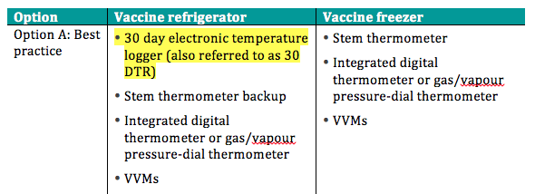

**Figure 1 Excerpt from the WHO Vaccine Management Handbook**

The systematic and systemic use of 30DTR devices has three objectives:

1. To obtain continuous temperature summary data from each service delivery point without creating extra burden on the health workers;
2. To ensure that the information made available through 30DTR is systematically collected, shared and managed (at national, provincial, district and health facility levels);
3. To make sure that the data is actually acted upon.

Although 30DTR devices are being used in many countries, field observation shows that temperature-monitoring performance remains a challenge. In 2011, a survey of 32 countries that had procured 30DTRs through UNICEF found limited or no use of these devices.[2] Key issues included lack of clarity on how to deploy the 30DTR devices and how to use 30DTR features, and limited or inadequate training methods for health workers. This was also evidenced by the global analysis of Effective Vaccine Management (EVM) data, which

shows that out of 65 countries, only 26 per cent achieved adequate levels of temperature control, and only 20 per cent were operating with functional stock management systems.[3]

Although 30DTR devices are becoming relatively cheap, their use at health facilities does not provide sufficient information to significantly impact cold chains performance without the institutional backing of health services authorities. The health workers can read the alarms and be informed that the conditions in a specific refrigerator might not be up to standards and he/she can attempt to fix certain problems with the refrigerator. However without reporting this information, and without active follow-up action and proper supervision from the appropriate managerial level, the full benefit of the system will not be realized.

Purpose of this guidance

This guidance will provide decision makers from ministries of health, staff from UNICEF and WHO, and other technical implementing partners that intend to apply 30DTR temperature monitoring solutions with pragmatic step-by-step instructions. The aim is to support programmes through the process of successfully designing and implementing temperature monitoring systems as an integral part of best practice cold chain management. The content of this guidance is based on early experiences and lessons learned from the implementation of many 30DTR projects (E.g. Laos, Mali, Philippines).

It is important to note that a large amount of high-quality material already exists on 30DTR devices and a non-exhaustive sample of this material can be found on the Google Site established as a complement to this guide.[4] This guidance is not a replacement for the WHO Vaccine Management Handbook, *How to monitor temperatures in the vaccine supply chain* (July 2015); nor is ita procurement manual for temperature monitoring.[5]

The guide is focussing on 5 key steps to help mitigate the risks of potency loss of vaccines from temperature excursions in the cold chain:

* Planning
* Product/solution selection
* Procurement and deployment
* Training
* Management and monitoring

1. Plan and prepare

Countries wishing to deploy 30DTR require the strong commitment of the Government and the Expanded Programme on Immunization (EPI) team to actively manage the cold chain. Countries must also be willing to look beyond the technology at how the deployment of 30DTR devices can address the programme’s root bottlenecks and cold chain risks.

The technology itself is straightforward, but its deployment can impact how the programme operates, how reporting and supportive supervision will be performed and how it may affect the accountability of individuals at all levels. Changes in temperature monitoring control (TMC) processes are therefore required to take advantage of the new devices.

Experience from several countries shows that a strong driver/project manager should be identified. The manager should have authority and be in a position to motivate staff at all levels to adapt to the technology and drive the corresponding process at facility, district, provincial and national levels.

From the beginning, it is also important to plan for the determination of the baseline against which progress can be tracked over time and define the desired outcomes at an early stage. Existing assessment initiatives provide opportunities to understand the current state/existing baseline. EPI reviews and comprehensive multi-year plans can provide some evidence. EVM assessments and improvement plans[6] are the best tool for baseline assessment as they identify bottlenecks in temperature monitoring systems and point to areas that require improvement (*see Annex 1 for examples of EVM indicators)*. These improvements can then be used to develop GAVI Alliance Health Systems Strengthening (HSS) proposals and can also be integrated into national immunization action plans. However, the identified issues cannot be addressed in isolation. In-depth root-cause analyses are often needed to uncover performance issues related to temperature monitoring.

Evidence from countries suggests that the systematic deployment of 30DTR devices and their monitoring can have positive outcomes for the EPI programme, including:

* + Identifying vaccines that are temperature damaged and should be discarded
  + Identifying malfunctioning refrigerators that need repair/replacement
  + Improving refrigerator uptime and thus reducing wastage.

|  |
| --- |
| Key takeaways for implementation  Before a country engages in planning, the following should take place:   1. The identification of a dedicated person at country level to plan and drive the process 2. A description of what outcomes should be achieved; ideally these should be measureable and included in a ‘before/after’ evaluation 3. The establishment of a plan encompassing all aspects of 30DTR implementation |

* + Improving supportive supervision practices

1.1 Redefine/review cold chain policies linking data to action

1.1.1 Define key performance indicators

Already at the planning stage, and within the national goals, the project must define how and to what extent to use 30DTR. As such, indicators need to be developed and goals set to ensure that the programme can measure success.

The key performance indicators (KPIs) must be specific, measurable, achievable, realistic and time-bound (SMART) and incremental. For example, if the objective is to have 98 per cent of all health facilities providing duly filled temperature monitoring charts every month and if this currently only happens in 50 per cent of health facilities, the indicator should be incremented, i.e. 65 per cent after the first 6 months, 75 per cent after the first year and so on. The persisting trend in the right direction is vital, even after the first attention span for the project is receding. It should be acknowledged that change takes time and requires sustained effort.

Examples of goals that could be used:

* The WHO norms for temperature monitoring for refrigerators storing vaccines and diluents is met
* The number of monthly alarms for each refrigerator is recorded and reviewed with explanations
* 98 per cent of equipment should be functional at any time (India KPIs)
* Maximum of 15 days repair time for equipment (India KPI)
* The cold chain inventory links refrigerators to 30DTRs and is updated routinely with temperature data
* Percentage of sites correctly reporting temperature alarms (Lao KPI)

1.1.2 Review standard operating procedures

As 30DTR devices are introduced, it is imperative that existing policies and standard operating procedures (SOPs) are reviewed and aligned with the new devices *(see Annex 2 for an example of a temperature monitoring SOP)*. Reading and recording temperatures and alarms is insufficient in itself unless the information is communicated to and from the different levels in the EPI programme and triggers action. The definition of these chains of events/actions is an equally important element of the implementation process.

Procedures need to be reviewed to help achieve these objectives. These include the high level SOPs but also standard implementation protocols (SIPs) describing the detailed steps of activities that need to be performed, and written in simple and direct language that most staff will understand. SOPs should be very specific since their effectiveness is in the detail (e.g. SIPs for the replacement of old equipment or for the disposal of damaged equipment and damaged vaccines). Annex 3 provides an example from the Nigeria Forward Cold Chain project that shows how a detailed SIP could look, states clearly where it applies, who it applies for, from when it applies, what it entails, who is responsible for compliance and what the output should be.

1.2 Engage with the different stakeholders

|  |
| --- |
| Key takeaways for implementation   1. Measureable goals with corresponding KPIs should be defined for all levels and all health workers and be measured. Ideally, a baseline assessment (E.g. from EVM Assessment tool) is performed to measure success over time. These KPIs will also define which data needs to be collected and sent from the lowest to the highest level. 2. To ensure that information is used, it is recommended that data flow maps be established. 3. Processes such as SOPs and SIPs need to be aligned and terms of reference may need to be reviewed. These should be very detailed to drive the necessary organizational changes. 4. Reviewing SOPs at all levels is an interactive process that can lead to the identification of other opportunities for improvement. |

Roles and responsibilities need to be mapped against all activities: who does what and who is responsible for what for temperature monitoring information gathering and corrective action. The process’ communication flows need to be mapped at all levels and linked to managerial responses and responsibilities. This mapping is both a reference document but can also be used later for defining KPIs at all levels. A template of what this type of mapping might look like is shown in Figure 2. Annex 4 provides an example from the Cold Chain Information System project in Laos.

The adequacy and motivation of available human resources must be assessed to identify possible bottlenecks and risks to long-term sustainability. Ensuring strong buy-in from all stakeholders to the new system and processes has a large impact on success or failure when undergoing any change. Results from temperature studies can be used as proof of concept and can help generate stronger stakeholder buy-in. If health workers or health administrators understand the benefits of a strong temperature monitoring system, they are more likely to advocate to scale up efforts in this area.

It is important that the project leader has a strong understanding of who might benefit from the change; who might be hostile to the change; and how to motivate all stakeholders and maintain their motivation throughout. Staff at all levels should understand the expectations of them, including who is responsible for checking and recording the temperature twice daily; ensuring that vaccines, diluents and water packs are properly stored; carrying out preventive maintenance of the refrigerators; and serving as the back-up person in case of long absences due to illness or holidays.

Lack of follow-up and corrective action at any level can jeopardize the entire system as it cascades down. Busy health workers at the local health facility cannot be expected to ensure proper temperature monitoring and record keeping if they cannot see that a problem reported is duly addressed by the health authorities. It is important that health workers are heard and feel part of the system from the early design phase.

A comprehensive bottom-up approach encompassing all aspects of 30DTR implementation should be established with the strong leadership of a project manager. The project manager should be in a position to create a vision and engage and motivate stakeholders from different parts of the health system, both horizontally (i.e. within different departments in the ministry of health, such as Child Health, EPI, Logistic, as well as with WHO, UNICEF, non- governmental organizations (NGOs), community health workers, civil society or other partners) and vertically (i.e. at all levels of the administrative structure of the MOH).

|  |  |  |  |  |  |
| --- | --- | --- | --- | --- | --- |
| Figure 2 Example of roles and responsibilities mapping based on SMS communication | | | | | |
| **No** | **Process** | **Frequency** | **Expected action** | **Responsible** | **Supervisor** |
| 1 | Daily reading and recording of temperature (30DTR) | Daily, workdays | Each working day, spot reading of 30DTR temperature mornings and evenings, reading and recording of alarms. After weekends, reading of alarms from previous days | Health workers | District EPI manager |
| 2 | Monthly submission of temperature alarms (via SMS) | Monthly | Monthly submission of temperature alarms by fifth working day of the new month | Health workers | District EPI manager |
| 3 | Response to temperature alarm (30DTR indicator) | When alarm occurs | Respond to alarm on-site (through daily temperature monitoring) and take corrective actions as applicable (according to SOP) within set response time (KPI) | Health workers | District EPI manager |
| 4 | Response to temperature alarm (30DTR indicator) | When alarm occurs | Problem cannot be solved by health worker; health worker to escalate with SMS to technician and district EPI manager within set response time for escalation | Health workers | District EPI manager |
| 5 | Response to temperature alarm (SMS) | When informed of an alarm | Assess the causes of alarms; initiate repairs and maintenance as required; document problem and solution in a log; preventive maintenance training to health workers as needed, if cannot solve problem escalate to national technical staff within set response time | Technician | District EPI manager |
| 6 | Response to identified CC equipment problem (SMS) | When informed of major equipment issues | Provision of major repairs or replacement to reduce downtime of CC equipment within set response time (KPI) and update of inventory | National equipment management technical staffs | Director - equipment management authority |

Many countries that succeeded in implementing accurate temperature monitoring systems have engaged not only with EPI staff but also with other health institutions, partners, NGOs and local communities, even volunteers. Resources are scarce and leveraging resources available through other intervention programmes/channels should be considered to make the project more affordable and viable.

1.3. Budget and funding

When preparing a budget, the main elements include:

* Costs for developing a national temperature monitoring strategy including SOP development
  + Costs for national workshop
  + Costs of workshops at subnational level
  + Costs of developing SOPs
  + Costs of developing supportive supervision framework
  + Costs of printing new monitoring forms, SOPs, supervisory checklists, training materials and job aids
* Costs for training and SOP rollout

|  |
| --- |
| Key takeaways for implementation   * Develop a stakeholder mapping demonstrating the strong engagement of ministry of health EPI staff. * If needed, invest in establishing evidence on the advantages of implementing 30DTR through proof of concept. * Identify which external partners can or should be engaged, and reach out to them. |

* Costs for implementing monitoring framework
  + Costs for system development
  + Costs for collecting and transmitting data
  + Costs for analysis of the data collected
* Cost of 30DTRs
  + One 30DTR unit per refrigerator
  + Additional units for hands-on training
  + Additional buffer stock (15-20 per cent)
  + Replacement stock after the two-year battery operating life should be factored in
* Cost of transport
  + Transport from the manufacturer to the country
  + Customs clearance
  + Costs of distribution at the country level
  + Costs for final activation and placement in the refrigerators
* Cost of resource mobilization and capacity building
* Cost of staff salaries, extra staff and over-time
  + Cost of training health workers to use the devices and communication tools (SMS or other means)
  + Cost of training supervisors to use the device and the data generated
  + Cost of adequate supervision and on-going training (including supervisory travel)

It is important to note that a functioning 30DTR system can impact the costs of the EPI in general. For example:

* It may affect the costs of refrigerators one way or another (e.g. the cost of refrigerator replacement can increase as performance issues are revealed but it can also be reduced in the long term when replacement is based on performance rather than age).
* Cost of spare parts, technician time and transport may also increase as the true performance of the refrigerators is tracked.
* Cost for additional supervisory visits and field missions (petrol, per diem, etc.)
* Cost of maintaining the system used to monitor the data
* Cost of follow up and extra managerial costs
* Costs of replacing 30DTRs (replacement process should start after 18 months)

In March 2013, the Cold Chain and Logistics Taskforce[7] guideline[8] estimated the cost of 30DTR deployment at US$ 60 per refrigerator, assuming the cost of the actual 30DTR devices represented one third of that cost. However, this estimate may not take into account country-specific bottlenecks and implementation costs will vary depending on the country.

When considering funding a temperature monitoring system through a GAVI Alliance HSS proposal, countries should know that at least four of the six pillars of the HSS (namely, service delivery, health workforce, information systems and governance) could be positively impacted by improving temperature monitoring and stock management systems.

1.4. Cost benefit analysis

A realistic and objective cost benefit study of the systematic use of 30DTR is difficult to realize. Without systematic monitoring, much of the information on the temperature damage that takes place during the process remains hidden. Furthermore, some elements are difficult to translate into costs. For example, as a human life, a child inoculated with a damaged vaccine has an inestimable value. However, a cost benefit analysis should consider the different alternatives available for temperature monitoring: baseline (paper-based with stem thermometer), 30DTRs with a solid monitoring system or remote temperature monitoring. WHO recommendations provide guidance on which solution is most suitable for which types of storage location; however, this also depends on the quantity of vaccines stored. As technology is advancing rapidly with the development of new products, the cost of remote solutions is expected to decrease. A template for calculating the cost of vaccines at risk of freezing based on the population, and a template on the cost benefits of the different models of temperature monitoring are provided on the Google Site, ‘30DTR Guidance & Planning Website’, located at <sites.google.com/site/vaccines30dtr/resources>.

Another component to consider when conducting a cost benefit assessment is vaccine closed-vial wastage. Vaccine wastage can be significant in some countries. Projected WHO vaccine wastage rates are as high as 50 per cent for lyophilized vaccines in multi-dose vials.[9] Initially, systematic and effective 30DTR temperature monitoring might actually lead to an increase in the wastage, since it brings more transparency and accuracy into the system; more vaccines that would otherwise have been inoculated are then identified as potentially temperature-damaged. However, a significant reduction in the wastage can be expected with sustained implementation over a number of years and therefore can represent substantial cost savings. This should be considered in the decision-making processes of countries interested in adopting new temperature monitoring systems. In addition, in the absence of an effective temperature monitoring system, children may be immunized with vaccines that have been damaged by freezing and therefore have lost their potency. These children may not actually be protected from vaccine preventable diseases because they received ineffective immunization. A comprehensive cost benefit study would also quantify the benefits of the temperature monitoring system in maintaining vaccine potency.

|  |
| --- |
| Key takeaways for implementation   1. Develop a comprehensive budget for implementation, ideally distinguishing one-off investment costs (e.g. technology, computers, software) and recurring costs; and among the recurring costs, distinguishing fixed costs (e.g. staff salaries) and variable costs (e.g. petrol, extra staff or overtime). 2. Review the budget regularly to identify shortfalls early on, and considering the time needed to identify additional funding to be raised. 3. For external funding, be cautious when linking general milestones (i.e. all devices are dispatched throughout the country) to the release of funds. If external factors delay implementation, for example in one region, this may impair the next project phase for all regions, including regions where the milestone is achieved. 4. Plan and budget for the replacement of the devices every two years. |

Methodologies for performing cost-benefit studies do exist, but are beyond the scope of this guidance note.

1.5 Define realistic timeframe

It is good practice to define the planned time frame using a simple Gantt chart and identify the bottlenecks through the interdependency of tasks *(see Figure 3 for what is considered an indicative realistic timeframe)*. A strong leader, close to the ministry of health EPI should be responsible for monitoring and managing the timeframe.

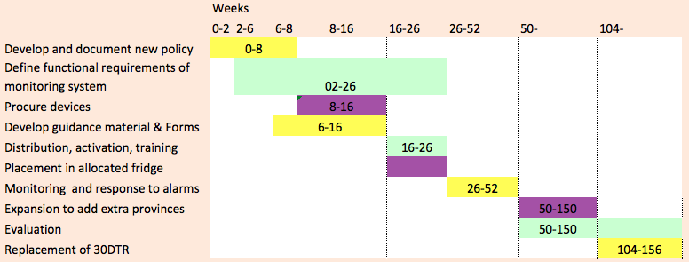

**Figure 3 Estimated timeline based on the original 30DTR guidelines from 2007. Should only be used as an example.**

|  |
| --- |
| Key takeaways for implementation   1. Develop a comprehensive budget for implementation, ideally distinguishing one-off investment costs (e.g. technology, computers, software) and recurring costs; and among the recurring costs, distinguishing fixed costs (e.g. staff salaries) and variable costs (e.g. petrol, extra staff or overtime). 2. Review the budget regularly to identify shortfalls early on, and considering the time needed to identify additional funding to be raised. 3. For external funding, be cautious when linking general milestones (i.e. all devices are dispatched throughout the country) to the release of funds. If external factors delay implementation, for example in one region, this may impair the next project phase for all regions, including regions where the milestone is achieved. 4. Plan and budget for the replacement of the devices every two years. |
| Key takeaways for implementation   1. Develop a simple Gantt chart to plan ahead and communicate progress. 2. Build in buffers for possible delays and review frequently. |

2. Choose products and technologies

2.1. 30DTR products

For detailed and step-by-step instructions on how to procure 30DTR devices, please refer to the UNICEF Supply Division procurement guidelines on temperature monitoring devices,[10] which forms part of the Cold Chain Support Package. The procurement guidelines provide detailed information about the different types of temperature monitoring devices available, how these devices are supplied through UNICEF Supply Division, how WHO Performance, Quality and Safety (PQS) works for those devices and how these items can be ordered. For continuous monitoring of refrigerators, countries may need other types of devices or systems.

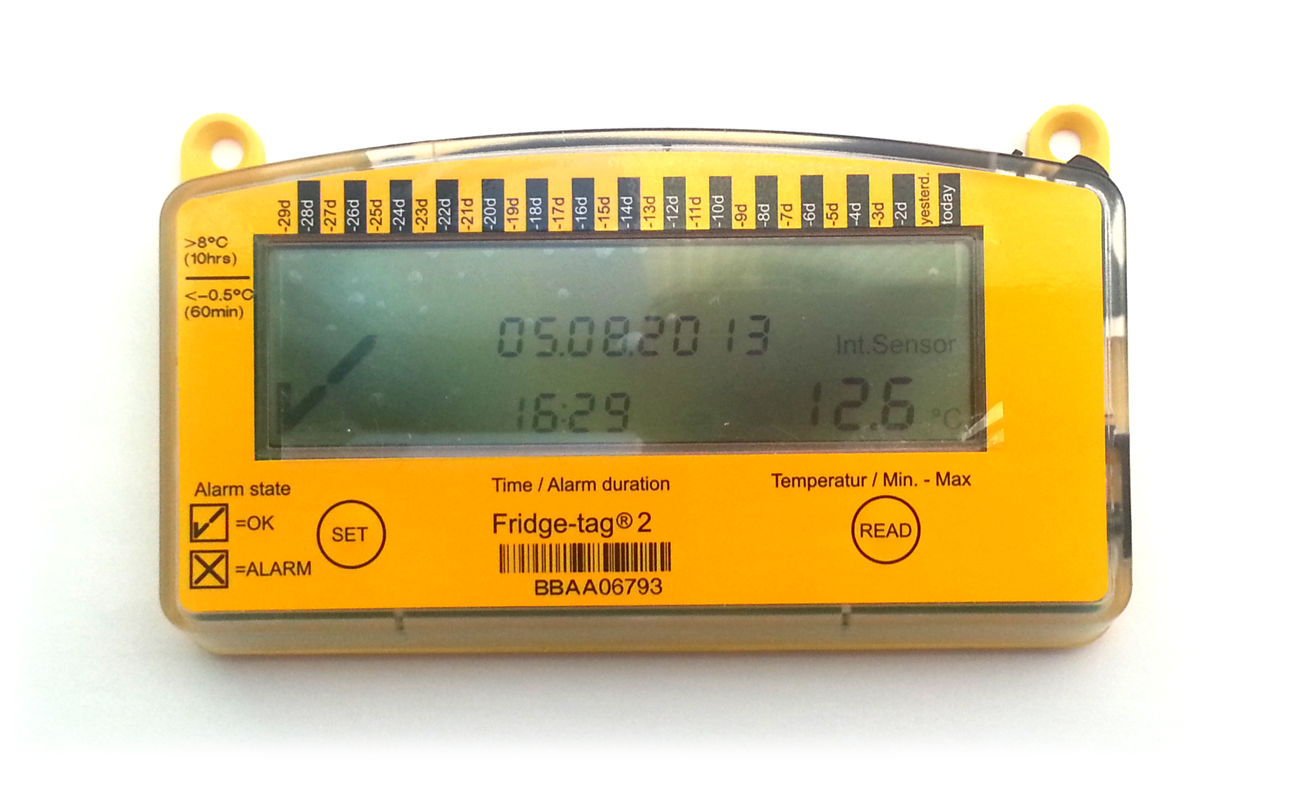

**Figure 4 Fridge-tag 2 temperature recorder**

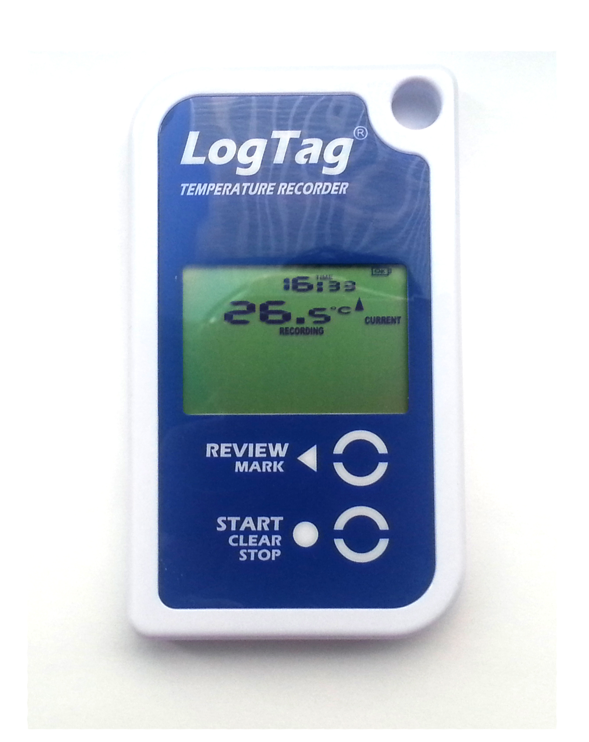

**Figure 5 LogTag temperature recorder**

To complement the Procurement Guidelines, the following will focus on the programmatic aspects of the choice and procurement of these items. The WHO PQS catalogue[11] lists a number of pre-qualified devices available for temperature mapping or monitoring. For 30DTR, however, the most commonly used models are the Fridge-tag 2 and LogTag devices. Please note that it is recommended to decide on one single 30DTR model for the country to ensure consistency of training and use.

All 30DTR devices:

* Monitor refrigerator performance, indicating any days that a refrigerator goes below and above optimal temperatures.
* Store 30 days worth of temperature records. The devices incrementally overwrite data older than 30 days (60 days of data are stored for the Fridge-tag 2).
* Operate with a non-replaceable battery with a minimum operating life of two years from the date of activation.
* Should be activated within 12 months of manufacturing date.

These devices can be used in health facilities and intermediate stores but not to monitor temperatures in walk-in cold rooms (the Cold Chain Support Package indicates which devices are adequate temperature monitoring devices for use at those levels). According to the WHO recommendations,[12] health workers should perform temperature readings and record temperature twice a day, typically in the morning and at the end of the session or day. The 30DTR devices also enable health workers to obtain temperature information for those days when the health worker is absent (e.g. weekends, public holidays, etc.). When using 30DTR devices after following the weekend or days of absence, the WHO recommended practice is that health workers read the minimum and maximum temperatures of the previous days (up to 30 days). If temperature excursions have occurred during such days, appropriate action should be taken in accordance with WHO recommendations. A poster of appropriate checks to be performed by the health workers in response to alarms is provided in Annex 5. Any heat or freeze alarm will show if the temperature inside the refrigerator has been at greater than 8° Celsius (C) for more than 10 hours, or below -0.5°C for more than one hour.

The temperature measurements from the devices should be recorded twice a day in the temperature monitoring charts, which should be attached to the refrigerator with the name of the health facility and the reference number of the refrigerator *(see Annexes 11 and 12 for chart templates in English and French)*. The recommended form also includes space for recording the duration of the alarms, which is important for the risk assessment. The data thus recorded should be used to trigger appropriate corrective actions from the health worker and from the local managers in case of alarms. When the health worker encounters a problem that he/she cannot solve, the issue needs to be escalated according to the SOPs. The escalation must include manager’s follow up and maintenance and repairs issues.

In terms of considerations for choosing 30DTR devices, the WHO PQS website and corresponding catalogue[13] provides a useful overview of how these devices differ from a technical point of view. For an introduction to these devices, refer to the following videos: the LogTag Vaxtag setup guide[14] and the Fridge-tag 2 setup guide and user guide.[15]

When choosing between devices, users may want to consider additional criteria that can impact the success of the programme:

* Previous experience using the devices
* Costs of the devices and the required peripherals (e.g. cables and software will usually be included with the device, but LogTags require additional cradles if users want to download data from the devices)
* Operating lifetime
* Ease of reading the display (i.e. size of characters on the display)
* Ease of activating the device
* Ease of downloading data/reports from the device (e.g. the Fridge-tag 2 model offers data download functionality through a universal serial bus (USB) port, while the LogTag offers data download functionality through a cradle that is purchased separately. One cradle can be used for many devices)
* Ability to analyse the data after downloading data/reports from devices (e.g. the Fridge-tag 2 provides 60 days of downloadable data reports in HTML format (with possibility to convert to Excel), while LogTag provides software that allows the user to perform detailed analysis of the data and to transfer it to other programs such as Excel)

Some countries have organized workshops with stakeholders and users of those devices to make an evidence-based decision about which devices are best suited to the specific country context and its users. Such workshops can support strong decisions and are a good way of engaging the health community and conducting training at the same time. This approach was adopted in Madagascar *(see Annexes 6 and 7 for the protocol and device comparison matrix)*. It is important to note, however, that the outcomes reported in Madagascar represent the experience of one group of users in one country and may not apply universally.

2.2. Technology: from data to action

|  |
| --- |
| Key takeaways for implementation   1. When considering the implementation and large-scale procurement of 30DTR several issues that go beyond technical specifications need to be taken into account. 2. Workshops that gather key stakeholders from district levels can support the process of choosing the most appropriate devices for the country, since these stakeholders are ultimately the end-users. Such workshops also help to clarify the objectives and SOPs. |

Data gathered through 30DTR and temperature monitoring sheets at health facility level, which represents a wealth of information and provides a detailed history of individual refrigerator performance, should be communicated to higher levels (district/regional/national). This data can be aggregated at a higher level and used for supervisory support to monitor the performance of the entire cold chain, including such KPIs as ‘response time between alarms and repairs’. At an aggregate level, this data can also be used to understand the performance of certain refrigerator models.

The key issues are:

* How is this data communicated between health workers, supervisors and managers and shared across the health system?
* How is this data organized and recorded in a database so that it is accessible for decision makers?

2.2.1. How to report the information

There are multiple ways to transmit temperature data to the managerial level, depending on the country-specific resources and equipment that are available. For example:

1. During a monthly supervisory visit, the supervisor collects a copy of the temperature-monitoring chart to subsequently re-enter data into a central database.
2. During the supervisory or technical visit, the supervisor or a visiting technician downloads the data from the device into a portable device (i.e. laptop, tablet or USB device).
3. Health workers send periodic SMS reports with selected data (e.g. the number of monthly temperature alarms). This solution can be efficient and effective, particularly for geographically remote places with limited infrastructure. Negotiations with local service providers can help reduce communication costs, which can be significant for big countries. In some countries, international partners supported these negotiations to involve companies as part of their corporate social responsibility (CSR).
4. Health workers enter the temperature monitoring data from the health facility level directly into an online database. This requires that computers (or tablets), electricity and Internet connectivity are available.
5. Alternatively, through remote temperature monitoring (RTM), temperature data is transmitted directly from refrigerators to a database through general packet radio service (GPRS)/global positioning system (GPS) communication. The approach is currently being evaluated in Kenya, Haiti and Mozambique, but is beyond the scope of this document.

If the country is working with District Health Information System 2 (DHIS2) on a monthly basis to capture programme data at the district level (as many countries already do) and since DHIS2 makes a provision for temporary data, it is an appropriate system for capturing temperature and cold chain data and ensuring that the data is integrated with ministry of health data.

2.2.2. Case study 1: Data collection by technical teams in Mali

In Mali, where 30DTRs are being deployed throughout the country, a monitoring system is being established with trained teams of national technicians that are downloading temperature monitoring data and maintaining the refrigerators. Each health facility is visited every three months and supervision, maintenance and corrective actions follow a three-month cycle. Although the frequency of data collection and data aggregation has three-month delays and the data collected only covers two out of every three months, the data can provide a reasonable overview of the working status of the refrigerators at the health facility level since current available resources do not allow for more frequent visits. The teams are equipped with tablets and transmit data to a centralized system as it is collected. During the supervisory visits, the technicians perform the following checks (which have been added to their SOP):

* The national serial number of the refrigerator and the 30DTR
* The functional status of the refrigerator
* The placement of the 30DTR within the refrigerator

They then download and transmit the collected data. Based on the data collected, Mali is able to generate a national scale temperature-based cold chain equipment performance diagnostic, which is used (a) as a monitoring and evaluation metric for newly installed refrigerators; and (b) to identify and prioritize existing refrigerators in need of repair or replacement.

2.2.3. Case study 2: SMS coding in Laos

An integrated 30DTR and stock management project called Cold Chain Information System has been developed and implemented in Laos. The system uses SMS coding for communication *(see Figure 6 below)* and is being linked with DHIS2. In countries where most health workers have mobile phones, where SMS communication is cheap and where telephone networks are reliable, use of SMS for data collection can be an effective and efficient way of leveraging existing equipment.

*Source: From the Laos Cold Chain Information System Status Report Presentation by Richard Anderson, Paul Colrain, Ranjit Dhiman, Martin Lucak and Sompasong Phongphila, September 2014.*

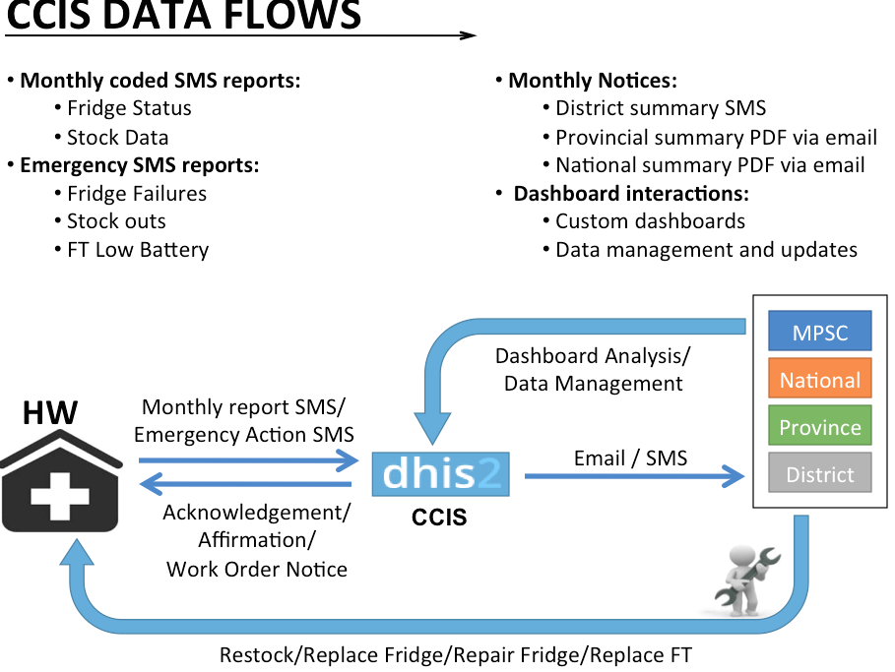

**Figure 8 Lao Cold Chain Information System Status Report Presentation**

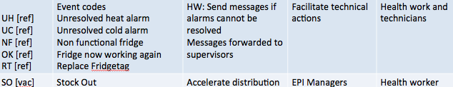

**Figure 6 Lao Communication Model**

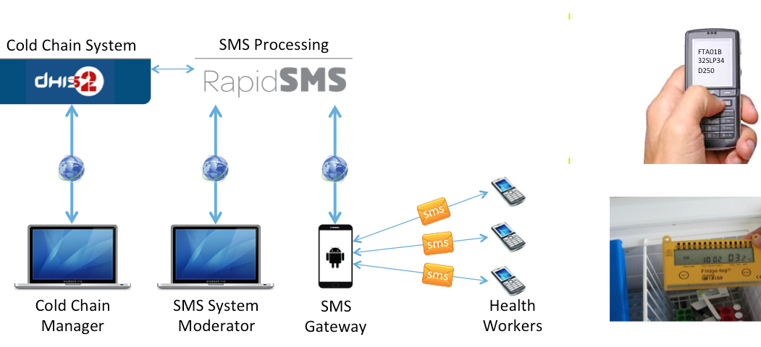

**Figure 7 Lao Cold Chain Information System communication structure**

At the beginning of each month, the health worker sends high and low temperature alarm counts to the district supervisor. The system software sends a confirmation of receipt of data via SMS and follows up by SMS if the data has not been received. These SMS messages are written in a simple standardized code that makes them machine-readable. The code includes the refrigerator identifier (this is especially important if there are multiple refrigerators at the same location) and the number of heat/freeze alarms. The health facility that sends the message is identified by its specific code. The SMS also includes reporting on the available stock level, currently only for pneumococcal conjugate vaccine (PCV) and pentavalent vaccines.

More information on the Laos SMS coding description can be found in Annex 8. This system is being extended to include so-called ‘event codes’ SMS. As shown in Figure 7 above, these codes are used in the SMS sent by health workers either to technicians or to EPI managers to report important issues calling for immediate attention and action. The SMS includes the ‘event code’ and the reference of the health facility or refrigerator for easy identification. The system then sends action messages to technicians and/or to EPI managers to report important issues that require immediate attention and action. The SMS includes the event code and references the health facility or refrigerator for easy identification.

2.2.4 Generic characteristics

A web-based global platform accessible at national, regional, district and local levels offers a comprehensive solution for building and maintaining online real-time inventory of cold chain equipment, tracking cold chain performance using alarms raised by 30DTR as an indicator, recording actions taken in response to the alarms and maintaining monthly vaccine stock records.

The benefits of aggregating data are many:

* Collection of information on temperature performance (stock data can be integrated).
* History of this information can provide feedback to managers on recurrent problems and prompt follow-up actions at all sites and all levels.
* Temperature maintenance performance can be used to manage cold chain equipment, triggering short-term and long-term corrective actions.
* The system’s dashboard makes data visible at all levels, supporting remote access so that updates can be made from a web browser at any location.
* The web-based system, which is accessible by all, can increase cross-functional collaboration and accountability and bring visibility to the health system.
* Substantial cache memory, which enables users to work offline and updates are performed by the system when Internet connection is re-established.

A number of platforms based on rapid SMS are currently being developed. The challenge is their integration with other health intervention systems (District Health Information System (DHIS2), Logistics Management and Information System (LMIS)). For countries that already use DHIS2, further customization with rapid SMS provides a standard approach across the ministry of health with the existing system already in place for necessary maintenance of infrastructure and adaptation to existing systems, presenting a cheaper, easier and quicker option. Integration through customization from DHIS2 is the best solution when possible.

|  |
| --- |
| RapidPro: Example of an off-the-shelf SMS-based communication tool  More than 20 countries are currently using or developing SMS-based communication approaches for health services. Based on the principle of economies of scales and the benefits of long-term agreements with suppliers, UNICEF has launched a standardized, off-the-shelf mobile phone-based system called RapidPro[16] for real-time data collection to improve service delivery monitoring. RapidPro provides a cloud-based platform with dashboard reports, is compatible with many other health systems standards and represents a cheap and attractive off-the-shelf solution.  RapidPro capitalizes on previous pilot projects like Rapid SMS and U-report. The system is easy to install and adapt to create SMS-based workflows (that can trigger action at some specific points of the workflow), track activities and monitor with the dashboard functionality.  The target audience is programme staff, rather than computer systems specialists. RapidPro allows users to broadcast personalized messages, for example, organizing which messages should be sent to which specific target users and on what schedule. SMSs can be organized and labelled like emails. RapidPro can be used everywhere, through a free Android-based application. The rationale is that providing a standard system will save on customization costs, reduce deployment lead-times and make it easier to implement. The package offers agreements with mobile network operators. |

|  |
| --- |
| Key takeaways for implementation   1. Many models for communicating data from health facilities to the higher levels have already been developed. These solutions need to be evaluated against the specific system objectives and adapted to the country context. 2. The choice can be between off-the-shelf solutions or the customization of the SMS gateway and the cloud-based database. 3. The compatibility with other existing systems used in the country (e.g. DHIS2, health management information system (HMIS) and/or LMIS systems) must be considered from the very beginning. |

3. Order and procure

3.1. Ordering process

The UNICEF Supply Division Cold Chain Support Package provides procurement guidance and technical support for the procurement of cold chain equipment and services. UNICEF Supply Division provides procurement services[17] and can assist countries with their procurement, including with benefits from bulk prices since most products are part of long-term agreements with suppliers. In addition, UNICEF Supply Division can review procurement plans and assess whether orders are consistent with the available country-specific cold chain information. The temperature monitoring devices currently covered by long-term agreements between UNICEF Supply Division and suppliers can be found in the UNICEF Supply Catalogue.[18]

Countries can also manage their own procurement directly with the suppliers. The UNICEF Supply Division *Procurement Guidelines: General Guidelines for Cold Chain Equipment[19]* references the public procurement process. For temperature monitoring devices, supplier lead times are from one to four weeks. Processing time for the bidding, procurement process and transport should be added. In contrast to the UNICEF Supply Division manuals, the following guidelines provide some programmatic considerations.

When quantifying needs, one should generally consider a minimum of one 30DTR device per refrigerator and add some units for training purposes and some as buffer stock to replace damaged or failed devices. Provision must be made for the timely ordering of replacement units when the battery life is depleted. A single annual procurement is recommended, even for a phased deployment, to benefit from bulk discounts and to limit transaction costs. If the LogTag model is chosen, the quantity of cradles necessary for the data download will depend on country-specific strategies. Three questions need to be addressed:

1. Does the country intend to download the temperature data from the device for systematic analysis?
2. Who will be responsible for downloading the data? (E.g. a health worker, district supervisor, etc.)
3. How many health facilities will the official responsible for downloading the temperature data cover?

If the standard temperature monitoring charts are changed, new forms will need to be ordered as well.

3.2 Arrival process

All equipment must be inspected upon arrival, to check that all devices are received and that the shipping boxes/packaging are in good condition. In case of failure, it is very important that UNICEF Supply Division is notified and that the devices are returned to the supplier.

The cold chain inventory should record the expected operating life of the devices (the production date is indicated on the reverse side of the device), which might not be exactly the same for all devices received. Given the limited operating lifetime of the devices, it is important to keep track in order to avoid wastage.

3.3. Storage process

Once they have arrived, all devices should be kept at room temperature in a dry storage area. This storage area should not be exposed to direct sunlight. It should be noted that very low and very high temperatures during storage might reduce the shelf life of the battery. Manufacturers usually ship the devices within a week of production. The production date (on the reverse side of the device) should be taken into account when arranging stocks so as not to exceed one year of storage time from the production date. Given the time element, there needs to be a plan for quick deployment before the devices arrive in the country. The lack of such a plan has been identified as a gap in previous procurements.

3.4. Disposal and replenishment

The 30DTR devices contain lithium batteries, which should be removed and disposed of in containers for used batteries. Once the battery runs low, the devices should be replaced within 30 days. Since the ordering process and delivery lead times are much longer than 30 days, the ordering process must be organized in advance. Collection of expired devices, disposal of this electronic waste and a replacement system need to be organized.

|  |
| --- |
| Key takeaways for implementation   1. EPI authorities must take the limited battery operating life into consideration and plan replenishment of 30DTR in good time. 2. A substantial buffer stock (15-20 per cent) should be kept to cover devices that stop working due to technical defects, bad manipulation or exposure to extreme temperatures. |

A replenishment order should be planned 18 months after the first order. All devices should be replaced within two to three years and the necessary budget lines should be established.

4. Train and validate standard operating procedures

4.1. Training and capacity development strategy

Training end-users and their supervisors is very important to the change management process. Training is very time and resource consuming and should not be underestimated. The content of and materials for the training programme must be adapted to the specific needs of health professionals. Various teaching approaches are possible: face-to-face, eLearning using simulators, or a combination of the two, known as ‘blended learning’. Efficient face-to-face training practices have involved:

* Classroom-based training with one device per participant
* Connecting training to monthly meetings or on-site training (on-the-job training) during health centre supervisory visits to provide supportive supervision.
* Training of trainers (or cascading training), or staggered training for pilot sites

The gender factor in the learning process has not been sufficiently considered and no training materials have been specifically tailored to women. However, most of the nurses are female and most of the district supervisors, technicians and trainers are male. This might undermine the efficacy of training for women vs. men. Studies based on different learning behaviours in adult education show that men and women learn differently.[20] Men are more active speakers and more interested in detailed knowledge particularly in technical subjects, whereas women learn better in a more applied way through hands-on training and in practical settings. Women are more dubious about the usefulness or the applicability of the knowledge imparted, in particular with regards to technical subjects, and studies show that women’s computer skills are comparatively less developed.[21] Taking the gender factor into account in teaching approaches, based on the different learning and interaction styles of men and women could mean that the most efficient training for female health workers should be segregated for male and female groups or more training should be conducted by women.

4.1.1. Required skills for health workers

* Ability to perform the spot temperature reading for the current day, as well as the reading of minimum/maximum temperature and alarms for the few past days
* Knowledge of which procedure to follow when 30DTR readings show heat excursion or freeze risk in the refrigerator (for example, adjust thermostat or make sure the refrigerator is properly loaded allowing air circulation)
* Knowledge of where the 30DTR devices should be placed in the refrigerator
* Ability to record the 30DTR readings in the temperature monitoring chart
* Ability to carry out basic corrective actions in case of alarms
* Knowledge of why temperature reading is important and awareness that this is an integral part of the job (vaccine management skills)
* Knowledge of how good temperature information can improve the quality of the health service because it can improve the monitoring of the quality of the vaccines (vaccine management skills)

Extra elements can be added, when necessary:

* Ability to activate and set date, time and temperature scale
* Ability to change date, time and temperature scale
* Ability to download data from the 30DTR
* Ability to carry out technical corrective action and preventive maintenance

Depending on the deployment method, these elements can be added by the supervisors at district level, before dispatch, in which case the health workers do not need to learn these skills.

4.1.2. Required skills for supervisors and Health Managers

Supervisors/health technicians need to be trained in their new routine procedures and checks, which should be recorded in a SOP or SIP:

* Check that the temperature monitoring charts are filled in and done so correctly
* Check that extra supplies of the temperature monitoring chart are available
* Check that the teaching aids are still placed in the correct locations
* Check that the correct device is still in the correct refrigerator and appropriately placed
* Check that the correct vaccines are still in the correct refrigerator
* Stress that these activities are part of the job description and that to build accountability, their performance will be assessed based on these criteria

Supervisors should also be trained on how to download and review the available data and may need extra information technology and data management skills. It is advisable to standardize the software installed on the supervisor’s laptops as it eases the process for the training on how to download and convert onto Excel (for FridgeTag2). They should also be trained in supportive supervision: how to support health workers with corrective action when required and how to follow up on corrective actions *(see Annex 9 for an example checklist for supportive supervision).*

Annex 6 provides an example of a training workshop protocol from Madagascar. Note that this example invites direct feedback from the participants on the desired process and ensures that participants get involved. At the end of the training, all participants must show that they can read the information displayed on the device during the current day and the two to three previous days, that they can read the alarm and that they can record this data into the temperature-monitoring chart. This is even more crucial in the training of trainers; trainers will not be able to conduct the training if they are not fully confident and proficient in operating the devices. Practical exercise sheets are available so that users can check their ability to read the temperature.

The training should be hands-on with at least one device per participant. It is recommended that the devices be activated a few days in advance as documented in the lessons learned from the Madagascar training workshop example *(see Annex 6)*.

Countries planning to use SMS coding to report alarms and events must also include on-site field tests of SMS messages, including practical exercises. While not complicated, a system where SMSs are written in a machine-readable code must be fully understood by health workers and requires user compliance and training.

4.2. Training materials and protocols

Comprehensive packages of training materials have been developed and improved upon in many countries and much of this can be reused. The guides[22] contain a clear set of actions to be taken when a vaccine refrigerator’s temperature is out of range. Available materials also include posters and pictograms (which can be affixed on the walls at the health facility) on the use of 30DTR and on their placement in the refrigerators. Other materials cover the actions to be performed in response to alarms. Prior experiences have shown that the material should be ready well ahead of time and material/charts/forms should be standardized; so if any new format needs to be approved by the ministry of health, this process must be finalized before the training starts. Having different temperature monitoring charts at the time of the training and at the time of implementation can be unnecessarily confusing. SOPs or protocols can bring structure to the training and ensure that all trainings are aligned.

Annex 10 provides examples of training material in English and French that can be used or customized. These example materials show how the WHO guidelines translate into pictograms for easy understanding.

As per the Madagascar protocol in Annex 6, it is important to have well-prepared, hands-on training on the use of the device that involves:

* One device per participant
* Some devices that have been activated for some days and exposed to heat or sub-zero temperatures, and other devices that have been activated and left in the correct temperature zone
* Discussion on the different scenarios
* Acquainting participants with the various scenarios that they may encounter in the field setting, so that participants have been through all possible outputs of the device.

An effective alternative found in a pilot project in Nepal was to equip training sites to provide each participant with one tablet pre-loaded with training material and with a simulator of the 30DTR for manipulation.

|  |
| --- |
| Key takeaways for implementation   1. What tends to works well is a mix of a short presentation of the device, followed by hands-on sessions with exercises and discussions in plenary and in small groups. 2. It is important to verify that all participants have the skills to perform the necessary tasks. In particular, the supervisors or trainers should be very familiar with the device. 3. In order to ensure that all devices are correctly set-up with the date, time and Celsius/Fahrenheit selection, and correctly placed in the refrigerators, some training should take place before the devices are dispatched. However, when this is not feasible, a technical or supervisory visit relatively soon after the devices have been received and used is highly recommended to check the devices and verify that the health workers do not have problems with the readings. 4. The gender element must be factored in. 5. Training should not be a one-off event. Follow-up visits with renewed training that re-stresses the reasons and benefits of temperature monitoring and good vaccine storage practices are important, especially in case of high staff turnover. 6. For communication to the district level via SMS, a lessons learned was on the importance of considering literacy and language skills. |

5. Deploy and implement

It is recommended that users be first trained on how the devices are activated and used before the devices are dispatched and not the other way around.

5.1 Dispatching and recording in inventory

A centralized cold chain equipment inventory system needs to track the locations where 30DTRs are deployed, both for those devices that are activated and for those inactivated devices that remain in storage. Activated 30DTR devices are linked to each refrigerator. The 30DTR devices require that the inventory account for the limited shelf life of 30DTR batteries. The devices can be kept for one year before being activated. After activation, the operating life of the batteries is advertised as lasting another two years (two to three years for the LogTag). It is therefore important to incorporate the expected expiration date into the inventory. It is important to note that 30DTRs should not normally be moved from one refrigerator to another, as this can impact the historic records associated with the device and can then make retrospective analysis more difficult. However when a new one replaces a defective refrigerator, the device can be “re-used” in the new refrigerator, keeping in mind it is monitoring different equipment from a certain date.

It was also identified as excellent practice to record in the inventory which vaccines are normally stored in which refrigerator in case of malfunction. Corrective action will depend to some extent on the vaccines.

Finally, if the cold chain equipment inventory was not absolutely up to date, the deployment of 30DTR provides an opportunity to check and update the equipment and its working status.

5.2 When to activate the devices

Different strategies have been used for device activation and setting up the date, time and temperature scale (Celsius/Fahrenheit). Feedback from past experiences would suggest the following positive (+) and negative elements (-) in each method:

1. Activation upon receipt at the central or regional level before dispatch, throughout the country or in selected areas:

* Fast
* Most likely the cheapest option
* Easy to keep track of the expiry date of all batteries since all 30DTR devices are all activated at the same time
* Wastes battery time from the time of activation to the time of actual use in the refrigerators
* Unless the devices are kept in the right temperature condition during transport, alarms will appear and will continue to show on the display for 30 days. This might confuse health workers.

1. Activation on site during the supervisory visit or technical visit

* Effective, ensures correct placement
* Ensures correct activation of all devices
* Allows for a vaccine management training in the field
* Requires heavy resources in terms of the number of staff needed to visit each health facility and activate all devices or activate and train health facility staff simultaneously

1. Activation on site by the health workers when they receive the devices before training

* Cost efficient
* It can be difficult for health workers to activate the devices if they have not had any prior training
* Not very user-friendly for the health workers who receive this imposed new piece of technology without learning the benefits of its use. This was identified as not recommended practice
* Risk that the devices will not be activated and used

1. Activation on site by the health workers when they receive the device after training

* Cost efficient
* Better chance than option (c) that the devices will be activated and correctly set
* No way of checking that the devices are correctly activated until the next supervisory or technical visit

1. Activation during the training sessions
   * Enables the trainers to check that the date, time and temperature scale are set correctly.
   * Avoids wasting battery time. This strategy was clearly identified as a good practice.

|  |
| --- |
| Key takeaways for implementation   1. Devices should not be deployed before training has been provided. 2. EPI or logistics authorities must follow up on how many devices are present and how many are in use and where, ideally after a recent and updated cold chain equipment inventory. |

* Slower deployment and activation

5.3 Placement of device in the refrigerator

As per WHO guidelines,[23] the 30DTR device should be placed in the coldest part of the refrigerator, especially if it is used to store freeze-sensitive vaccines. This part would typically be the bottom of the basket in chest refrigerators or nearest to the evaporator plate in front-opening models and absorption units *(see Figure 9 for a table of vaccine sensitivity to heat and freezing)*. If the stored vaccines are not freeze-sensitive, the device can be placed at the top of the load in the refrigerator for easier reading, also taking into account the risk of the device falling when opening the door or during manipulation. The stem thermometer should also be kept in the refrigerator as a back up. Since the recommended placement depends on the type of vaccines, it is important to know which vaccines are stored in which refrigerator.

*Source: WHO recommended temperatures for vaccine storage (PATH/WHO, 2014).*

5.4 Full deployment or phased scale-up approach

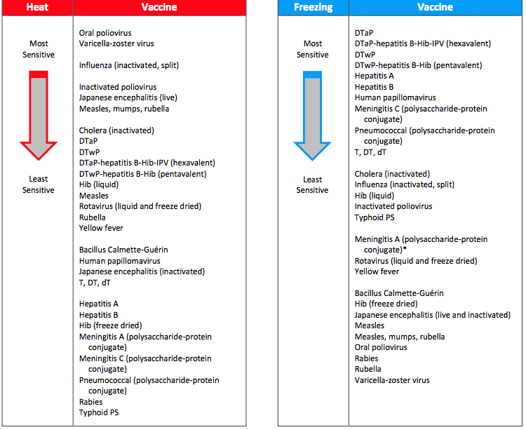

**Figure 9 Sensitivity of vaccines to heat and freezing**

Initiatives that began with small-scale pilots in selected locations and that have subsequently been scaled-up have been effective. These approaches have generally started with a small-scale pilot with a lot of attention and the leverage of a local leader. Feedback was collected from the pilot through an iterative process to prepare for an expansion to larger entities such as a group of provinces. Following evaluation of this segment and readjustment, countries can either proceed with full deployment to the remaining sites or continue with a spiral deployment of, for example, three districts added every three months. This phasing model allows for some reuse of resources in the new segments, such as managerial, supervisory and training resources, as well as use of the experience of the first segments to evaluate and readjust. The same technical team of agents can conduct the training and device placement in refrigerators in a number of assigned locations during the first phase, then perform the same training and placement in another group of locations during the following phase. This team will have gained experience in their first assignment that additional districts can benefit from.

Although full-scale, nationwide deployment from the very beginning adds the advantages of bulk ordering and bulk dispatching, for big countries, organizing at this scale is highly labour and resource intensive. In contrast, phasing by provinces or groups of provinces offers flexibility not only to reuse resources for training but also to better redeploy buffer stocks from one phasing area to the next.

6. Monitor and evaluate: Device + system + responsibility = success

6.1. Monitor

The implementation of activities must be closely monitored from the very beginning and throughout the year, against agreed objectives, implementation milestones and KPIs. Most monitoring plans include the monitoring of resource allocation, the provision of all expected inputs, the completion of activities within the timeframe and the achievement of respective outputs.

Previous experiences highlight the importance of planning several supervisory visits, as well as training refresher visits, to verify that the readings were done correctly, the temperature monitoring charts were filled in correctly and that health workers knew what to check in case of alarms. These visits can also involve conducting follow-up training. Ideally, and as recommended by WHO, these visits should be monthly, in connection with stock replenishment. If this cannot happen, the visits should be carried out as often as possible and no less than once every three months, to maintain the momentum on temperature monitoring, re-stress its benefits and check its performance. Visits can be prioritized according to data received highlighting places with problems. Continuous follow up and sustained supervision are the most significant factors for success.

As discussed in Section 4 (training), district level supervisors should integrate extra checks on the correct implementation of 30DTR into their routines.

6.1.1 Key performance indicators

Possible Indicators for supervisory checks:

1. Number of temperature monitoring sheets completed
2. Number of refrigerators not working and reason (e.g. lack of kerosene, power cuts, missing spare parts, etc.)
3. Number of days with alarms and reason
4. Number of no reporting of the monthly data and reason
5. Number of incorrect reporting and reason
6. Number of days delay in reporting and reason
7. Number of expected follow up actions not performed and reason
8. Number of 30DTRs incorrectly positioned in the refrigerator and reason
9. Number of days with stock-out and reason

Once a system is established for reporting to the next level of responsibility (supervisor), a surveillance system must monitor that the charts/reports are filled in, received by the health authority, responsible for gathering them and that they trigger some reaction when they are supposed to. Timely reporting is a key driver of successful implementation, since the more recent the data acted upon is, the more efficient the corrective action will be. The mTrac project evaluation stresses the importance of appropriate response and corrective action to address reported issues. When health workers or district health managers perceive that their extra reporting efforts do not trigger a response from the next management level, their motivation is at risk of not being sustained. To address this, district compliance in terms of follow-up on late or missing reports, reviews of issues highlighted in the reports and pursuit of corrective actions, should also be monitored.

6.1.2 Quality assurance

Validation of the data received but also of the measurement is a crucial element in the evaluation process, in order to improve cold chain and vaccine management and specifically temperature monitoring. One way to monitor and evaluate the quality is to ask the users directly. This approach cannot give a measure of cold chain temperature performance itself but can be used as a proxy to provide information on the general quality of immunization or the health services provided.

Using SMS for polling and quality checks in Uganda

SMS reporting was used in the mTrac project to obtain direct feedback from the recipients of health services. National media campaigns, radio programmes and poster campaigns encourage users and community members to call a toll-free number to report any underperformance of the system (i.e. health facilities being closed during working hours, vaccine stock outs or rude behaviour). Although district level staff initially opposed the system, they accepted it in the end. The system both exposed chronic underperformance and acknowledged good performance. It can help identify health systems bottlenecks. For example, SMS polling was used with mTrac to check if important immunization information had been correctly dispatched and understood and that appropriate action had been taken. To prepare for the introduction of PCV in Uganda, the National Immunization Programme (NIP) sent special PCV stickers with the request that these stickers be affixed to all refrigerators identified to contain the PCV. The NIP used SMS polling to verify that this request was implemented. Health workers were asked if they had received their PCV stickers and whether they were put onto their refrigerators. Only 25 per cent had done so, with disparities among districts. This polling was effective and provided a quick response to a specific question and its underlying root causes (e.g. have health workers not received the stickers? Have they not received the instruction to put the sticker on the refrigerator? Have they not understood? Have they not felt they had time to do it?).

The cost of such surveys was estimated at US$ 150 (excluding the establishment of the system) and responses were received within 48 hours. This is an example of a system that provides real-time reliable data at a low cost.

Acknowledgment of good performance can be a good incentive. Health workers are more motivated to sustain their temperature monitoring efforts when they see that their behaviour makes a difference and that their reporting is used to improve the system as a whole. This was the case in Uganda, where the Ministry of Health followed up on the issues reported.

Triangulation offers the possibility of verifying that the data collected is correct. One way of triangulating is to use in random location/random refrigerators long-term temperature monitoring devices (or remote devices) in parallel with the 30DTR system. This could be done for the initial implementation period (six months) to corroborate the recorded data.

At the district level, a system for issue tracking could also be beneficial and can be easily deployed within the DHIS2 platform. For example, a health worker at a health facility escalates a temperature performance problem to the district and the district then has two months to solve and close the issue, with records of what the corrective action was (e.g. the replacement of spare parts, new delivery of 30DTR in case of low battery, escalation of open issues to a higher management level, for example, to trigger replacement of a faulty refrigerator). This system is evidence-based and each step is very visible. As a result, lack of action is hard to hide and this is a great incentive to improve performance.

|  |
| --- |
| Key takeaways for implementation   1. Systematized follow-up and monitoring probably represents the most important single element of implementation and should be sustained and institutionalized. Short-term monitoring can yield positive results but the long-term perspective matters even more. 2. Scaled KPIs might be useful as they give a sense of the trend or direction in which the project is going. Although some KPIs might not be achieved during the first year, as long as the trend continues to be positive, the project is on track. |

6.2. Review and evaluation

As part of the post-installation review process, having the districts visit all of the sites to check the readings after one to two months is strongly advisable. This would most likely uncover valuable new issues, and would clearly highlight the value of this system to the ministry of health and districts, which would in turn help increase demand and interest for

future (routine) reports. This would corroborate whether the devices are being used correctly and enable evidence-based readjustments and further training. It includes testing the tasks being performed against the SOPs and enables an early verification that the SOPs fully and exactly cover actual practices within the system.

Evaluation of the project includes:

* Objectives achieved; not achieved
* Rate of adoption of new processes
* Rate of compliance with SOPs
* Root-cause analysis for under-achieved objectives
* Appropriateness and quality of technical support
* Success of training
* Budget deviations
* Validation of data

In addition, an evaluation of the product and its appropriateness for achieving the objective is required, including measurements of temperature fluctuation in vaccine storage refrigerators. Do the 30DTR devices provide adequate measurements? Do they provide most of the necessary information, all of the necessary information for all vaccines, or excessive information? Do they rely too much on human action and compliance? Is it an issue for data analysis that the information recorded during the week is spot readings and for weekends it is alarms only or alarms and minimum/maximum temperatures?

Feedback from countries includes:

* USB connectivity (a cord attached to a Fridge-tag 2 or a LogTag USB cradle) is useless because neither health workers nor supervisors have the equipment to download data, nor the accountability to systematically review it.
* 30 days of data is not sufficient since the supervisory visits/transmission of data often occurs every three months (in some places this is even a best case scenario)
* Some countries do not find the definition of alarms sufficient, particularly if they do not have many vaccines with vaccine vial monitor labels. They use specially programmed Fridge-tags, which show alarms for exposure to +8 °C already after 60 consecutive minutes. However, this practice results in many alarms and it has been found to be very demanding in terms of resources to monitor the many alarms and interpret when their accumulation becomes really critical for the vaccines.
* Temperatures not reaching the established WHO thresholds of +8°C but still high (for example +7.5°C) and for a very long period are not reported as alarms. So if the health worker focuses on the alarms, it might not trigger any corrective action. This has raised concerns with some cold chain specialists.
* 30 days of low battery alarm might not be enough considering the time it could take to pass this information to the person in charge and for action to be taken for replenishment of the device.

WHO, UNICEF and other partners are working with the industry towards the development of products best adapted to country needs. It is crucial that they get feedback on the ease of use and the appropriateness of the products, as well as suggestions from the users on the ground on how these products can be improved. Health workers, EPI managers and cold chain and logistics consultants in the field often come across product performance that differs from what it should be in theory. For example, a duly pre-qualified and tested refrigerator might not provide sufficient capacity to maintain adequate temperature in a concrete building with a tin roof and no aeration when outside temperatures reach more than 48 °C and the surface on which the refrigerator is placed is not even. Specific combinations of these adverse factors may hinder the normal performance of the refrigerator model. Long-term temperature measurements can provide health authorities with performance information on all refrigerators in the country, thereby enabling them to make the right decisions for the purchase of equipment adapted to their circumstances. This can also be of high diagnostic value for manufacturers as it can provide evidence-based data on vaccine refrigerator performance in the field.

|  |
| --- |
| 30DTR temperature monitoring is part of a range of systemic monitoring options and should not be considered in isolation, but rather as one of the important pillars of the vaccine supply chain. Its implementation, in order to be effective, needs to be part of an overarching eHealth plan, bringing change, transparency and accountability into the health system through an innovative mechanism. Although the technology exists and has shown evidence of its effectiveness, data without action will not make the change. Countries can only make this change through institutionalized systems improvements. |

Experience has shown that systematic recording can lead to many improvements, as recently documented in a study on accidental vaccine freezing in Tunisia.[24] In that case, the number of temperature alarms was decreasing as a result of health workers becoming more aware of the issues and better at performing all of the checks on the refrigerator. Furthermore, communication between all levels increased, leading to higher stocks at the health centre level and thereby reducing the risk of stock-outs.

|  |
| --- |
| Outstanding issues with 30DTR   * Need for clear suggested waste management policies and practices * More systematic ways of gathering feedback from users for product improvement * Systematic ways to follow up on replenishment (warnings sent by supplier?) to avoid stock out of operating devices when batteries expire. * Integration of more functionality in the cold chain module in DHIS2, taking into account all of the requirements for temperature and equipment monitoring (integration of SMS gateway, temperature and equipment performance, repairs tracking, etc.) |

List of Annexes

Annex 1 Sample of indicators from EVM assessments

Annex 2 SOP example based on an SOP from Nepal

Annex 3 SIP Nigeria

Annex 4 Mapping of functions, expected actions, roles and responsibilities – Lao People’s Democratic Republic

Annex 5 Corrective actions in response to alarms based on WHO recommendations

Annex 6 Protocol of a training workshop – Madagascar

Annex 7 Comparison matrix – Madagascar

Annex 8 SMS coding teaching – Lao People’s Democratic Republic

Annex 9 Checklist for supervisory visits for supportive supervision – EPI

Annex 10 Extra training material: posters on corrective actions in response to alarms, based on WHO recommendations

Annex 11 Temperature monitoring chart, English

Annex 12 Temperature monitoring chart, French

Annex 1. Sample of indicators from EVM assessments

Examples of indicators from the EVM v2.1

Can the health worker(s) give the correct storage temperature range for each of the vaccines on the schedule?

Do the health worker(s) know which vaccines on the schedule can be damaged by temperatures below 0°C

Can the health worker demonstrate correct reading of all types of thermometer and/or temperature recording device(s) used in the store?

Are refrigeration temperatures recorded manually?

Are the manual temperature records complete (twice daily, every day) for each and every cold room, freezer room, vaccine refrigerator and vaccine freezer?

Does the temperature record form include space for entering alarm events?

Have temperature records been kept in a safe place for at least three years?

Are temperature records and alarm events formally reviewed at least once a month in order to identify temperature excursions and their causes?

If temperature records and alarm events are formally reviewed at least once a month, is there documentary evidence that remedial action has been taken in response to excursions or breakdowns?

Do all vaccine refrigerators have working continuous temperature recorders or refrigerator loggers?

Do all vaccine refrigerators have a working thermometer stored with the vaccine?

Is the stock control system designed to record vaccine and diluent wastage in unopened vials due to expiry, freezing or heat-exposure?

Were freeze indicators packed with deliveries of freeze-sensitive vaccines?

Do storekeepers/health workers know how to read vaccine vial monitors?

Are the vaccine vial monitors on all vaccines in the health facility refrigerator, cold box or vaccine carrier before the discard point?

Annex 2. SOP example based on an SOP from Nepal

|  |  |  |  |
| --- | --- | --- | --- |
| SOP-logo | Standard Operating Procedure  **Monitoring vaccine storage temperatures at fixed storage locations** | | |
| **Approvals** | **Name** | **Date** | **Signature** |
| Authorized by: |  |  |  |
| Reviewed by: |  |  |  |
| Revised by: |  |  |  |
| Original author: |  |  |  |

**Version history**

|  |  |  |  |
| --- | --- | --- | --- |
| **No** | **Date** | **Description of change** | **Reason for change** |
| 1 | 07 Oct 2011 | Original |  |
| 2 |  |  |  |
| 3 |  |  |  |
| 4 |  |  |  |
| 5 |  |  |  |

*Disclaimer:* This is a model standard operating procedure. It incorporates generic guidance only. Countries are encouraged to adapt it as necessary to suit local requirements.

Queries or comments may be addressed to [evminitiative@who.int](mailto:evminitiative@who.int)

Table of content

Distribution 39

1. Policy and objectives 40

1.1 Policy **Error! Bookmark not defined.**

1.2 Objectives 40

2. Responsibility 40

3. Associated materials and equipment 40

4. Procedure 41

4.1 Training 41

4.2 Where to place temperature monitoring devices 41

4.2.1 Freezer rooms 41

4.2.2 Cold rooms 41

4.2.3 Vaccine freezers 42

4.2.4 Vaccine refrigerators 42

4.3 How to read a dial or stem thermometer 42

4.4 How to maintain the temperature record charts and reports 42

4.5 What to do if temperatures are out of range 42

4.5.1 Cold rooms and vaccine refrigerators 42

4.5.2 Freezer rooms and vaccine freezers 43

4.6 Daily tasks 43

4.6.1 Freezer rooms in primary and sub-national stores 43

4.6.2 Cold rooms in primary and sub-national stores 44

4.6.3 Vaccine freezers in primary stores and large sub-national stores 44

4.6.4 Vaccine refrigerators in primary stores and large sub-national stores 44

4.6.5 Vaccine freezers in small sub-national stores 44

4.6.6 Vaccine refrigerators in small sub-national stores and health facilities 44

4.7 Weekly tasks (stores with continuous temperature monitoring) 45

4.8 Monthly tasks 9

4.9 End of year tasks 45

4.10 Record keeping 45

5. Related documents and SOPs 45

Annex 1 – Temperature chart for electronic recording devices 46

Annex 2 – Monthly temperature review report 48

Annex 3 – Annual temperature review report 0

Distribution

Distribute this SOP to the following:

|  |  |
| --- | --- |
| **Facility type** | **Position(s)** |
|  |  |

1. Policy and objectives

1.1 Policy

Personnel who are responsible for looking after vaccines should know how to operate and interpret the temperature monitoring devices that are used in their workplace. They should also know how to keep daily temperature records and how to carry out periodic temperature reviews.

It is essential that the temperature monitoring process is not purely mechanical. Personnel must be made responsible for their actions and must know how to react effectively to problems as soon as they arise.

1.2 Objectives

This document explains the daily, weekly and monthly procedures for monitoring vaccine storage temperatures at fixed storage locations throughout the vaccine supply chain. The objective is to use the temperature records for three purposes:

1. To verify whether the storage temperature is within the acceptable temperature ranges of +2°C to +8°C in cold rooms and vaccine refrigerators and - 25°C to -15°C in the freezer room and freezers.
2. To detect temperature alarm conditions,[25] which may have caused vaccine damage and to take appropriate action.
3. To assess the performance over time of vaccine handling at each link of the cold chain and to monitor the performance of cold chain equipment.

The document also describes the emergency actions to take in the event of a breakdown in the continuous temperature monitoring equipment. Contingency action to take in the event of cold chain equipment failure is described in: *EVM-SOP-E3-01: Responding to emergencies in fixed storage locations.*

2. Responsibility

Cold chain assistant/officer, mechanical engineer, refrigerator technician, EPI supervisor/officer, cold chain section chief and all storekeepers and health workers who are responsible for monitoring and recording temperatures in the cold chain equipment at fixed storage locations throughout the vaccine supply chain.

3. Associated materials and equipment

Daily entry log form for walk-in-cooler and walk-in-freezer, temperature chart for electronic monitoring devices

| **Cold chain equipment** | **Temperature monitoring devices** | |
| --- | --- | --- |
| Recommended devices | Minimum requirement |
| Freezer rooms in primary or sub-national stores | * External digital thermometer or gas/vapour pressure dial thermometer * Electronic continuous temperature monitoring system * Temperature alarm system with auto-dialer | * External digital thermometer * Alcohol stem thermometer * Pen recording thermometer |
| Cold rooms in primary or sub-national stores | * External digital thermometer or gas/vapour pressure dial thermometer * Electronic continuous temperature monitoring system * Temperature alarm system with auto-dialer | * External digital thermometer * Alcohol stem thermometer * Pen recording thermometer * Temperature alarm system |
| Vaccine freezers in primary stores and large sub-national stores | * Electronic continuous temperature monitoring system * Temperature alarm system with auto-dialer | * External digital thermometer * Alcohol stem thermometer ** |
| Vaccine refrigerators in primary stores and large sub-national stores | * Electronic continuous temperature monitoring system * Temperature alarm system with auto-dialer * Electronic freeze indicators | * Alcohol stem thermometer ** * External digital thermometer |
| Vaccine freezers in small sub-national stores | * Alcohol stem thermometer ** | * Alcohol stem thermometer ** |
| Vaccine refrigerators in small sub-national stores and health facilities | * Alcohol stem thermometer ** * 30-day electronic refrigerator temperature logger | * Alcohol stem thermometer ** |

** Bi-metallic dial thermometers are not recommended because they quickly loose their calibration.

4. Procedure

4.1 Training

Responsibility: Cold chain section chief

Conduct training on the use and interpretation of electronic temperature monitoring devices.

4.2 Where to place temperature monitoring devices

Responsibility: Mechanical engineer, cold chain officer/assistant, EPI supervisor/officer

4.2.1 Freezer rooms

The sensor for the digital thermometer and the sensors for the continuous temperature monitoring equipment are fixed by the cold room installer and should not be moved.

4.2.2 Cold rooms

The sensor for the digital thermometer and the sensors for the continuous temperature monitoring equipment are fixed by the cold room installer and should not be moved.

A minimum of four electronic freeze indicators (FreezeTag®, FreezeAlert® or similar) should be placed on the cold room shelves in front of the vaccine in places where the lowest temperatures are found. Try to cover the positions where temperatures are consistently lower than the average reading shown by the continuous temperature monitoring device. Use an electronic thermometer to find the coldest places in the room where vaccine is stored.

In a typical cold room up to 40 cubic metres:

1. Place one device on the shelf which is closest to the evaporator air stream from each of the refrigeration units.
2. Place two more devices on the shelves in the centre of the cold room, one on the middle shelf and one on the bottom shelf.

Use additional devices in cold rooms larger than 40 cubic metres.

4.2.3 Vaccine freezers

Place the thermometer on top of the vaccine where is can easily be read.

4.2.4 Vaccine refrigerators

Place the temperature monitoring devices (30-day refrigerator temperature logger, sensors for computerized temperature monitoring systems, thermometer and freeze indicator) on top of the vaccine where the devices can easily be read.

4.3 How to read a dial or stem thermometer

Responsibility: Cold chain officer/assistant

When you read the temperature on a dial or stem thermometer you must look at the device with your eyes at right angles to the instrument. If you read the instrument at an acute angle, the temperature you observe on the scale will be incorrect by as much as ±1°C.

4.4 How to maintain the temperature record charts and reports

Responsibility: Cold chain officer/assistant

Ensure that every freezer room, cold room, vaccine freezer and vaccine refrigerator has a current chart on which to record the twice daily temperature readings. File the charts and replace them with a new one every week[26]. Annex 1 shows a monthly recording chart. Annex 2 shows a monthly temperature review reporting form.

4.5 What to do if temperatures are out of range

Responsibility: Cold chain officer/assistant, fridge technician

4.5.1 Cold rooms and vaccine refrigerators

1. *Temperature between +2°C and +8°C:* Situation normal, no action necessary.
2. *Temperature between 0°C and +2°C:* Monitor the situation carefully. If the temperature has NOT returned to between +2°C and +8°C by the time of the next inspection:

* *Electric refrigerators:* Adjust thermostat[27]. Continue to monitor the temperature carefully to make sure it does not drop below 0°C. If the thermostat is not adjustable, call the maintenance technician.
* *Kerosene refrigerators:* Lower the flame setting.

1. *Temperature at or below 0°C:* VACCINE AT RISK.

* *Electric refrigerators, including solar:* Adjust thermostat. Continue to monitor the temperature carefully to make sure it does not drop below 0°C. If the thermostat is not adjustable, call the maintenance technician.
* *Kerosene refrigerators:* Adjust the flame setting.
* If a freeze indicator shows 🗷 or a 30-day refrigerator temperature logger shows a ‘low alarm’, the temperature has dropped below -0.5°C for more than 60 minutes. Inspect the freeze-sensitive vaccines and carry out a Shake Test to establish if any has been frozen. Frozen vaccine will have to be discarded. Make a report.

1. *Temperature between +8°C and +10°C:* Monitor the situation carefully. If the temperature has NOT returned to between +2°C and +8°C by the time of the next inspection:

* *Electric refrigerators, including solar:* Check that the refrigeration unit is working. If there has been a temporary power failure, continue to monitor carefully after the power comes back to make sure the temperature returns to +2°C and +8°C. If it does not, adjust the thermostat. If the thermostat is not adjustable, call the maintenance technician.
* *Kerosene refrigerators:* Check the fuel tank and fill if necessary. If fuel is OK, raise the flame setting.

1. *Temperature above +10°C:* VACCINE AT RISK. Take immediate action to implement the agreed contingency plan. Check VVMs for colour changes to establish whether vaccine has been damaged or shelf life shortened. Make a report.

4.5.2 Freezer rooms and vaccine freezers

1. *Temperature between -25°C and -15°C:* Situation normal, no action necessary.
2. *Temperature below -25°C:* Adjust thermostat[28]. Check that the temperature is within the normal range at the time of the next inspection.
3. *Temperature above -15°C:* If there has been a temporary power failure, no further action is necessary. A temporary rise to +10°C is permissible following an extended power cut. Check that the refrigeration unit is working, monitor the situation closely and take appropriate action if conditions are not normal at the time of the next inspection.
4. *Temperature above +10°C:* VACCINE AT RISK. Take immediate action to implement the agreed contingency plan, and make a report.

4.6 Daily tasks

4.6.1 Freezer rooms in primary and sub-national stores

Responsibility: Cold chain officer/assistant

1. Read the temperatures shown on the external dial or digital thermometers twice daily, 7 days a week. Take readings at 10am and 4pm. Check that the readings are between -15°C to -25°C.
2. Check that the readings on the chart recorder or electronic continuous temperature monitoring system have been between -15°C to -25°C. throughout the previous 24 hours.
3. For each freezer room, record the results of the twice-daily readings on the temperature chart and daily entry log form.

4.6.2 Cold rooms in primary and sub-national stores

Responsibility: Cold chain officer/assistant

1. Read the temperatures shown on the external dial or digital thermometers twice daily, 7 days a week. Take readings at 10am and 4pm. Check that the readings are between +2°C to +8°C.
2. Check that the readings on the chart recorder or electronic continuous temperature monitoring system have been between +2°C to +8°C. throughout the previous 24 hours.
3. Check the status of the electronic freeze indicator(s).
4. For each cold room, record the results on the temperature chart.

4.6.3 Vaccine freezers in primary stores and large sub-national stores

Responsibility: Cold chain officer/assistant

1. Read the temperatures shown on the dial or digital thermometer stored with the vaccine twice daily, 7 days a week. Take readings at 10am and 4pm. Check that the readings are between -15°C to -25°C.
2. IF INSTALLED: Check that the readings on the electronic continuous temperature monitoring system have been between -15°C to -25°C. throughout the previous 24 hours.
3. For each vaccine freezer, record the results on the temperature chart.

4.6.4 Vaccine refrigerators in primary stores and large sub-national stores

Responsibility: Cold chain officer/assistant

1. Read the temperatures shown on the dial or digital thermometer stored with the vaccine twice daily, 7 days a week. Take readings at 10am and 4pm. Check that the readings are between +2°C to +8°C.
2. Check that the readings on the electronic continuous temperature monitoring system or 30-day electronic refrigerator temperature logger have been between +2°C to +8°C throughout the previous 24 hours.
3. Check the status of the electronic freeze indicator(s).
4. For each vaccine refrigerator, record the results on the temperature chart.

4.6.5 Vaccine freezers in small sub-national stores

Responsibility: Cold chain officer/assistant

1. Read the temperatures shown on the dial or digital thermometer stored with the vaccine twice daily, 7 days a week. Take readings at 10am and 4pm. Check that the readings are between -15°C to -25°C.
2. For each vaccine freezer, record the results on the temperature chart.

4.6.6 Vaccine refrigerators in small sub-national stores and health facilities

Responsibility: Cold chain officer/assistant

1. Read the temperatures shown on the dial or digital thermometer stored with the vaccine twice daily, at least 5 days, and preferably 7 days a week. Take readings at 10am and 4pm. Check that the readings are between +2°C to +8°C. Check the status of the electronic freeze indicator(s).
2. For each vaccine refrigerator, record the results on the temperature chart.

4.7 Weekly tasks (stores with continuous temperature monitoring)

Responsibility: Cold chain officer/assistant

1. Electronic continuous monitoring: Print out the weekly charts for all connected cold chain equipment in the store. Check whether there have been any excursions outside the acceptable temperature ranges. Mark these on the chart and discuss with your supervisor any action that needs to be taken. File the chart in weekly order in the current year’s temperature record file.
2. Chart recorder: Change the disc at the end of each week. Write the start date on the new chart. Write the finish date on the old chart and file it in the temperature record file. Check the pens and replace if necessary.
3. File the charts and/or discs in weekly order in the current year’s temperature record file.

4.8 Monthly tasks

Responsibility: Cold chain section chief

1. Hold a meeting to review the past month’s temperature records.
2. Identify any systematic temperature trends which may indicate cold chain equipment problems.
3. Discuss and agree any remedial action needed.
4. Record results of the meeting on the monthly temperature review form and file the form in the monthly temperature record file.  *See Annex 1*.

4.9 End of year tasks

Responsibility: Cold chain section chief

1. Start new files for the daily and weekly temperature records and for the monthly temperature review reports.
2. Store all the previous year’s temperature records and files as described in 4.8.
3. Prepare an annual storage temperature report based on the previous year’s records. *See Annex 3***.**

4.10 Record keeping

Responsibility: cold chain officer

1. File temperature records and monthly temperature review records in date order.
2. Retain records for a minimum of three years.
3. Store the previous year’s records in a designated filing area.

5. Related documents and SOPs

* EVM-SOP-E2-02: *Checking the accuracy of temperature monitoring devices.*
* EVM-SOP-E3-01: *Responding to emergencies in fixed storage locations.*
* EVM-SOP-E8-01: *When and how to conduct the Shake Test*.

SOP- Annex 1. Temperature chart for electronic recording devices



**Example**

SOP – Annex 2. Monthly temperature review report

|  |  |  |  |  |  |  |  |  |
| --- | --- | --- | --- | --- | --- | --- | --- | --- |
| Location: |  | | | | | Serial no: | |  |
| Review period: |  | | | | | | | |
| Reviewers: |  | | | | | | | |
| Date: |  | | | | | | | |
| **Enter all vaccine losses during the review period which are formally recorded on loss/adjustment reports.** | | | | | | | | |
| **Equipment** | **Date** | **L/A report #** | | **Affected vaccine** | | **Doses lost** | | |
|  |  |  | |  | |  | | |
|  |  |  | |  | |  | | |
|  |  |  | |  | |  | | |
| **Record all instances during the review period when storage temperature was outside recommended limits.** | | | | | | | | |
| **Equipment** | **Date** | **Temperature** | | | **Vaccine at risk?** | **Action taken at time of event** | | |
|  |  |  | | |  |  | | |
|  |  |  | | |  |  | | |
|  |  |  | | |  |  | | |
|  |  |  | | |  |  | | |
| **Narrative:** | | | | | | | | |
| **Recommendations:** | | | | | | | | |
| **Original copy** | **Copy 1** | | **Copy 2** | | | **Copy 3** |  | |

**Example**

|  |  |  |  |  |  |  |  |  |
| --- | --- | --- | --- | --- | --- | --- | --- | --- |
| Location: | National Vaccine Store | | | | | Serial no: | | MR11/06 |
| Review period: | 1/6/11 to 31/6/11 | | | | | | | |
| Reviewers: | A. Store. Manager, A Storekeeper | | | | | | | |
| Date: | 8/7/11 | | | | | | | |
| **Enter all vaccine losses during the review period which are formally recorded on loss/adjustment reports.** | | | | | | | | |
| **Equipment** | **Date** | **L/A report #** | | **Affected vaccine** | | **Doses lost** | | |
| Cold room # 1 | 3/6/11 | L/A02/01 | | HepB | | 9,500 | | |
| Cold room # 1 | 3/6/11 | L/A02/01 | | DTP | | 5,500 | | |
| Etc. |  |  | |  | |  | | |
| **Record all instances during the review period when storage temperature was outside recommended limits.** | | | | | | | | |
| **Equipment** | **Date** | **Temperature** | | | **Vaccine at risk?** | **Action taken at time of event** | | |
| Cold room # 1 | 1/6/11 | -1° C | | | Yes | None | | |
| Cold room # 1 | 2/6/11 | -2° C | | | Yes | None | | |
| Cold room # 1 | 3/6/11 | -6° C | | | Yes | Engineer called L/A # 02/02 raised | | |
|  |  |  | | |  |  | | |
| **Narrative:** Cold room #1 had a defective thermostat sensor between 1st and 3rd June, resulting in an unacceptable loss of vaccine. On enquiry I found that the duty staff did not know that HepB freezes at -0.5° C, so they ignored the sub-zero temperatures on 1st and 2nd June and only notified the storekeeper that there was a problem on 3rd June. The cold room has not yet been fitted with a temperature alarm, although this has been on order since April. No other problems were noted during the period. | | | | | | | | |
| **Recommendations:** Duty staff should receive additional training in temperature monitoring. Until this has been done, the storekeeper should monitor temperatures each day. Temperature alarms should be fitted to cold rooms 1, 2 and 3 and to the three vaccine freezers before 21st July. | | | | | | | | |
| **Original copy** | **Copy 1** | | **Copy 2** | | | **Copy 3** |  | |

SOP – Annex 3. Annual temperature review report



**Example**



Annex 3. SIP Nigeria

## 

Annex 4. Mapping of functions, expected actions, roles and responsibilities – Lao People’s Democratic Republic

|  |  |  |  |  |  |  |  |  |
| --- | --- | --- | --- | --- | --- | --- | --- | --- |
| **Lao's People Democratic Republic** | | | | | | | | |
| **Ministry Of Health**  **National Immunization Program** | | | | | | | | |
|  | |  | |  | |  | |  |
| **Supervisor and designations as agreed by MoH on actions matrix** | | | | | | | | |
|  | |  | |  | |  | |  |
| **No** | **Function** | | **Expected action** | | **Supervisor** | | **Aaction** | |
| 1 | Monthly submission of temp. alarms and stocks | | Regular Monthly submission and on time | | EPI manager at each individual level | | Health Workers | |
| 2 | Temperature alarms (indicators) and details | | Health worker: respond to alarm onsite (through daily temperature monitoring) and take corrective actions as applicable (alarms due to maintenance/electrical issues);  Technician: Assess the causes of alarms; initiate repairs and maintenance as required; Preventive maintenance training to health workers as needed | | EPI manager at each individual level Medical Products Supply Centre (MPSC) technical staffs | | Technician at each levels (Provinces, MPSC) | |
| 3 | Information to MPSC managers on cold chain performance indicators (with details of functional status) | | Provisions of resources for repair and maintenance/replacement to Reduce downtime of cold chain equipment | | Director - MPSC | | National MPSC , MPSC- Technical staff s(Dr. kapkeo and Mr. Khamtik) | |
| 4 | Information to EPI managers on stock level (stock level indicators, etc.) | | For stock outs and under-stock: provisions for supply of required quantities (including buffer stock) For over stock: Adjust supply quantities In accordance with timeline for next delivery | | Director - EPI , Deputy Director -Dr. kongxay | | EPI managers at respective levels , central level? | |
| 5 | Each month summary | | Create a summary of each month and send it to supervisor in each levels (EPI manager, district, Province, Central). For eg. The summary of all health centres will be send to the district as well as district to provinces and provinces to central | | EPI manager at each individual level MPSC technical stuff EPI- Deputy director | | System administrator | |
| 6 | Update inventory: functional status and inclusion of new equipment | | Update functional status (within 24 hours) by SMS, new equipment by baseline data collection tool within 30 days of installation) | | National Cold Chain Executive Officer (CCEO) - MPSC MPSC-Technical staffs | | Health worker (for updating status)  EPI manager at province level for baseline data collection | |
| 7 | Information on non functional equipment (breakdown reports) | | Equipment needing repairs: see action on alarms  Equipment beyond repair: Initiate condemnation process | | National CCEO - MPSC, EPI technical stuff, EPI Director | | Technician (province) | |
| 8 | Report on cold chain functional status: including gaps | | Feedback to annual procurement plan to MPSC (required number of refs; spare parts etc) | | Director - MPSC, Director -EPI | | National MPSC | |
| 9 | Updating the demographics data like population, GPS coordinates and other facility related information in database | | Update data annually or corrections as needed | | Director-EPI | | Data manager (national EPI) Mr. Khamphet | |
| 10 | Managing end user accounts, including phone numbers for SMS data submission and queries | | Update information as needed | | Director-EPI | | Data manager (national EPI) Mr. Khamphet | |
| 11 | Analysis of cold chain equipment need and performance by type (capacity, model, source of energy etc) | | Feedback on type of equipment preferred for annual procurement | | Director - MPSC, Director - EPI? | | National MPSC | |
|  |  | |  | |  | |  | |
|  |  | |  | | **Vientiane, Lao People’s Democratic Republic. Date:** | | | |
|  |  | |  | | **Aprroved By:** | | | |

Annex 5. Corrective actions in response to alarms based on WHO recommendations

|  |  |  |
| --- | --- | --- |
|  | **Possible causes** | **Actions proposed** |
| 1 | Electricity cut or lack of gas/kerosene | Complex response, depends on cause and duration.  Prevent future causes, if possible; identify back-up storage for extended power cuts |
| 2 | Fuse failure | Replace fuse or reset switch |
| 3 | Refrigerator un-plugged. | Connect and switch on the refrigerator |
| 4 | Voltage too low; no stabilizer provided | Obtain a stabilizer |
| 5 | Voltage too low; stabilizer provided but mal-functioning | Repair or replace the stabilizer |
| 6 | Too many icepacks inserted in freezer at a time to freeze | Reduce the quantity of icepacks inserted at one time |
| 7 | Door of the refrigerator left open, even a little | Close the door properly after each access |
| 8 | Ventilation in the store insufficient | Increase the ventilation in the store |
| 9 | Refrigerator against a wall or too close to the wall | Space the refrigerator away from the wall or another refrigerator by at least 15cm |
| 10 | Refrigerator not functioning due to fault (evaporator/cooling plate warm) | Call a technician to repair the refrigerator |
| 11 | Thermostat not working  (no ‘click’ when turned fully to max?) | A technician should be called to replace the thermostat |
| 12 | Door seal worn out, not functioning | Replace the door seal |
| 13 | Door to the freezing compartment broken | Repair the door or change the refrigerator |
| 14 | Not identified | Seek technical support |

Annex 6. Protocol of a training workshop – Madagascar

Workshop report: Training and choice of 30DTR device

Madagascar, 7 August 2013

Introduction

On 7 August 2013, as a prelude to the introduction of 30-day temperature recorders (30DTRs) in Madagascar, a small workshop was held to choose between the LogTag and the Fridge-Tag. The workshop was held at the Common UN House, with health workers from different levels (Health Centres and Health District Office of Antananarivo Renivohitra and Ambohidratrimo, the Regional Directorate of Health for Analamanga, the EPI service of the Ministry of Health, and Unicef EPI team as well as the 2 facilitators from Unicef Headquarters.

Objectives of the workshop

* To familiarize health personnel to the two types of 30DTR: Fridge-tag (FT) and LogTtag (LT).
* To choose the device for use in the country.

Flow

* Presentation on, and handling, of each type of device.
* Performing exercises on the reading of devices;
* Presentation of the comparison table of the two devices;
* Presentation of a sample temperature monitoring sheet incorporating temperature alarms;
* Choose of the type of device for Madagascar;

The session began at 8:30am and ended at 10:30am, with training that was both practical and theoretical.

Participants

The primary participants were 13 EPI personnel covering all levels: three from national level, two from regional level (Analamanga), two from district level (The District Health service of Antananarivo Renivohitra and Ambohidratrimo) and six people from Health Centres (Centre de Santé de Base [CSB]).

Presentation of the two devices

Dr. Francois Gasse and Dr. Valentina Buj presented on the Fridge-tag and LogTag, respectively following these steps:

* How to enable devices?
* How to read the temperature?
* What to do in case of an alarm?
* How to change the date/ time, temperature scale (Celsius or Fahrenheit)?

During the presentation, participants got hands-on experience with the devices (activation of the device, set the date / time and temperature scale (C vs. F), error correction date / time, degrees of temperature, alarms and historical reading). Participants also were able to read each device that had been exposed to temperatures to generate alarms as follows:

* 30DTR with heat alarms only;
* 30DTR with freeze alarms only;
* 30DTR with both heat and freeze alarms

Technical specifications and cost

An Excel spreadsheet summarizing the characteristics of two 30DTR devices was presented. The Fridge-Tag 2 has an expected operating life of up to 3.5 years duration compared to at least two years for LogTag, with a cost $25.50 and $16.50( +/-30$ if the cradle is added up), respectively.

Choice of type of equipment for Madagascar

Participants focused their choice on the Fridge-Tag for a number of reasons which are summarized in the table below.

|  |  |  |
| --- | --- | --- |
| **Parameter** | **Fridge-Tag 2** | **Log-Tag** |
| **Activation** | Easy, and with few errors | Difficult, and with many errors |
| **Chainging the time and temperature scale** | Easy | Difficult |
| **Readability** | Easy to read at once information on 30 days. The writing (figures and letters) characters are easier to read. | Shows data only for a day and requires a lot of manipulation to obtain information. The writing (figures and letters) characters are not easy to read and are tiny, for those having accommodation problems, it is strenuous to read. |
| **Operating life** | Up | 36 months |
| **Unit cost** | $ 25.50 (if >1000 ordered) | $ 16.50 (+ need cradle at $ 30 to read) |
| **USB download** | Included | No – separate cradle needed |
| **Conclusion** | Select | Not selected |

Recommendation

During the 7 August 2013 training, to improve the monitoring of the temperature of the cold chain in the country from the central level to the peripheral (CSB), the participants unanimously opted for the use of Fridge-Tag 2.

Although we are aware that CBS did not have computers as well as EPI focal point at the district level do not have a laptop. As the central level has a few executives who travel with their laptops during the supervision and field missions, they can download and build the temperature curves. The built in USB will be of use for such purpose.

Annex. Workshop worksheets Madagascar – 7 August 2013

|  |  |  |
| --- | --- | --- |
|  | **Facility level**  (Evaluate the current process used to check and record temperature) | **Data management level**  (Evaluate the current process used to aggregate and evaluate recorded data)  *NB: Temperature are recorded in a monthly sheet but not analysed.* |
| **WHO** | **Who is recording the temperature?**  The health worker at the CSB level(health facility) | **Who receives the aggregated data?**  The Responsible PEV at the district level and at the regional level |
| **WHAT** | **What instrument is used to read the temperature?**  Internal and external thermometers | **What software/hardware is used to evaluate the data?**  DVD-MT( which is too heavy for most of the computers at the health districts which are very old)/RIM2 |
| **WHEN** | **When are they recording?**  In the morning and afternoon  **How often?**  Twice daily | **When do they evaluate the data?**  **How often?**  During monthly reviews for the districts, the regional level and national level monthly during analysis of data. |
| **WHERE** | **Where are fridges located?**  At the health Centres (CSB), at the District Health Office and the regional Directorate EPI store. | **Where is data evaluated?**  Locally by the health staff, then the Health district, the Regional Directorate of Health and the central EPI service. The last 3 stages are in theory as it is not real practiced. |
| **WHY** | **Why are recordings taken?**  To document and ensure good functioning of the refrigerators and storage of vaccines | **Why is data evaluated?**  To assess the functioning status of the refrigerator and the way the vaccines have been conserved at various locations. |
| **HOW** | **How is data recorded?**  -Paper format daily  -DVDMT format of month for compilation (theory). | **How is the data evaluated?**  Usually during spot checks at the CSB level, district and the regional directorate of Health by immediate supervisors or those of higher levels. |

**Facility level**

Do you often skip recording temperature (alams) for more than 2 consecutive days?

**No**

Is immediate response to temperature alarms likely to happen if you observe the alarm?

**Maybe**

There is very limited space in facilities refrigerators?

**No**

**Data management level**

It will be a desirable and feasible practice for health workers to upload monthly temperature alarm data locally in lieu of maintaining manual daily temperature records?

**No, because most health centres vaccinating do not have a computer.** But it will be good that when some central or regional level staffs go on supervision with laptops, they dot stop downloading of this information and analyse locally with the staff while creating a data base for this in their region.

Monthly temperature graphs and data from multiple health facilities will be routinely analysed at district or higher Ministry of Health level?

**No for now as there is not enough up to date computers at the district level to carry out the work.**

Digital temperature data and graphs have limited or no use in addition to manual tally sheets showing monthly heat and freeze alarm?

**No, it has a use** as what is has can’t be manipulated is will help the supervisor know if what the health staff put on the tally sheet is accurate with what the digital thermometer recorded.

Annex 7. Comparison matrix – Madagascar

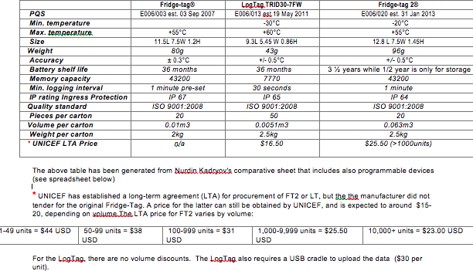

Annex 8. SMS coding teaching – Lao People’s Democratic Republic

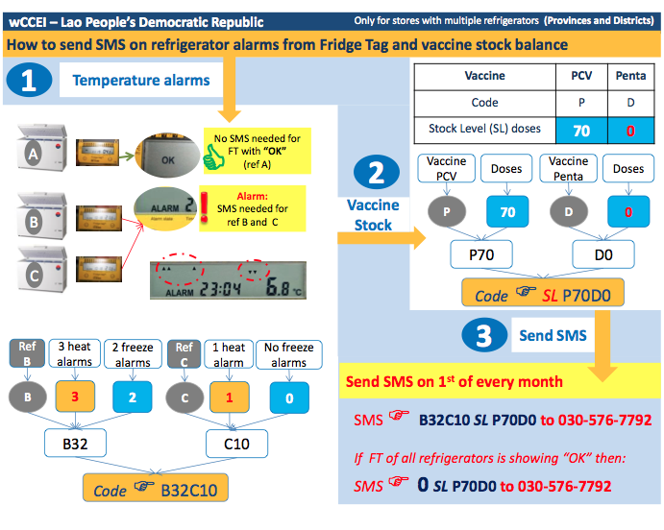

# 

Annex 9. Checklist for supervisory visits for supportive supervision - EPI

* Top of Form

Prior to the visit

 Plan the visit, what spot checks of data, what information needs to be collected, what reports to review and plan any On-the Job-Training.

 Arrange transport and allowances for the visit.

 Notify facility of the visit, agree with staff on specific time and duration.

 Review notes and action points from previous visit.

 Prepare a list of questions/issues that should be addressed during the visit.

 Take copies of relevant forms/job aids that might be useful to bring.

 Take 2 copies of relevant current SOPs.

During the visit

 Meet with the nurse in charge of the facility to inform her of the objective of the visit and request permission to discuss with staff.

 Make necessary introductions creating an informal atmosphere and explain the objective of the visit to all staff (to help them do even better).

 Enquire about SOPs/ job aids used at the facility, to check that they match with latest versions and if not provide a copy of new ones with instructions about how they should be kept for easy reference.

 Conduct the visit on EPI supply chain management aspects, storage, record keeping and reporting, stock status with appropriate separate checklist.

 Ask staff for any aspect they would like to have clarified and take identified problem aspects (from staff and from inspection) to conduct short On-the-Job-Training within areas that need to be refreshed or reinforced.

After the visit

 Fill in supervision checklist and discuss issues with the supervisees to understand their perspective and how issues should be addressed (corrective actions) and monitored.

 Provide feedback report to the health facility, with recommendations as how to address uncovered issues, get supervisee to sign it and file it. Reports should be shared at regular intervals with higher levels, provincial, regional and aggregated for national level).

 Eventually, call (or send SMS) supervisee in charge of the clinic to hear how they are doing in respect to the issues and encourage them to call if they need support.

Annex 10 Extra training material: Posters on corrective actions in response to alarms, based on WHO recommendations

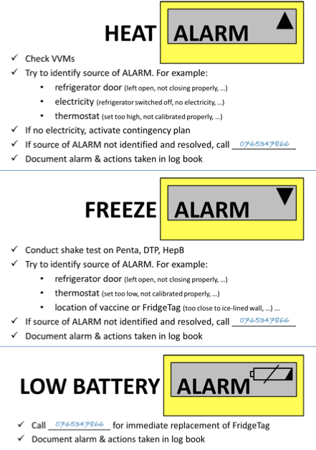

# 

Annex 11. Temperature monitoring chart, English

Annex 12. Temperature Monitoring Chart, French

|  |  |  |  |  |  |  |  |  |  |  |  |  |  |  |  |  |  |  |  |  |  |  |  |  |  |  |  |  |  |  |  |  |  |  |  |  |  |  |  |  |  |  |  |  |  |  |  |  |  |
| --- | --- | --- | --- | --- | --- | --- | --- | --- | --- | --- | --- | --- | --- | --- | --- | --- | --- | --- | --- | --- | --- | --- | --- | --- | --- | --- | --- | --- | --- | --- | --- | --- | --- | --- | --- | --- | --- | --- | --- | --- | --- | --- | --- | --- | --- | --- | --- | --- | --- |
| **Département:** | | | | | | | | | **Nom de l’institution:** | | | | | | | | | | | | | | | | | | | | | | | **Marque et Type du Réfrigérateur:** | | | | | | | | | | | | | | | | | |
| **Commune:** | | | | | | | | | **Personne Responsable:** | | | | | | | | | | | | | | | | | | | | | | | **Energie utilisée:** | | | | | | | | | | | | | | | | | |
| **Mois:** | | **Année:** | | **1** | **2** | | **3** | | | **4** | | **5** | | **6** | | **7** | | **8** | | **9** | | **10** | | **11** | | **12** | | **13** | | **14** | | | **15** | **16** | **17** | **18** | **19** | **20** | **21** | **22** | **23** | **24** | **25** | **26** | **27** | **28** | **29** | **30** | **31** |
| **TEMPERATURE Matin** | | | |  |  | |  | | |  | |  | |  | |  | |  | |  | |  | |  | |  | |  | |  | | |  |  |  |  |  |  |  |  |  |  |  |  |  |  |  |  |  |
| **TEMPERATURE Après- midi** | | | |  |  | |  | | |  | |  | |  | |  | |  | |  | |  | |  | |  | |  | |  | | |  |  |  |  |  |  |  |  |  |  |  |  |  |  |  |  |  |
| **AFFICHAGE FRIDGE TAG** | **ALARME** | |  |  | |  | |  | | |  | |  | |  | |  | |  | |  | |  | |  | |  | |  | |  | |  |  |  |  |  |  |  |  |  |  |  |  |  |  |  |  |  |
|  |  | |  | |  | | |  | |  | |  | |  | |  | |  | |  | |  | |  | |  | |  | |  |  |  |  |  |  |  |  |  |  |  |  |  |  |  |  |  |
| **OK** | | **√** |  | |  | |  | | |  | |  | |  | |  | |  | |  | |  | |  | |  | |  | |  | |  |  |  |  |  |  |  |  |  |  |  |  |  |  |  |  |  |
| **MAX** | **HEURE** | | |  | |  | |  | | |  | |  | |  | |  | |  | |  | |  | |  | |  | |  | |  | |  |  |  |  |  |  |  |  |  |  |  |  |  |  |  |  |  |
| **TEMPERATURE** | | |  | |  | |  | | |  | |  | |  | |  | |  | |  | |  | |  | |  | |  | |  | |  |  |  |  |  |  |  |  |  |  |  |  |  |  |  |  |  |
| **MIN** | **HEURE** | | |  | |  | |  | | |  | |  | |  | |  | |  | |  | |  | |  | |  | |  | |  | |  |  |  |  |  |  |  |  |  |  |  |  |  |  |  |  |  |
| **TEMPERATURE** | | |  | |  | |  | | |  | |  | |  | |  | |  | |  | |  | |  | |  | |  | |  | |  |  |  |  |  |  |  |  |  |  |  |  |  |  |  |  |  |
| **GAZ** | **Nouvelle bonbonne** | | |  | |  | |  | | |  | |  | |  | |  | |  | |  | |  | |  | |  | |  | |  | |  |  |  |  |  |  |  |  |  |  |  |  |  |  |  |  |  |
| **SOLAIRE** | **Nettoyage du Panneau** | | |  | |  | |  | | |  | |  | |  | |  | |  | |  | |  | |  | |  | |  | |  | |  |  |  |  |  |  |  |  |  |  |  |  |  |  |  |  |  |
| **Ajout de L’eau dans les Batteries** | | |  | |  | |  | | |  | |  | |  | |  | |  | |  | |  | |  | |  | |  | |  | |  |  |  |  |  |  |  |  |  |  |  |  |  |  |  |  |  |
| **TOUS** | **Dégivrage et Nettoyage du réfrigérateur** | | |  | |  | |  | | |  | |  | |  | |  | |  | |  | |  | |  | |  | |  | |  | |  |  |  |  |  |  |  |  |  |  |  |  |  |  |  |  |  |

Feuille de Contrôle du Réfrigérateur- Fridge-Tag Version V4

1. The shake test is described in the video included in the extra resources at the end of this document.
2. In 2011, the UNICEF Supply Division surveyed 32 country offices that had purchased 30DTR through the Supply Division.
3. World Health Organization and United Nations Children’s Fund, Draft version *Joint Statement Effective Vaccine Management,* WHO/UNICEF, Geneva/New York, 2014, available at <www.who.int/immunization/sage/meetings/2014/April/2_EVM_JS_Statement_5.2.pdf>.
4. Available at <sites.google.com/site/vaccines30dtr/resources>.
5. For this, please refer to the recently updated UNICEF Supply Division Cold Chain Support Package, available at <www.unicef.org/supply/index_68367.html>.
6. World Health Organization, United Nations Children’s Fund, GAVI Alliance and PATH, ‘Effective Vaccine Management Initiative,’ Background paper, Version 1.7, WHO, UNICEF, GAVI Alliance and PATH, September 2010, available at <www.who.int/immunization/programmes_systems/supply_chain/EVM-background.pdf>.
7. UNICEF convened a Cold Chain and Logistics Taskforce with partners involved in immunization to enhance and coordinate the collective support provided to national governments. The Cold Chain and Logistics Taskforce Workshop held in New York from 2-4 November 2009 sought to reach a consensus on the approach and key actions needed to address cold chain and logistics needs. For a report on the workshop, see <http://www.unicef.org/immunization/files/CCL_Workshop_Report_Nov_2009.pdf>.
8. Systematic Temperature Monitoring for CCL Systems: Implementation guide for 30-day temperature recorders
9. World Health Organization, ‘Immunization service delivery: Projected vaccine wastage,’ <apps.who.int/immunization_delivery/systems_policy/logistics_projected_wastage/en/index.html>, accessed 29 April 2015.
10. Available at <www.unicef.org/supply/index_74631.html>.
11. World Health Organization, *PQS devices catalogue: Pre-qualified equipment for the Expanded Programme on Immunization (EPI),* WHO, September 2011, <http://apps.who.int/immunization_standards/vaccine_quality/pqs_catalogue/categorylist.aspx?cat_type=device >, accessed 29 April 2015.
12. World Health Organization, ‘WHO/IVB/04.06 Immunization in practice – Module 2: The vaccine cold chain,’ <www.who.int/immunization/documents/iip2014mod2aug4.docx>, accessed 29 April 2015.
13. World Health Organization, ‘PQS Catalogue,’ <apps.who.int/immunization_standards/vaccine_quality/pqs_catalogue/>, accessed 29 April 2015. Login and password required.
14. World Health Organization, *The LogTag vaxtag setup guide,* video, WHO, 3 August 2014, <www.youtube.com/watch?v=M2PgEuFkFDs>, accessed 29 April 2015.
15. For Berlinger & Co. AG setup and user guide videos, see <https://www.youtube.com/channel/UCrB2-oxAPaxvKb4SCSjBveg>.
16. For more information on RapidPro, see <www.rapidpro.io>.
17. For more information on UNICEF procurement services, see <www.unicef.org/supply/index_procurement_services.html>.
18. The UNICEF Supply Catalogue is available at <supply.unicef.org/unicef_b2c/app/displayApp/(layout=7.0-12_1_66_67_115&carea=%24ROOT)/.do?rf=y>.
19. United Nations Children’s Fund, *Procurement Guidelines: General Guidelines for Cold Chain Equipment,* Cold Chain Support Package, UNICEF Supply Division, 28 October 2014, <http://www.unicef.org/supply/files/General_Procurement_Guideline_Oct_28_2014.pdf>.
20. Derichs-Kunstmann, Karin, et al., ‘A study of gender and learning styles’, University of New Mexico, 1995.
21. Reinen, Ingeborg Janssen and Tjeerd Plomp, ‘Information technology and gender equality: A contradiction in terminis?’, *Computers & Education,* vol. 28, issue 2, February 1997, pp. 65-78.
22. World Health Organization, ‘WHO/IVB/04.06 Immunization in practice – Module 2: The vaccine cold chain,’ <www.who.int/immunization/documents/iip2014mod2aug4.docx>, accessed 29 April 2015.
23. World Health Organization, ‘WHO/IVB/04.06 Immunization in practice – Module 2: The vaccine cold chain,’ <www.who.int/immunization/documents/iip2014mod2aug4.docx>, accessed 29 April 2015.
24. Lloyd, John et al., ‘Reducing the loss of vaccines from accidental freezing in the cold chain: The experience of continuous temperature monitoring in Tunisia,’ *Vaccine*, vol. 33, issue 7, 11 February 2015, pp. 902-907.
25. WHO pre-qualified electronic temperature monitoring devices for refrigerators and cold rooms have the following standard alarm settings:   
    - Low alarm setting: Exposure to -0.5°C or below for 60 minutes.  
    - High alarm setting: Exposure to a +8°C or above for 10 hours.
26. Some countries use weekly charts, some use monthly charts and some use booklets which are replaced once a year.
27. Recent PQS pre-qualified refrigerators have non-adjustable thermostats.
28. Recent PQS pre-qualified freezers have non-adjustable thermostats.