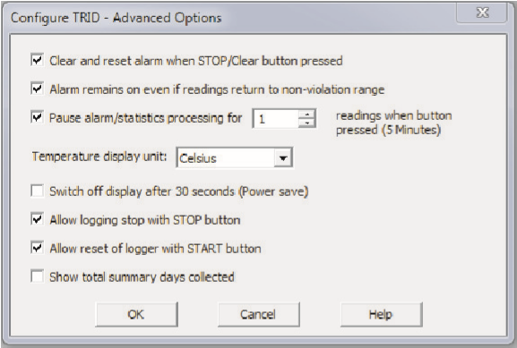
- If enabled, any button activity will prevent readings being processed for max/min/duration statistics and alarm triggers for the configured paused duration. This allows the user to review current statistics or clear an alarm without causing a false alarm or statistic while handling the Recorder.
- The Recorder can display temperature in units of ºC or ºF, select the units you require.
- The option ‘Switch off the display after 30 seconds (Power save)’ will extend battery by automatically deactivating the display after 30 seconds of no button activity, button activity will temporarily reactivate the display.
- The Recorder can be configured to allow the user to Stop and/or Reactivate the Recorder, tick which options are required.
- Click ‘OK’ to exit the Advanced dialog, returning to Configuration Options.
- Click and the Recorder will be configured.‘Next’
- When configuration is complete remove the Recorder from the Interface Cradle.
- If you wish to configure more Recorders with the same configuration profile, insert the next Recorder into the Interface Cradle and click ‘Again’. Repeat until all Recorders are configured.

The Recorder must be configured before you can take readings. |  |  | Select recording mode - Continuously (overwrites old readings when memory is full) or Reading for a specific time (note that changing the recording interval automatically re-calculates the recording duration).  Enter a start delay if required (allows the Recorder to stabilise before recording starts).  Set a upper temperature alert value and tick ‘Trigger alarm’ if you require a visual upper ‘ALARM’ to show on the Recorder’s display once triggered.  Set a lower temperature alert value and tick ‘Trigger alarm’ if you require a visual lower ‘ALARM’ to show on the Recorder’s display once triggered.  You can also setup various trigger conditions for both the upper and lower alarms, single violation or a set of consecutive violation readings or a total of violation readings encountered (called accumulative).
Start the LogTag Analyzer software.
Insert the Recorder into the Interface Cradle with the blue label to the front. You will here a click as the contacts engage.
The screen will show ‘A new LogTag has been detected..... Please wait.....’.
If a Recorder has been used previously, a chart will appear.
Select ‘LogTag’ - ‘Wizard’ to bring up the configuration wizard. The ‘Welcome and general instructions’ will be displayed.
Click on ‘Next’; LogTag Analyzer will scan for a Recorder, once found the configuration options will be displayed.
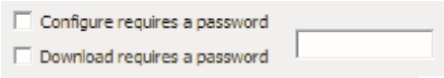
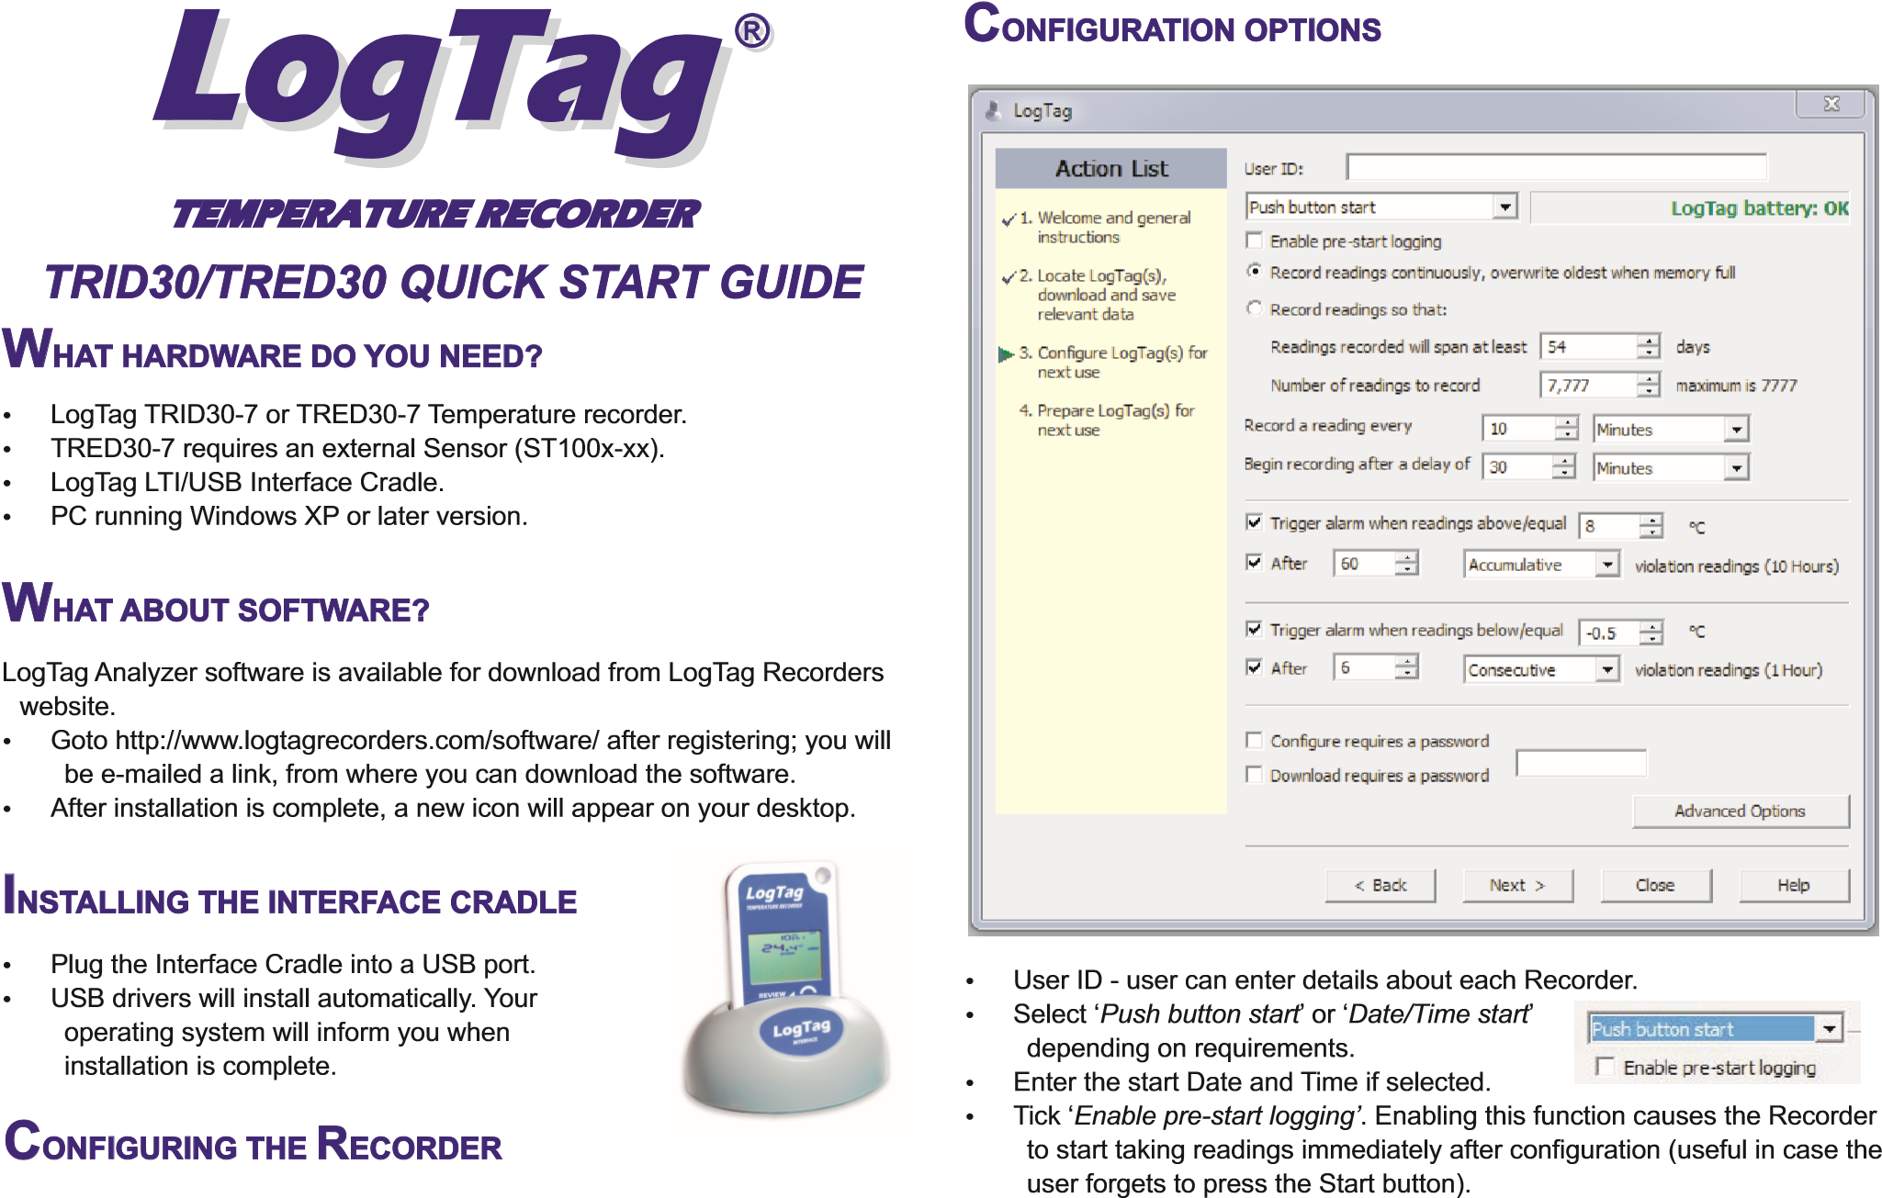
- If you wish to control future configuration of this Recorder, tick the ‘Configure requires a password’ box and enter a password. You can also control future downloads, tick the ‘Download requires a password’. NOTE: Passwords are case sensitive.
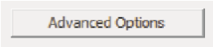
- Click ‘Advanced options’ to view and change the Recorder’s Advanced features including the ‘Pause’ function, Stopping and Re-activation,
Clearing and Latching Alarms, Power save and displayed units ºC or ºF.
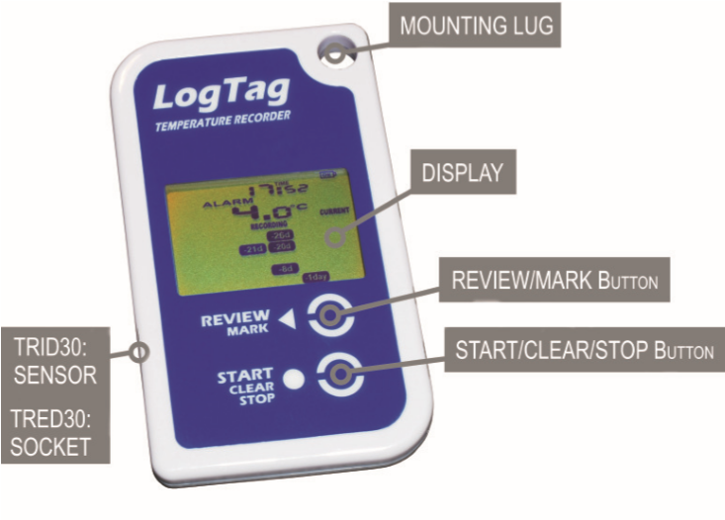
Document Revision C 070911 - © Copyright 2011, LogTag Records Ltd. LogTag® is a registered trade mark of LogTag Recorders Ltd.
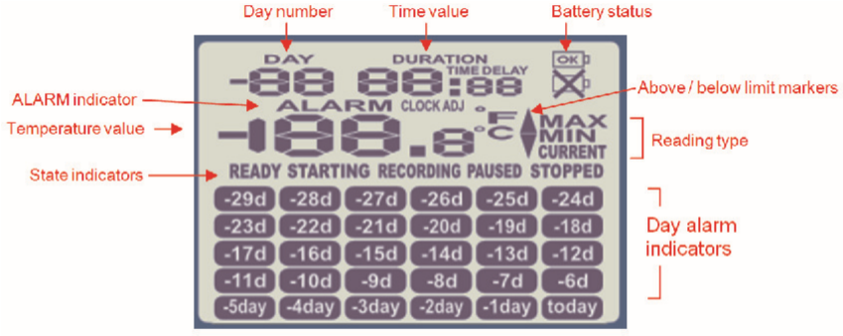
D
R
LAY
P
IS
VIEW
OVE
The temperature can be displayed in
or
.
Reading type:-
=
The temperature of the last reading taken.
The maximum reading in a given 24hour period.
=
ºC
ºF
Battery test is performed hourly:-
displayed when battery tested OK
displayed when battery tested LOW.
MAX
CURRENT
^{MIN} = The minimum reading in a given 24hour period. ^{State indicators:}READY Ready to start recording.
Above/below limit markers:-
Preparing to start recording. If a delayed
Up arrow marker appears when the temperature STARTING start is configured then displays time displayed is above the upper alert limit. remaining to start recording.
Down arrow marker appears when the temperature RECORDING Recording. displayed is below the lower alert level.
Max/Min statistics collection paused due PAUSED
ALARM appears when an alarm is triggered. ^{to button press activity.} STOPPED Recording has stopped.
The time (in HH:MM) can be current time, time remaining
to start of a delayed start or duration of a given max min value above or below the specified limits. The value displayed is indicated by the following:TIME = displaying Current Time.  TIME DELAY = displaying DELAYED START time remaining.  DURATION = displaying duration of a given MAX or | The display is organized with a table of ‘day alarm indicators’ segments named “Today” to “-29d” which are switched on when a given day has an alarm trigger present.  The day number of the currently selected day statistic is displayed when in review mode. TODAY is day 0, yesterday is day ‘-1'. Can be configured to display the total number of days collected while recording.
MIN statistic above/below the limits on a given day.

STARTING THE RECORDER
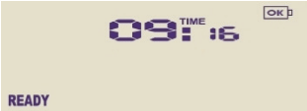
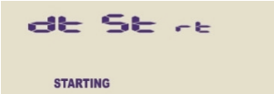
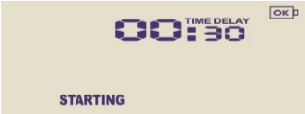
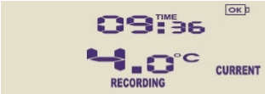
If the Recorder has been configured with a Date/Time start, it will start automatically.
Only when the display shows READY can the Recorder be started manually. Press and hold the Start  button. Continue to hold while STARTING flashes on the display; release the button when the flashing stops (after approx 5 seconds).
The Recorder will now display the delayed start time remaining (if configured). This example shows a start delay of 30 minutes remaining.
At the end of the delayed start (if configured) the Recorder will start collecting data and show the word RECORDING on the display.

PAUSED FUNCTION
If enabled, any button activity will suspend processing of readings and the Recorder will display PAUSED. This allows the user to review the statistics or clear an alarm without causing an invalid reading, alarm or statistic.

SETTING THE DISPLAY CLOCK
LogTag Analyzer sets the Recorder’s internal real time clock to the configuration PC’s time however the user can manually change the display clock if required. Press and hold the  and  buttons together continuously for 8 seconds. During this period the display will flash CLOCK ADJ. Release the buttons when the flashing stops to enter ‘clock adjust’ mode.
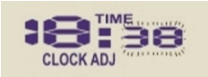
The minutes will flash. Press  to increment the minutes and  to accept the minute changes and to start editing the hours. The hours will now flash, press
 to increment the hours and  to accept and store the new time.
If recording is active a clock change event will be recorded with the next logged reading which will be displayed when the data is downloaded.

RECORDING DISPLAY
During recording, the display shows the temperature of the last reading taken, the current time, battery status and a combination of alarm status and history. A reading is taken and the display updated every logging interval as configured in LogTag Analyzer.
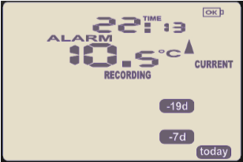
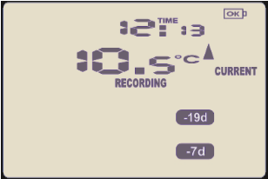
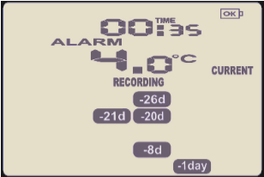
Following are some examples:-
Here the display shows that alarm events occurred 7 and 19 days ago. The current temperature is over the upper limit (indicated by the ) but has not been over for long enough to trigger an alarm.
10 Hours later the over temperature has triggered an alarm. The ALARM symbol and the today marker day alarm are shown.
A further 2 hours later the temperature has returned to the acceptable range but the alarm remains present.
The day summary has shifted by 1 day as the time has gone through midnight.

CLEARING AN ALARM
When an alarm event has occurred, the ALARM symbol is displayed.
To clear the ALARM symbol from the display, press and hold the Clear  button until the ALARM symbol stops flashing then immediately release.
Alarm events continue to be displayed in the history area of the display and
can be reviewed with the day statistics.
Note: The option to clear and latch alarms can be disabled see advanced options in LogTag Analyzer.

REVIEWING DAY STATISTICS
The Recorder will display up to 30 days of max/min/duration and alarm
statistics. If the Recorder is configured to record longer than 30 days (or continuously) then the day statistics will contain up to the latest 30 days.
To review the day statistics press the Review  button. Each press of the button will step through the Max and Min temperatures for each day starting with today and moving backwards through the days (displayed day will flash).
Any button activity during recording will place an inspection mark in the next reading of logged data which will be displayed when the data is downloaded.

RE-ACTIVATING THE RECORDER
If enabled, the Recorder can be re-activated for re-use by either reconfiguring using LogTag Analyzer or using the Start  button.
To re-activate using the Start  button, press and hold the Start  button observing the READY text flashing on the display; release the button when the flashing stops. The recorder will then be ready for a push button start.
Data/time start is only possible by re-configuring with LogTag Analyzer.
Re-activating the Recorder will erase all previously recorded readings and statistics!
Note: The option to re-activate the Recorder can be disabled, see advanced options in LogTag Analyzer.

BATTERY
The Recorder contains a Lithium Battery. Dispose or recycle the battery in accordance to your local regulations. Do not expose to extreme temperatures.
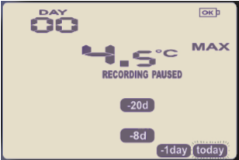
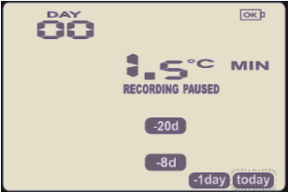
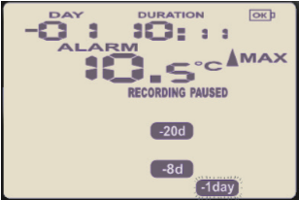
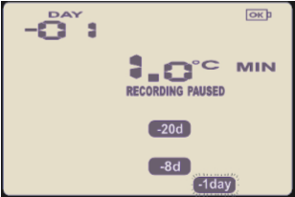
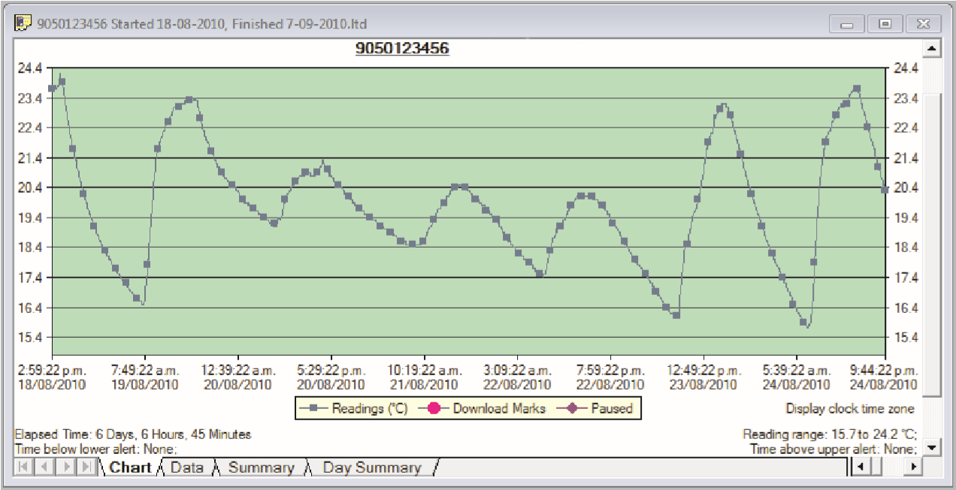
The end of battery life is indicated by a low battery symbol, the Battery/Recorder should be replaced within 30 days when this symbol appears.
G
ETTING HEL
P
If after reading this guide you still need further information, please visit the
LogTag Recorders website http://www.logtagrecorders.com/support
D
A
T
A
DING D
A
OWNLO






Start LogTag
Analyzer software.
Insert the Recorder into the Interface Cradle.
The screen will show
‘
‘.
After a few seconds, the downloaded data will appear (by default shown
as a chart, see below).
Data can be displayed in Chart, Data, Summary or Day Summary
formats by clicking the tabs at the bottom of the chart dialog.
Data can also be saved in a number of formats including
TXT, PDF,
HTML
and CSV for import into a spreadsheet program.
A
new LogTag has been detected..... Please
wait.....
S
DE
R
R
ECO
R
ING THE
PP
TO
If enabled you can stop the Recorder; press and hold the
flashes
Stop
button. Continue to hold while
on the display; release the button when the flashing stops.
The Recorder will no longer take any readings, however
you can still review the day statistics and download the
logged results to a PC with LogTag
Analyzer.
Note:
The option to stop the Recorder can be disabled, see
Analyzer.
advanced options in LogTag

STO
PP
ED
Following are some examples:-
Pressing the Review
button displays current
segment
The
statistic.
day’s
is shown to indicate the
flashes and
‘Today’
selection.
The selected day (today)
does not have any recordings outside the
preset limits.
Pressing the Review
button again displays the
statistic.
day’s
statistic is not below the limit and did
The
not trigger an alarm.
button again displays the
Pressing the Review
next previous day’s
statistic.
There are
recordings that are above the upper limit.
The
statistic is above the upper limit (indicated
by ) and the
was triggered for a
duration of 10 hours and 11 minutes.
Pressing the Review
button again displays the
statistic.
day’s
statistic is not below the limit and did
The
not trigger an alarm.
❖
❖
❖
❖
M
A
X
D
A
00
Y
MIN
MIN
M
X
A
X
A
M
M
R
A
A
L
MIN
MIN
today

If less than 30 days of recordings have been collected, the
day marker only advances as far as there is data
available.
After the last day for which statistics have been
collected is displayed, the next press of the
button rolls
. Pressing the
the summary back to the statistic for
button at any time shows the normal recording display
again.
❖

today
TRID30-7R and
The
TRED30-7R have a replaceable CR2032 battery. Battery
access sits behind the square white label on the back of the Recorder’s
case. Contact your supplier or check the LogTag website for further details.
TRID30-7F and
TRED30-7F Recorder battery’s are not user replaceable
The
and should be replaced or serviced by a suitably qualified and authorized
service centre.
Example of a Zoomed in chart within LogTag
Analyzer.

Document Revision C 070911 - © Copyright 2011, LogTag Records Ltd. LogTag® is a registered trade mark of LogTag Recorders Ltd.

