**Standard operating procedure for shipping yellow fever (YF) specimens to Regional Reference Laboratories (RRLs)**

**04 April 2022**

1. **Background**

Until recently, international shipping of suspected YF samples for diagnostic confirmation, or for External Quality Assessment (EQA) to a reference laboratory, would prove to be challenging for some laboratories due to multiple factors. As a result, delayed shipments and confirmation could lead to deferred field interventions, thus potentially amplifying the spread of the virus.

Within the EYE (Eliminate Yellow Fever Epidemics), Secretariat the EYE.ops team, with financial support from GAVI, the Vaccine Alliance, has set up a shipping service to assist all national laboratories receiving YF suspected samples, and to ensure a timelier and efficient transport system of samples to regional reference laboratories, to either confirm an epidemic, or to support for an EQA.

This shipping mechanism can transport YF samples from all countries to the three identified Regional Reference Laboratories (RRLs) within the African Regional Office (AFRO) and to the Centers for Disease Control and Prevention, Fort Collins, USA, when required. Upon request, additional transport routes can be identified, and transportation can be implemented.

Pending the establishment of a long-term agreement with a specific courier company, EYE.ops is currently collaborating with several international courier companies to provide the best solutions for laboratories. Up until now, HAZGO International has been supporting several countries’ requests, and will continue to do so, with prior approval from EYE.ops.

It should be noted that the use of this shipping mechanism is not mandatory and if some laboratories are using other, efficient shipping systems, they may continue to do so. However, to ensure that all YF laboratories receive similar assistance, the EYE Secretariat plans to provide financial support for the cost incurred by these shipments.

This support will effectively take place if the shipping laboratory agrees, and if the transport costs are not already supported by other WHO programs or by the WHO country office of this shipping laboratory.

1. **Procedure and documentation for shipping** (To use this shipment mechanism, please carefully follow the instructions below.)
   1. For each shipment, laboratories are requested to complete the Booking Form (Annex 1) and send it by email to EYE.ops, eye.ops@who.int
   2. A copy of the Booking Form needs to be sent to all WHO staff listed in the Booking Form, i.e. [roviraj@who.int](mailto:roviraj@who.int) , cibrelusl@who.int, demanoum@who.int.
   3. An acknowledgement message will be sent to the shipping laboratory focal person within 24 hours maximum, and after ensuring that all required information in the Booking Form is complete.
   4. The EYE.ops team will contact the representative of the selected international shipping company who will provide transport quotations, routes, and timelines for delivery.
   5. Upon acceptance, a national or international representative of the selected courier company will contact the shipping laboratory to organize the cargo management and arrange for a pick-up date and address any other request.
   6. Based on the requirements mentioned in the Booking Form, the courier company will provide, the packaging, perform the labelling and paperwork required to comply with international transport regulations.
   7. Dry ice will be provided should the laboratory request, identify a "Frozen" shipment on the Booking Form.
   8. To date, except for shipping cultures of YF viruses, all cargoes are identified as UN 3373, Biological Substances, Category B.
   9. Packing instructions P650, will apply for all the cargoes falling under this category. For advice on shipment temperatures see table in Annex 2
2. **Documentation**

The shipping laboratory is required to complete the following paperwork before the agent can accept the package for shipment:

1. the complete booking form,
2. A packing list/invoice indicating the recipient's address, number of packages, detail of contents including weight and value. NB: for international transport, a minimal value is recommended. The courier company will be able to advise the laboratory on any of the above administrative requirements,
3. An export permit for the originating country as relevant,
4. An import permit for the recipient country as relevant,
5. Any other document requested by national regulations for importing infectious substances,
6. A House Airway Bill (HWB). This document will be provided by the courier agent to EYE.ops.
7. The courier’s local shipping agent will be able to help concerning export documentation upon request.
8. **Finances**

All invoices resulting from these requests will be directly sent by the relevant courier company to EYE.ops and to roviraj@who.int and Kelly Ronan from the EYE Secretariat ronank@who.int.

In case a laboratory uses its own transport, system and has the financial support of a WHO country office to pay the invoice, a copy of the invoice will need to be sent to EYE.ops. In return, the EYE Secretariat will provide the WHO country office with the means to repay the invoice.

Annexes

Annex 1 Booking Form in a separate document

Annex 2 if available the testing table

Annex 3 the functional organigram

**ANNEX 1 – BOOKING FORM**

 [](https://www.hazgo.com/en)

**BOOKING FORM / EYE STRATEGY**

**ARBOVIRUSES**

**Use one form per shipment**

**Please send this booking to HAZGO BRUSSELS and to the World Health Organization.**

**HAZGO country representative will arrange pick up of the materials described below.**

**Information of booking form**

**DATE: (dd, mm, yyyy) :**

**PAGE(S): :**

**From: Name of the laboratory :**

**Number of the request in the current year:**

**Type of request: Emergency EQA pls cross one box only**

**Sent by email Sent by fax: Please (cross the box (es) you chose)**

**TO: Hazgo Belgium** Email: [olivier.kadjata@hazgo.com](mailto:olivier.kadjata@hazgo.com) , [tom.heymans@hazgo.com](mailto:tom.heymans@hazgo.com) Fax: +32 2 751 72 00

**CC**: **World Health Organization**

WHE/ IHM Eye Secretariat Email: [eye.ops@who.int](mailto:eye.ops@who.int)

Mr Jose Rovira Vilaplana + 41 79 217 34 23 Email: [roviraj@who.int](mailto:roviraj@who.int)

Dr Cibrelus Yamamoto + 41 79 467 34 83 Email: [cibrelusl@who.int](mailto:cibrelusl@who.int)

**Laboratory contact person for the pick up**  :

**Mobile phone** :

**Email**  :

**Laboratory to collect the samples:** **Laboratory to deliver the samples**

Laboratory Name: **WHO Yellow Fever Collaborating Centres.**

Address:

Address:  Institute Pasteur Senegal- Dakar

City:

Zip Code:  Institute Pasteur - Cameroun

Country:

Contact:  UVRI Entebbe -Uganda

Mobile phone:  Other, pls provide the full address

Address:

WHO ACCOUNT: to be filled in by the EYE Secretariat

**HAZGO or ITS LOCAL REPRESENTATIVE WILL PROVIDE DRY ICE, ADEQUATE PACKAGING MATERIALS and REQUIRED PAPERWORK (DGD; AWB, other, FOR THIS SHIPMENT.**

**Please cross the box(es) below and the specify the type of temperature control required**

INFECTIOUS SUBSTANCES AFFECTING HUMANS’ CATEGORY A - UN 2814

Ambient / Refrigerated (Gel packs +2/+8°C) Frozen (-20°C) Dry Ice (-80°C)

NUMBER OF VIALS AND ML:

BILOGICAL SUBSTANCES CATEGORY B - UN3373

Ambient / Refrigerated (Gel packs +2/+8°C) Frozen (-20°C) Dry Ice (-80°C)

NUMBER OF VIALS AND ML:

OTHER

Ambient / Refrigerated (Gel packs +2/+8°C) Frozen (-20°C) Dry Ice (-80°C)

NUMBER OF VIALS AND ML:

Number of inner packaging and size (if available):

Other information: Import Permit / Export permit /detailed packing list

**Date, Name and Signature of requestor**

**ANNEX 2**

Example Annex2. Recommended conditions for international shipment of specimens referred for yellow fever testing.

|  |  |
| --- | --- |
| **Specimen type (test)** | **Shipment category** |
| * Serum/CSF 1,2 * Whole blood 3 * Plasma | Cultures Biological Substance, Category A– **UN2814**  Blood products  Biological Substance, Category B – UN 3373 |
|
| Tissue from biopsy or autopsy   * Fresh tissue * Fixed tissue |
|

1: Separated serum should be shipped to the laboratory on wet ice within 48 hours or stored at 4°C to 8°C (DO NOT FREEZE WHOLE BLOOD!) if there is a delay in arranging transport.

2: Serum samples collected for serological analysis have proved the easiest and most effective samples for the detection of YF by RT-PCR.

3: If no separation facilities are available, whole blood may be held at refrigerator temperatures (4°C to 8°C) and sent to the laboratory as soon as possible and not later than 24 hours after collection. But In order to reduce problems of hemolysis it is preferable for serum to be separated at the point of collection

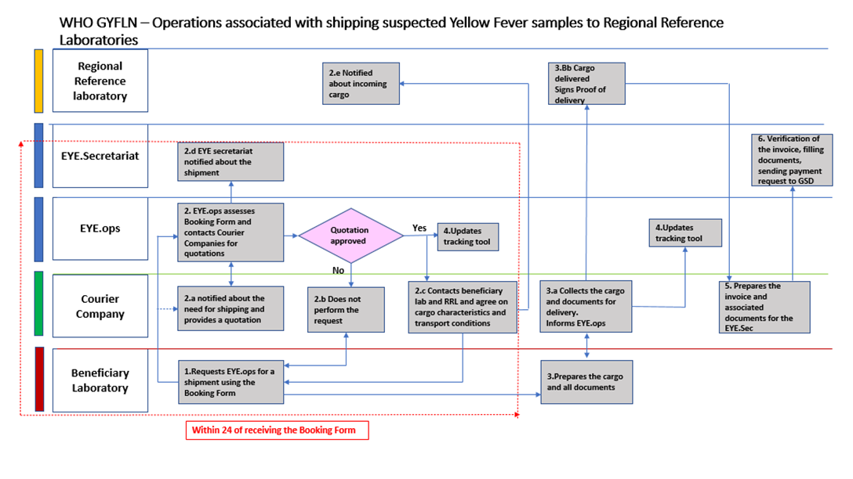**Annex 3 the functional organigram**