Lil’ Fi
Diary dates
TERM 1:
Daily zoom starts: 27th JAN 2021
11 weeks finishes 1st APRIL

TERM 2:
Daily zoom starts: 19th APRIL
10 wks : 25th June

TERM 3:
Daily zoom starts: 12th JULY
10 wks: 17th SEPT

TERM 4:
Daily zoom starts: 5th OCT
10 wks : 17th DEC
SEMINARS -
“Intentional teaching with music”
FEB 20th, MAY 22nd, AUG 21st 2021

UKULELE ADVENTURES with Lil’ Fi
MAR 20th, JUNE 19th, SEPT 11th 2021

Calendar of Events 2021
All bookings through
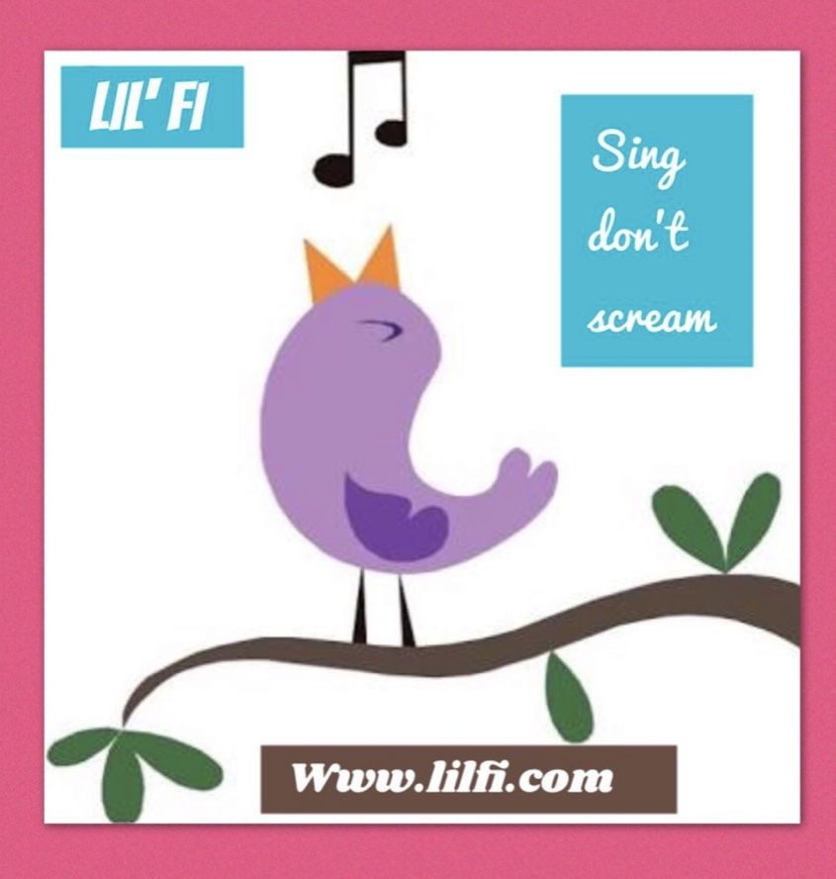
www.lilfi.com
lilfi@lilfi.com
Mob: 0417 479 152

DAILY ZOOM LESSONS – 10.30am aest
All terms follow NSW timetable. $25/WK or as neg.
FREE HOLIDAY LESSONS as per Website and FaceBook posts.

SEMINARS on ZOOM
Lil’ Fi presents
“Intentional teaching with music”
- This outstanding seminar has inspired educators to think musically first.! Lil’ Fi unpacks the scientific evidence of why music and the early years is essential for our childrens best learning experience. It is experiential and immediately applicable in your daily routine with childcare. Having toured this seminar for 6 years it never gets old and is an all time favourite for centres to use for their staff training. Now it’s available on the zoom so FDC’s have access to it in their own time. A super fun experience and full of really useful info.
- FEB 20th, MAY 22nd, AUG 21st 2021. Bookings essential. Prices on enquiry.

“Ukulele Adventures” with Lil’ Fi for beginners
- This seminar supports you to intentionally teach using music. If you’ve always wanted to play an instrument, Ukulele is for you. “just sing with your hand” Lil Fi has a tried and tested method and will have you playing music after this 90 minute session. The most fun. Limited spots. You will need a tenor or Concert Ukulele (Sopranos are not recommended with early years children – wrong tone) Ukuleles can be sourced through BONDI UKULELES online. Suitable for Adults and school aged children who are keen to learn.
- MAR 20th, JUNE 19th, SEPT 11th Bookings essential. $80 + Ukulele if needed.

