­­

penumbra.org.uk

**Application Pack**

Board Member

**“Recovery isn’t waiting for the storm to pass… it’s learning to dance in the rain!”**

Registered Office: Norton Park, 57 Albion Road, Edinburgh, EH7 5QY

Penumbra is a charity (SC 010387) and a company limited by guarantee (SC 091542) registered in Scotland.

Dear Applicant,

Thank you for your interest in the post of Board member. This is an exciting, opportunity to volunteer with one of the leading mental health organisations in Scotland. This is an important role within our organisational governance and we seek someone with the combined business, inter-personal and self-management skills.

**Application Process**

All applicants should submit a CV and complete the personal statement form.

In order to assist you with your application we have enclosed:

* Background information on Penumbra
* An overview of the Ordinary Board member
* Personal statement form (word doc)

I hope you will find these documents informative when applying for the role.

**Closing date for applications: 5pm on Friday 19th October 2018**

**Interviews will be held: Afternoon/early Evening Thursday 1st Nov and Friday 2nd Nov 2018**

Applications can be sent to: [anne.wilson@penumbra.org.uk](mailto:anne.wilson@penumbra.org.uk) or via post to

Anne Wilson

Penumbra

Norton Park Centre

57 Albion Road

Edinburgh

EH7 5QY

If you would like to speak to the Chief Executive informally about this position please contact us on 0131 475 2588 to arrange a suitable time for this.

Good luck with your application.

Yours sincerely,

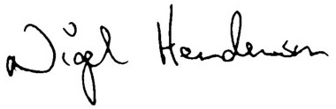

**Nigel Henderson**

Chief Executive

Penumbra: an overview

FigureFigureFigureFigureFigureFigureFigureFigureFigureFigureFigureFigureFigureFigureFigureFigureFigureFigureFigureFigureFigureFigureFigureFigureFigure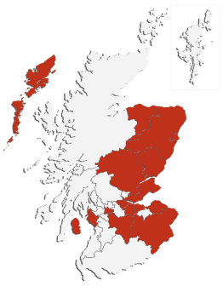

INNOVATION

EMPLOYER

SUPPORT

ABOUT

We provide recovery-focused support delivering measureable personal outcomes.

**Edinburgh**

**Crisis**

**Centre**

Edin

We run Scotland’s only dedicated mental health crisis centre. It provides a 24 hour help line and a safe space and overnight accommodation.

We host the

Scottish

Recovery

Network

- a non-profit initiative working to promote recovery in mental health.

**How we help**

We offer a range of services to improve health and wellbeing that provide practical, emotional and social support. All our services are recovery focussed and offer personalised support.

**We have over**

**30 years**

**experience in mental health**

We pay all staff at least:

**£8.89**

per hour

(that’s more than the Scottish living wage).

Our vision

We envisages a society where people with mental health problems expect recovery and are accepted, supported and have the resources to fulfil their potential.

+

**1600**

- the number of people we support every week in Scotland.

Find out more:

penumbra.org.uk

penumbra\_scot

/penumbraScotland

Penumbra Master Logo No StrapFacebookTwitter

We operate over 40 projects, covering half of Scotland’s local authorities.

We believe in

recovery. This does

not necessarily mean

being ‘cured’ or living without medication or support, it is the realisation of a meaningful and fulfilling life in the presence or absence of mental health problems.

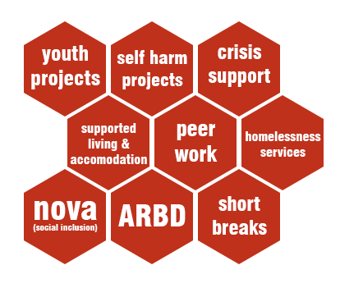

**Recovery**



Relief

staff

the number of people we employ

We employ

25 peer workers

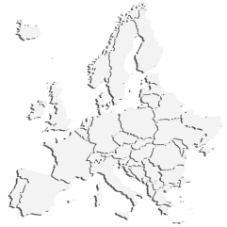

**Mental**

**Health**

**Europe**

Penumbra are active members of this important European network.

We developed the Individual Recovery Outcomes Counter (I.ROC) to measure recovery. It is based on 12 wellbeing indicators (not just mental health). It is now being used world-wide by mental health organisations.

**About Penumbra**

Aims

Penumbra is a charity working to PROMOTE mental health and wellbeing for all, PREVENT mental ill health for people who are ‘at risk’ and to SUPPORT people with mental health problems.

Penumbra campaigns to influence national and local government policy, and to increase public knowledge and understanding about mental ill health.

Penumbra hosts the Scottish Recovery Network (SRN) and was a founding partner in the See Me campaign to end mental health stigma and discrimination.

Services

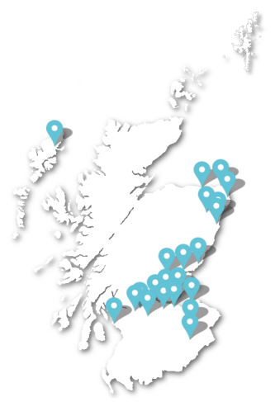Penumbra provides high-quality, personalised and recovery focused services for adults and young people who are experiencing mental ill-health.

Penumbra was founded in 1985 and provided the first registered mental health supported accommodation service in Scotland. It is now one of Scotland’s largest mental health charities, supporting around 1600 people each week across 19 local authority areas.

From its beginnings with supported accommodation, Penumbra now runs supported living services, NOVA (community/social inclusion) services, self-harm projects, crisis centres, services for people with alcohol related brain damage, youth projects, homelessness services and respite breaks (Nova Short Breaks).

In 2014 Penumbra won the Care Accolade for investing in workforce development for our outcomes focused approach. In 2015 Penumbra Milestone won the Innovation Award at the Scottish Health Awards.

Organisation structure

BOARD

Penumbra is structured around three operational areas - North, East and West Scotland. The Directorate is based at HQ and comprises the Chief Executive, Director of Corporate Services and Director of Services and Development.

BUSINESS DEVELOPMENT

AREA

MANAGEMENT

QUALITY

PEOPLE

CHIEF EXECUTIVE

DIRECTOR OF SERVICES & INNOVATION

DIRECTOR OF CORPORATE SERVICES

FINANCE

In 2016 Penumbra launched a wholly owned subsidiary called Penumbra (trading) Limited. This now trades as I.ROC Wellbeing (www.irocwellbeing.com). I.ROC wellbeing is an innovative and transformational approach to mental health and wellbeing. It provides a powerful set of tools for organisations, for practitioners and for the people that use their services.

First and foremost it's a validated measure of individual recovery. But it's also a set of online applications (including mobile app) which help you to capture, track and measure recovery data.

I.ROC wellbeing is an approach that helps transform working together to deliver tangible, meaningful outcomes for people, practitioners and organisations.

QUALITY & IMPROVEMENT

Strategic Plan

**OUR VISION:**Penumbra envisages a society where people with mental health problems expect recovery and are accepted, supported and have the resources to fulfil their potential.

*Our vision is aspirational, ambitious and hopeful. It gives an overarching view of what we are trying to achieve through the activities and services of Penumbra.*

Our strategic plan has five key strategic aims; these are supported by objectives and an annual results and monitoring framework. Each year we review the activities that we undertake in pursuit of our strategic aims so that we can ensure we learn from our experience and continuously improve.

QUALITY & IMPROVEMENT

These objectives are represented by the mnemonic ‘RPIII’:

* RECOVERY
* PEOPLE
* INNOVATION
* INFLUENCE
* IMPROVEMENT

We have also introduced key targets and milestones to achieve by 2020. Each year we will monitor our results in relation to Recovery, People, Innovation, Influence and Improvement which will demonstrate our continued progress towards these key targets and milestones.

Overall our aim is to continue to provide, innovate and develop high quality activities. These will reflect current policies, contemporary ideas and the needs and aspirations of people to improve their mental health and wellbeing.

Funding

Penumbra has an annual budget of around £10 million. This is made up of contracts/service level agreements with local authorities, grants from statutory bodies and charitable trusts and donations from individuals. We have unrestricted reserves of £2.7 million.

Information on Penumbra is held by OSCR and our most recent audited accounts are available from Companies House.

Employer

Penumbra employs approximately 380 staff (340 full time equivalent) and 90 sessional/relief staff, with a number of volunteers also working with various services. All Penumbra staff undertake a variety of training and learning and are registered (where appropriate) with the Scottish Social Services Council or other professional bodies.

Penumbra offers flexible working and is committed to paying the Scottish Living Wage or above to all staff.

Our people

We employ a diverse range of people in a wide range of roles and we are committed to developing the skills and talents of our staff.

Within the organisation there are a range of support-focused roles such as Recovery Worker, Recovery Practitioner, Peer Worker, Management, and others roles in areas such as Finance, Human Resources and Learning & Development.

We provide excellent terms and conditions, a comprehensive learning and development programme and regular practice supervision for all staff. This includes the opportunity to achieve SVQ qualifications appropriate to their role.

BOARD MEMBER Role Description

**GENERAL STATEMENT OF RESPONSIBILITIES**

The task of the Board is to work under the direction of the Chair to ensure probity, to provide governance and to work in partnership with the Chief Executive to achieve the aims of Penumbra.

Penumbra is a company limited by guarantee with charitable status. Members of the board have a dual role as a company director and a charity trustee.

**MAIN DUTIES**

1. To ensure that the organisation conducts its business in accordance with its Memorandum and Articles of Association and in adherence with relevant legislation.
2. To govern Penumbra within best practice frameworks.
3. To attend Board meetings and relevant sub committees and contribute actively to the role of the Board in determining strategy, approving policy, and monitoring organisational performance.
4. To ensure that the organisation's resources are deployed in pursuance of its objects and that its finances are systematically accounted for, audited and made publicly available.
5. To oversee the management of existing services and the development of new ones.
6. To foster effective relationships between Board members, staff, service users, other stakeholders and others who are important to Penumbra.
7. To participate where appropriate in the recruitment of senior staff.
8. To safeguard the good name and the ethos of Penumbra and to promote the organisation and its work, along with fellow Board members and staff, to existing and potential funding agencies, donors, supporters and beneficiaries.
9. To contribute any specific skills, knowledge and experience to assist the Board of Management reach sound decisions. This may involve scrutinising reports and consultations, leading discussions, chairing of or attendance at working groups as well as providing specific advice and guidance on issues where you have particular expertise.

**PERSON SPECIFICATION**

Penumbra Board Members will be committed to the aims and ethos of the organisation and to ensuring that its activities are in the interests of beneficiaries.

Members will come from a range of backgrounds and experience including commercial and business management, finance, marketing and public relations, law, social and mental health policy or care provision, human resource management. Some will also have direct or family experience of mental health issues.

Board members should have, or be prepared to gain, an understanding of the legal duties, responsibilities and liabilities inherent in the role. Board members may also be subject to the Protecting Vulnerable Adults (PVG) scheme.

**Essential Qualities**

* Understanding and acceptance of the legal duties, responsibilities and liabilities of a Trustee/Company Director.
* Commitment to Penumbra’s vision, objects, aims and values and willingness to devote time to carry out responsibilities.
* Good, independent judgement, political impartiality and the ability to think creatively in the context of the organisation and external environment.
* Good communication and interpersonal skills and the ability to respect the confidences of colleagues.
* Balancing tact and diplomacy with willingness to challenge and constructively criticise.

**Desirable**

* Prior experience of committee/trustee work.
* Knowledge of the type of work undertaken by Penumbra.
* A wider involvement with the voluntary sector.
* Experience of committee work, some experience of charity finance, charity fundraising.



**Time Commitment**

* The Board meets 6 times a year in Edinburgh. In addition board members join either the People, Quality, Improvement sub-committee or the Finance, Risk and Audit sub-committee (these meet 3/4 times per year each).
* The Board and Senior Management have a residential 24 hour event once every two years
* In addition to Board Meetings, other contact – usually electronic or by telephone – will be necessary.

What our staff say

2015

staff survey

**2017**

staff survey

**HEADLINE**

**RESULTS**

Every two years we ask staff for their thoughts on Penumbra. The survey covers everything from their experience of employment and training, to the quality of the newsletters we produce. In 2015 67% of staff completed the survey, up from 63% in 2013.

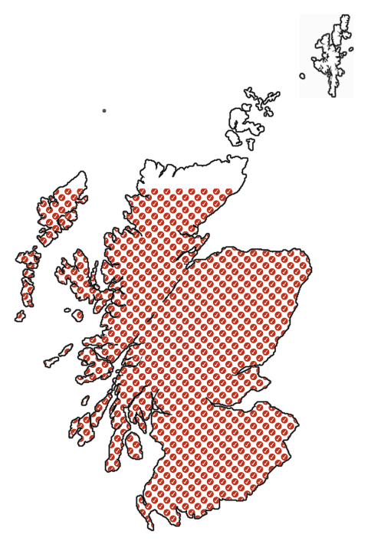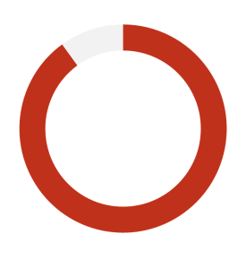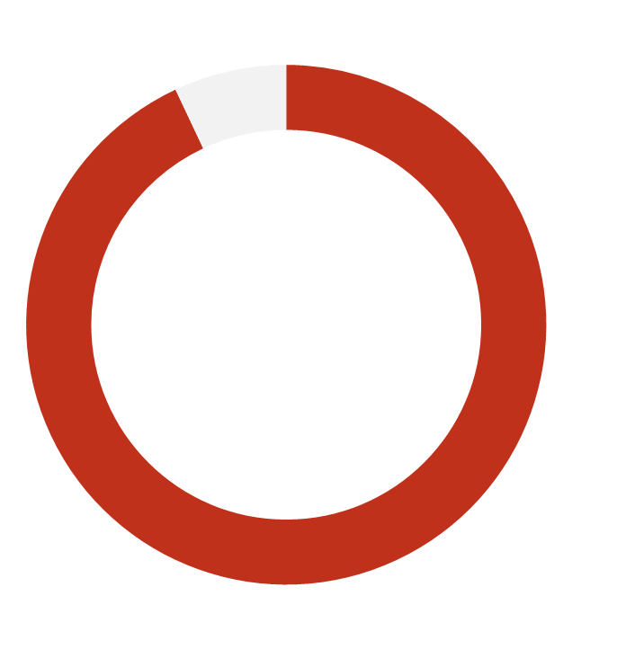

?!

?!

**97%**

are proud to work for Penumbra

93%

Recommend Penumbra as a good place to work

91%

270

number of people

who completed the 2017 staff survey

96%

**92%**

feel they have the necessary skills to do their job

agree Penumbra has a good

local reputation

say their manager treats them with respect

say their role gives them strong job satisfaction

94%

More information

For more information about Penumbra & I.ROC please visit:

[www.penumbra.org.uk](http://www.penumbra.org.uk)

www.irocwellbeing.com

For enquiries about the position please contact:

Nigel Henderson - Chief Executive

[nigel.henderson@penumbra.org.uk](mailto:nigel.henderson@penumbra.org.uk) or 0131 475 2588

**Penumbra**, Norton Park, 57 Albion Road, Edinburgh, EH7 5QY

T 0131 475 2380 | F 0131 475 2391

W www.penumbra.org.uk E enquiries@penumbra.org.uk

Facebook

facebook.com/penumbraScotland

LinkedIn_logo_initialsTwitter

linkedin.com/company/penumbra

twitter.com/penumbra\_scot