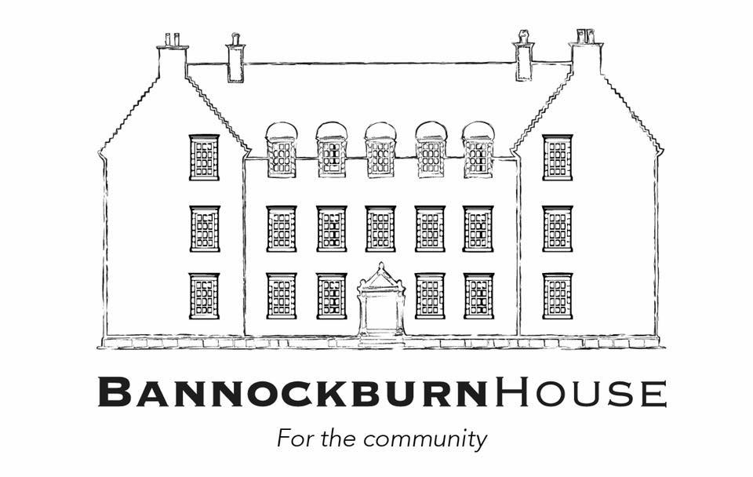

Dear Applicant,

**Volunteer and Events Coordinator Contract**

Thank you for your interest in the Volunteer and Events Coordinator Contract at Bannockburn House. We have provided an outline of the contract below, as well as some context relating to Bannockburn House for you.

Please submit a CV and covering letter to [jimbennett@sksscotland.co.uk](mailto:jimbennett@sksscotland.co.uk) by 5 pm on October 26th 2018. Receipt of your submission will be acknowledged by e-mail. If you don’t receive an acknowledgement, please call Jim on 07932 736006 to double check that it has been safely received.

You should note that this isn’t an employed post; it is a self-employed contract. We have an approximate fee of c.£24500 until June 2020 which we anticipate will be delivered at a rate of £150 - £175 per day. Currently, we expect the contract holder to work from home/own-office with very regular on-site communication with our volunteer teams. One of our Board members, Penny Ellis, has the role to strategically overview our volunteering and the contract holder will be expected to work closely with her, as well as the BHT Project Director.

Our contracts team currently comprises: Project Director; Project Support Manager; Construction Advisor and Board Mentor. We are also in the process of appointing a Marketing/Communications contractor.

We hope that you enjoy reading the materials we’ve put together and will perhaps visit us on one of our tours.

Yours,

Jim Bennett

Project Director

[jimbennett@sksscotland.co.uk](mailto:jimbennett@sksscotland.co.uk)

07932 736006

**Bannockburn House**

**Volunteer and Events Coordinator Contract**

**Freelance, up to June 2020**

**Total budget around £24.5k**

**Volunteer Coordination Responsibilities**

Bannockburn House Trust currently has c.140 volunteers. Approximately 40 of those volunteer on a weekly basis; c.60 monthly, and the remainder as specific events take place. We expect that the Volunteer coordinator’s role will include:

* Delivering/Enabling delivery of the resources, support and training needed for volunteers to complete their roles
* Working in a cooperative manner to resource each of the BHT volunteer groups: Gardens, Operations, History, Events etc Ensuring that systems are in place to enable volunteers to maximise their own development whilst with BHT
* Volunteer recruitment (including interviewing and screening), induction and performance development, resolving disputes and other challenging situations.
* Producing and maintaining volunteer agreements, role descriptions and policies, e.g. expenses; consulting with members (including volunteers) in their drafting.
* Monitoring, approving and arrangement for paying volunteer expenses, ensuring full records are passed to the treasurer at agreed intervals
* Convening and producing a written record of regular volunteer meetings, ensuring that appropriate actions are taken on volunteer suggestions
* Delivering operating systems for volunteers which are compliant with regulatory requirements
* Ensuring the delivery of training programmes which suit the needs of BHT, volunteers and any regulatory agencies
* Working with the Marketing/Communications Coordinator to ensure a flow of information between volunteers, contractors and the Board
* Maintaining written records of volunteer activities, hours completed and compilation of reports.

**Events Responsibilities**

Bannockburn House Trust aims to provide a pro-active programme of events which ensures that the local and wider community is fully engaged with Bannockburn House. We also wish our events programme to financially contribute to BHT. The Events element of the post includes:

* Working with our Events team to plan our programme of events
* Reviewing/consulting on entry payment
* Ensuring that all relevant volunteer groups within BHT have a stake in our events
* Resourcing the Events team to enable their successful delivery of each event
* Ensuring that each aspect of any event is compliant with appropriate legislation
* Co-designing with volunteers a programme of events for their personal development as well as BHT’s organisational development
* Liaising with relevant external agencies such as Stirling Council Events team, Historic Environment Scotland etc to integrate BHT into their events thinking
* Liaising with potential clients regarding BHT hire for their events
* Developing (in conjunction with Project Support Manager) and maintaining CRM database covering clients and suppliers and arranging opportunities for increasing client and supplier base.

**Person specification**

* Previous relevant experience in working with volunteers
* Previous experience in event programming and events start-to-completion organisation
* An understanding of , project planning, budget management, costing and profitability
* Knowledge / understanding about community led projects and how these relate to delivering positive impacts in the local community
* A commitment to diversity and inclusion
* Good organisation, administration and IT skills
* Good oral and written communication skills
* Excellent team player and motivator
* Possesses knowledge and understanding of compliance issues around both events and volunteer support
* Proactive self-starter.

**Bannockburn House** **Community ownership**

The owners of Bannockburn House are the community of Bannockburn. Through their membership of Bannockburn House Trust, local people can exercise control over the appointment or removal of Board members and the direction of the Trust, which must act on their behalf and be accountable to them through a variety of means including formal AGMs.

Bannockburn House appears to be one of the largest truly community owned heritage projects in the UK and is therefore regarded as a critical “pathfinder”.

**Background**

The house is located off the A91 close to the Stirling motorway services area (M80 / M9 intersection). It is A listed and around 14,000 sq. feet on four floors surrounded by various outbuildings and chauffeur’s house, set in 28 acres.



**The Bannockburn House Project and Organisation**

In 2016, Bannockburn House came on the market and stimulated enormous public interest from the local Bannockburn community. It quickly became evident that the local community wished to carry out a community purchase of the house.

Bannockburn House Trust (BHT) was formed in January 2017 as a two-tier SCIO with a Board of local people. By mid-2017 BHT secured a second stage Scottish Land Fund award to purchase the house, with additional financial support from Stirling Council. BHT has owned the house since December 2017.



Currently BHT has 9 board members, around 300 SCIO members and 140+ signed up volunteers who already maintain the house and gardens, organise events and carry out other project activities.

BHT’s objectives include:

* Ensure Bannockburn House (BH) is open and available for the use and enjoyment by local people
* Build a strong community-driven organisation (BHT)
* Improve and maintain the heritage, building fabric, interiors, fittings / furnishings and grounds of Bannockburn House, in line with community wishes and with regard to the advice of heritage professionals
* Encourage public access (including visitors to the area) to the house and grounds for purposes of leisure, heritage and cultural activities, learning, health and well-being
* Create a visitor attraction that generates income and employment benefitting local people
* Initiate, develop and facilitate a range of community projects and activities at BH, providing benefit to the local community
* Secure all necessary funding and support to protect and conserve the house.

Website: <http://www.bannockburnhouse.scot/>

Facebook: <https://www.facebook.com/BannockburnHouse/> (currently a closed group - apply to join).

**Plans for Bannockburn House - delivery**

The House does not have a collection of artefacts and is not going to be a museum. Its planned use is as community space and a community led heritage visitor attraction. It will provide space and facilities for a range of community led services, projects and activities which could include:

* Communal garden
* Community café
* Traditional skills / apprenticeships / workshops for training
* Living in the past (tours, re-enactments, visitor accommodation)
* Our House, Our Stories exhibitions
* Artists’ studios / arts and crafts
* Heritage trails / cycle paths
* Events / markets / fayres
* New horizons learning
* Horse riding
* Brewery.

The House will need to be financially sustainable and the possible sources of income include:

* Visitor guided tours (may be via prompted donations rather than charging)
* Shop
* Café / bistro / bar / catering (including potentially large events)
* Parking (perhaps refundable against purchases in shop, café)
* Visitor accommodation - camping, B&B, holiday apartment
* Event space (including weddings, corporate, conference)
* Exhibitions
* Ticketed events e.g. arts, cultural, festivals
* Fees for learning events / workshops / residentials / themed week-ends (murder mystery, ghost hunting)
* Location: for film, TV, radio (Outlander, Antiques Roadshow, BBC Radio 4 Question Time etc)
* Meeting room hire e.g. for meetings, activities, private events
* Workshop / studio hire
* External land hire e.g. re-enactments, rallies, concerts
* Public fundraising
* Donations
* Community fundraising.

**Overview of capital plans**

The House will need major repairs and there is a phased plan to raise the capital required and implement the repairs. The house can already be made usable for temporary meetings and public events by bringing in mobile heaters, Portaloos etc.

There is a small capital budget available being used to upgrade facilities in the chauffeur’s house to provide temporary facilities for volunteers and others working on site, and also to provide immediate short-term repairs to the House to halt water ingress.