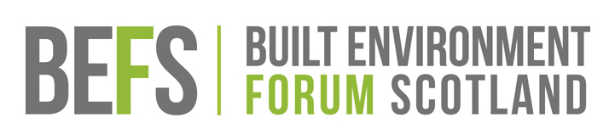

**BUILT ENVIRONMENT FORUM SCOTLAND**

**BEFS CHAIR: ROLE SUMMARY  
JUNE 2018**

As the current BEFS Chair, Dr Graeme Purves, is stepping down at the next AGM in December we are inviting expressions of interest from potential candidates for the role.

**Expressions of Interest**

If you are interested in the position of BEFS Chair then please write to the BEFS Director, Euan Leitch in the first instance, outlining (no more than one side of A4) why you would be a suitable candidate for the post. Please also include a brief career synopsis (maximum 500 words).

Please write to or email:  
Euan Leitch  
BEFS Director  
Built Environment Forum Scotland  
3rd Floor, 125 Princes Street

EDINBURGH EH2 4AD

Tel: 0131 220 6241  
Email: euan.leitch@befs.org.uk

**DEADLINE FOR APPLICATIONS: Monday 22nd October 2018**

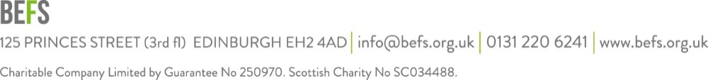

**About BEFS**The Built Environment Forum Scotland (BEFS) is the strategic intermediary body for Scotland’s built environment sector, bringing together voluntary and professional non-governmental organisations that operate at the national level.

As an umbrella organisation, BEFS informs, mediates and advocates on strategic issues and policies affecting the built environment, historic and contemporary.  Adopting a holistic approach, our aim is to put people at the heart of places that are both valued and of the highest possible quality.

How does BEFS work? Through its membership, working groups and workshops, BEFS provides a forum for debate and discussion on matters relating to the built environment.  Issues are discussed and views presented to key decision makers in national and local government.

Visit [www.befs.org.uk](http://www.befs.org.uk) for further information about BEFS and its activities.  
Visit <http://www.befs.org.uk/resources/corporate-papers> for copies of recent accounts and annual reports

**The role**

The position of Chair is an exciting opportunity for a resourceful and confident individual to play a central role in developing BEFS not only as the Scottish intermediary body for the historic environment but also the wider built environment. As well as continued engagement with the Planning (Scotland) Bill, implications of Brexit and other relevant live policy topics, BEFS main lines of enquiry are currently: the future of religious heritage with a conference in Spring 2019; improving tenement maintenance, holding the secretariat for a cross party working group; addressing the issue of prioritisation in the historic environment; and maintaining an interest in ongoing discussion on land ownership, management and tax issues. BEFS has an important and pivotal role to play in ensuring sector engagement in these developments and candidates will be expected to provide leadership and direction. Candidates will have a passion for Scotland’s places, excellent strategic, organisational, interpersonal, communication skills and enjoy working with a focussed and motivated small team.

A significant role of the Chair will be to carry out ambassadorial functions for BEFS, helping the organisation to develop its profile and its upward and outward representation with government and with economic, social and other sectors. The ambassadorial role will involve:

* helping to identify contacts and open doors to key individuals and decision-makers (public, private, NGO)
* attending certain functions for BEFS
* leading certain high-level BEFS delegations (e.g. some ministerial or agency liaison meetings)
* attending, and on occasion hosting, some BEFS’ events
* developing an understanding of, and contributing to, thinking on the Built & Historic Environment and wider place-making.
* Attending meetings of the Strategic Historic Environment Forum, chaired by the Cabinet Secretary for Culture, Tourism and External Affairs.

**Requirements**

* Approximately 3-4 days per month.
* Meetings are mainly held in Edinburgh, but may on some occasions be held in Glasgow, Stirling, Perth etc.
* The position of BEFS’ Chair is an honorary one. There is no honorarium but all reasonable expenses are paid.
* The position is subject to re-election every three years.

The Chair needs to be able to adopt a broad perspective taking on board all views within BEFS and ensure that, at meetings and in statements etc, decisions made are representative of the Forum.

The Chair is a company director that leads the BEFS’ Trustees (fellow company directors) with responsibility for governance of the organisation. BEFS has a staff of 4 people. The Chair is supported by the Vice-Chair.

The Chair has particular responsibilities in relation to BEFS’ meetings including:

* Attending and chairing Board and General Meetings
* Ensuring meetings are structured and run competently
* Ensuring discussion and decision-making is democratic and everyone is able to participate fully in meetings
* Holding the casting vote in the event of a split decision
* Preparing agendas for the meeting in consultation with the Director
* Acting in partnership with the Director to ensure that BEFS has a clear vision and a resolute strategic direction in line with its core values and principles
* Ensuring with fellow Trustees the future funding of the organisation.
* Ensuring relevant matters are discussed and appropriate decisions made.

**The Person**

BEFS is looking for a confident and resourceful individual who is proactive, determined and collaborative. The Chair will be required to speak with an authoritative voice on matters relating to the built and historic environment. He/She will be able to demonstrate a strong interest and past experience of working in the built and historic environment but they will not necessarily require a professional qualification in these areas.

Desirable qualities include:

* Political credibility, authority, chairing and leadership abilities
* Proven and credible experience of board level governance
* Visionary and motivational leadership; able quickly to earn and command respect, build trust and inject enthusiasm
* Excellent communication and negotiation skills
* Proven intellectual strengths but with flexibility to move from broad strategy to the management of detail
* Considerable presence and credibility; an obvious standard bearer for BEFS and a champion for the built and historic environment
* Strong and effective networking skills; able to relate well to people at all levels
* The ability to work collaboratively building a broad range of positive alliances and partnerships, able to build consensus
* A high degree of personal and professional integrity
* Empathy with the voluntary sector environment movement in Scotland
* Experience of public life and understanding of the way in which government works
* Sensitivity to the range of interests represented through BEFS, including sustainable development, urban design and place making, and associated issues relating to the cultural heritage
* Experience of providing leadership to a charitable organisation of BEFS’ size
* Confidence and humour.