APPLICATION PACK

DIRECTOR OF FINANCE & CORPORATE SERVICES

Thank you for requesting an application pack for the position of Director of Finance and Corporate Services at the Royal Society of Edinburgh.

Application Pack:

- A Job Description including key responsibilities, competencies, skills & experience needed to do the job, salary & hours
- An Application Form
- Information about the Royal Society of Edinburgh
- An Equal Opportunities Monitoring Form
- A note summarising RSE non-pay benefits

Job Application Form

Please complete the job application form as fully as possible demonstrating how you meet the competencies and skills required for the post and the relevant experience you bring to the role. If you need additional space for any section, continue on a separate A4 sheet. If you have any questions about filling in the form, do not hesitate to contact me.

Diversity

Completion of the Equal Opportunities Monitoring Form is optional.

How to apply

Your completed application and your Equal Opportunities Monitoring Form should be returned to the RSE HR Office by the closing date, which is 11.59pm on Sunday 25th November 2018 to vacancies@theRSE.org.uk

Interviews

If you are invited for interview, this will take place at the Royal Society of Edinburgh building, 22 George Street, Edinburgh EH2 2PQ, on a date and at a time to be confirmed.

Eligibility

In accordance with the Immigration, Asylum and Nationality Act 2006 The RSE, as an employer, has a legal responsibility to prevent illegal working and therefore must check that all employees are entitled to work in the United Kingdom. To do so we require to see original documents evidencing right to work in the UK before commencement of employment and this will be carried out at the interview stage. Details will be provided to candidates invited for interview.

Feedback on your application

Please note that feedback will only be provided to candidates after interview.

Finally, I would like to thank you for your interest in the Royal Society of Edinburgh.

Yours faithfully,

Ms Christel Baudère
Senior HR Advisor

Job Title | DIRECTOR OF FINANCE & CORPORATE SERVICES
Grade  Salary  Hours | RSE Grade 4  C65K  35 hours per week Monday to Friday, 9.00 to 17.00  Occasional work out-with these core hours may be required  Permanent
Starting Date | As soon as possible
Role | - To lead and provide direction and effective management for RSE Finance and Corporate Services (FCS) functions, and to provide strategic financial advice to Trustees and staff
Key Responsibilities | - Lead and manage the finance function within RSE to support financial decision-making and ensure compliance with all statutory and related accounting and tax regulations  - Lead and manage the corporate services function including HR, IT and business management  - Lead the staff teams within the FCS Directorate, promoting and supporting a wider culture of continuous improvement  - Contribute to the leadership of the RSE as a member of the senior management team  - Support bids for funding, engaging in negotiations as appropriate, and ensure compliance with reporting and accountability requirements of funders  - Work with trustees and senior management to develop and maintain appropriate financial policies (including pensions policy)  - Oversee business planning and risk management activities across the organisation  - Lead and oversee the management of investments and legacy funds
Competencies / Skills | ESSENTIAL  - Full professional accounting qualification (CCAB) with good general experience of computerised accounting systems & thorough understanding of accounting principles  - Proven track record of financial management at a senior level and working as part of a senior management team  - Broad knowledge of employment law, employee relations & management  - Excellent written and oral communication skills, including in presenting financial information to lay people  - Sound judgement and ability to use both analysis and creativity in problem-solving  - Highly developed people skills including building relationships of trust and influence with staff and stakeholders  - Ability to lead, manage and motivate a group of teams including leading teams through change  - Excellent organisational and planning skills | DESIRABLE  - Charity accounting experience and / or diploma in Charity Accounting or equivalent  - Broad understanding of pension schemes  - Broad understanding of financial investments  - CIPD qualification
IT Skills | Word |  | Excel
 | Intermediate level |  | Advanced level
 | Outlook |  | PowerPoint
 | Intermediate level |  | Basic level
 | Integra Database |  | Others
 | Basic Level |  | Sage 200  Bank “Commercial Banking online”  Sage Pay  BACS direct debit/credit
Staff Management | Overall management of Finance & Corporate Services Directorate and the teams operating within in it. The Directorate will comprise c 11 staff. Direct reporting responsibilities will be for c 3 staff.  The structure below Director level is under review, which is why the staff numbers are shown as indicative. The successful candidate will have the opportunity to contribute to the review and be engaged in supporting the wider evolution of the organisation.
Responsible to | The Chief Executive
Stakeholders | External: Funders, Banks, Universities, Trade Debtors and Creditors, Investment Managers, professional advisers, service providers  Internal: Treasurer, Trustees and all RSE staff and Fellows

JOB SPECIFICATION

- Lead and manage the finance function to support RSE’s financial decision-making
- Lead and direct, as appropriate, the operations of the Finance team, ensuring the effective management of record keeping, budgeting & forecasting, management reporting, control system and financial accounting
- Produce the annual statutory consolidated accounts for RSE, including RSE Scotland Foundation & RSE Scotland SCIO in accordance with accounting standards and regulations
- Prepare annual consolidated budgets and forecasts
- Plan and manage cash flow and payments
- Continually improve & develop systems and procedures within the Finance function
- Prepare regular financial reports to Committee, Trustee Boards, and Directors Group
- Liaise with professional advisers, including tax, accounting, and audit and manage banking relationships
- Develop and maintain appropriate accounting systems, controls and records, ensuring compliance with all statutory and related accounting and tax regulations
- Keep track of changes in the wider operating environment and evolve processes and systems as required.

- Lead and manage the corporate services function including HR, IT and business management
- Ensure the efficient and effective discharge of the following functions including compliance with all relevant legislation:
  - Human Resources including employee relations, recruitment, health and safety and organisational development
  - Information Technology including strategy development and Customer Relationship Management systems
  - Business Support Services including records management (including Data Protection) & Archives, office services and monitoring and evaluation of impact and associated reporting
  - Corporate Governance including secretariat to Trustee Boards
- Support the continuing evolution of corporate services within the new Directorate structure

- Lead the staff teams within the Directorate, promoting and supporting a wider culture of continuous improvement
- Line manage team leaders and other staff as required within the FCS Directorate
- Support joint working across the Directorate and with other teams out-with the directorate as required to support effective and efficient working
- Support a culture of continuous improvement supporting the development of individuals and teams within the directorate

- Contribute to the leadership of the RSE as a member of the senior management team
- Actively participate in meetings of the senior management team (Directors’ Group) providing input, ideas and advice
- Support the ongoing development of the RSE including contributing to discussions and strategic plans across the full range of RSE activities
- Build effective working relationships with key stakeholders and partners and act as an ambassador for RSE
- Deputise, as required, and as other Directors are required, for the Chief Executive. For example, representing the RSE at internal and external events and meetings
- Provide senior management input on the facilities and building in the absence of the Director of Commercial Development and Property as required

- Support bids for funding, engaging in negotiations as appropriate, and ensure compliance with reporting and accountability requirements of funders
- Prepare or review costings for proposed new activities to ensure an appropriate level of recovery
- Agree contract conditions for major projects and participate in negotiation as required
- Oversee budget proposals for Outcome Agreement with Scottish Funding Council
- Ensure reporting to all funders reflects the requirements of the grant / funding agreements and is completed on a timely basis

- Work with trustees and senior management to develop and maintain appropriate financial policies
- Provide financial advice and information to Council, the Chief Executive, senior management, and managers on both strategic and operational matters as required
- Advise on likely financial and tax implications of proposed courses of action and activity
- Act as the leading interface between the Executive and the Council on financial and corporate service matters, ensuring clear and accurate communication.
- Provide information and advice on pensions matters
- Develop and maintain an effective working relationship with the Treasurer

- Oversee business planning and risk management activities across the organisation
- Work with the Business Manager and Directors’ Group to ensure effective business planning across the organisation
- Oversee the development of business plans and associated budgets through input provided by and discussion with individual Directorates and CEO
- Present annual budgeted business plans for consideration and approval by Trustees
- Disseminate agreed final business plan to team leaders and staff
- Oversee the maintenance of the risk management register and ensure completion of risk actions
- Oversee the maintenance of the Incident Recovery Plan and testing of incident scenarios
- Renew and review insurance policies annually

- Lead and oversee the management of investments and legacy funds
- Provide day-to day contact with and instructions for investment managers
- Manage Cash deposits to maximise income
- Provide secretariat for the Investment Committee

- To undertake other tasks required by RSE, this includes but is not limited to the following:
- Apply RSE’s key behaviours and skills (See “Our Expectations” enclosed). You are committed and adhere to the RSE vision, mission and values
- Ensure all finance and corporate services processes comply with data protection legislation and are in accordance with RSE record management policy and processes
- Observe all health and safety requirements
- Work within and promote policies in relation to the RSE Diversity Policy

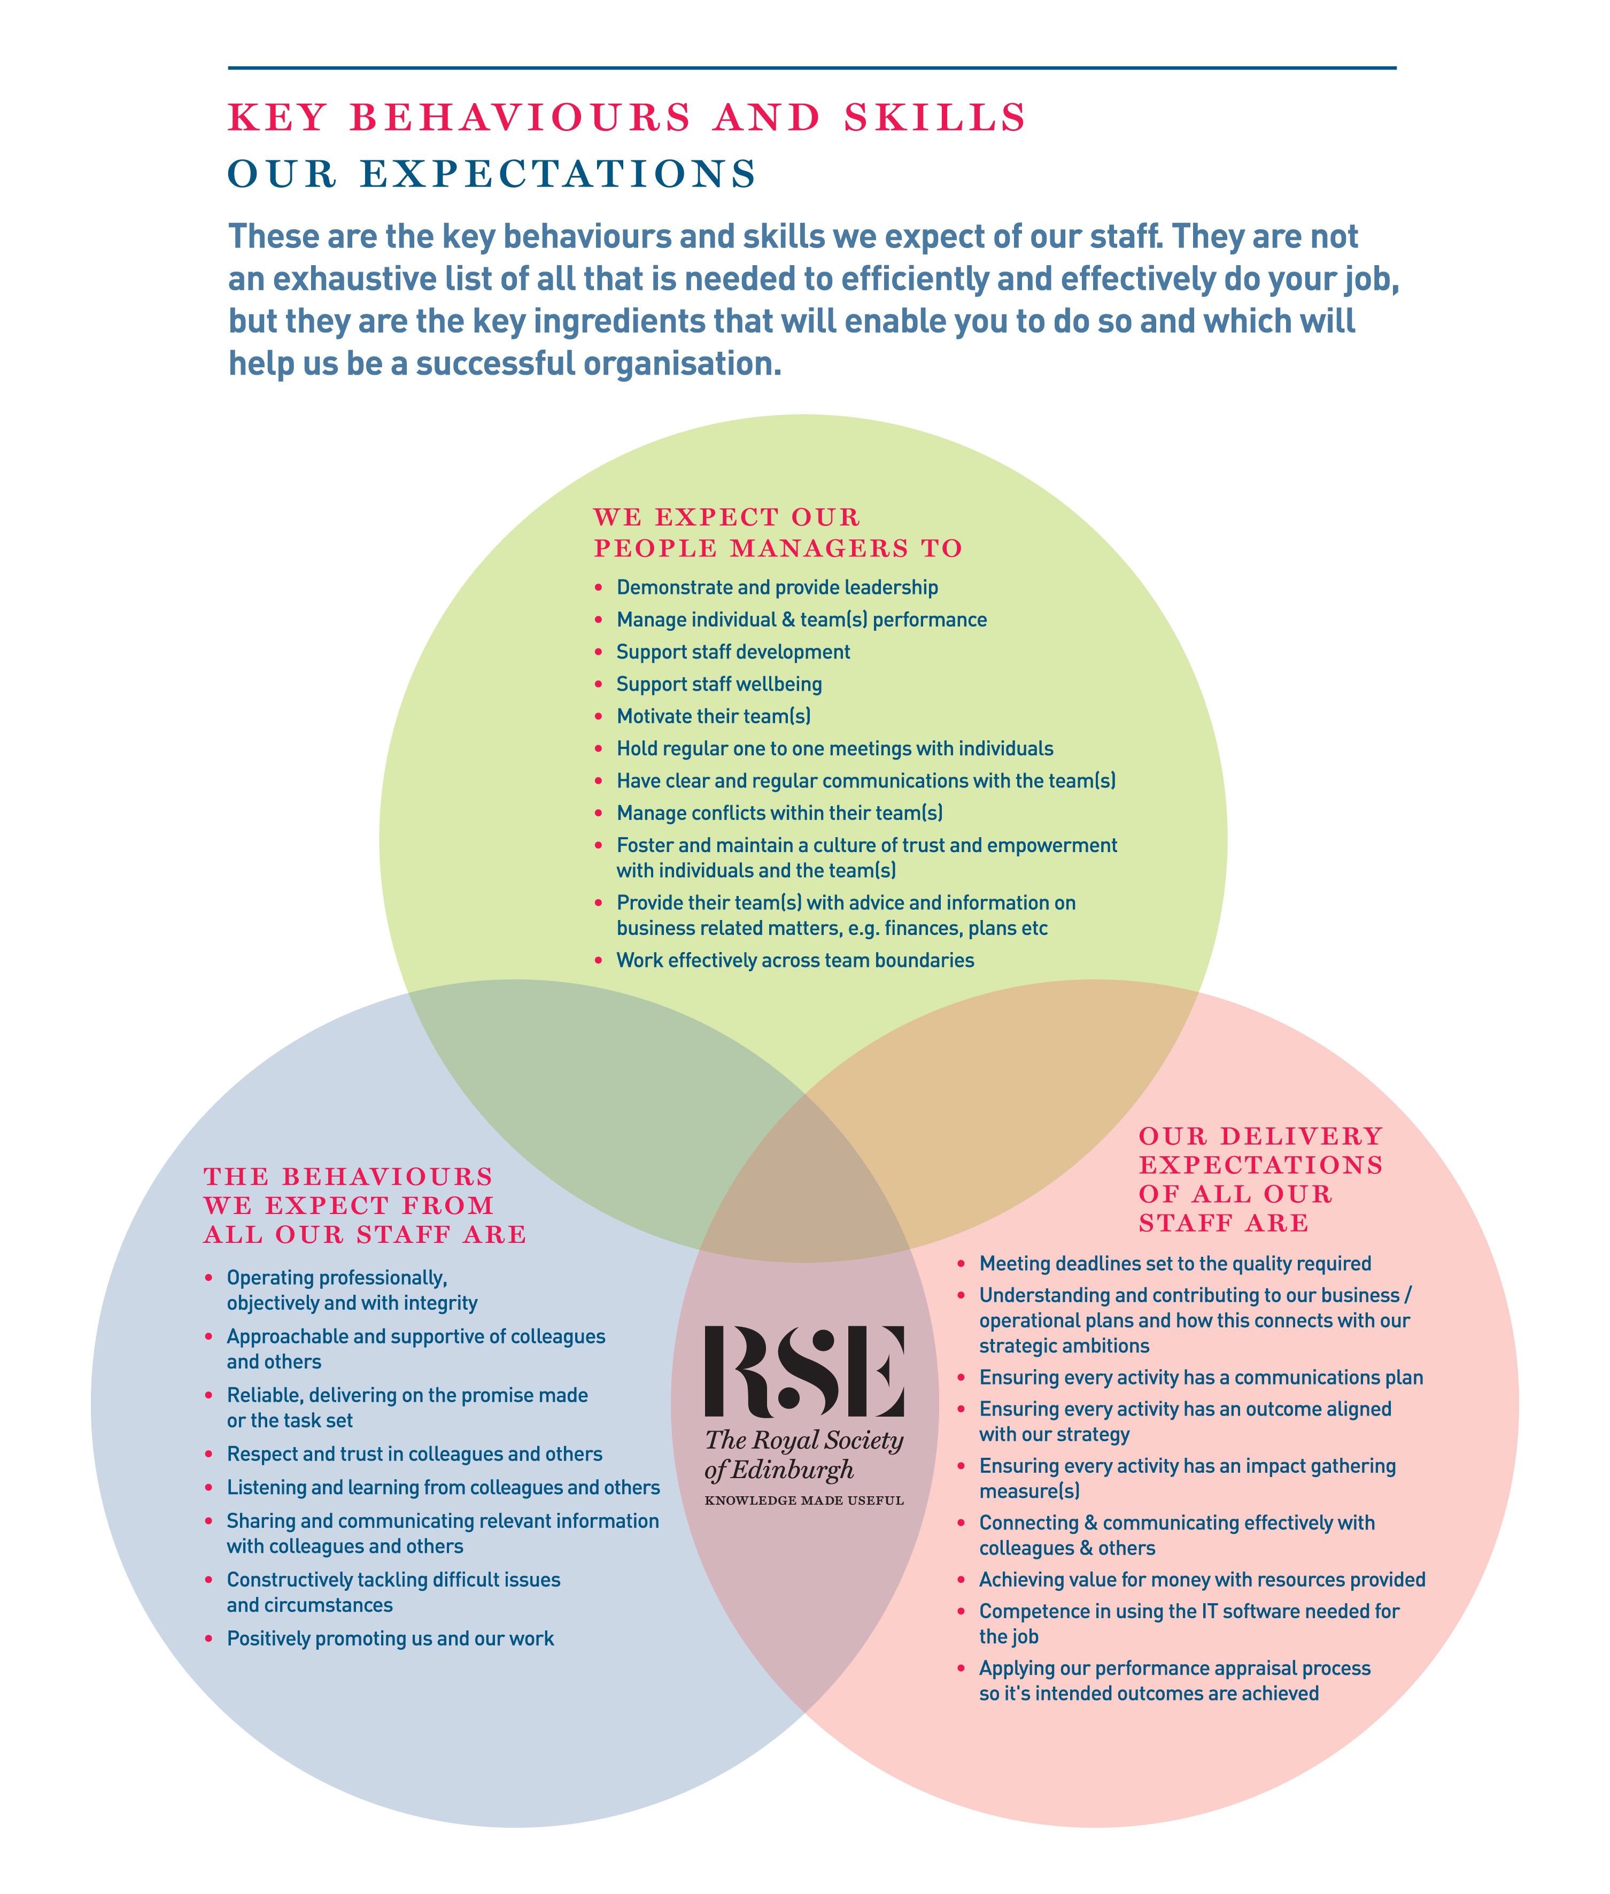

About the RSE
The Royal Society of Edinburgh, Scotland’s National Academy, is an educational charity that provides public benefit throughout Scotland through a diverse range of activity including awarding research funding, informing public policy and delivering events across Scotland to inspire knowledge and learning.
The RSE’s mission, set out in its Royal Charter of 1783, is “the advancement of learning and useful knowledge”. Its contemporary purpose remains the same – the deployment of knowledge for public good: knowledge that contributes to the social and economic well-being of Scotland and its people and the nation’s wider contribution to the global community.
The RSE draws upon a body of elected fellows who are leaders and experts in their fields. The breadth of expertise and experience within the Fellowship ranges from life sciences, physical sciences and technology, to arts, humanities, social science, business, public service and civil society. The multidisciplinary breadth of the RSE – reaching well beyond the academic world – is a distinctive strength and unique within UK national academies.
Our staff group, is responsible for executing our programmes of activities and ensuring due governance is followed.

Our Strategic Framework

Published in 2016, our Strategic Framework 2016-2021 sets out the Royal Society of Edinburgh’s vision and strategic objectives to 2021. It identifies the distinctive impact the RSE aims to make nationally and internationally, and the benefits that a vibrant multidisciplinary national academy can bring to Scotland.

The Framework sets out four strategic objectives to:

- Inspire and support Scotland’s most promising young talent across the research, business and public sectors, to create value for the economy and society;
- Engage on key contemporary issues by providing an impartial forum for public debate and discussion;
- Provide expertise to ensure that Scotland’s policy makers and influencers have access to the best national, and indeed global expertise;
- Promote Scotland’s interests and reputation on the global stage.

Alongside these strategic objectives, the Framework identifies four development aims:

- To create an active and more diverse Fellowship;
- To secure increased funding from a diverse range of sources;
- To enhance and widen the RSE’s outreach and impact;
- To redevelop our premises.

In line with the ambitions set out in the Strategic Framework the RSE is embarking on a major programme of change, building on existing strengths, to further enhance the Society’s visibility, reach and impact.

APPLICATION FORM

Please provide the information requested below outlining your experience and skills. You should then send your job application form to the RSE HR Office as soon as possible.

1. Post Applied For: Director of Finance & Corporate Services

2. Application No: (for RSE use only)

3. Your Details:

Title
Forename
Surname
Address
Postcode
Telephone Number
Mobile Number
E-mail Address

4. Do you need a work permit to take up this post? (please tick)

Yes No

Application Number (for RSE use only)

5. Present Post

Job Title:

Employer’s details:

Date of employment (From – To):

Reason for leaving (if applicable):

Notice period required:

Role Purpose / Summary of responsibilities:

Application Number (for RSE use only)
6. Employment history
Starting from the most recent first and working down the page. (Please, use a separate sheet if needed).

Job Title | Employer | Responsibilities | Dates from | Dates to

Application Number (for RSE use only)

7. Education or relevant courses

Subject(s) | Qualification achieved | Date obtained

8. Membership of Professional Bodies

Full name of Organisation | Registration Number | Date obtained

Application Number (for RSE use only)

9. Statement of Application
Please demonstrate how you meet the competencies and skills required for the post and the relevant experience you bring to the role with reference to the key responsibilities set out in the job description. You may also wish to provide other information that may be relevant to your application such as your reasons for applying for this position, major achievements to date, personal qualities, interests or other skills and attributes (Use a separate sheet if needed).

Application Number (for RSE use only)

- References: Please give the names of two referees who can provide references on your suitability for the post, and who you are content the RSE approaches if required (do not enclose references with this application).

Note that references will only be taken up for successful candidates following the interview.

I am content that the RSE approaches the referees below
(Please tick the box accordingly)

REFEREE 1
Title
Forename
Surname
Address
Postcode
Telephone Number
Mobile Number
E-mail Address

REFEREE 2
Title
Forename
Surname
Address
Postcode
Telephone Number
Mobile Number
E-mail Address

Application Number (RSE use only):

11. Where did you see the advertisement for this post (please tick accordingly)?

Good Moves / Third Force News website
RSE Website
Indeed
LinkedIn
Twitter
WOM
Other

Data Protection

The Data Protection legislation regulates the use of personal data (“information”) about an individual and requires the RSE to receive your consent to use the information you give in this form and in any attachments to it, to assess your suitability for the post you have applied for. By signing this application form, you will be consenting to the RSE processing information for this purpose.

If you are unsuccessful, this form will only be kept in the RSE files for 3 months and will only be viewed by staff involved in the recruitment process. If you are successful, this form will be kept for the length of your employment with the RSE.

Date:

Name:

Signature:

POLICY ON CRIMINAL RECORD DISCLOSURE

In line with its overall recruitment policy, the RSE seeks criminal record information before making an offer of employment to a successful job applicant. The note below describes the process that will be followed and what happens to any information received. Please read it carefully.
The post for which you have applied requires the applicant who is successful at the interview stage to complete a personal disclosure of any unspent convictions, details of any cautions, reprimands and final warnings administered, and details of any charged offences. There will, also, be open and measured discussion about disclosure information at the interview stage. If an applicant fails to disclose relevant information at interview, it may lead to the withdrawal of an offer of employment, or following appointment, disciplinary action being taken, which may include the termination of employment.
If an interview, or subsequent personal disclosure, provide information about a conviction, cautions, reprimands, final warnings administered and charged offences, RSE will assess the relevance of the information by considering:
- The seriousness of the offence and whether it is relevant to the protection and safety of RSE staff, others and RSE property.
- The length of time since the offence took place
- Whether there is a pattern of offending behaviour
- Whether an individual’s circumstances have changed since the offending took place, making re-offending less likely.
- Relevant information offered by an individual about the circumstances which led to the offence being committed
- The country in which the offence was committed; some activities are offences in Scotland and not in England and Wales, and vice versa.
- If the offence has since been decriminalised by Parliament.
- The degree of remorse, or otherwise, expressed by an individual and their motivation to change.
Personal disclosure information provided will only be used for recruitment purposes and will only be shared with those authorised to see it during their duties. No image or photocopy of the information will be made. The Personnel Office will keep all information disclosed in a secure and confidential file for 6 months after the start of employment.

RSE EQUAL OPPORTUNITIES MONITORING FORM

As an equal opportunity employer, the RSE welcomes applications from all suitably qualified people and aims to employ a diverse workforce. To help us meet that aim we would be grateful if you could complete this form and return it to us. The form is completed on an anonymous basis, will not be used in the short-listing process for the post, and cannot be reconciled with your application.

The information you provide may, however, be stored on a computer system for the purposes of personnel administration and statistical analysis. It will be treated as strictly confidential and only be used for Equal Opportunities purposes.
Post Applied for | Director of Finance & Corporate Services

Where did you see this vacancy advertised?

What is your age? (Please tick the appropriate box)
17-25
26-44
45-64
65+
Prefer not to say

What is your gender? (Please tick the appropriate box)
Female
Male

Ethnic / Racial Origin

Please indicate how you would describe your ethnic / racial origin from the selection below. (Ethnic origin is not about nationality, place of birth or citizenship, but about colour and broad ethnic group).

White | Black African | Black Caribbean | Black Other | Indian | Pakistani | Bangladeshi | Chinese | Other

- The Equality Act 2010 defines disability as a “physical or mental impairment which has a substantial and adverse effect on a person’s ability to carry out normal day to day activities”

Do you consider yourself to have a disability?
Yes
No

Thank you for your co-operation in completing the form

In addition to the basic salary paid, the RSE offers staff a generous package of rewards. The package includes:

Salary | - Subject to what we can afford, you may receive an annual pay award to maintain the real terms value of your pay. There is also discretionary scope for additional consolidated or non-consolidated pay awards
Contributory Pension Scheme | - You can join the RSE AVIVA Group Pension Plan. You contribute 3%. On your behalf, we pay a further contribution of 6% of your annual salary. Further information about the scheme is available here http://www.aviva.co.uk  - The contributions will change in April 2019. From that date staff will contribute 5%; and the RSE 10%  - AVIVA may accept transfers from other schemes so please check with them prior to applying for a transfer.
Annual leave | All employees employed after 1 August 2018 receive the following annual allowances (pro-rata for part time staff):  - 25 days up until completion of 3 years employment  - 27 days following completion of 3 years employment (+ 2 days)  - 30 days following completion of 5 years employment (+ 3 days)
Public Holidays | - You get 9 days public holiday (pro-rata for part time staff). This is built into your total holiday allowance (annual leave + public holidays) each year
Sick Absence | - You receive sick absence pay once you have satisfactorily completed your probation period. The period of paid absence increases progressively according to your length of service and reaches, after 4 years of service, full pay for 26 weeks absence and half pay for a further 26 weeks absence
Family Leave | - We recognise and fully comply with your legal rights in relation to paid (Adoption, Maternity & Paternity leave, Shared Parental Leave) and unpaid time off, and flexible working. Where your contracted salary is greater than the statutory minimum for paid time off, during, or for part of the absence, you will be paid your contracted salary. In addition to these legal rights, you can also, depending on the circumstances, receive paid “Family Responsibility Leave” to cover unforeseen family circumstances.
Performance Management | - We care about your performance and development and assess, manage and support it through our performance review system.
Flexibility with medical appointments | - We are flexible in how we deal with dental and medical appointments. We expect these to be arranged out-with your normal hours of work, but we recognise that for many reasons this might not always be possible. Where that is the case we exercise discretion and provide reasonable time off during your normal working hours to attend your appointment.
Healthy Working Lives | - We are part of the Healthy Working Lives Award Programme. We obtained our Bronze Award in 2005 and have obtained our Silver Award in July 2011 and since then maintained both Awards. A group of staff volunteers organise events focussing on health promotion, occupational health and safety, health and the environment, raising awareness about mental health and well-being and we are working towards the Gold Award.  - Types of Events: RSE Wellness Day - Health Checks for staff (diabetes, cholesterol, BMI, Blood Pressure), Big & Healthy breakfast, Running Club at lunchtime (Jog Scotland), Pedometer Competitions, Walking group, Lunchtime Yoga classes, social cycle rides at the weekend, training on First Aid for baby and child for all new parents, event of information on Nutrition, Cancer, Salt Intake, Legal Highs, etc.
Support with VDU | - As part of the Health and Safety at Work legislation, employers are required to designate which staff members are classed as regular users of computers. We have designated that all staff fall into this category.  - Employers also have an obligation to provide eye tests, or a facility, which will allow staff to have their eyes tested so that their ability to see the screen properly can be assessed. We are committed to complying with this obligation by paying for eye tests related to computer usage only.  - Additionally, if a member of staff requires glasses for computer use only, we will contribute to the cost for an amount of up £45  - We organise online DSE checks for all staff and monitor these as part of our wellbeing programme
Occupational Health | - To help support the health & well-being of staff in the workplace, we are registered with the Lothian Health Occupational Health & Safety (LHOHS), which is an arm of NHS Lothian’s Primary and Community Care Division  - LHOHS provides a range of occupational health services if they are needed. These services include guidance and advice on legal; requirements, support and advice on health-related issues, promotion of health in the workplace, and counselling.  - The service is available to all staff, individually and collectively. Anyone wishing to draw on it should speak to the HR Office, which has the contact details and can advise on appropriate courses of action (Physiotherapy, Counselling, helping with Mental Health issues, etc…)
Learning & Development | - We support your learning and development and have a budget dedicated to these activities as well as an annual Learning & Development programme. You can also apply for up to a 50% contribution towards the costs of maintaining or achieving a professional membership or qualification.
Travel Loans | - You can apply for an interest free loan to cover the cost of a public transport season ticket.
Overtime | - You will get time off in lieu (TOIL) to compensate for overtime worked out-with normal hours at our request, which is not already compensated through your annual leave entitlement.
Give as you earn | - We are committed to supporting you should you wish to donate to charities directly from your monthly salary. The Direct Donation allows you to personally nominate your own favourite charity or charities to benefit from regular donations straight from your pay. Giving through your pay is tax free and flexible. You can make donations to any charitable or voluntary organisation in the UK. This can include places of worship, schools, scout groups and many other organisations. We pay the administration fee to the scheme and all your donation will therefore go to your nominated charity.
Staff Away Day | - We arrange and pay for a staff away day each year. The purpose of this is to give you an enjoyable, informal day away from your normal work-place, where you can get to know your colleagues better.

