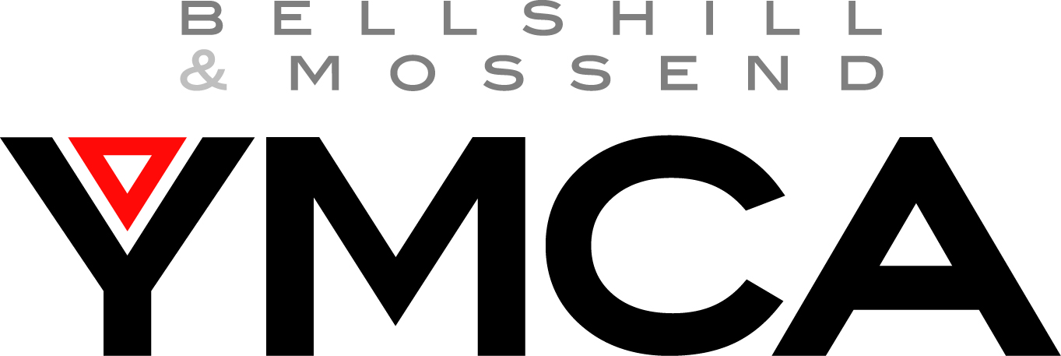

APPLICATION FORM

The YMCA is an Equal Opportunities Employer. To help us monitor our policy, there is a questionnaire included with this form. IT IS NOT COMPULSORY THAT YOU COMPLETE THIS SECTION. It will be removed from the application form before interview, as it is for recording purposes only.

Position applying for:

Personal Details

Name
Address
Postcode

Home telephone number

Mobile telephone number
E-mail address
D.O.B
Do you hold a full driving license? * | Yes / No
Do you have access to a car? * | Yes / No

* If this job does not require you to drive you are not obliged to complete this section

Current Employment

Job Title
Name and address of current employer
Telephone no.
Can you be contacted at work | Yes / No
Current duties and responsibilities

Date of appointment

Notice Required

Education/Qualifications

Please record all education examinations passed and the relevant grades (including secondary school, further & higher education or any relevant training courses undertaken)

Date | Education body/ training provider | Subject & Grade

Employment Record
Please give details of all posts you have held since leaving full time education with most recent
first. Continue on a separate sheet if necessary

Dates | Name of employer | Nature of post held | Reason for leaving

Please give details of any skills and/or experience gained outside any period of paid employment:

If you have had any previous contact with the YMCA, please give details

Health

If you are a Registered Disabled Person, please state RDP number, validity date and details of disability:

If you are not registered as a disabled person but have disabilities please give details:

Have you had any serious illness/operations? Yes / No (if yes please give details):

When did you last have a routine check?

Supporting Statement
Please give any other relevant information in support of your application.
Include hobbies, interests, experiences etc

Continue on a separate sheet if necessary

References

We will ask 2 individuals to complete a reference form on your behalf. Please give the names and address of two people (not relatives), one of whom should be your present, or most recent employer.

Please seek permission before using a person as a referee.

 | REFERENCE 1 | REFERENCE 2
Full name
Job Title
Address
Tellephone number
How you know this person

We will also need to gain a health evaluation from your GP, if you can provide their details here:

Name
Address
Postcode

Contact telephone number

Agreement and Signature

I confirm that the information I have given on this form is correct and complete. False or misleading statements may be sufficient ground for cancelling any agreements made

Signed Date

Please return this form to: Bellshill & Mossend YMCA
294 Main Street
Bellshill
ML4 1AB
admin@ymcabellshill.co.uk

