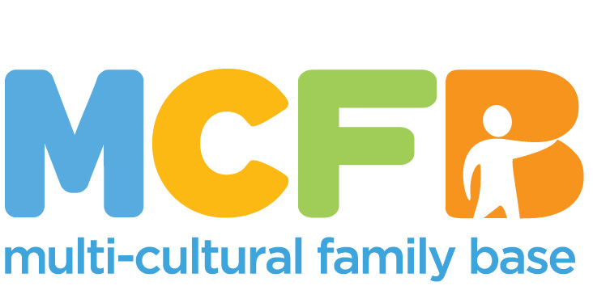

What happens after you have applied for this post?

Shortlisting

Once the closing date is reached, all applications will be considered for shortlisting. The information which you provide in your application form will be assessed against the relevant items in the Person Specification for the post.
Candidates with the highest scores will be invited for interview.

Please note, due to the high cost of postage we are unable to acknowledge unsuccessful applications. If you do not hear from us by Friday 21st December , please assume you have not been shortlisted.

Interviews

Candidates who are selected for interview will be contacted by telephone and invited to attend for interview at Multi-Cultural Family Base.

Offer

After interviews have taken place the successful candidate will first be offered the post verbally and that will then be confirmed in writing. This initial offer will be subject to clearances including PVG and references. The other candidates will be informed of the outcome of their interview.

