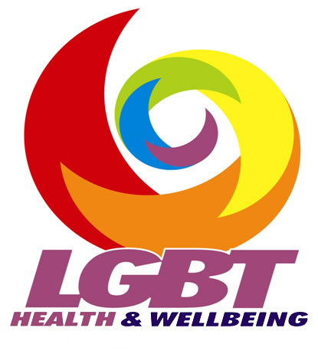
December 2018

Application Pack

Development Worker (LGBT Community Programme) – maternity cover

Salary: £24,536
Hours: Full time (36 hours per week)

Thank you for your interest in the above position.

LGBT Health and Wellbeing is a dynamic community development organisation set up in 2003 to promote the health, wellbeing and equality of lesbian, gay, bisexual and transgender (LGBT) people.

We are seeking to recruit a Development Worker (LGBT Community Programme) – maternity cover to play a key role in our organisation. Join us to help us deliver our ambitious vision for LGBT health, wellbeing and equality in Scotland.

This application pack contains the following:
- Job description and person specification
- Application form
- Information on general terms and conditions of employment
- Diversity Monitoring Form (to be returned separately)
- Organisational chart

The closing date for applications is 5pm on Monday 21st January 2019.

Interviews will take place on Wednesday 30th January in our Edinburgh office. We therefore require you to be available for interview on the respective day; please indicate your availability on the application form.

We aim to contact short-listed applicants by 6pm on Wednesday 23rd January, therefore please ensure that your application includes a telephone number or email where you can be easily contacted.

Applications will be accepted by email to louise@lgbthealth.org.uk; as long as the emailed application reaches us by the dead line, your application will be considered. However please post your equal opportunity monitoring form, separately.

Due to financial constraints, applicants who are not short-listed for interview will not be contacted.

Kind regards
Annette Rae

Service Manager


