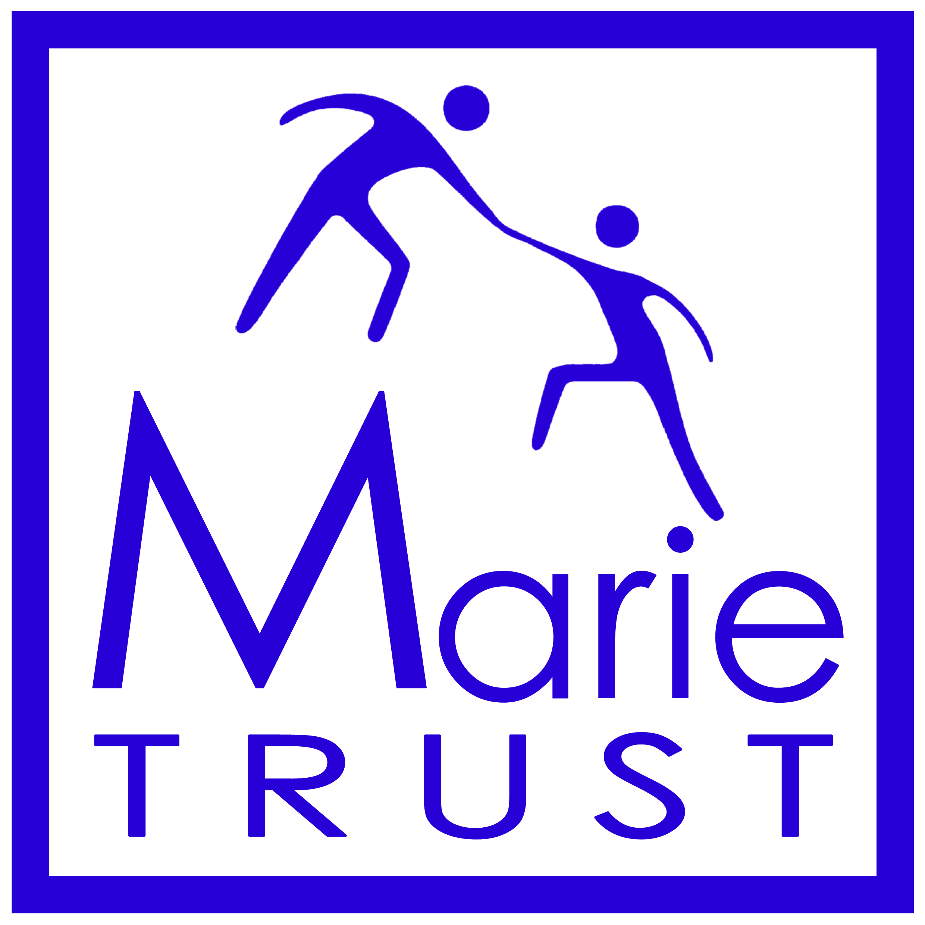

Please tick to indicate level in the relevant boxes.

If you feel you wish to note any other skills you would bring to the Board please add to the list in the spaces below:

|  |  |  |  |
| --- | --- | --- | --- |
| **Skills** | **Experience & Understanding of** | **Understanding of but no experience** | **No experience or understanding of** |
| Chairing committees |  |  |  |
| Board / committee participation |  |  |  |
| Ensuring good corporate governance |  |  |  |
| Regulatory environment of charity sector (OSCR) |  |  |  |
| Ensuring compliance with values & charitable purpose |  |  |  |
| Setting strategic direction |  |  |  |
| Business Development |  |  |  |
| Fundraising |  |  |  |
| Marketing & Communications |  |  |  |
| Financial control |  |  |  |
| Auditing |  |  |  |
| Performance management and monitoring |  |  |  |
| Risk management |  |  |  |
| Overseeing policy review framework |  |  |  |

|  |  |  |  |
| --- | --- | --- | --- |
| **Skill** | **Experience & Understanding of** | **Understanding of but no experience** | **No experience or understanding of** |
| Customer care |  |  |  |
| Diversity and inclusion |  |  |  |
| Asset management |  |  |  |
| Legal knowledge / experience |  |  |  |
|  | | | |
| **Please use rows below to note any other skills you feel you could bring to the Board:** | | | |
|  |  |  |  |
|  |  |  |  |
|  |  |  |  |
|  |  |  |  |
|  |  |  |  |
|  |  |  |  |