**Self Directed Support Forth Valley** 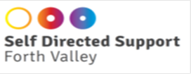

January 2019

Dear Applicant

Role: Self Directed Support Community Engagement Officer

Thank you for your interest in the above post.

The closing date for applications is 1pm on 18th February 2019.

Interviews will be held in Grangemouth week commencing 4th March 2019.

Please note that CVs will not be considered as part of the application process. Completed application forms should be returned to Self-Directed Support Forth Valley, Dundas Resource Centre, Oxgang Road, Grangemouth, FK3 9EF or emailed to myself at the address below [violet4thvdpss@hotmail.com](mailto:violet4thvdpss@hotmail.com)

Please note when returning your application form by post to check for the right postage as failure to pay sufficient postage fee will result in your application not reaching us.

Thank you once again for your interest in SDS Forth Valley.

Yours sincerely,

Violet M. Keenan

Service Manager