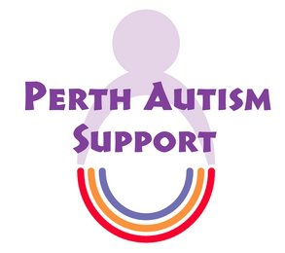 Equal opportunities monitoring form

This form is separated from your application form and will not be provided to the short-listing panel. Your answers will be treated in the strictest confidence. The information you provide will only be used for monitoring purposes and to assist us with improving our recruitment process to ensure we are reaching all sections of the community. How you complete this form has no connection to the evaluation of your application in any way.

Position Title

Sex: | o Male  o Female

ABOUT YOU Gender Identity:
Is your gender identity the same as the gender you were born with? | o Yes  o No | Do you live and work full time in the gender role opposite to the one you were born with? | o Yes  o No

ABOUT YOU | What is your ethnic group? Please choose one selection from (a) to (e) and then tick the appropriate box to indicate your cultural background.
(a) White | o British  o Irish  o Other. Please specify:
(b) Dual Heritage | o White and Black Caribbean  o White and Black African  o White and Asian  o Other. Please specify:
(c) Asian | o British  o Indian  o Pakistani  o Bangladeshi  o Other. Please specify:
(d) Black | o British  o Caribbean  o African  o Other. Please specify:
(e) Chinese or Other | o Chinese  o Other. Please specify:

ABOUT YOU | Do you consider yourself disabled?
Yes | o | No | o

ABOUT YOU |  | Please select your age group
16 - 19 o | 20 - 29 o |  | 30 – 39 o | 40 - 49 o | 50 - 59 o | 60 and over o

ABOUT YOU | How would you describe your sexual orientation? Please tick one box only.
Heterosexual/straight | o | Gay Man | o
Gay Woman/Lesbian | o | Bisexual | o
Other | o | Prefer not to say | o

ABOUT YOU | What is your faith / religion / belief? Please tick one box only.
Agnostic | o | Jewish | o
Atheist | o | Muslim | o
Buddhist | o | Sikh | o
Christian | o | Other. Please specify
Hindu | o | Prefer not to say | o

How did you find out about this vacancy? (Please give the name of the newspaper/journal/website).

