# APPLICATION PACK

## DIGITAL COMMUNICATIONS OFFICER

Thank you for requesting an application pack for the position of **Digital Communications Officer** at the Royal Society of Edinburgh.

**Application Pack:**

* **A Job Description including key responsibilities, competencies, skills & experience needed to do the job, salary & hours**
* **An Application Form**
* **Information about the Royal Society of Edinburgh**
* **An Equal Opportunities Monitoring Form**
* **A note summarising RSE non-pay benefits**

**Job Application Form**

Please complete the job application form as fully as possible demonstrating how you meet the competencies and skills required for the post and the relevant experience you bring to the role. If you need additional space for any section, continue on a separate A4 sheet. If you have any questions about filling in the form, do not hesitate to contact me.

**Diversity**

Completion of the Equal Opportunities Monitoring Form is optional.

**How to apply**

Your completed application and your Equal Opportunities Monitoring Form should be returned to the RSE HR Office **by Monday 11 March 2019 by 5 pm** **to** [vacancies@theRSE.org.uk](mailto:vacancies@theRSE.org.uk)

**Interviews**

If you are selected and invited for interview, this will take place at the Royal Society of Edinburgh building, 22 George Street, Edinburgh EH2 2PQ, on Friday 22 March 2019 at a time to be confirmed.

**Eligibility**

In accordance with the Immigration, Asylum and Nationality Act 2006 The RSE, as an employer, has a legal responsibility to prevent illegal working and therefore must check that all employees are entitled to work in the United Kingdom. To do so we require to see original documents evidencing right to work in the UK before commencement of employment and this will be carried out at the interview stage. Details will be provided to candidates invited for interview.

**Feedback on your application**

Please note that feedback will only be provided to candidates after interview.

Finally, I would like to thank you for your interest in the Royal Society of Edinburgh.

Yours faithfully,

Ms Christel Baudère

Senior HR Advisor

|  |  |  |
| --- | --- | --- |
| **Job Title** | **DIGITAL COMMUNICATIONS OFFICER** | |
| **Grade**  **Salary**  **Hours** | Grade 2  £25,000 pa  Monday to Friday, (35 hours per week). Contracted hours are 09.00 to 17.00 with 1 hour unpaid for lunch each day. A pilot flexible working system is currently being used so there will be flexibility to work the 35 hours between 0830 and 1930 across the contracted days.  **There will be occasional work required out-with the flexi-periods.** | |
| **Starting Date** | As soon as possible | |
| **Role** | To support the development and lead the delivery of the RSE’s digital communications activities. | |
| **Key Responsibilities** | * Develop and lead the digital strategy for the RSE * Produce engaging, targeted content across all RSE digital platforms * Lead and develop digital marketing campaigns with clear objectives and outcomes * Lead the redevelopment of the RSE website * Co-ordinate the monitoring, evaluation and reporting of all RSE digital channels * Continually seek ways to improve the way RSE digitally communicates | |
| **Key Competencies /Skills** | **ESSENTIAL**   * Creative digital content creation and editing skills * Experience of managing content management systems * Experience in using a range of social media monitoring tools * Excellent written and oral communication skills * Ability to plan, work under pressure and manage multiple projects simultaneously * Experience of working within /or for a similar working environment | **DESIRABLE** |
| **IT Skills** | **Digital Software packages** | **Word** |
| Adobe Creative Cloud - advancedAdobe Premier Pro/Final Cut ProMobile apps editing | * Advanced |
| Outlook | PowerPoint |
| All skills | Advanced |
| CRM | Excel |
| Internal database (currently Integra Software) training will be provided | Advanced |
| **Staff Management**  **Responsibilities** | The post has no staff management responsibilities | |
| **Responsible to** | Head of Communications | |
| **Customer Groups** | **External**: General public, government and other public organisations, other academic organisations, service providers  **Internal**: All RSE Staff & Fellows | |

**Job specification**

**1. Develop and lead the digital strategy for the RSE**

* Engage with colleagues within the Communications Team and across the organisation, primarily with our Awards, Public Engagement, Policy and International Teams to establish digital communication needs
* Plan and prioritise messaging, tools and channels to produce the RSE’s first digital strategy which supports the RSE’s Communication Strategy and business objectives
* Coordinate delivery of strategy with underpinning plan within agreed time and spending levels.

**2. Produce engaging, targeted content across all RSE digital platforms**

* Determine the content required for each RSE digital channel in terms of target audience, user profiles, frequency of updates and establish clear guidelines for content creation and scheduling
* Create posts for RSE digital channels involving text creation, images, graphics and video content
* Ensure content produced is on brand and delivered to a high degree of detail

**3. Lead and develop digital marketing campaigns with clear objectives and outcomes**

* Develop and lead on digital external marketing campaigns including Women in Science in Scotland travelling exhibition, projects celebrating RSE Fellows and their achievements; RSE outreach work in Inverness; public engagement activities around Scotland
* Produce clear digital marketing plans for each project establishing goals, objectives, messaging, implementation and evaluation
* Produce reports at the end of each campaign evaluating success and highlighting lessons learned

**4. Lead the redevelopment of the RSE website**

* Produce a schedule for redevelopment of the RSE website
* Engage with internal and external audiences to determine areas requiring improvement in terms of content, format and access
* Establish a working group to set scope for redevelopment and to guide project to completion
* Work closely with external website designers to communicate website requirements and oversee delivery of website to specification
* Manage the content and appearance of the RSE website, uploading and approving content

**5. Co-ordinate the monitoring, evaluation and reporting of all RSE digital channels**

* Establish and produce accessible monthly and project impact reports for internal and external use to measure effectiveness of RSE output
* Provide regular analysis of RSE digital audience for Impact Team and Senior Management Group
* Monitor digital channels on daily basis and take appropriate action in response to emerging issues or trends.

**6. Continually seek ways to improve the way RSE digitally communicates**

* Using audience analysis and research, propose new digital tools, channels and techniques to constantly be looking to improve how we reach our audiences as effectively as possible.
* Provide training and advice to colleagues on how to get the best out of the digital tools we use
* Work with colleagues to examine their existing output – digital and otherwise – and work collaboratively to suggest ways to improve this to achieve best reach and impact
* Produce guidelines for digital channels which address e-communications such as newsletters and updates to create consistency and ensure quality

**7. Support the Head of Communications on other projects as and when required**

* Assist on other aspects of the Communications Team’s work including contribution to Communications Strategy and business development, research and information
* Contribute thoughts and ideas which complement and enhance the PR, marketing and publications output of the RSE.

**Other reasonable tasks / behaviours as required by the RSE, this includes, but is not limited to the following:**

* Application of the RSE’s key behaviours and skills (see enclosed)
* Adherence to the RSE vision, mission and values (see enclosed)
* Ensuring all administrative processes comply with data protection legislation and are in accordance with RSE record management policy and processes
* Observing all health and safety requirements
* Working within and promoting approaches consistent with the RSE Diversity Policy

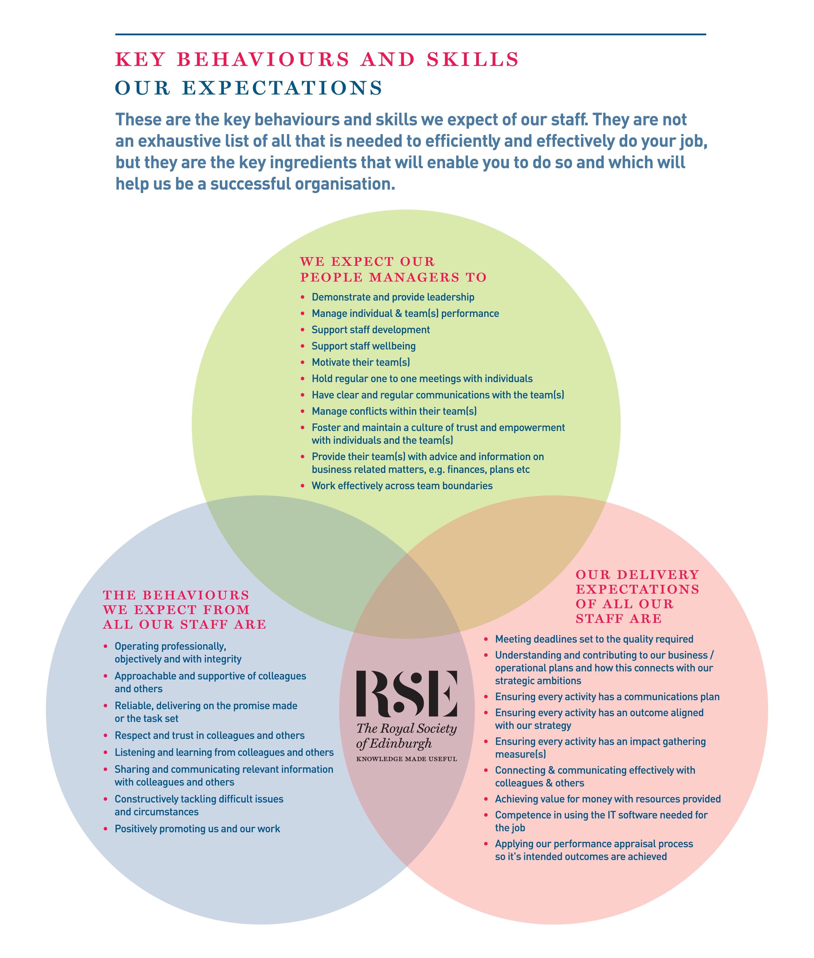

**About the RSE**

The Royal Society of Edinburgh, Scotland’s National Academy, is an educational charity that provides public benefit throughout Scotland through a diverse range of activity including awarding research funding, informing public policy and delivering events across Scotland to inspire knowledge and learning.

The RSE’s mission, set out in its Royal Charter of 1783, is **“the advancement of learning and useful knowledge”.** Its contemporary purpose remains the same – the deployment of knowledge for public good: knowledge that contributes to the social and economic well-being of Scotland and its people and the nation’s wider contribution to the global community.

The RSE draws upon a body of elected fellows who are leaders and experts in their fields. The breadth of expertise and experience within the Fellowship ranges from life sciences, physical sciences and technology, to arts, humanities, social science, business, public service and civil society. The multidisciplinary breadth of the RSE – reaching well beyond the academic world – is a distinctive strength and unique within UK national academies.

Our staff group, is responsible for executing our programmes of activities and ensuring due governance is followed.

**Our Strategic Framework**

Published in 2016, our Strategic Framework 2016-2021 sets out the Royal Society of Edinburgh’s vision and strategic objectives to 2021. It identifies the distinctive impact the RSE aims to make nationally and internationally, and the benefits that a vibrant multidisciplinary national academy can bring to Scotland.

The Framework sets out four strategic objectives to:

* ***Inspire*** and support Scotland’s most promising young talent across the research, business and public sectors, to create value for the economy and society;
* ***Engage*** on key contemporary issues by providing an impartial forum for public debate and discussion;
* ***Provide*** ***expertise*** to ensure that Scotland’s policy makers and influencers have access to the best national, and indeed global expertise;
* ***Promote*** Scotland’s interests and reputation on the global stage.

Alongside these strategic objectives, the Framework identifies four development aims:

* To create an active and more diverse Fellowship;
* To secure increased funding from a diverse range of sources;
* To enhance and widen the RSE’s outreach and impact;
* To redevelop our premises.

In line with the ambitions set out in the Strategic Framework the RSE is embarking on a major programme of change, building on existing strengths, to further enhance the Society’s visibility, reach and impact.

***APPLICATION FORM***

Please provide the information requested below outlining your experience and skills. You should then send your job application form to the RSE HR Office as soon as possible.

**1. Post Applied For: DIGITAL COMMUNICATIONS OFFICER**

**2. Application No:** (for RSE use only)

**3. Your Details:**

|  |  |
| --- | --- |
| **Title** |  |
| **Forename** |  |
| **Surname** |  |
| **Address** |  |
| **Postcode** |  |
| **Telephone Number** |  |
| **Mobile Number** |  |
| **E-mail Address** |  |

**4. Do you need a work permit to take up this post? (please tick)**

Yes  No

**Application Number** (for RSE use only)

**5. Present Post**

**Job Title:**

**Employer’s details:**

**Date of employment (From – To):**

**Reason for leaving (if applicable):**

**Notice period required:**

**Role Purpose / Summary of responsibilities:**

**Application Number** (for RSE use only)

**6. Employment history**

Starting from the most recent first and working down the page. (Please, use a separate sheet if needed).

|  |  |  |  |  |
| --- | --- | --- | --- | --- |
| **Job Title** | **Employer** | **Responsibilities** | **Dates from** | **Dates to** |
|  |  |  |  |  |
|  |  |  |  |  |
|  |  |  |  |  |

**Application Number** (for RSE use only)

**7. Education or relevant courses**

|  |  |  |
| --- | --- | --- |
| **Subject(s)** | **Qualification achieved** | **Date obtained** |
|  |  |  |

**8. Membership of Professional Bodies**

|  |  |  |
| --- | --- | --- |
| **Full name of Organisation** | **Registration Number** | **Date obtained** |
|  |  |  |

**Application Number** (for RSE use only)

**9. Statement of Application**

Please demonstrate how you meet the competencies and skills required for the post and the relevant experience you bring to the role with reference to the key responsibilities set out in the job description. You may also wish to provide other information that may be relevant to your application such as your reasons for applying for this position, major achievements to date, personal qualities, interests or other skills and attributes (Use a separate sheet if needed).

**Application Number** (for RSE use only)

1. **References**: Please give the names of two referees who can provide references on your suitability for the post, and who you are content the RSE approaches if required (do not enclose references with this application).

**Note that references will only be taken up for successful candidates following the interview.**

**I am content that the RSE approaches the referees below**

**(Please tick the box accordingly)**

**REFEREE 1**

|  |  |
| --- | --- |
| **Title** |  |
| **Forename** |  |
| **Surname** |  |
| **Address** |  |
| **Postcode** |  |
| **Telephone Number** |  |
| **Mobile Number** |  |
| **E-mail Address** |  |

**REFEREE 2**

|  |  |
| --- | --- |
| **Title** |  |
| **Forename** |  |
| **Surname** |  |
| **Address** |  |
| **Postcode** |  |
| **Telephone Number** |  |
| **Mobile Number** |  |
| **E-mail Address** |  |

**Application Number (RSE use only):**

**11. Where did you see the advertisement for this post (please tick accordingly)?**

|  |  |
| --- | --- |
| **Good Moves / Third Force News website** |  |
| **RSE Website** |  |
| **Indeed** |  |
| **LinkedIn** |  |
| **Twitter** |  |
| **WOM** |  |
| **Creative Scotland Jobs** |  |
| **Other** |  |

**Data Protection**

The Data Protection legislation regulates the use of personal data (“information”) about an individual and requires the RSE to receive your consent to use the information you give in this form and in any attachments to it, to assess your suitability for the post you have applied for. By signing this application form, you will be consenting to the RSE processing information for this purpose.

If you are unsuccessful, this form will only be kept in the RSE files for 3 months and will only be viewed by staff involved in the recruitment process. If you are successful, this form will be kept for the length of your employment with the RSE.

**Date:**

**Name:**

**Signature:**

**POLICY ON CRIMINAL RECORD DISCLOSURE**

In line with its overall recruitment policy, the RSE seeks criminal record information before making an offer of employment to a successful job applicant. The note below describes the process that will be followed and what happens to any information received. Please read it carefully.

The post for which you have applied requires the applicant who is successful at the interview stage to complete a personal disclosure of any unspent convictions, details of any cautions, reprimands and final warnings administered, and details of any charged offences. There will, also, be open and measured discussion about disclosure information at the interview stage. If an applicant fails to disclose relevant information at interview, it may lead to the withdrawal of an offer of employment, orfollowing appointment, disciplinary action being taken, which may include the termination of employment.

If an interview, or subsequent personal disclosure, provide information about a conviction, cautions, reprimands, final warnings administered and charged offences, RSE will assess the relevance of the information by considering:

* The seriousness of the offence and whether it is relevant to the protection and safety of RSE staff, others and RSE property.
* The length of time since the offence took place
* Whether there is a pattern of offending behaviour
* Whether an individual’s circumstances have changed since the offending took place, making re-offending less likely.
* Relevant information offered by an individual about the circumstances which led to the offence being committed
* The country in which the offence was committed; some activities are offences in Scotland and not in England and Wales, and vice versa.
* If the offence has since been decriminalised by Parliament.
* The degree of remorse, or otherwise, expressed by an individual and their motivation to change.

Personal disclosure information provided will only be used for recruitment purposes and will only be shared with those authorised to see it during their duties. No image or photocopy of the information will be made. The Personnel Office will keep all information disclosed in a secure and confidential file for 6 months after the start of employment.

**RSE EQUAL OPPORTUNITIES MONITORING FORM**

As an equal opportunity employer, the RSE welcomes applications from all suitably qualified people and aims to employ a diverse workforce. To help us meet that aim we would be grateful if you could complete this form and return it to us. The form is completed on an anonymous basis, will not be used in the short-listing process for the post, and cannot be reconciled with your application.

The information you provide may, however, be stored on a computer system for the purposes of personnel administration and statistical analysis. It will be treated as strictly confidential and only be used for Equal Opportunities purposes.

|  |  |
| --- | --- |
| **Post Applied for** | **DIGITAL COMMUNICATIONS OFFICER** |

|  |  |
| --- | --- |
| **Where did you see this vacancy advertised?** |  |

|  |  |
| --- | --- |
| **What is your age? (Please tick the appropriate box)** | |
| **17-25** |  |
| **26-44** |  |
| **45-64** |  |
| **65+** |  |
| **Prefer not to say** |  |

|  |  |
| --- | --- |
| **What is your gender? (Please tick the appropriate box)** | |
| **Female** |  |
| **Male** |  |

|  |  |  |  |  |  |  |  |  |
| --- | --- | --- | --- | --- | --- | --- | --- | --- |
| **Ethnic / Racial Origin**  Please indicate how you would describe your ethnic / racial origin from the selection below. (Ethnic origin is not about nationality, place of birth or citizenship, but about colour and broad ethnic group). | | | | | | | | |
| **White** | **Black African** | **Black Caribbean** | **Black Other** | **Indian** | **Pakistani** | **Bangladeshi** | **Chinese** | **Other** |
|  |  |  |  |  |  |  |  |  |

|  |  |
| --- | --- |
| 1. **The Equality Act 2010 defines disability as a “*physical or mental impairment which has a substantial and adverse effect on a person’s ability to carry out normal day to day activities*”**   **Do you consider yourself to have a disability?** | |
| **Yes** |  |
| **No** |  |

Thank you for your co-operation in completing the form



**In addition to the basic salary paid, the RSE offers staff a generous package of rewards. The package includes:**

|  |  |
| --- | --- |
| **Salary** | * Subject to what we can afford, you may receive an annual pay award to maintain the real terms value of your pay. There is also discretionary scope for additional consolidated or non-consolidated pay awards |
| **Contributory Pension Scheme** | * You can join the RSE AVIVA Group Pension Plan. You contribute 3%. On your behalf, we pay a further contribution of 6% of your annual salary. Further information about the scheme is available here <http://www.aviva.co.uk> * There is scope for you to pay a higher employee contribution. If you decide to do so, the RSE will pay double the employee contribution rate up to a maximum employer contribution limit of 12%. * AVIVA may accept transfers from other schemes so please check with them prior to applying for a transfer. |
| **Annual leave** | **All employees employed after 1 August 2018** receive the following annual allowances (pro-rata for part time staff):   * 25 days up until completion of 3 years employment * 27 days following completion of 3 years employment **(+ 2 days)** * 30 days following completion of 5 years employment **(+ 3 days)** |
| **Public Holidays** | * You get 9 days public holiday (pro-rata for part time staff). This is built into your total holiday allowance (annual leave + public holidays) each year |
| **Sick Absence** | * You receive sick absence pay once you have satisfactorily completed your probation period. The period of paid absence increases progressively according to your length of service and reaches, after 4 years of service, full pay for 26 weeks absence and half pay for a further 26 weeks absence |
| **Family Leave** | * We recognise and fully comply with your legal rights in relation to paid (Adoption, Maternity & Paternity leave, Shared Parental Leave) and unpaid time off, and flexible working. Where your contracted salary is greater than the statutory minimum for paid time off, during, or for part of the absence, you will be paid your contracted salary. In addition to these legal rights, you can also, depending on the circumstances, receive paid “Family Responsibility Leave” to cover unforeseen family circumstances. |
| **Performance Management** | * We care about your performance and development and assess, manage and support it through our performance review system. |
| **Flexibility with medical appointments** | * We are flexible in how we deal with dental and medical appointments. We expect these to be arranged out-with your normal hours of work, but we recognise that for many reasons this might not always be possible. Where that is the case we exercise discretion and provide reasonable time off during your normal working hours to attend your appointment. |
| **Healthy Working Lives** | * We are part of the Healthy Working Lives Award Programme. We obtained our Bronze Award in 2005 and have obtained our Silver Award in July 2011 and since then maintained both Awards. A group of staff volunteers organise events focussing on health promotion, occupational health and safety, health and the environment, raising awareness about mental health and well-being and we are working towards the Gold Award. * Types of Events: RSE Wellness Day - Health Checks for staff (diabetes, cholesterol, BMI, Blood Pressure), Big & Healthy breakfast, Running Club at lunchtime (Jog Scotland), Pedometer Competitions, Walking group, Lunchtime Yoga classes, social cycle rides at the weekend, training on First Aid for baby and child for all new parents, event of information on Nutrition, Cancer, Salt Intake, Legal Highs, etc. |
| **Support with VDU** | * As part of the Health and Safety at Work legislation, employers are required to designate which staff members are classed as regular users of computers. We have designated that all staff fall into this category. * Employers also have an obligation to provide eye tests, or a facility, which will allow staff to have their eyes tested so that their ability to see the screen properly can be assessed. We are committed to complying with this obligation by paying for eye tests related to computer usage only. * Additionally, if a member of staff requires glasses **for computer use only**, we will contribute to the cost for an amount of up £45 * We organise online DSE checks for all staff and monitor these as part of our wellbeing programme |
| **Occupational Health** | * To help support the health & well-being of staff in the workplace, we are registered with the Lothian Health Occupational Health & Safety (LHOHS), which is an arm of NHS Lothian’s Primary and Community Care Division * LHOHS provides a range of occupational health services if they are needed. These services include guidance and advice on legal; requirements, support and advice on health-related issues, promotion of health in the workplace, and counselling. * The service is available to all staff, individually and collectively. Anyone wishing to draw on it should speak to the HR Office, which has the contact details and can advise on appropriate courses of action (Physiotherapy, Counselling, helping with Mental Health issues, etc…) |
| **Learning & Development** | * We support your learning and development and have a budget dedicated to these activities as well as an annual Learning & Development programme. You can also apply for up to a 50% contribution towards the costs of maintaining or achieving a professional membership or qualification. |
| **Travel Loans** | * You can apply for an interest free loan to cover the cost of a public transport season ticket. |
| **Overtime** | * You will get time off in lieu (TOIL) to compensate for overtime worked out-with normal hours at our request, which is not already compensated through your annual leave entitlement. |
| **Give as you earn** | * We are committed to supporting you should you wish to donate to charities directly from your monthly salary. The Direct Donation allows you to personally nominate your own favourite charity or charities to benefit from regular donations straight from your pay. Giving through your pay is tax free and flexible. You can make donations to any charitable or voluntary organisation in the UK. This can include places of worship, schools, scout groups and many other organisations. We pay the administration fee to the scheme and all your donation will therefore go to your nominated charity. |
| **Staff Away Day** | * We arrange and pay for a staff away day each year. The purpose of this is to give you an enjoyable, informal day away from your normal work-place, where you can get to know your colleagues better. |