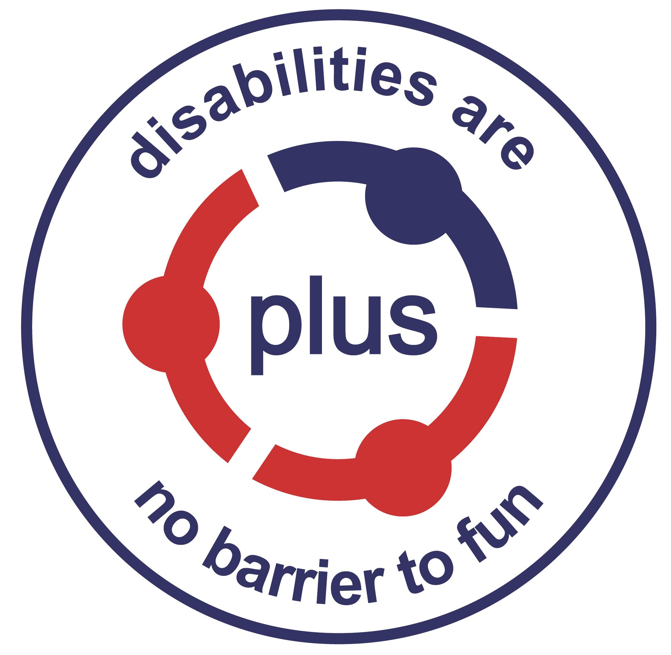
Notes for Applicants for the post of
Family Support Coordinator

Thank you for your interest in this post.

The Organisation
PLUS has worked with children and young people with disabilities and their families for thirty years and continues to grow and develop. PLUS provides individualised support and opportunities for service users to get out and have fun with people of their own age. This also gives parents and carers some time for themselves. It is a registered Charity, Company Limited by Guarantee and is registered with the Care Inspectorate. Further information about PLUS is available on our website - www.plusforthvalley.org.uk or by visiting our Facebook page at PLUS88.

The Vacancy
This post, funded by the Big Lottery and Agnes Hunter, offers a unique opportunity to maintain and develop a partnership approach to supporting families of children and young people with disabilities. This exciting role would suit a dynamic and self-motivated individual who has the drive to utilise their experience and creativity to build relationships and support the continued development of services within PLUS.

This role would suit a creative, flexible and self-motivated individual who has the drive to develop this project.

The Post
A job description and a person specification are attached.

Applications
The closing date for applications is Monday 25th February 2019 at 12 noon. Interviews will be held on Thursday 28th^{th} February 2019. Applications must be submitted on the form provided and any additional sheets as necessary. Please do not send a CV. Applications sent by email will be acknowledged. If you apply by post and wish your application form acknowledged, please send a stamped addressed envelope.

For further information, please contact Lillian Campbell, on 01786 450086, or by email lillian@plusforthvalley.org.uk

