JOB DESCRIPTION

- JOB IDENTIFICATION

Job Title: | Activities Facilitator | Job Family: | Care
Location: | Rachel/Robin House | Responsible to: | Activities Co-ordinator
Salary: | CHAS Band 5

- JOB PURPOSE

Working within the culture, ethos and philosophy of CHAS, to assess, plan, deliver and evaluate programmes of play, activity experiences and emotional support for children or young people with life-limiting conditions and their families, giving due consideration to their individual needs, abilities, preferences and wishes.

- ORGANISATIONAL POSITION

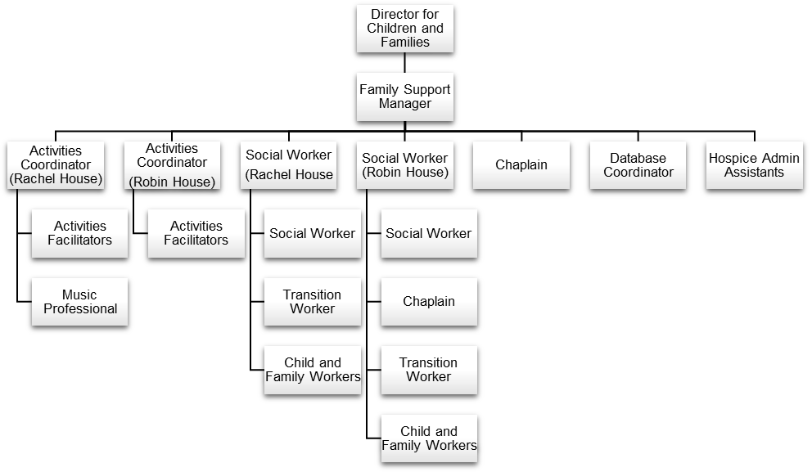

- MAIN TASKS

- Child and Young Person Support
- Family Support
- Administrative and Clerical
- Learning and Development

- JOB ACTIVITIES

Child and Young Person Support

- Regularly assesses the needs of children and young people who use the services.
- Plan, implement and evaluate a range of activities and outings and ensure that these are tailored to individual requirements.
- Works alongside the nursing team to ensure that activities are incorporated into the daily care of the children and young people during their stay.

Family Support

- In conjunction with appropriate members of the multi-disciplinary nursing team, leads the assessment, planning, implementation and evaluation of the support offered to bereaved siblings, ensuring that it is appropriate and meets the needs of the individual.
- Acts as a resource for family who may need guidance on specialised programmes of play, activities and emotional support for their children.
- As part of the family support team, provide planned therapeutic support to families.

Administrative and Clerical

- In line with appropriate legislation and organisational standards ensure hospice records and data are accurate and are stored in accordance with requirements.
- Assumes responsibility for the delegation of volunteers during any activity or outing, ensuring that individual skills are utilised appropriately and that excellent standards of care are maintained.
- Actively participates in the development, implementation and maintenance of CHAS policies, procedures, standards and protocols, for own area, ensuring best practice in the delivery of care.

Learning and Development

- Provides induction, orientation and training, on all aspects of play, for any new support staff, volunteers and students, ensuring that they are aware of the developmental, social and emotional needs of the children or young people, enabling them to maintain the required level of care, as set by the organisation.
- As required, participates in research and audit projects at a local level in support of best practice.
- Maintains Personal Development Plan (PDP), in accordance with the organisation’s recommendations, identifying own training and development needs and ensuring the maximum contribution to the organisational goals
- Supports the multi-disciplinary nursing team, enabling them to develop their skills in relation to play activities, experiences and outings, ensuring that high levels of professional practice and care standards are maintained.
- Provide training and guidance in bereavement/emotional support both within CHAS and external agencies.

- DIMENSIONS

- Frequently responsible for handling petty cash and collecting monetary donations.
- In performing this role, frequently has contact with children or young people with life-limiting conditions, their families, the multidisciplinary nursing team, the wider CHAS team, volunteers, students, other healthcare professionals and external contacts.

- KNOWLEDGE, SKILLS AND EXPERIENCE

- Professional qualification in the care of children or young people.
- Relevant expertise in therapeutic play.
- Relevant post-qualification experience of working with children or young people with complex care needs.
- Motivation to undertake continuous professional development to meet and maintain professional standards of care and support.
- Relevant experience of working autonomously and as part of a multi-disciplinary nursing team.
- Demonstrable commitment to working with the whole family and to delivering high levels of care and support.
- Requires excellent communication skills, having to convey complex and sensitive information, often in difficult circumstances.

- DECISIONS AND COMMUNICATIONS

- Within the agreed management structure of CHAS, is allocated work by senior staff but generally works with a degree of autonomy within the clearly defined policies, protocols, procedures and codes of conduct of the organisation.
- In consultation with the child, young person and their families, assesses, monitors and changes programmes of play plans.
- On a daily basis, communicates complex and sensitive information to the child, young person, their families, the multi-disciplinary nursing team and other healthcare professionals.

- SPECIAL CONDITIONS

Equipment

- On a daily basis is required to use a range of equipment involved in the delivery of care along with a range of play and activities equipment
- On a daily basis, is required to use the following IT systems and packages; Microsoft Office and XP; Children’s Database System; CHAS IT systems including iCON (CHAS Intranet) and the internet; external hard-drives.

Working Conditions

- Occasionally comes into direct contact with body fluids and soiled linen.
- Occasional exposure to verbal abuse or aggressive and threatening behaviour.

Physical Effort

- Frequent moving and handling of the child or young person, with life-limiting condition, utilising appropriate training and equipment in the process.
- Requirement to drive to the child or young person’s home address or when taking the child or young person on an outing.

Mental Effort

- Frequent requirement to drive CHAS vehicles when going to the child or young person’s home address or when taking the child or young person on an outing.
- Frequent requirement for periods of concentration when preparing and adapting the plans and activities for the child or young person.
- Frequent planning and preparing group work and presentations.

Emotional Effort

- Frequent exposure to distressing or emotional situations when dealing with the care of a child or young person who has a life-limiting condition.
- Occasional exposure to distressing or emotional situations such as imparting unwelcome news to the family of the child or young person.
- Frequent exposure to distressing and emotional situations when providing pre and post bereavement support.

PERSON SPECIFICATION

Activities Facilitator

Rachel and Robin House

Attributes | Essential | Desirable | Method of Assessment
Education, Qualifications and Training | - Professional qualification in the care of children and young people.  - Relevant expertise in a therapeutic play scheme. | - HPS qualification
Skills, Abilities and Knowledge | - Motivation to undertake continuous professional development to meet and maintain professional standards of care and support.  - Commitment to working with the whole family and to delivering high levels of care and support.  - Requires excellent communication skills, having to convey complex, sensitive and contentious information, often in difficult circumstances.  - Basic level of IT competence. | - Current driving licence and willingness to undertake MIDAS training.

Experience | - Relevant post-qualification experience of working with children or young people with complex care needs.  - An understanding of the provision of palliative care to children with life limiting conditions.  - Experience of using therapeutic play with children and young people.  - Relevant experience of working autonomously and as part of a multi-disciplinary nursing team. | - Experience of working with bereaved children.
Personal Qualities | - Friendly, outgoing manner  - Positive and confident  - Personal drive, initiative and effectiveness  - Accountable for self, actions and decisions  - Commitment to ongoing learning and development  - A commitment to CHAS core value vision and purpose  - A commitment to working with/supporting volunteers | - Child and family focused | - Interview
Other Requirements | - Willingness to travel between CHAS sites | - Access to a car and full driving licence

