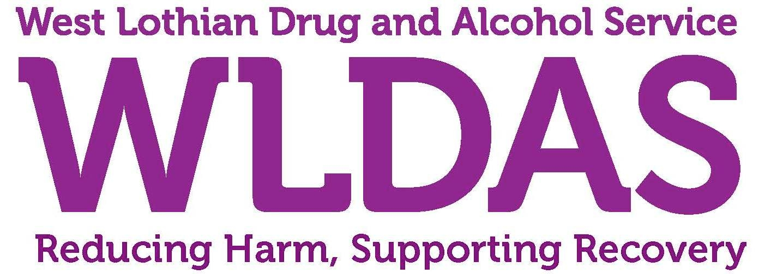

A Charity Registered in Scotland, No: SC005776
Company No: 212157

Job Description

Job Title: | Therapeutic Support Service Adult Worker
Purpose of Job: | Provide psychological interventions for adults and their families, in a range of settings across West Lothian to support recovery and reduce the harms linked to alcohol and substance use.
Responsible To: | Senior Worker Therapeutic Support Service
Responsible For: | None

Job Scope:

This post centres on providing psychological interventions support for adults and their families, in a range of settings across West Lothian to support recovery and reduce the harms linked to substance misuse.

The role will mainly involve providing 1:1 support providing a range of evidenced based psychological interventions and counselling as required. This role will also involve co-working with staff from the West Lothian Addiction Care Partnership to develop, deliver and evaluate a suite of psychologically focussed group work interventions.

The post holder will also be expected to maintain supporting systems for the service, including confidential record keeping as required, recording and producing statistical information, and evaluating the approach within an outcomes based framework.

The post holder will believe in a strengths based approach to recovery, value partnerships and proactively engage with staff from stakeholder organisations to promote the service ensuring it maximises its reach.

Main Job Activities:

- To assess and work with people with alcohol and drug problems and their families to develop and implement a strength based recovery plan;

- To provide 1:1 support and a range of manualised and non-manualised psychological interventions;

- To deliver evidenced based psychological interventions group programmes;

- To provide a range of harm reduction and additional activities such as Naloxone, BBV testing, needle exchanges and sexual health information and contraception;

- To participate in a regular duty worker slot;

- To assist and encourage people you work with to engage with other external agencies and mutual aid programmes, building their social supports and skills;

- To build relationships with statutory and non-statutory organisations, promoting the service to ensure appropriate referrals;

- To keep accurate records and adhere to confidentiality guidelines;

- To play an active part in the evaluation of the service through identification of service outcomes and developing and implementing recording and evaluation tools;

- To maintain a sound working knowledge of new developments in substance misuse counselling and in the broad fields of community development and health improvement;

- To keep a working knowledge of developments in services across West Lothian;

- To operate within child protection and vulnerable adult guidelines;

- Attend regular supervision sessions with both their line manager and our external supervisor in line with COSCA guidelines.

Responsibilities of all West Lothian Drug & Alcohol Service Staff

- Manage and prioritise workload and ensure that deadlines are met.
- Work flexibly and cooperatively with members of West Lothian Drug & Alcohol Service towards aims and objectives agreed by the organisation.
- Maintain positive and constructive working relationships with all colleagues
- Undertake relevant professional development activities and training as agreed with line manager.
- Undertake other duties relevant to the post and on occasion other wider duties pertinent to WLDAS strategic objectives.
- Maintain confidentiality, as appropriate, with sensitive or privileged information, including day-to-day observance of Data Protection guidelines.
- Adhere to all internal and external WLDAS policies, procedures, systems and guidelines, and contribute constructively, as required, to their ongoing development.
- If necessary, from time to time, work outside normal working hours for which time off in lieu (TOIL) will be given.
- Secure premises, as necessary.
- Have regard for your own personal health and safety and that of those around you.

