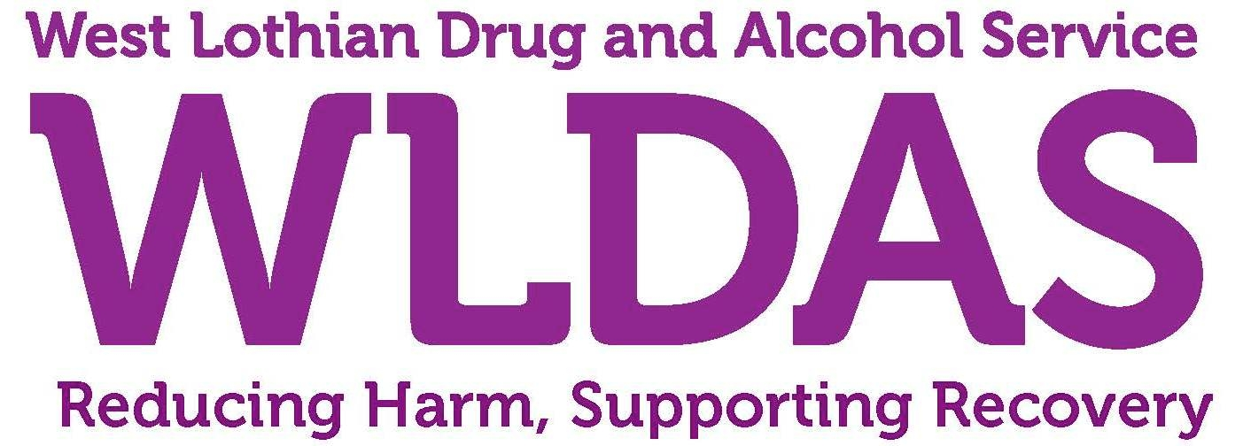

WEST LOTHIAN DRUG & ALCOHOL SERVICE

PERSON SPECIFICATION FOR

THERAPEUTIC SUPPORT SERVICE, ADULT WORKER

This specification sets out the required essential and desirable qualities expected for the successful post holder.

ESSENTIAL | DESIRABLE
Relevant qualification or experience related to working with alcohol or drug issues | Diploma in Counselling or CBT
Relevant experience, training or qualification in psychological interventions with a minimum of a Certificate in Counselling | Understanding of substance misuse and its consequences for individuals, family and community life.
A good knowledge of substance use and its effects | Experience of delivering presentations
Experience of working on a 1 to 1 and group basis | Experience of being involved in research
Experience of working within a multiagency approach | Driving Licence with access to own vehicle.
Experience of working within child protection and vulnerable adult guidelines | Experience of working in a multidisciplinary team
Ability to manage confidential record keeping

Understanding of mental health issues and inequalities

Have excellent oral, written communication and IT skills

Ability to work flexibly to meet the needs of service users
Ability to work on own initiative and within a team setting
Ability to work evening and weekends if required

