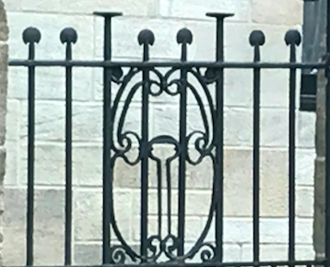
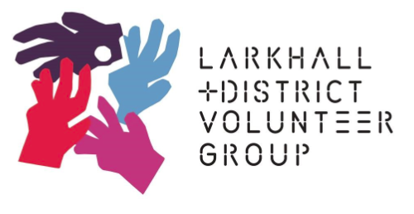

Anne Alston, Chairperson
LDVG
Registry House
55 Victoria St,
Larkhall, ML9 2BL
Tel: 01698 888893
Email: Board@ldvg.org.uk

CONFIDENTIAL
This document includes confidential and proprietary information of and regarding LDVG. This document is provided for informational purposes only. You may not use this document except for informational purposes, and you may not reproduce this document in whole or in part, or divulge any of its contents without the prior written consent of LDVG. By accepting this document, you agree to be bound by these restrictions and limitations.

Business Plan
2019-2022
LDVG

Business Plan

2019 2022
“There is no exercise better for the heart
than reaching down and lifting people up”
- John Holmes

Executive summary
Larkhall and District Volunteer Group (LDVG) provides a range of services and social activities, which have a significantly positive impact on the health and wellbeing of members of the community. Our focus is on isolated, vulnerable people and/or those with a disability assisting them to live independently and stay connected to their community.

This Business Plan sets out our aims for the next three years as we continue to develop and refine our services in response to need.
Following a period of consistent funding we now see both a reduction in available grants and increased competition for them, and we agreed the need for a step change in our practices in order to reduce grant dependency.
This plan articulates need and provides a framework for planning for organisational development. It also proposes actions to reduce our dependence on grants while recognising risks and mitigating factors.
Significant changes, both locally and nationally, present challenges and opportunities. These include:
- an aging population and increasing poverty in the Larkhall area
- reduced funding for Local Authority services
- increased pressures on Health and Social Care services
In effect, there is an increased need and demand for our services in a time of economic strain and uncertainty.
We recognise the need for strong financial planning and scrutiny and are prepared to respond appropriately to future income. We understand the financial risks going forward and have planned for three scenarios:
- Best case – we secure all expected grant income and continue to develop and increase our services and membership.
- Worst case - where we secure 0% expected grant income. We would begin planning a managed closure by December 2019
- Mid case - where we secure ~ 50% expected grant income. We maintain services but reduce opening hours and staff hours. The core of the organisation could survive and remain in a position to rebuild.
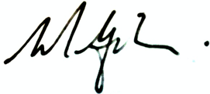
LDVG is committed to meeting this challenge. We will maintain our strong links with the local community and a continued awareness of social issues and recognise an operational need for lean, efficient internal processes that can adapt and change as required. This Business Plan describes an ambitious programme for development with greater emphasis on fundraising and revenue generation to ensure our long-term viability.

