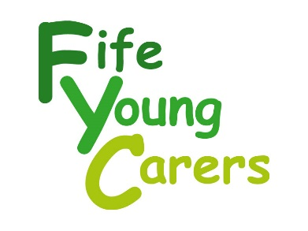

**Notes for Applicants**

Thank you for your interest in this post. You will find an application form, along with the job description and person specification on the Good moves website, they are also available by contacting us on 01592 786717 or by email to Kirstie@fifeyoungcarers.co.uk

**The Organisation**

Fife Young Carers was established in 1995 to provide respite, support and advocacy to children and young people aged 8-18, who care for a family member who has an illness, disability or substance misuse issue. In the last 5 years we have extended our services from primarily respite and 1 to 1 support to include support in schools and for young adult carers up to the age of 25.

Research shows that approximately 1:10 school pupils have a caring role at home and as such Fife Young Carers work in partnership with a variety of services in Fife including, Fife Social Work Services, Fife Education Directorate and NHS Fife, to improve the identification of and the support to hidden young carers in a variety of settings.

**The Vacancy**

We have a vacancy for an Administrator who will have overall responsibility for providing admin support across all aspects of the organisation’s work. Please see individual job description for more information.

This role would suit a dynamic, flexible and self-motivated individual who has the skills and experience to manage and meet the challenges of a small but busy voluntary sector organisation.

**Applications**

The closing date for applications is **Thursday 23rd May at** **5.00pm.** For further information please contact Kirstie Howell, Manager on 01592 786717, or by email [Kirstie@fifeyoungcarers.co.uk](mailto:roy@fifeyoungcarers.co.uk).