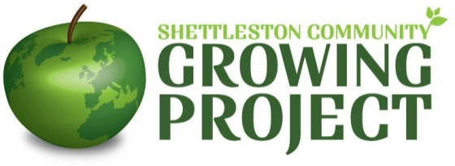

**Freelance Children /Youth Worker**

**Hourly rate** Up to£13.50 per hour

**Hours:** Tues & Thurs 2.45pm-5.45pm (after-school club)

Tues, Wed & Thurs: 1.00 – 4pm (holiday club)

**Location:** Shettleston/Tollcross area of Glasgow

# General Description

Shettleston Community Growing Project is a community-led organisation which manages a community garden and allotment site in the East End of Glasgow. The project runs a children’s club (Smelly Welly Club) whose members get involved in growing food, healthy eating and caring for their environment through activities like practical gardening, cooking, recycling, arts and crafts and games. Children are provided with healthy snacks at after-school sessions and, during the holiday club, with more substantial meals as part of the Glasgow holiday food programme.

The SCGP wishes to recruit a freelance children/youth worker to assist in the delivery of the Smelly Welly club activities. **Please note: the children/youth worker will not be employed by the Shettleston Community Growing Project but will be contracted on a freelance basis to carry out specific services for agreed hours.**

**Children/youth worker profile**

We are looking for competent and experienced youth workers who also have experience of gardening and food growing. A basic food hygiene qualification would be an advantage. ***The work is regulated work as defined by legislation and post holders will be required to be members of the PVG scheme.***

# Main activities:

1. To plan, organise and deliver gardening and environmental education themed activities for children.
2. To be involved in the provision of healthy food for Smelly Welly Club participants at each club session.
3. To work alongside other freelance workers in the delivery of Smelly Welly Club activities.
4. To be involved in the organisation and delivery of Smelly Welly Club events.

**Sessional Children / Youth Worker**

**Person Specification**

|  |  |  |
| --- | --- | --- |
|  | **Essential** | **Desirable** |
| **Qualifications** | No formal qualifications required | Recognised qualification in youth work/community work or equivalent  Food hygiene qualification  First Aid certificate |
| **Experience** | At least 2 years paid employment in a youth work or equivalent role, or substantial experience of voluntary youth work  Experience of devising, planning and delivering outdoor activities | Experience of gardening and food growing  Experience of devising, planning and delivering arts and crafts activities  Experience of environmental education  Experience of working with children with additional needs |
| **Knowledge** | An understanding of the issues facing children in disadvantaged areas | Knowledge of gardening and food growing |
| **Skills and Abilities** | Able to inspire and motivate children and young people  Excellent organisational skills  Able to work on own initiative with minimal direction |  |
| **Personal Qualities** | Self-motivated, enthusiastic and energetic  Trustworthy, reliable and flexible |  |