Job title: Head of Policy & Communications (Scotland)

Department: Policy & External Affairs

Reporting to: Director of Policy & External Affairs

Salary: £47,500 per year

Hours: 35 per week

Location: Based in Crisis’ Scotland office, with the ability to travel across   
Scotland and within the UK for training and meetings

Contract type: Permanent

Aim and influence

* Responsible for Crisis’ communications, external affairs and policy influencing in Scotland,
* Responsible for developing a strategy to substantially increase the scope and scale of Crisis’ profile, campaigning and public facing work in Scotland

Financial and supervisory responsibility

* Line management of Senior Policy Officer (Scotland), Senior Campaigns & Public Affairs Officer (Scotland)
* Line management of interns or volunteers as appropriate

Other key details

* The nature and scope of this post will require you to work closely with the Head of Policy and Campaigns, Head of Marketing and Communications, Head of Research and Evaluation, and the Director of Crisis Skylight Edinburgh
* Up to two days working from home may be considered in line with Crisis’ homeworking policy
* Some evening and weekend work including travel time and overnight stays will be required and time off in lieu will be given in accordance with Crisis TOIL policy

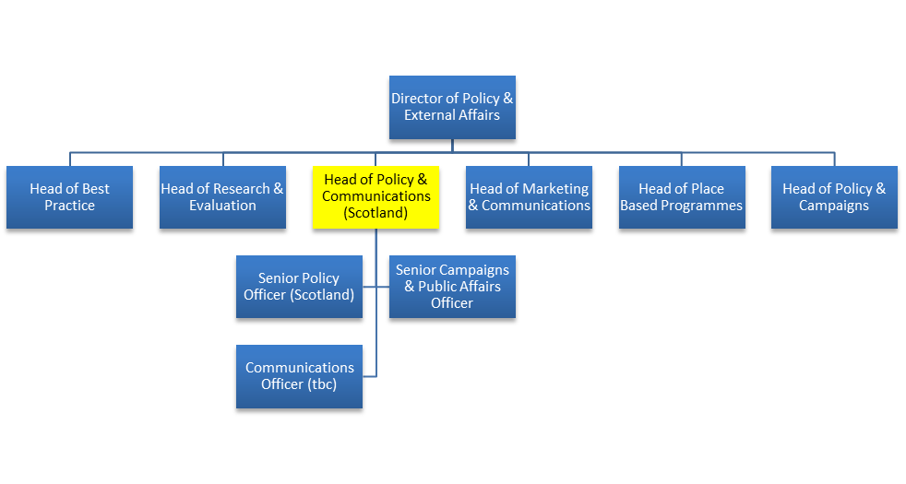Organisational chart

*Please note structure is subject to change*

Job responsibilities

* Lead a team of policy, campaigns and communications specialists to achieve a significant improvement in influence and profile for Crisis in Scotland
* Play a leadership role within Policy and External Affairs and Crisis more broadly, helping to ensure that objectives across Great Britain are achieved
* Secure positive change for homeless people in Scotland through achieving significant policy changes, aligned with Crisis’ Plan to end homelessness
* Grow Crisis' profile in Scotland, working with the Head of Marketing and Communications to develop and deliver a communications and media strategy aligned to the organisational marketing strategy
* Ensure that Crisis’ policy positions are informed by the provision of client services, and vice versa
* Act as a media spokesperson for Crisis in Scotland and build and manage relationships with key journalists in the country
* Position Crisis as a thought leader in Scotland through the delivery of meaningful and impactful policy, research and campaigning activity
* Work with the Head of Research and Evaluation to develop Crisis’ research and evaluation agenda for Scotland and ensure it is delivered effectively and informs all our work in Scotland
* Work with the Head of Policy and Campaigns to identify and develop Scotland specific campaigns to achieve policy change, and contribute to the development of UK wide Crisis campaigns, where relevant
* Work with the Skylight Director (Edinburgh) to develop and maintain a network of strategic relationships both within Crisis and with key external individuals and organisations (including MSPs, MPs, Cabinet Secretaries, Ministers, officials and councillors) enabling Crisis to develop partnerships, gain intelligence and influence effectively
* Work with the Skylight Director (Edinburgh) to embed a policy and practice approach, by involving frontline staff and service users in shaping policy influencing objectives and ensuring external policy developments to inform service development
* Represent Crisis at a range of levels including public platforms, parliamentary events and media opportunities

General responsibilities

* Actively encourage and support member involvement within Crisis
* Develop an understanding of homelessness and Crisis’ aims
* Follow Crisis policies and procedures, including health and safety
* Carry out other reasonable duties that may be required

Person Specification

Essential

1. Proven ability to achieve meaningful social change through policy, campaigns and media work
2. Ability to design and deliver effective communications and marketing strategies, targeted at a range of audiences, to increase public awareness and understanding of Crisis’ work in Scotland and to support influencing and fundraising objectives
3. Excellent knowledge of the Scottish media and contacts with key national journalists
4. Ability to design and deliver a high-profile external affairs strategy based on a strong political understanding and knowledge of the policy making process in Scotland
5. Experience of leading on the development of evidence based, innovative policy and research programmes of work for Scotland
6. Experience of designing and implementing public campaigns that generate tangible outcomes
7. Ability to represent Crisis externally - generating increased public support and growing our profile within Scottish Government
8. Excellent communication (both written and oral), influencing and analytical skills with an ability to use facts and statistics to increase impact and generate a strong public profile
9. Knowledge and experience of social policy and working in a policy environment in homelessness, housing or related social policy area
10. Strong team player with track-record of working cross-organisationally, including with frontline services and communications teams
11. Commitment to Crisis’s purpose and values including equality and social inclusion

*We encourage applications from all sections of the community and particularly from people who have lived experience of homelessness.*

Supporting your application

Thank you for your interest in working for Crisis.

Before you apply, please take a moment to read through the frequently asked questions below which are designed to support your application and help you understand our recruitment processes.

How do I apply for a job?

Most of our roles are advertised via *Crisis Jobs Online,* a secure recruitment portal. Once you have registered, you will be asked to provide some personal details as well as information about your work experience, education and referees who can be contacted if you are offered the role. You will also be required to complete a personal statement, demonstrating how you meet each of the points on the person specification for the job.

The person specification requires a qualification or experience that I do not have. Is it still worth me applying?

The person specification has the key knowledge, skills, experience or behaviours needed to carry out the job successfully and you will be scored based on any information you provide. If you don’t quite meet the criteria, for example if you have an understanding of something rather than experience of doing it yourself, you may still pick up points for explaining your understanding or how you might approach it. However, some of the person specification points, for example specific qualifications, are critical to the role so if you don’t meet those requirements, you are unlikely to be shortlisted.

Can I apply by sending my CV?

Occasionally we accept CVs and a covering letter but only if this requested in the advert for the post. We don’t accept speculative applications or hold CVs on file.

What should I do if I can’t complete an online application?

If you would like to apply in a different format, for example in a Word document, because you are unable to use the online process, please contact the HR Team on 020 7426 3814 / 3819 / 3864 or by email at [human.resources@crisis.org.uk](mailto:human.resources@crisis.org.uk). It is helpful if you provide details of your requirements or suggestions about how we might best support you to apply so that we’re able to consider alternatives.

How can I maximise my chance of being shortlisted?

It is important that you complete all sections of the online application form to ensure that the recruiting panel understand your interests, skills, behaviours, knowledge and experience.

Shortlisting is mostly based on the information you provide in the **personal statement** section. When completing this, please reference **each of the points listed in the job description** in the order in which they appear. There will be 15 boxes, so if there are less than 15 points, you won’t need to use all the boxes.

Support your statements with specific examples that show how you meet each of the person specification points. You may wish to use the STAR approach:

S or T – Situation or task

Describe the situation or the task that you had to complete. It could be something from your previous employment or personal experience – just make sure it’s relevant. Given enough detail for the person shortlisting to understand what was involved

A – Action

Describe the action you personally took to resolve the situation or task. Explain the process/steps you took. Even if you are describing a group project, describe what you did rather than what the team did as a whole

R – Result

This is the crucial part of the answer. Explain how your actions resulted in a successful outcome. Talk about what you achieved, the benefits and what you learned.

A strong application will also be in line with the Crisis Values that you can find on our website.

Please note! If you don’t provide full responses against all the person specification points, the panel won’t be able to score your application fully and it will be unlikely there is enough information for you to be shortlisted.

How quickly will I know if I have been shortlisted?

Every recruitment campaign will be different depending on how quickly the shortlisting panel can review applications but if you have not been shortlisted, you will receive an email from us confirming that.

If I am not shortlisted, can I get feedback on my application?

Unfortunately, we are not able to offer feedback on your application if you are not shortlisted for interview.

Can I get feedback after my interview?

We appreciate that information about where you did well or less well can be useful, so if you are not successful following interview we are able to provide feedback.

Will you notify me of future vacancies?

Once you have registered via Crisis Jobs Online, you can sign up to receive notifications of new vacancies based on the criteria you select. We also recommend that you check our website regularly for details of new vacancies as well as the national and sector media where we advertise most of our roles.

I recently applied for a role and was not successful, but have seen the role re-advertised. Is it worth me applying again?

If the gap between advertising has been short, we would normally advise that candidates need not apply again, unless you have re-written and enhanced your application. Some examples might be that you have strengthened your examples using the STAR technique above or put in responses against all the person specification points where previously you hadn’t.

Crisis Jobs Online

I would like to re-apply for a vacancy, but I cannot submit my application. What should I do?

If a role has been re-advertised, you will need to create a new account with a different email address to re-apply. Where the position has been re-advertised with a different reference number then you shouldn’t have any problems using your existing account.

I have registered to apply for a vacancy but now I’m unable to access my account and can’t seem to reset my password. How can I get access?

You should follow this [link](https://jobsatcrisis.irecruittotal.com/PasswordRecovery.aspx) to reset your password and allow 15 - 20 minutes for a new password to arrive. We find that emails can go to junk or clutter folders so it's worth checking there. As Crisis Jobs Online is managed by an external provider we are unable to access the email addresses registered or provide further information on your password, but following this step should resolve the issue.

If you did not receive a welcome email when you registered, there may have been an error in the email address that you provided. Unfortunately, there is no way to resolve this and you would need to re-register with the correct address.

I have typed my personal statement answers into the online form, but it won’t let me save them. What should I do?

There is a word limit of 400 per answer so it could be that you have exceeded the limit and that is what is preventing you from saving your work.

I filled in the personal statement section and tried to save it/submit it. However, it wouldn't do this and my information was lost. Is there any way to retrieve it?

You are encouraged to record your answers in a Word document first before copying and pasting your answers into the online application form, using the keyboard shortcuts Ctrl + C to copy and Ctrl + V to paste. The application form has a strict time out limit and so if you take longer than that limit you will lose your work and we are unfortunately not able to retrieve it.

Where can I get help?

If your query has not been answered above, you can contact the HR Team on 020 7426 3814 / 3819 / 3864 or by email at [human.resources@crisis.org.uk](mailto:human.resources@crisis.org.uk) for further information or support.