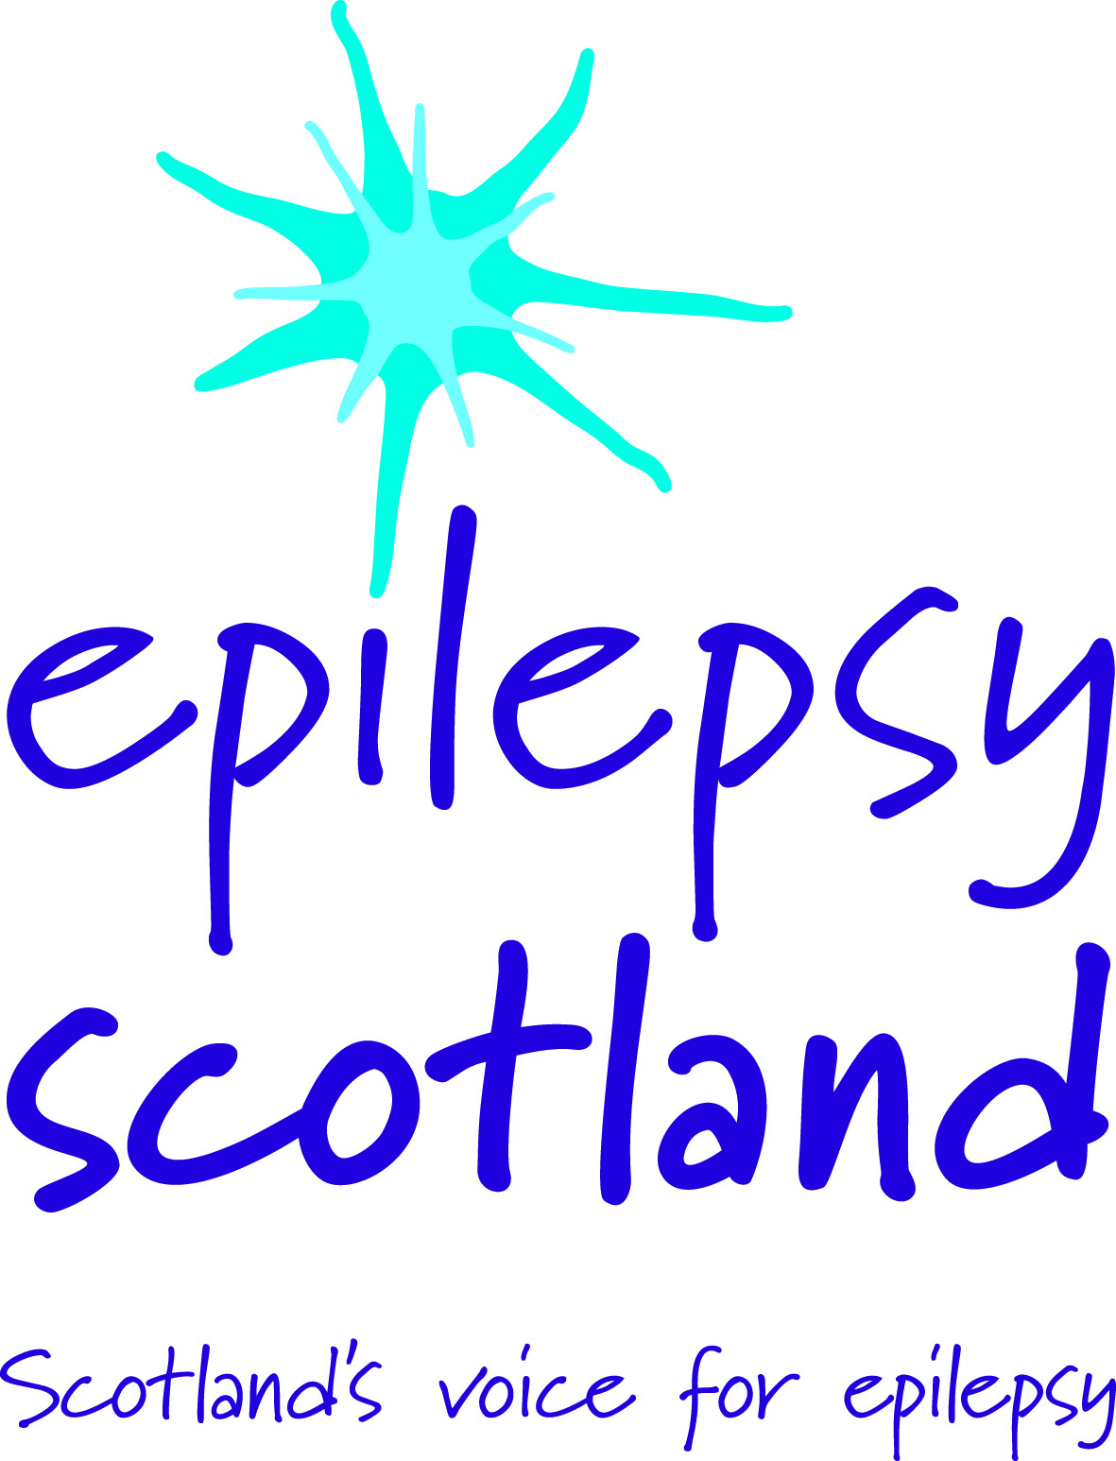

Right to work in the UK

In order to be considered for a role with Epilepsy Scotland you will need to sign this form to confirm that you have the right to work in the UK.

You will be required to provide ONE of the documents listed below if you are short listed for an interview.

- A passport showing that you are a British citizen

- A UK passport showing that you have the right of abode in the UK

- A national passport or national card showing that you are a national of a European Economic Area (EEA) country or Switzerland

- A residence permit issued to you from a European Economic Area EEA) country or Switzerland

- A passport or other document issued by the Home Office which has an endorsement stating that you have a current right of residence in the United Kingdom as the family member of a national from a European Economic Area (EEA) country or Switzerland who is a resident in the United Kingdom.

- A passport or other travel document endorsed to show that you are exempt from immigration control, can stay indefinitely in the United Kingdom or you have no time limit on your stay.

- A passport or other travel document endorsed to show that you can stay in the United Kingdom and that this endorsement allows you to do the type of work we are offering provided it does not require a work permit.

- If you are an asylum seeker please provide an Application Registration Card issued by the Home Office stating that you are permitted to take up employment

I confirm that I have the right to work in the UK and will be able to produce one of the documents listed above.

Name …………………………………………………………………………………………….
(please write your name in block letters)

Signature …………………………………………………. Date …………………………….

