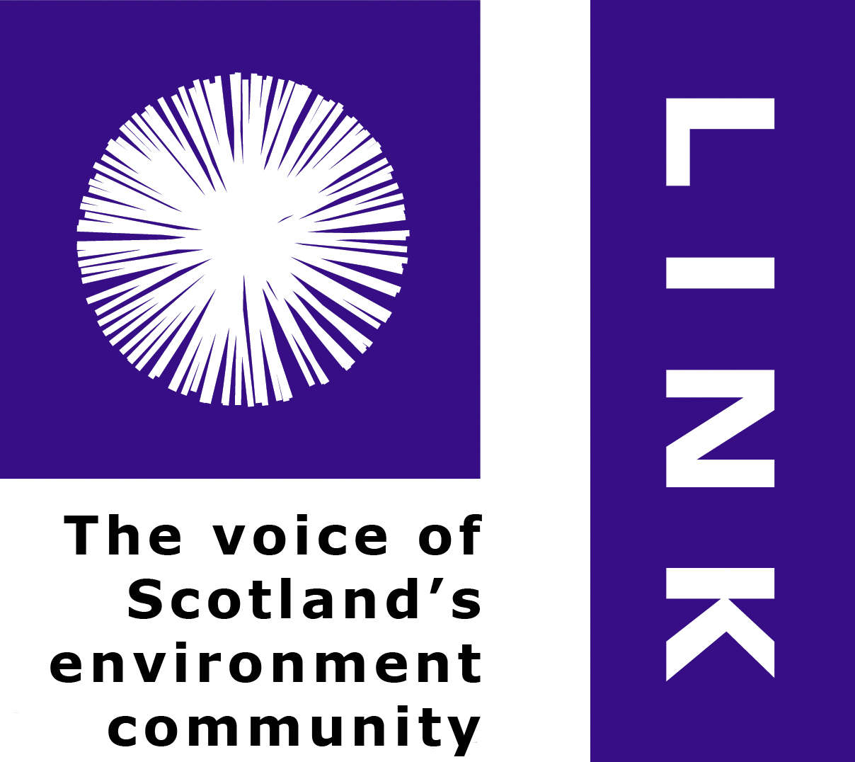

LINK Advocacy Manager (Full-time)
Job Description
Contract type: Core post
Location: LINK advocacy office in Edinburgh
Nature: Political strategy, policy advocacy, communications, management
Reports to: Chief Officer
Salary: £30,000 - £35,000, depending on skills and experience
Funding: LINK core
Hours: Normally 35 hours per week; flexibility is important in this role for some evening
and weekend work, for which time off in lieu is given
Scope: Reporting to: Chief Officer
Line manages: Advocacy Officer, Advocacy Officer Administrator, on occasion other
short-term positions
Budget: Joint responsibility for various headings relating to advocacy, communications & HR

JOB PURPO
LINK is the national intermediary for Scotland’s voluntary, citizen-led, environmental organisations, with over 35 member organisations and a collective membership of around 500,000 people. Members represent a wide range of environmental interests including land managers, service providers, campaigners, policy experts on issues including agriculture, wildlife, landscape, health and wellbeing, environmental economics, environmental governance and environmental justice. They have a common goal of contributing to a more environmentally sustainable society. LINK’s aim is to secure sustainable development in and beyond Scotland, where all aspects of the country’s environment are valued to enhance the quality of life for all.

Job Purpose
To provide strategic advice and support on policy advocacy to the LINK network, a clear point of access for parliamentarians and political parties spokespeople contacting LINK and appropriate advocacy and communications support for LINK work areas prioritized on a rolling basis. To represent the network as required with decision makers and other stakeholders.

Key Responsibilities
The Advocacy Manager will be expected to deliver across the following areas:
- Identify broad advocacy and communications opportunities for furthering LINK’s strategic goals, helping to develop and maintain broad political strategy with, and for, the network
- Support the network’s relationship with Parliament, Government and the wider policy community (including all those sectors exercising power or influence within public policy) in Scotland, maintaining an overview of important connections needed at the UK, EU and international levels
- Provide advice to LINK groups and subgroups on political, parliamentary and wider aspects of the network’s advocacy goals; provide training in advocacy
- Schedule and manage the advocacy office workload in conjunction with the Advocacy Officer and Advocacy Office Administrator, providing line management support for these Posts

Principal Activities

Planning and coordination:
- In conjunction with Chief Officer plan and monitor LINK’s support to groups and subgroups
- Participate as required in terms of the role in these groups’ activities as priorities demand
- As appropriate, help to develop responses, positions, briefings
- Help to plan, in some cases lead, in the coordination of events
- Attend other LINK meetings when appropriate, to report, inform discussion including Board & Network meetings, inductions, liaison with funders

Political and advocacy strategy:
- Maintain overview of politics and developments across the policy community in relation to Scotland’s environment and LINK’s strategic goals, providing political strategy reports to the Board and Network for discussion twice a year
- Maintain overview of LINK’s relationships in political terms across the policy community in Scotland, in the UK and in Europe
- Advise LINK groups and subgroups:
- monitor political contexts for trends affecting the environment, proactively advising LINK members and groups and subgroups of issues and opportunities
- support LINK groups and subgroups to develop effective advocacy strategies and advise these groups in relation to delivery of their advocacy objectives
- coordinate LINK bill teams as required for work on legislation going through Holyrood
- coordinate LINK manifestos work & promotion with political parties and decision-makers
- In conjunction with Chief Officer identify priority areas for support by the Advocacy Officer, maintaining an overview and advising the Officer in their provision of support to these areas
- Coordinate regular training for LINK members in advocacy strategy, including in media and wider communications
- Maintain oversight of the content and scope of the weekly Advocacy Monitoring Report and contribute to the creation of other LINK communications
- Provide political advice to member bodies on request

Promotion:
- Help to maintain LINK’s profile with Scotland’s policy community including parliamentarians and the political parties, proactively seeking opportunities to develop relationships at Holyrood, and where appropriate at Westminster, helping to coordinate network representation at relevant conferences and events including up to four LINK parliamentary events per year
- Coordinate liaison in support of LINK advocacy goals including with MSPs and MPs, Ministers, researchers, parties’ spokespeople; and the attendance at party political and other policy community conferences, hustings, and other events as required
- Monitor and advise on opportunities to link to the academic sector
- Advise the Advocacy Office Manager in development of aims, theme and content of the annual Scottish Environment Reception, providing such support as needed in terms of detailed coordination of the event
- Advise LINK groups and subgroups as requested on media and social media work; on strategic advocacy issues and on issues beyond the scope of these groups take lead responsibility for media work; coordinate LINK’s strategic use of LINK Thinks (web-based) and LINK’s Friends of the Scotsman subscription
- Help to market the benefits of LINK membership to eligible, charitable organizations; support development of LINK’s Organizational affiliation
- Contribute to the development of improved connections between LINK, its members and environment and community groups as appropriate across Scotland

Management:
- Plan and schedule the advocacy office work, managing competing priorities, and ensuring the network is kept regularly informed of progress and developing plans
- Provide line management support for the Advocacy Officer and the Advocacy Office Administrator – and where appropriate for relevant temporary positions
- Coordinate as appropriate commissioned research and expert advice in support of LINK advocacy goals
- Maintain good communications with LINK staff, group leads, trustees, fellows and president, to ensure the network is well informed on key issues and developments. This will involve
- updates to various players
- concise written reports on specific issues/work in progress as required
- consulting with LINK staff and trustees on planning and development of work

Communications and Campaigning:
- Work with the network to identify campaign needs which support its objectives, including means of delivery, monitoring and assessment
- Advise on campaign advocacy strategy including use of media, social media, and website
- Advise on campaign materials, audiences and events
- Coordinate network media material in relation to advocacy objectives, advising groups and subgroups on media opportunities and statements, often pitching and delivering these communications and liaising with journalists
- Coordinate with wider stakeholders including on joint policy positions

Representation:
- Represent LINK in relation to advocacy aims and positions with audiences including Ministers, politicians, officials, special advisers, researchers, media and other sectors
- Attend meetings of the EEB, of the Environment Links UK and other events as required

The Advocacy team has an important role in responding to enquiries coming through the LINK advocacy office from members and wider players. This entails good, up-to-date working knowledge of the network, its priorities and structures

Other activities
Coordinate meetings of LINK’s Governance Group, Brexit and Parliamentary Subgroups, as a means of sharing intelligence about environmental governance and members’ political strategies
In conjunction with others in the network, provide a balance of advice and support to the delivery of collective work, advise on changing priorities and help to identify the need for capacity building amongst members
Contribute brief reports for LINK Bulletin (monthly), annual and other reports e.g. to funders
Brief LINK Trustees, President, Honorary Fellows as required
Contribute to LINK’s assessment of network progress in relation to its strategic priorities
Carry out such other duties as are deemed relevant to the post

Relationships

Internal -
- Work closely with the LINK policy groups to support delivery of priorities
- Advise LINK groups and gather intelligence from across these
- Liaise with other LINK advocacy staff providing dedicated support to specific work areas
- Liaise with LINK’s wider core staff team
- Responsible to Chief Officer and ultimately to the LINK Board

External relationships
- Liaise with representatives of other civil society and statutory organisations in the wider policy arena in Scotland and further afield as required
- Form constructive relationships with political parties, with relevant politicians, officials and decision-makers at national and local levels, and with business and civil society organisations
- Develop good relationship with relevant players in the print and broadcast media

Terms and conditions

This is a full-time contract, reporting to the Chief Officer. The post is subject to a six-month probationary period. Salary will be in the range of £30,000-£35,000 per annum, depending on skills and experience. LINK makes an employer contribution to employee personal pensions of up to a maximum of 8% of basic salary, complementing employee contributions. The employer contribution is payable after the first three months in employment. The annual leave quota is 25 days' annual leave and 10 public holidays. All approved and receipted expenses are reimbursed.

Background on Scottish Environment LINK

LINK is the liaison body for Scotland’s voluntary sector environment organizations. Established in 1987, LINK provides a forum for its member organizations to meet, exchange information and take joint action on issues of common concern. LINK’s 35+ organizations share a common interest in seeing Scotland develop sustainably, in being a strong voice for the environment in Scotland and an effective efficient and accountable network. Their total, combined, membership is around half a million people.

LINK members work through policy groups and subgroups which focus on a range of policy issues, developing common positions and advocating to decision-makers in Scotland and, where appropriate, at UK and international levels. Network priorities are reviewed annually and inform the work of staff who provide advice, support and coordination to the collective work programme. A cycle of membership events keeps members informed and ensures integration across the network including members’ Congress, AGM and forward planning meetings, and a festive reception.

LINK is supported by a Board of volunteer trustees most of whom are involved in the network on behalf of their organizations; also by an active president and honorary fellows. Core work is supported by a small staff (currently just over 5FTE) including (Perth HQ) Chief Officer, Development Officer, Finance and Office Manager, and (Edinburgh) Advocacy Manager, two Advocacy Officers, Administrative Office Administrator and Campaign Coordinator. Staff liaise closely to support members and groups in achieving collective objectives. LINK also manages projects via its Marine and Economics groups, funded discretely and employing a dedicated Marine Policy & Engagement Officer and Sustainable Economics Policy Officer. Core activity is funded by subscriptions from member bodies, grants from Scottish Natural Heritage and Scottish Government and donations from charitable trusts.

Staff share in the active upkeep of the LINK websites, designed to carry up-to-date information for members, the public, government audiences and other interests. Many LINK meetings are held in Edinburgh or Perth, besides which staff may be required to travel to other parts of Scotland, and sometimes further afield. LINK operates an environmental policy in relation to procurement, travel and energy use, which staff and members work together in promoting.
LINK strives to be an equal opportunities employer.

Scottish charity SCN000296 and Scottish Company Limited by guarantee under SC250899
Head office: 13 Marshall Place, PERTH PH2 8AH
Tel 01738 630804 www.scotlink.org www.savescottishseas.org

