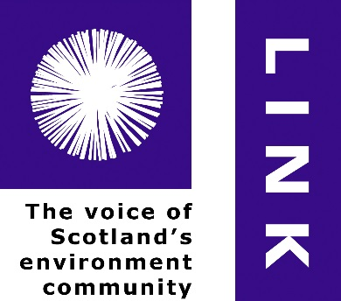

**LINK Advocacy Manager (Full-time)**

**Person Specification**

The following experience, qualifications and skills will be important in this complex and demanding role.

**Essential**

1 **-** Degree or degree-level experience in a relevant discipline and at least three years’ work experience in a relevant organization

2 - Very good working knowledge of Scottish, UK and EU government and parliamentary institutions and structures

3 - Ability to manage and prioritise within a large, diverse and unpredictable workload and to maintain standards under pressure

4 – Strong experience in developing advocacy strategy and in delivery of advocacy at high levels

5 – Experience in working with multiple and diverse interests

6 - Excellent team-working skills and an understanding of corporate disciplines including confidentiality, mutual briefing, and acting within limits of authority

7 - Good listening skills, the ability to communicate succinctly and persuasively to a range of audiences; skill in both written and oral presentation

8 – Demonstrated experience of developing and delivering effective campaigns

9 – Skills and experience of public affairs relevant to the roles outlined

10 - Skills and experience in coordinating media work, building relationships with journalists and commentators, managing media effort including through social media, online blogs and through the print press

11- Enthusiasm and self-motivation: essential to success in the post and job satisfaction of the appointee

12 - Excellent IT skills including Microsoft Office (Outlook, Word), internet and Office 365 (the ‘Cloud’)

**Desirable**

1 – Experience of managing staff

2 – Experience of managing projects

3 – Familiarity with the voluntary sector

4 - Knowledge of environmental issues and the debate around sustainable development

5 - Experience of policy analysis and development

6 - Knowledge of the media network in Scotland