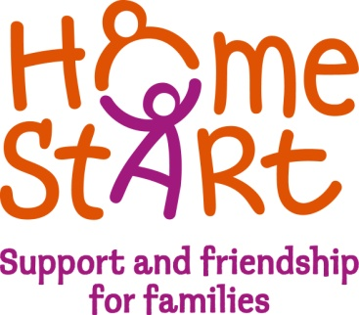
HOME-START FALKIRK WEST
Job Description – Family Support Worker

Home-Start is a voluntary organisation committed to promoting the welfare of families with at least one child under five years of age. Volunteers offer regular support, friendship and practical help to families under stress in their own homes helping to prevent family crisis and breakdown.

In many Home-Start schemes home-visiting work is complemented by group work where it can be identified that there is a need for additional support outside the home.

The Family Group Hubs are managed by the Family Support Worker and staffed by a Play Worker, with help from trained volunteers. The aim of the Family Group Hub is to provide vulnerable families with a supportive environment where they can: reduce their social isolation; improve their financial, physical and emotional health; access a wide range of specialist supports in the one place; explore training, learning and work experience opportunities; participate in safe and stimulating activities for all the family to encourage positive interaction between parent and child .

Job title: Family Support Worker

Location: The post is based at 72 Duke Street, Denny. Travelling is involved for which expenses are paid.

Hours of work: 25 hours per week.

Responsible to: Manager

Purposes of job: To plan, organise and facilitate the running of the Family Groups and work together with the Manager to encourage parents/carers to mould the direction and content of the sessions.
To work co-operatively with local employers, colleges, CVS and other organizations to identify and support learning, training and volunteering opportunities for parents attending the Hub.

To work with the Play Worker to deliver a stimulating and interesting range of activities for children and their parents/carers.

Main responsibilities:
Supporting the scheme
- To contribute to the effective day to day operation of the scheme in accordance with the Home-Start Governing documents, Standards and Methods of Practice, Home-Start Agreement and Quality Assurance Standards.
- To maintain high standards of practice in supporting families within the ethos of Home-Start.
- To ensure inclusion and diversity in all aspects of the scheme’s operation and work.
- To implement good safeguarding practices in all areas of work.
- To operate within and be aware of budget constraints.

Support for families
- Introducing families to appropriate support through the Family Group Hub.
- Ensuring support to families is reviewed at regular intervals and at the end of Home-Start support.
- To undertake designated responsibilities to protect and promote children’s welfare.

Project Work
- To support the development of Family Group Hubs in various locations across Falkirk.
- To develop and implement training and volunteering opportunities with local companies, colleges and CVS.
- To lead on initiatives relating to young children.

Working in Partnership
- Liaising with referrers.
- Working alongside and building relationships with other key partners and stakeholders.
- Networking appropriately within the wider community.

Supporting the Wider Context
- Promoting the scheme, its profile, ethos and practice.
- Contributing to the development and sustainability of Home-Start Falkirk West and promotion of Home-Start within the locality.

The post holder may be required to undertake any other duties that fall within the nature of the role and responsibilities of the post as detailed above.

This job description reflects the major tasks to be carried out by the post holder and identifies the level of responsibility at which they will be required to work. In the interests of effective working, the major tasks may be reviewed from time to time to reflect changing scheme needs and circumstances. Such reviews and any consequential changes will be carried out in consultation with the post holder.

This Job Description was reviewed in June 2019.

