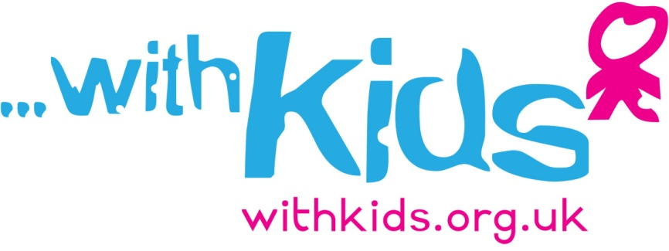**

**Children’s Zone Project Wester Hailes – Project Details**

This project is a follow on from our Stage 1 project which established a Children’s Zone within the Calder estate of Wester Hailes and although only funded for 6 months has had a real and tangible impact on community life. Some examples of this success are establishing a number of social support networks and maintaining contact with 65% of the families who live in Calders. By acting as a catalyst of community activity we have brought about a positive change in the community life of the estate.

Stage 2 funding will replicate this Children’s Zone model across the whole of Wester Hailes. The Children’s Zone is a neighbourhood based model which engages all households not just those with children. The aim being to raise community aspirations and provide a birth to adulthood approach to improving attainment through lifelong learning and improved mental health. Following on from the Stage 1 pilot we will set up zones to support geographical communities and the challenges that they face locally. This will include creating a project steering group of local residents who will be given the opportunity to impact on and shape the delivery of the project and over time take on parts of its ownership. In addition to this groups will be established across Wester Hailes to support communities of interest such as kinship families, families affected by bereavement, substance misuse or lone parents. Children affected by multiple adverse childhood experiences will also be offered individual or group play therapy.

There will be 3 main developmental aspects to the project which are enhancements to Stage 1.The first will be the establishment of a new collaborative approach to support communities affected by mental health challenges and will involve a partnership with CAMHS and other local health agencies. The second will be the creation of a training programme on the development needs of children impacted by adverse childhood experiences for local people delivered through groups and workshops. The third development will be establishing a pilot project outside Wester Hailes to allow us to understand what might be needed to deliver a children’s zone across the whole of Edinburgh. This new Children’s Zone location will encompass the catchment area of Stenhouse Primary School which houses a hub for children with additional support needs; almost all of whom live in Wester Hailes. It is also geographically close with good public transport links ensuring that families from that community will be able to access the wider support groups.

To help facilitate these developments we are appointing a family worker, project manager and play therapist. The project will be delivered within the community, meeting families where they feel most comfortable, including at home. Therapeutic support and groups will be delivered from local primary schools or the Wester Hailes Healthy Living Centre.

The following time frame is anticipated:

**Month 1-2: Project creation**

* Finalise working agreements with partnership organisations.
* Appoint staff.
* Establish referral pathway for health and community professionals.
* Begin community engagement exercises with local residents.

**Month 3-5: Project establishment**

* Provide initial CPD and training on play therapy and trauma affected communities.
* Identify communities of need across Wester Hailes and start support programmes.
* Begin providing Play Therapy.
* commence evaluation

**Month 6-12: Project delivery**

* Project fully operational.
* Preliminary report to be complete by month 9, evaluating the project establishment and initial community impact.
* Review of project in collaboration with NHS Lothian to explore a continuation of the project post funding. This will be carried out by month 12.

**Month 12-15**

* Final project review.

It is only when we begin to understand the varied factors which influence social differences in education that it is possible to design effective services which support children and families effectively and which help to break the cycle of social, economic and educational disadvantage. A key message of the evidence is that equality of educational opportunity cannot rely solely on better delivery of the school curriculum for disadvantaged groups, but must address multiple aspects of disadvantaged children's lives (Joseph Rowntree Foundation, 2012).

It is our belief that the work we plan to do in Wester Hailes will begin to address the impact of disadvantage and adverse childhood experiences.