Dear Applicant

Senior Project Officer

Thank you for expressing an interest in the above post. Please find enclosed further information and application details:

- Organisational Background
- Job Description & Person Specification
- Application Form
- Equal Opportunities Monitoring Form

When submitting your completed application, please include the following documentation:

- Your completed Application Form
- Your completed Equal Opportunities Monitoring form

Please do not enclose your Curriculum Vitae.

Once completed, your Application Form and Equal Opportunities Monitoring Form should be returned no later than 12 noon on Monday 19th August 2019. Please note that applications returned after this time will not be considered.

Applicants invited to interview will be notified by Thursday 22nd August, with interviews for the post being held on Wednesday 28th August 2019.

Unsuccessful candidates will be notified by email.

Thank you for your interest in this post, we look forward to receiving your application.

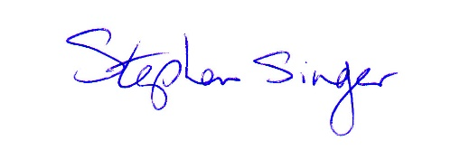
Yours sincerely

Stephen Singer
Director

