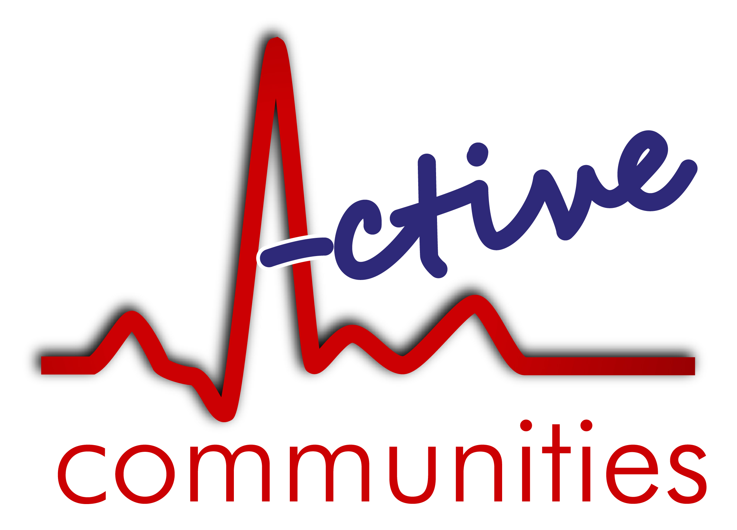
Job Application Form
Confidential

Vacancy Details
Post applying for:  (please tick one – if you are applying for both posts please put in two separate applications) | Project Assistant |  | Project Worker
The jobs are available as a job share. Please tell us the hours you’d prefer for the post you’re applying for: | Project Assistant |  | Project Worker
 | 30-hours |  | 35-hours  (full time)
 | Less than 30-hours |  | Less than 35-hours

Personal Information
Surname |  |  | First Names
Address (incl. postcode)
Email
Phone number |  |  | NI Number
Worked or volunteered for us before?
Are you related to anyone within Active Communities?
How did you learn about the post?
PVG Member and for what group? |  | PVG Membership  Number

Employment and Volunteering History
We require your full employment history and account for any gaps of employment and voluntary or unpaid work. Please start with the most recent and give exact dates where possible and use an additional sheet if necessary.
Current/Most Recent
Employer
Address
Position
Duties
Notice Period
Reason for leaving
Start Date |  | End Date

Previous
Employer
Address
Position
Duties
Reason for leaving
Start Date |  | End Date

Employer
Address
Position
Duties
Reason for leaving
Start Date |  | End Date

Employer
Address
Position
Duties
Reason for leaving
Start Date |  | End Date

Education (in chronological order)
Secondary Education - Examinations Passed

Further/Higher Education
Course
Provider
Qualification name
Qualification grade
Date achieved

Course
Provider
Qualification name
Qualification grade
Date achieved

Course
Provider
Qualification name
Qualification grade
Date achieved

Other relevant courses/training undertaken

Supporting Statement
Please state below your reason for applying for this post and the qualities and experience you consider make you a suitable applicant.
Please ensure your statement demonstrates how your skills and experience match the criteria laid out in the person specification.

Referees
One Referee should be your present, or most recent employer for either paid or voluntary work. We would prefer two business referees but will accept one personal referee if necessary. Referees should not be related to you.
 | Referee 1 | Referee 2
Name
Job Title
Address
Email Address
Telephone
Relationship with referee

Declaration

I understand that if I have deliberately used misleading information to obtain employment with Kairos Women’s Space at Active Communities I may be instantly dismissed at a later date. The information contained in this application, to the best of my knowledge, is correct.

(For online applications, you will be asked to sign this form if selected for interview)

Signed

Dated

Please return your completed application to

Colette@activecommunities.co.uk
Or
Active Communities
Room 11, 41 Blackstoun Road
Paisley PA3 1LU

Active Communities (Scotland) Ltd. Room 11, 41 Blackstoun Road, Paisley, PA3 1LU.
Tel: 0141 258 9923 | Email: info@activecommunities.co.uk | www.activecommunities.co.uk |
Company number: SC370513. Charity number: SC041275.

