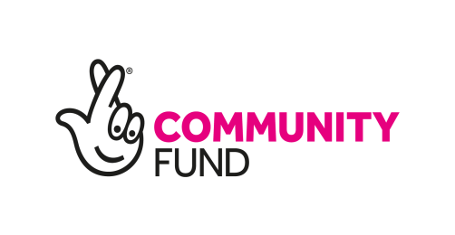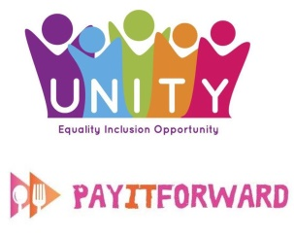

**Catering Support Coach**

**Salary: £16,380**

**Hours of Work: 35 hours per week**

**Location: 46 Trongate, Glasgow, G1 5ES**

Unity are launching a new project ‘The Spoon Social Kitchen’ supported by The National Lottery Community Fund, which will include a training kitchen and dining experience to support work-based training to adults with learning disabilities as well as other vulnerable groups and those who are socially isolated.

We are now looking to recruit a positive, enthusiastic and self-motivated Full Time Catering Support Coach to join our friendly team on a 3-year fixed term contract. You will be in a unique position to contribute in the development and implementation of this brand new project. You will work with the Service Coordinator to support participants in their journey to better health, wellbeing and inclusion through our social kitchen.

**Catering Support Coach - Main Purpose of the Post**

To assist the Service Coordinator in the development of service users and volunteers in establishing the training Kitchen, social dining experience and expansion of our ‘Pay it Forward’ scheme. This role will involve balancing coaching responsibilities with food production/workshops and administration duties, working both in the kitchen, a social dining experience and administration of personal development plans for vulnerable adults. The successful candidate will be driven with excellent communication and interpersonal skills, with the ability to develop successful relationships with staff, volunteers, service users with multiple needs, other agencies and members of the public to create a thriving social kitchen and dining environment.

**About Unity**

Unity believes in fair and inclusive communities where everyone is valued and has opportunities to fulfil their potential. We support this aim by working with individuals and communities, providing a variety of support services to vulnerable people. We also explore and develop initiatives that maximise opportunities for inclusion and equality in our communities Our Projects include Social Enterprise Catering, Carers Centres and Services for Adults with Learning Disabilities.

**The Ideal Candidate will possess the following experience and skills and must be able to evidence these.**



|  |  |  |  |
| --- | --- | --- | --- |
| **Skills and Experience** | **Essential** | **Desirable** | **Evidence** |
| **Qualifications** | Competent Cookery Skills | Community Development/Food/Nutrition SVQ 3 in Health and Social Care or equivalent, qualifications  Food Hygiene Certificate | **Educational and Training Certificates**  **Work/Volunteering or Personal Experience** |
| **Design and Delivery of Cooking Based Workshops** | Cookery, Nutrition and Food Safety Instruction | Example themes ‘Cooking on a budget’. Open to all but particularly supporting the most vulnerable including isolated / disconnected families and those on low incomes. | **Work/Volunteering Experience** |
| **Person Centred Care Experience** | Working holistically with service users and volunteers to achieve individual  goals | Compiling Personal Development and Training Plans | **Work/Volunteering Experience** |
| **Kitchen Management** | Understanding of Food hygiene, health and safety, stock control cleanliness. | Community Kitchen Experience | **Work/Volunteering Experience** |
| **Support and Coaching** | Ensure service users can work to their best ability, to promote their learning and new skills. This includes 1:1 and group work. |  | **Work/Volunteering Experience** |
| **Working in a complex multi stakeholder environment-** | Working with Vulnerable Groups | Working with adults with learning disabilities, mental Illness, social isolation, homelessness and other  Working with Volunteers | **Work /Volunteering** |
| **Additional Job Requirements** | Flexibility with working hours and regular Sunday working |  |  |