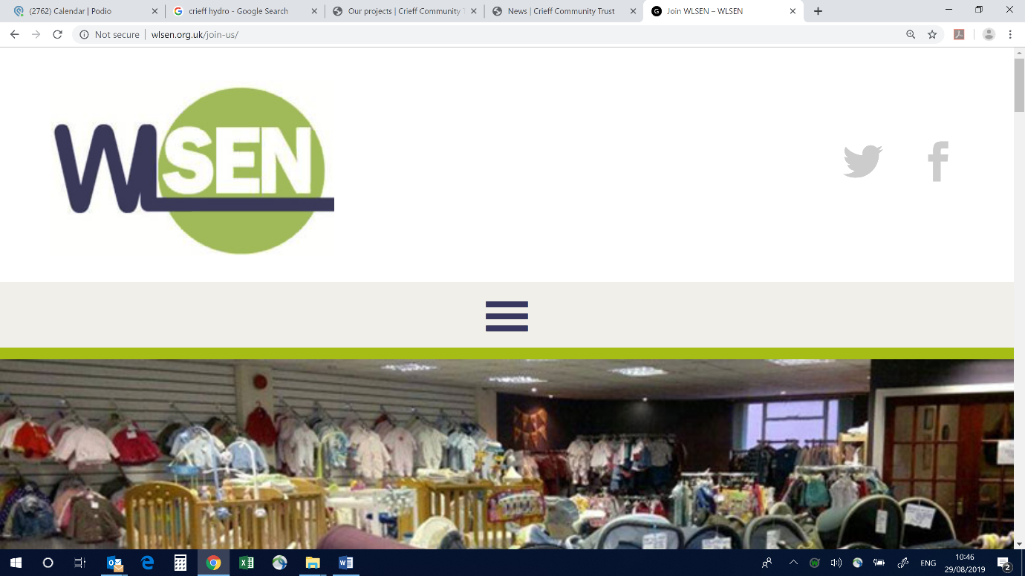WLSEN: Background Information

WLSEN was established over 6 years ago in response to a need for local social enterprises to connect up, share learning, promote their work and develop a collective voice. Initially operating as an informal group, WSLEN evolved into a Company Limited by Guarantee with charitable status in 2014 and has a small elected Board of Directors drawn from the social enterprise community. In 2014, WLSEN secured funding to directly employ its first dedicated Network Co-ordinator and latterly, funding for some additional administrative support.

As the social enterprise sector has grown, so has the work of WLSEN. Membership has steadily increased over the years covering a broad range of themes including children and young people, employability, food and well-being, sports, recycling and re-use, arts and culture, older people and care services. Membership of the network currently stands at 66 with a combined turnover in excess of £19m.

Areas of Activity

There are two key areas of activity for WLSEN:

1. Strategy: Ensuring that the Network is represented and promoted at a policy and resource level. Work involves developing relationships with key partners (such as West Lothian Council, Voluntary Sector Gateway, Business Gateway and national intermediary and support organisations) and contributing to consultations and planning.
2. Member services: Supporting members to strengthen and grow their businesses. Work involves providing opportunities for members to engage with each other, share opportunities (including inter-trading) and learning through events and other platforms: levering in or signposting to additional and bespoke support for members where needed and promoting member services more widely.

Our successes

* Being recognised as one of the strongest, best resourced Social Enterprise Networks in the country
* Consistently growing our membership
* Developing strong working relationships across West Lothian in both the statutory and voluntary sectors and being highly regarded by partners
* Contributing to social enterprise development at a national level and developing strong links to Government and agencies outside of West Lothian
* Developing and commissioning a unique business support programme for the benefit of our members and successfully levering in support from other areas

What We Need

The retirement of our current Network Co-ordinator provides an exciting and challenging opportunity to work with our members in one of Scotland’s most well regarded and effective Social Enterprise Networks. The post involves developing an environment in which local social enterprise can thrive and we wish to build on our early work, enhancing member engagement and ensuring the long term future of the Network. Over the term of this contract, we are particularly keen to develop a robust communication and engagement strategy for members and secure continuation funding.

This Post

This is a fixed term 5 month contract to tie in with a current funding round, however, there is a good chance funding will be extended for a further 12 months. We are therefore looking for someone who will be able to hit the ground running and work with the Board to maximise our impact to March 2020.

For further information, please contact the Chair, Paul Renwick: [paul.renwick@fauldhouse.org.uk](mailto:paul.renwick@fauldhouse.org.uk)