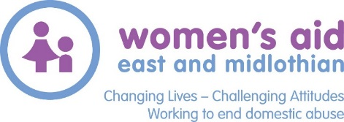
Info For Applicants
WANTED - Women who want to make a difference

Women’s Aid East and Midlothian Ltd was originally founded in Midlothian in 1979 for women and children who have experienced or are experiencing Domestic Abuse. The service has been, and will continue to be, developed by listening to the women, children and young people using our service.

WAEML is empowering women until all women, children and young people are free and safe from abuse. We are doing this by:
- Changing Lives – we ensure that services, including local support and safe accommodation are available to women, children and young people with experience of domestic abuse
- Challenging Attitudes – through promoting and safeguarding women’s equality and children’s rights
- Working to end Domestic Abuse – by engaging partner agencies to create policy and responses that actively prevent all forms of violence against women.

We now want to build upon our success by recruiting four new trustees to make a real difference to women and children’s lives by providing strategic direction and ensuring WAEML is effectively run. We’re looking to find new premises and develop a Women’s Empowerment Centre over the next few years, so if you work well in a team, can offer constructive opinions to help us reach good collective decisions, then we’d like to hear from you. We would particularly welcome applications from creative and innovative feminists with skills and experience in:
- property development
- Finance
- human resources
- Law
- income generation
- project management

Our charity trustees have ultimate responsibility for directing WAEML’s activities, safeguarding assets and making financial decisions, and ensuring the organisation meets the needs of its beneficiaries. You need to commit to preparing for and attending regular evening board meetings in either East or Midlothian, usually once every two months. You would also be expected to join one of our sub-committees and support the organisation at various events throughout the year.
In return you will be given a full induction to help familiarise you with our services and what it means to be a charity trustee. You’ll develop networking and leadership skills and boost your own CV with an opportunity to gain experience in budgeting and financial planning, staff recruitment, project management, managing risk and developing strategy.
If you share our core values, have a passion for women’s and children’s rights and would like to help us make a real difference to women and children’s lives find out more from Julie Watson – julie@womensaideml.org

Application

Please submit the Board of Director application form (attached) by email. Please write WAEML Board application in the subject line. Applications should be received by 5pm on Friday 11th October 2019 to Julie Watson: julie@womensaideml.org

Shortlisted applicants will be invited to an evening interview on Monday 28th October.

