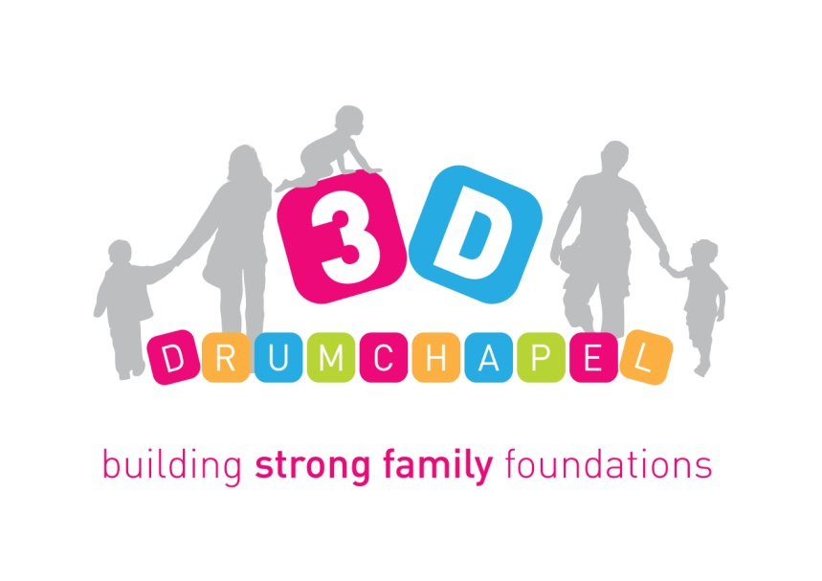
3D Drumchapel
c/o Drumchapel Community Centre
320 Kinfauns Drive
Drumchapel
Glasgow
G15 7HA
0141-944-5740
www.3ddrumchapel.org.uk

Dear Applicant,

Application pack for post of Perinatal Family Worker (30 hours) - Fixed term contract to 30th June 2020.

Thank you for your request for an application pack for the post of Perinatal Worker at 3D Drumchapel.

Please find enclosed the following:-
- Application Form
- Equal Opportunities Monitoring Form
- Job Description & Person Specification
- Background Information

Please note the closing date for applications is Monday 7th October at 9am. Applications should be submitted electronically to info@3ddrumchapel.org.uk or can be posted to the address above. If you are successful with your application, you will be invited for interview. If you would like more information about the post beyond what is included in this pack, please contact myself at nadiabrown@3ddrumchapel.org.uk or 07483121263. Thank you for your interest in this post and I look forward to receiving your application form.

Yours sincerely,

Nadia Brown
Operations Manager

