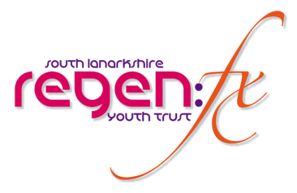
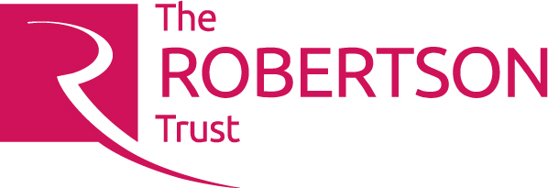

Job Description & Person Specification
Post: Youth Support Worker (The Street)
Location: Hamilton, South Lanarkshire
Hours: 35 hours per week (including evenings and some weekends)
Salary: £28,345
Term: 2yrs Fixed Term (Big Lottery & Robertson Trust)

GENERAL
Role | Youth Support Worker
Purpose | To further develop our existing Street Project. Recruit & support targeted young people 14 – 21yrs to participate in youth work activities using immersive theatre and issue-based workshops. Organise groupwork and 1:1 support session that will provide outcome-focussed solutions for participants.
Reporting to | Trust Manager
Liaising with | Drama Worker, Participants, partners, wider staff team, volunteers, all staff, and external bodies

KEY AIMS AND RESPONSIBILITIES
Key Aims | - Identify targeted young people from referrals and or self-referral to the programme  - Build confidence and trust with participants and together explore any complex issues they may be facing  - Support participants to identify solutions and or coping strategies for the difficulties that they face  - Identify appropriate referral agencies to assist and make the necessary connections and follow through with the participant timeously.  - Break down barriers to participation to ensure young people benefit from the full programme on offer.  - Co-ordinate Volunteers, Peer Educators and sessional staff.  - Help the young people drive the project forward.  - Help the young people identify the necessary resources required for new developments.
Key Responsibilities | - Undertake comprehensive needs assessment and risk assessment to ensure that participant’s support needs are fully identified at the outset  - Develop an outcome-focussed, flexible support plan with each young person.  - Provide practical and emotional support for young people to develop their capacity and take responsibility for their actions/inactions that could result in positive change.  - Co-ordinate Street staff team with support from the Trust Manager  - Undertake all relevant monitoring and evaluation as required by the service and then submit regular progress report.  - Maintain participant records as required by the service.
Additional Responsibilities | - Develop and maintain effective working relationships with wider staff team at Regenfx and those working in external agencies.  - Participate in in-house team events and any identified training.  - Maintain professional and personal development to meet the changing demands of the role.  - Other tasks as required by the management to meet the needs of The Street.

JOB AND PERSON SPECIFICATION
Essential knowledge and experience | - Relevent youthwork qualifications or equivalents  - Proven track record of working effectively with young people between 14 plus with complex needs.  - Sound knowledge and experience of partnership working with external agencies to ensure the best opportunities for our participants.  - Experience of supporting and promoting peer education.
Desirable skills, knowledge and experience | - Degree or SVQ level 4/5 Youth Work qualifications  - Experience of working with families.  - Knowledge of youth development methodologies.  - Any additional specialisms i.e. alcohol & drugs work, bullying initiatives, domestic abuse and sexual health knowledge would be welcome.  - Experience of using drama as a youth work tool.
Personal Qualities | - A genuine interest in working with vulnerable young people.  - Ability to communicate at all levels effectively.  - Good observational and analytical skills.  - Ability to motivate and enthuse the most disengaged young person.  - Personal commitment to making activities equally accessible and appropriate to the diverse needs of young people.  - Approachable and non-judgemental  - Ability to work under pressure.  - Ability to work autonomously and as part of a team.  - Ability to work flexibly and proactively.  - Sound IT skills including social media.
Training and Development | - Willingness to undertake training and supervision, as required

