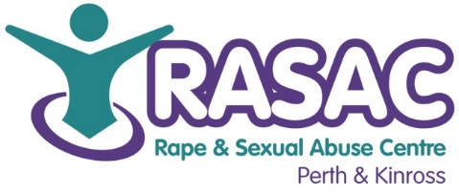
RASAC P&K Equal Opportunities Monitoring Form

Rape and Sexual Abuse Centre Perth & Kinross aims to be an equal opportunities employer. To assist us in this aim, we ask if you could complete this form. This information is for monitoring purposes only and will not affect the outcome of your application. Completion of this questionnaire is voluntary. You do not have to answer any or all of the following questions, but we would be grateful if you could.
This form should be returned in a separate envelope. Please do not include your application form with this. RASAC P&K gives a commitment that this information will remain confidential and held for no longer than is necessary under the Data Protection Act 1998. If emailed, information will be separated immediately.

Post Applied For: Therapeutic Support & Group Worker (Maternity Cover)

Where / how did you hear about this post? _____________________________________

PLEASE TICK YOUR RESPONSES

Age Monitoring:

Under 18 19-24 25-40 41-55 56-65 66+

Language:

Is English your first language? Yes No

If English is not your first language please state what your first language is:

Ethnicity monitoring:

African, Caribbean or Black

African African Scottish African British Caribbean

Caribbean Scottish Caribbean British Black Black Scottish

Black British Any other Black background (please describe)

Asian, Asian Scottish or Asian British

Indian Indian Scottish Indian British Pakistan Pakistani Scottish

Pakistani British Bangladeshi Bangladeshi Scottish Bangladeshi British

Chinese Chinese Scottish Chinese British

Any other Asian background (please describe)

White

British Scottish Irish English Welsh Northern Irish Polish

Gypsy / Traveller Any other white ethnic group (please describe)

Other Ethnic Group

Arab Any other missed or multiple ethnic group (please describe)

Religion and Belief monitoring:

Christian (including Church of Scotland, Catholic, Protestant and all other Christian denominations)

Buddhist Hindu Jewish Muslim Sikh

No Religion Other (please describe)

Sexual orientation monitoring:

To make positive changes RASAC P&K wants to address the different barriers faced by disabled people. Survivors with a disability or health condition are entitled in law to ‘reasonable adjustment’ to address their need for support in the rape crisis centre. Therefore we are interested in any disability or health condition that may require a reasonable adjustment to overcome any such barriers.

Do you consider yourself to have a disability or long term health condition? Yes No

If YES, please give details:

Gender monitoring:

RASAC P&K aims to be an inclusive organisation and supports survivors from all communities.

Please describe your gender:

Female (including male to female trans women) Male (including female to male trans men)

Other Gender Identity Prefer not to answer

Is your gender identity the same as the gender you were originally assigned at birth?

Yes No Prefer not to say

Please not there is no obligation for individuals to disclose transgender status or gender reassignment history as a condition of applying to RASAC P&K.

