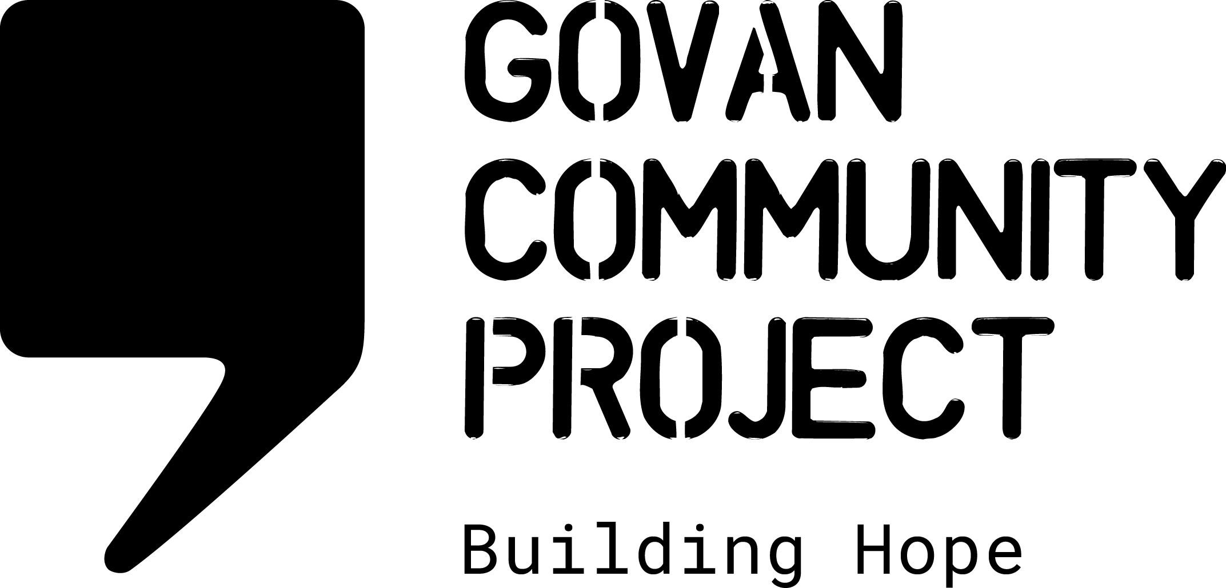
VOLUNTEER ROLE DESCRIPTION

ROLE | SECRETARY, BOARD OF DIRECTORS
TIME COMMITMENT | The role of Secretary will require a minimum time commitment as follows:  - For Board meetings – commitment of time to read all Board Papers in preparation for meetings, minimum 2 hours for attendance every 2 months in the evening and time to produce and disseminate minutes from Board meetings.  - Availability to respond to communications in between meetings  - Commitment to attend AGM  There may be additional ad-hoc requests for availability dependent on the needs of the Charity eg short life working groups
REPORTING TO | BOARD OF DIRECTORS

ROLE OBJECTIVE

The role of Secretary is a crucial role with the Board of Directors, carrying legal and financial responsibilities, which will require time and commitment.

The Secretary will be responsible for ensuring all meetings are held and conducted according to the organisation’s Articles of Association. The Secretary will work closely with the Chair in preparing for and organising Board meetings, AGM’s and any EGM’s and supporting the Board of Directors to understand the responsibilities in compliance with company/charity law and legislation. Some of the administrative duties can be delegated to or conducted jointly with staff members.

RESPONSIBILITIES

Governance
- Work with the Chair in organising meetings and distributing minutes and agenda’s
- Ensure all necessary documentation is sent to Companies House and OSCR within appropriate deadlines
- Ensure that all appointments/resignations are completed in line with the Articles of Association and records are updated on Companies House
- Advise the board on charity and company law issues/implications
- Work with the Head of Charity to oversee regular reviews of contracts/leases etc
- Ensure all AGM’s or EGM’s are administered effectively
- Work with Head of Charity, Chair and staff team to ensure annual report is produced for presentation at AGM
- Ensure that membership records are kept up to date and stored to comply with GDPR
- Ensure the organisation is adequately insured for the business objectives
Efficiency and Effectiveness of the Board

- Ensure that all Board meetings are quorate and all decisions are minuted accurately
- Ensure that minutes of Board meetings are distributed in a timely manner to allow follow up on actions

Support to Head of Charity & Staff Team

- Establish and build a strong, effective and constructive working relationship with the Head of Charity and Social Enterprise Manager, respecting the boundaries which exist between the roles
- Ensure regular contact with the Head of Charity in relation to membership records and compliance with Charity/Company law, developing and maintaining an open and supportive relationship within which each can speak openly about concerns, worries and challenges

Additional information

The Secretary will be required to commit to additional availability for training and induction following appointment.

The above list is indicative only and not exhaustive. The Secretary will be expected to perform all such additional duties as are reasonably commensurate with the role.

PERSON SPECIFICATION

In addition to the qualities required of a Director of the charity, the Secretary must also meet the following requirements:-

Personal Qualities

- Able to demonstrate a strong and visible passion, understanding of and commitment to the charity, its charitable objectives and cause
- Strong inter-personal and relationship building skills and feeling confident with an ambassadorial role
- Ability to listen and engage effectively to manage relationships
- Strong networking capabilities that can be utilised for the benefit of the charity
- Ability to foster and promote a collaborative team environment
- Ability to commit time to conduct the role well

Experience
- Skills/background in administration or law
- Understanding of charity and company reporting.
- Ability to explain company/charity law obligations to Directors and other stakeholders.
- Analytical skills, demonstrating good judgement.
- Good communication and leadership skills.

Knowledge and skills

- Some basic knowledge and understanding of the challenges and barriers faced by individuals involved in the asylum process although training will be given.
- Strong leadership skills, ability to motivate staff and volunteers and bring people together
- Good understanding of charity governance issues

