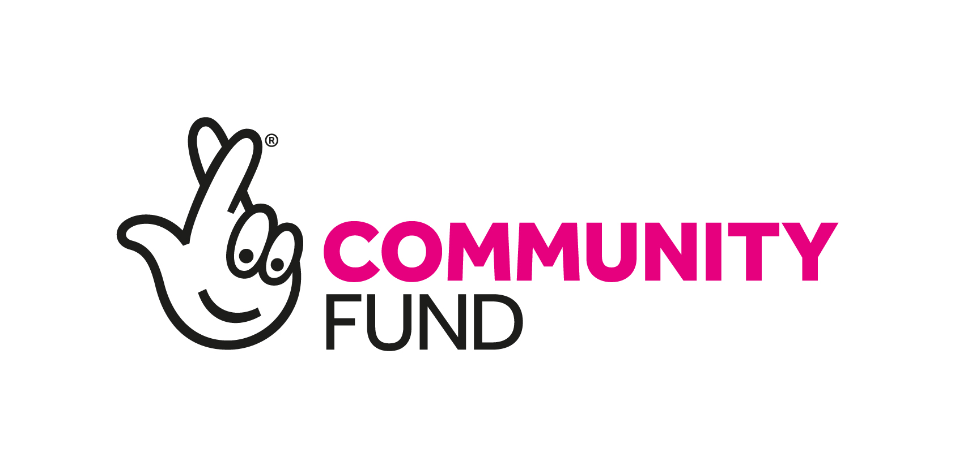

Could you help decide how National Lottery money supports communities in Scotland?
Scotland Committee Candidate Briefing Pack
October 2019

Thank you for your interest in The National Lottery Community Fund.
The National Lottery Community Fund (the Fund) is the largest community funder in the UK. We are recruiting a new Scotland Committee member. The Scotland Committee sets the direction of our work and takes decisions about our large grants in Scotland. There are seven members including the Chair. We are looking for someone who will add to the broad base of knowledge, skills and experience of current members.
The National Lottery Community Fund: People in the Lead
We believe that when people are in the lead communities thrive, forming relationships, developing skills and sharing ideas. This is the goal we’re working towards - a society where people can take the lead in growing happy, sustainable communities.

We help fund all kinds of organisations in Scotland. Our funding ranges from small grants of under £10,000 through, National Lottery Awards for All Scotland, to large grants in excess of £500,000 investing in projects to develop community owned assets, tackle issues like loss, isolation and loneliness or deliver new approaches to supporting families through early intervention work. Further details of our programmes can be found here:

https://www.tnlcommunityfund.org.uk/funding

In 2018/19 we awarded 1,098 grants worth over £50 million supporting organisations in every local authority area in Scotland.

Our commitment to supporting Scotland’s young people to thrive continued as we refreshed our Young Start fund, awarding £4 million to projects which put young people at the heart of planning and delivering activity.

But we’re more than just a funder. We also collaborate with other funders, charities and individuals, sharing knowledge and building partnerships, so we can all be as effective as possible. We like to bring our stakeholders and the groups we fund together so that they can share their learning, influence policy and practice and strengthen links between them.

Skills and Experience Required
We want our Committee to have a broad base of knowledge, skills and experience and to reflect the diversity of modern society and the communities that we serve.

Our focus on place has seen the development of closer relationships in communities across Scotland. This has increased opportunities for Committee members to work more closely with our Area Teams and engage directly with local stakeholders, grant holders and people who want to apply for funding. The skills and experience we are seeking for this role reflect the need to engage effectively at this level as well as performing core committee roles.

The following criteria are essential for the role:
- An understanding of and interest in the Scottish social, cultural and political landscape and the role of the voluntary and community sector in it.
- An understanding of the principles of the National Lottery Community Fund’s strategic framework ‘People in the Lead’.
- Experience of representing an organisation and willingness to represent the Fund at public events.
- A clear understanding and commitment to achieving diversity and inclusion
- The ability to understand complex issues and make decisions taking into account competing demands.
- An understanding and commitment to the principles required to hold a public post of this nature (The Nolan Principles).

We are committed to enhancing diversity and inclusion in our organisation to reflect the communities within which we work and proactively encourage applications from all groups and communities.

Time Commitment and Remuneration
The time commitment is expected to be an average of two days per month to include the following:
- The Scotland Committee meets seven times a year plus one annual planning day. Most meetings are in Glasgow but will be at other locations across Scotland at least once per year.
- Ad hoc attendance at project visits and meetings with other stakeholders at locations throughout the country.
- The successful candidate will receive an annual fixed payment of £5,232 plus expenses such as travel, and subsistence incurred on The National Lottery Community Fund business.
- The appointment is for an initial period of three years

How to Apply
Complete the application form, equality monitoring form and provide a brief CV.

Please note that CVs will not be accepted unless also accompanied by a completed application form.

All documents should be submitted to scvacancy@tnlcommunityfund.org.uk

The Fund is committed to equal opportunities. Please indicate on the monitoring form if you have any special requirements which will help you fully engage with the appointment process. This information is for monitoring purposes only and will not be seen by the selection panel.

If you have any questions on any aspect of the appointment process, need additional information or wish to have an informal discussion, please contact Fiona Grant at fiona.grant@tnlcommunityfund.org.uk before submitting your application.

All applications will be assessed against the skills and experience required for the post. Shortlisted candidates will be invited for an interview at The National Lottery Community Fund’s offices at Pacific House, 70 Wellington Street, Glasgow G2 6UA.

The closing date for receipt of completed applications is Sunday 1st December 2019 at 23:59

Interviews are expected to be held w/c 6th January 2020

Travel expenses for attendance at interview can be claimed.

About the Way We Work

Disability Confident committed employer
The National Lottery Community Fund is proud to be a Disability Confident committed employer. We will commit to interview an applicant with a disability if they meet the minimum criteria for selection. The National Lottery Community Fund will make any reasonable adjustment to help attendance at the interview stage of the selection process. To assist us, applicants with a disability should complete the questions on disability in the application form.

Nolan Principles - The Seven Principles of Public Life
The Committee on Standards in Public Life (originally the Nolan Committee) set out Seven Principles of Public Life: Selflessness; Integrity; Objectivity; Accountability; Openness; Honesty; Leadership. All National Lottery Community Fund Board and Committee members are expected to uphold these.

All public appointments are based on merit
This appointment will be made in accordance with the OCPA Code of Practice which requires that appointments are made on merit with independent assessment and transparency of process. Political activity will play no part in the selection process.

Candidates may come from a wide range of backgrounds and experience. The National Lottery Community Fund welcomes applications irrespective of race, colour, ethnic or national origin, sex, marital status, disability, sexual orientation, religion, religious beliefs or similar philosophical beliefs, age, gender re-assignment or community background.

Accessibility to public appointments is a fundamental requirement and the public appointments process promotes, demonstrates and upholds equality of opportunity and treatment to all applicants. If you require any of the application documentation in an alternative format, please contact us.

