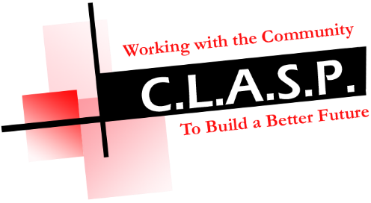

BRIEF BACKGROUND OF CLASP AND SERVICES PROVIDED

CLASP (Community led Action and Support Project) is a voluntary organisation based in Stevenston but delivering services throughout the whole of North Ayrshire. It was established in January 2000 initially to provide services within the Hayocks area of Stevenston but has expanded and developed over the years and currently delivers the following projects and services throughout North Ayrshire.

- HOPE (Helping Older People Evolve) Project – an older peoples project offering a wide range of services available for over 50’s including; one to one befriending, morning/evening call service, information and advice service, activities programme, weekly lunch clubs, social outings, health and fitness classes.
- Adult Literacies Community Service assisting clients with reading, writing and numeracy issues and assisting clients back into employment via the new Employability Hub in Stevenston.
- CLASP Digital Project to help people improve their digital skills by accessing one to one and group support and instruction in the use of the internet via ‘smart’digital devices such as iPad, tablets, iPhone, smartphones and laptops.
- Community base offering a signposting and referral service for clients with more complex issues, information library and clerical support services e.g. photocopying, typing, scanning, I.T. access and laminating.
- Letting facility providing meeting room facilities for use by local groups/organisations.
- I.T. suite available to let.

The CLASP Project is managed by a voluntary Board of Directors/management committee and currently employs 8 members of staff and 20 + volunteers.
The organisation is a registered Scottish Charity.
The main registered office is 140a Hayocks Road, Stevenston with a further office/I.T. suite at 144 Hayocks Road, Stevenston and our CLASP Resource Centre that forms the base for the HOPE Project situated at 10 Alexander Place, Stevenston (opposite Stevenston Health Centre).

For more information on CLASP, you can visit our website at www.clasps.org.uk

