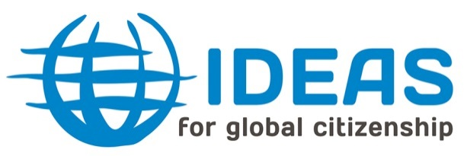
Background Information

IDEAS
International Development Education Association Scotland (IDEAS) is a network of organisations and individuals across Scotland that actively support and promote Development Education and Education for Global Citizenship.
Members include large NGOs, small organisations and individuals working in areas such as international development, global poverty, sustainable development, social justice and citizenship. They also include the regionally based Development Education Centres (DECs) who provide local practical teacher support.
IDEAS sees Development Education and Education for Global Citizenship as active learning processes that
- enable people to understand the links between their own lives and those of people throughout the world
- increase understanding of the economic, social, political and environmental forces that shape our lives
- develop skills, attitudes and values that enable people to work together to bring about change and take control of their lives
- contribute to the development of a more just and sustainable world, in which power and resources are more equitably shared
By raising awareness of global concerns and illustrating the potential for change, the IDEAS network aims to influence those in all sectors of formal and informal education and lifelong learning including teachers, policy makers, youth and adult education workers and a range of voluntary and statutory organisations.
Bridge 47
Bridge 47 focuses on advocating for Global Citizenship Education, building capacity and partnership for GCE practice, and innovating GCE methods at the national, European and global levels.
In Scotland, Bridge 47 is supporting IDEAS members to evidence the impact of global citizenship education and advocate for the extension of GCE throughout formal and informal education. Using best practice from our international partners, IDEAS is helping the Development Education Centres experiment with innovative practices for delivering GCE in Scotland.
Bridge 47 is also supporting IDEAS to extend GCE beyond Scotland’s education sectors, finding a role for GCE methods and values in policy-making. This includes building partnership with Scottish Government, policy makers and civil society organisations in areas such as Social Inclusion and International Development to strengthen the role of Global Citizenship Education in supporting progress towards the UN Sustainable Development Goals.

