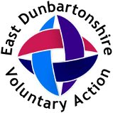

November 2019

Dear Applicant

# Re: Community Builder Development Officer

Thank you for expressing an interest in the above post by requesting an application pack. The pack consists of:

* an application form including an equal opportunities monitoring form
* a job description and person specification for the post
* background information

Should you decide to apply for this post please complete the application form and monitoring form and return them to the above address on or before

Please note that CVs will not be considered.

The closing date for applications is **24th January 2020.** Interviews will be held during the **week commencing 3rd February 2020.** Specific times will be communicated to those applicants successful for interview.

Should you require any further information please do not hesitate to contact Alex Meikle, Manager of East Dunbartonshire Voluntary Action at [alex.meikle@edva.org](mailto:alex.meikle@edva.org)

Yours faithfully,

Alex Meikle

Manager East Dunbartonshire Voluntary Action