Job title: PRS Tenant Support Officer – City of Edinburgh Council (CEC) Rent Deposit Guarantee Service

Department: Client Services

Reporting to: Progression Manager

Salary: £32,364 per annum

Hours: 35 per week

Location: Crisis Skylight Edinburgh

Contract type: 12 months fixed term contract

**Aim and influence**

* Assess, advise and support clients referred to the service to identify suitable accommodation in Private Rented Sector (PRS), establish and sustain tenancies therein, preventing future homelessness where possible
* Offer high quality information, advice and guidance on appropriate services and support (internal and external) to clients referred to the service and work in partnership with those services

**Financial and supervisory responsibility**

* No line management responsibility
* No formal budget management, but will be required to control spending in certain key areas including housing access budget (bonds, rent in advance etc)
* Supervision of volunteers where required

**Other key details**

* Based in Edinburgh with services delivered in partners’ facilities or community venues across Edinburgh
* Some evening and weekend work will be required and time off in lieu will be given in accordance with Crisis’ TOIL policy
* Role involves working with adults who are vulnerable, therefore a PVG membership certificate dated within the past year, or a satisfactory Basic Disclosure from Disclosure Scotland, is required
* Role will also require travel across the UK for training and meetings. In some instances, this will require overnight stays

**Organisational chart**

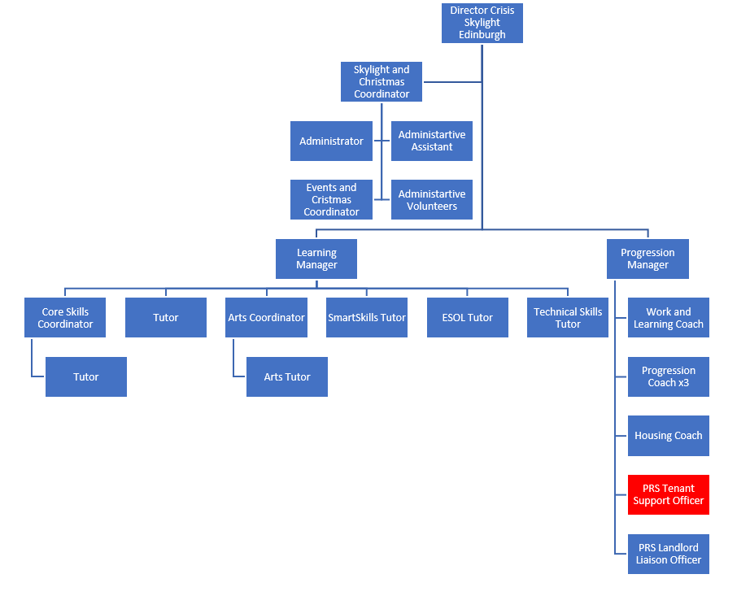

*Please note structure is subject to change*

**Job responsibilities**

**Referral, assessment and promotion**

* work with City of Edinburgh Council (CEC) to agree scheme referral criteria and processes
* promote and publicise scheme by designing service literature and standards for referrers and applicants, and providing presentations and briefings to staff
* conduct assessments of referred households’ eligibility for the service, support needs, financial circumstances and PRS suitability, seeking references or additional information where required
* make households aware of advice, support and training which can be delivered by Crisis and external agencies and signpost or refer into these as appropriate
* ensure households understand responsibilities entailed by provision of bond in lieu of deposit
* advise CEC timeously of outcomes of referrals

**Accessing suitable housing**

* assist households to understand their rights and responsibilities as PRS tenants, as well as practical issues in PRS tenancies
* ensure any identified training or support needs are met by Crisis or an external agency
* provide support for households to search, apply for and view PRS properties, including inspection of legal compliance, negotiating with landlords on behalf of applicants
* issues bonds in lieu of deposits, agreeing programme with households to save up to replace bond with deposit in a manageable timescale
* support households to move into PRS housing, including assistance with benefit claims, utilities, furniture and rent payments

**Sustaining tenancies**

* carry out ‘settling in’ visit and provide support quickly for any emerging issues
* establish clear communication and task distribution with other agencies working with household
* remain first point of contact for tenant through duration of bond, minimising potential for repeat homelessness and referring onto internal or external advice and support when required
* monitor tenant savings programme and support transfer of monies to landlord
* where a tenancy is ending, visit within notice period to check property standards and identify any actions for the tenant, providing advice on onward options where needed

**Recording and monitoring**

* maintain accurate records on client database and additional reporting tools specific to project
* ensure client feedback is recorded and where appropriate, acted upon
* assist in collation of service monitoring and evaluation information for reports to stakeholders
* ensure safeguarding concerns are identified and reported in line with Crisis’ procedures

**Contribution to team and organisation**

* prioritise own workload and ensure timely delivery on all tasks
* take part in team meetings and where necessary take minutes
* support work of PRS Landlord Liaison Officer, carrying out joint tasks where required
* identify service areas where volunteers could contribute and work with Volunteer Co-ordinator to define tasks for new volunteering roles
* assist in volunteer recruitment/induction and support and supervise volunteers recruited
* contribute to sharing of best practice relating to housing in wider organisation

**General responsibilities**

* actively encourage and support member involvement within Crisis
* develop and maintain an understanding of Crisis’ work and the needs and circumstances of homeless people
* comply with Crisis policies and procedures, including health and safety
* carry out any other duties that may reasonably be required in light of the main job purpose

**Person Specification**

**Essential**

1. Demonstrable knowledge of housing and homelessness legislation in Scotland
2. Demonstrable knowledge of how to access PRS accommodation and necessary requirements to secure a tenancy specific to the local area, including as this relates to people on low incomes, including benefits
3. Experience of working with socially excluded individuals and groups to promote and encourage inclusion
4. Experience of delivering advice and guidance and/or training
5. Ability to communicate effectively in a group setting and one to one, and relay complex information in a manner easily understood
6. Excellent interpersonal skills, with ability to develop and maintain working relationships with a diverse range of providers and individuals
7. Ability to negotiate with and influence different groups in order to achieve outcomes
8. Proven organisational skills, including ability to plan and prioritise work effectively, including high level of contact with clients on day to day basis
9. Ability to work on your own and work effectively in teams
10. Confident in use of MS Office and knowledge of data entry using databases
11. Knowledge of and ability to comply with safeguarding procedures, including ability to identify, manage and minimise potential conflict situations
12. Commitment to Crisis’ purpose and values including equality and social inclusion

**Desirable**

1. IAG qualification (SVQ level 2 or equivalent), or a coaching qualification, or willingness to work towards one
2. Demonstrable knowledge of welfare benefits system

*We encourage applications from all sections of the community and particularly from people who have lived experience of homelessness.*

Supporting your application

Thank you for your interest in working for Crisis.

Before you apply, please take a moment to read through the frequently asked questions below which are designed to support your application and help you understand our recruitment processes.

How do I apply for a job?

Most of our roles are advertised via *Crisis Jobs Online,* a secure recruitment portal. Once you have registered, you will be asked to provide some personal details as well as information about your work experience, education and referees who can be contacted if you are offered the role. You will also be required to complete a personal statement, demonstrating how you meet each of the points on the person specification for the job.

The person specification requires a qualification or experience that I do not have. Is it still worth me applying?

The person specification has the key knowledge, skills, experience or behaviours needed to carry out the job successfully and you will be scored based on any information you provide. If you don’t quite meet the criteria, for example if you have an understanding of something rather than experience of doing it yourself, you may still pick up points for explaining your understanding or how you might approach it. However, some of the person specification points, for example specific qualifications, are critical to the role so if you don’t meet those requirements, you are unlikely to be shortlisted.

Can I apply by sending my CV?

Occasionally we accept CVs and a covering letter but only if this requested in the advert for the post. We don’t accept speculative applications or hold CVs on file.

What should I do if I can’t complete an online application?

If you would like to apply in a different format, for example a Word document, because you are unable to use the online process, please contact the HR Team on 020 7426 3864 or by email at [human.resources@crisis.org.uk](mailto:human.resources@crisis.org.uk). It is helpful if you provide details of your requirements or suggestions about how we might best support you to apply so we’re able to consider alternatives.

How can I maximise my chance of being shortlisted?

It is important that you complete all sections of the online application form to ensure that the recruiting panel understand your interests, skills, behaviours, knowledge and experience.

Shortlisting is mostly based on the information you provide in the **personal statement** section. When completing this, please reference **each of the points listed in the job description** in the order in which they appear. There will be 15 boxes, so if there are less than 15 points, you won’t need to use all the boxes.

Support your statements with specific examples that show how you meet each of the person specification points. You may wish to use the STAR approach:

S or T – Situation or task

Describe the situation or the task that you had to complete. It could be something from your previous employment or personal experience – just make sure it’s relevant. Given enough detail for the person shortlisting to understand what was involved

A – Action

Describe the action you personally took to resolve the situation or task. Explain the process/steps you took. Even if you are describing a group project, describe what you did rather than what the team did as a whole

R – Result

This is the crucial part of the answer. Explain how your actions resulted in a successful outcome. Talk about what you achieved, the benefits and what you learned.

A strong application will also be in line with the Crisis Values that you can find on our website.

Please note! If you don’t provide full responses against all the person specification points, the panel won’t be able to score your application fully and it will be unlikely there is enough information for you to be shortlisted.

How quickly will I know if I have been shortlisted?

Each recruitment campaign is different depending on how quickly the shortlisting panel can review applications but if you’ve not been shortlisted, you will receive an email from us confirming that.

If I am not shortlisted, can I get feedback on my application?

Unfortunately, we are not able to offer feedback on your application if you are not shortlisted for interview.

Can I get feedback after my interview?

We appreciate that information about where you did well or less well can be useful, so if you are not successful following interview we are able to provide feedback.

Will you notify me of future vacancies?

Once you have registered via Crisis Jobs Online, you can sign up to receive notifications of new vacancies based on the criteria you select. We also recommend you check our website regularly for details of new vacancies as well as national and sector media where we advertise most of our roles.

I recently applied for a role and was not successful, but have seen the role re-advertised. Is it worth me applying again?

If the gap between advertising has been short, we would normally advise that candidates need not apply again, unless you have re-written and enhanced your application. Some examples might be that you have strengthened your examples using the STAR technique above or put in responses against all the person specification points where previously you hadn’t.

Crisis Jobs Online

I would like to re-apply for a vacancy but I cannot submit my application. What should I do?

If a role has been re-advertised, you will need to create a new account with a different email address to re-apply. Where the position has been re-advertised with a different reference number then you shouldn’t have any problems using your existing account.

I have registered to apply for a vacancy but now I’m unable to access my account and can’t seem to reset my password. How can I get access?

You should follow this [link](https://jobsatcrisis.irecruittotal.com/PasswordRecovery.aspx) to reset your password and allow 15 - 20 minutes for a new password to arrive. We find that emails can go to junk or clutter folders so it's worth checking there. As Crisis Jobs Online is managed by an external provider we are unable to access the email addresses registered or provide further information on your password, but following this step should resolve the issue.

If you did not receive a welcome email when you registered, there may have been an error in the email address that you provided. Unfortunately, there is no way to resolve this and you would need to re-register with the correct address.

I have typed my personal statement answers into the online form, but it won’t let me save them. What should I do?

There is a word limit of 400 per answer so it could be that you have exceeded the limit and that is what is preventing you from saving your work.

I filled in the personal statement section and tried to save it/submit it. However, it wouldn't do this and my information was lost. Is there any way to retrieve it?

You are encouraged to record your answers in a Word document first before copying and pasting your answers into the online application form, using the keyboard shortcuts Ctrl + C to copy and Ctrl + V to paste. The application form has a strict time out limit and so if you take longer than that limit you will lose your work and we are unfortunately not able to retrieve it.

Where can I get help?

If your query has not been answered above, you can contact the HR Team on 020 7426 3864/ 3814 / 3819 or by email at [human.resources@crisis.org.uk](mailto:human.resources@crisis.org.uk) for further information or support.