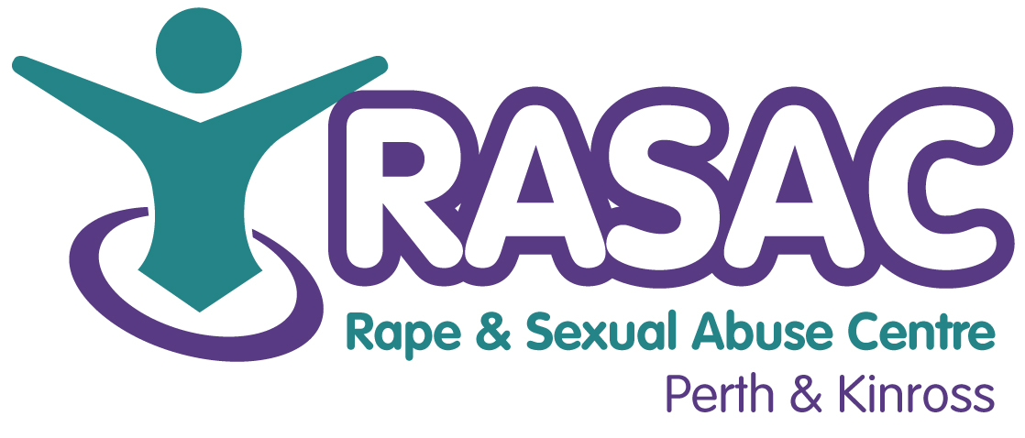

APPLICATION FOR YOUNG PEOPLE’S THERAPEUTIC SUPPORT WORKER
CONFIDENTIAL

PLEASE COMPLETE THIS FORM IN BLACK INK

Section 1: Personal details
Surname: | First name:
Address: | Tel (home):
Address: | Tel (mobile):
Address: | Tel (work):  May we contact you at work? yes/no
Postcode: | Email address:
Do you have any particular requirements to facilitate your access to interview, or relevant to the job, which we need to know about? | YES NO
If yes, please give details:

If completing this form electronically, you will be asked to sign a copy of this form if you attend interview.

Signed ______________________________________ Date _________

THIS SHEET WILL BE DETACHED FOR SHORTLISTING

Office use only / Reference number……….
Application to the Rape and Sexual Abuse Centre Perth & Kinross
(RASAC P&K) for the post of
THERAPEUTIC SUPPORT & GROUP WORKER

Section 2: Qualifications and training
Only enter those qualifications and/or training necessary or relevant to the job. Please continue on a separate sheet if necessary.
Qualification and/or training | Subject | Date(s)

 | Section 3: Present employer
 | Name & address of employer: |  |  |  | Date commenced employment:
 | Job title: |  |  |  | Notice required: |  | Current salary:
 | Section 4: Previous employment (list in order, with most recent employer first)
 | Please list all your previous employment, detailing any gaps between employments with reasons (continue on a separate sheet if necessary).
 | Dates |  | Name and address of employer |  |  | Job title and nature of work |  | Reason for leaving
 | From  DD/MM/YY | To  DD/MM/YY
Section 5: Working with Us / Knowledge and Understanding
RASAC P&K operates within a feminist analysis of gender based violence against women. Please complete the following questions:
RASAC P&K is a third sector, feminist organisation providing prevention and support services across Perth & Kinross. Please tell us why you are applying for this position and why you believe you are the best candidate for this role.

What is your knowledge and understanding of the causes and consequences of sexual violence?

Please provide a summary of the core skills you believe are necessary in responding to the needs of young survivors?

This box will expand if necessary to fit your answer if done electronically. Otherwise please continue on a separate sheet of paper.
With reference to the job description, please evidence below how your work experience (including voluntary positions) and your skills will enable you to meet the requirements of the person specifications set out below. Please include all information which you feel is relevant. (This box will expand if necessary to fit your answer if done electronically. Otherwise please continue on a separate sheet of paper).
Knowledge of, and commitment to, a feminist analysis of sexual violence (E)
Knowledge of the impact that rape and sexual abuse has on women, young people and children (E)
Knowledge and understanding of child sexual exploitation, including common risk factors and effective risk assessment (E)
Knowledge and understanding of the GIRFEC framework in supporting the wellbeing of children and young people (E)
Knowledge of the third sector and its role in addressing Violence Against Women (E)
Knowledge of the societal impact that gender based violence has on communities (E)
Knowledge and Understanding of Scottish legislation, policy and government strategy related to violence against women (D)
Experience of providing emotional and practical support and advocacy services to young people affected by trauma (E)
Experience of working with individuals affected by gender based violence (E)
Experience of assessing risk and following child protection procedures as necessary (E)
Experience of using creative methods for monitoring and evaluation processes (E)
Experience of prioritising and managing own workload (E)
Experience of producing written reports (E)
Liaison with appropriate statutory and voluntary agencies (E)
Experience of delivering training, presentations and workshops to a range of audiences (D)
Experience of supporting individuals who self-harm and/or express suicidal intention (D)
Experience of working with volunteers (D)
Ability to respond to survivors within a gendered analysis of violence against women (E)
Skilled in use of IT for self-administration e.g., Microsoft, excel, email and internet (E)
Excellent organisational skills (E)
Ability to communicate with a variety of agencies on all levels (E)
Capable of using own initiative and meeting tight deadlines (E)
HND level or above in Social Care, or similar discipline / COSCA Counselling Skills Certificate or similar (D)
Commitment to Equality and Diversity (E)
Are you able to work flexibly and do evening and weekend meetings as required? |  |  |  | Yes |  |  |  |  | No
Do you hold a current clean driving licence with access to a car and business use insurance? |  |  |  | Yes |  |  |  |  | No
Are you able to fulfil the requirement to drive regularly within Perthshire and occasionally outwith Perthshire? |  |  |  | Yes |  |  |  |  | No

Section 7: References
The Rape and Sexual Abuse Centre Perth & Kinross requires employment references to cover at least the last two year period – Please include voluntary work.
Reference 1: Current / most recent
Name: | Position: |  | Tel no:
Company name: |  | Address:
May we, with discretion, contact your employer to discuss this reference:
Yes/no
Reference 2: Previous employer / supervisor
Name: | Position: |  | Tel no:
Company name: |  | Address:
May we, with discretion, contact your previous employer to discuss this reference:
Yes/no
Reference 3: Previous employer / supervisor
Name: | Position: |  | Tel no:
Company name: |  | Address:
May we, with discretion, contact your previous employer to discuss this reference:
Yes/no

Section 9: Declaration
I certify that all the information contained in this form and any attachments is true and correct to the best of my knowledge. I realise that false information or omissions may lead to dismissal without notice.

Signature:

Date:

Please return completed applications to:

Jen Stewart
Centre Manager
RASAC P&K
16 King Street
Perth
PH2 8JA

or via email: admin@rasacpk.org.uk

RASAC P&K
CONFIDENTIAL SELF-DELCLARATION FORM

PLEASE COMPLETE THIS FORM IN BLACK INK

Full name:

Address:

Post code:

Phone (home): Phone (work/mobile):

Email:

- I have permission to live and work in the UK Yes No

- Do you have a criminal record? Yes No

- Have you ever been banned from working with children
(up to age18) or vulnerable adults? Yes No

If your answer is yes to either of these questions and you are shortlisted, the panel will discuss this at interview. You may wish to provide documentation concerning these.

Important: In the event of answering yes to the above questions, it is important to note that your application will be treated on its merits. A criminal record is not necessarily a barrier to employment. It would be weighed according to relevance and the circumstances and background to your record.

Statement: I confirm that I have read and understand the above provisions. I understand that if I have used misleading information to gain employment with this organisation then I may be instantly dismissed at a later date.

If filling this form electronically, you will be asked to sign a copy of this form if you attend an interview

Signed: Date:

Print Name:

