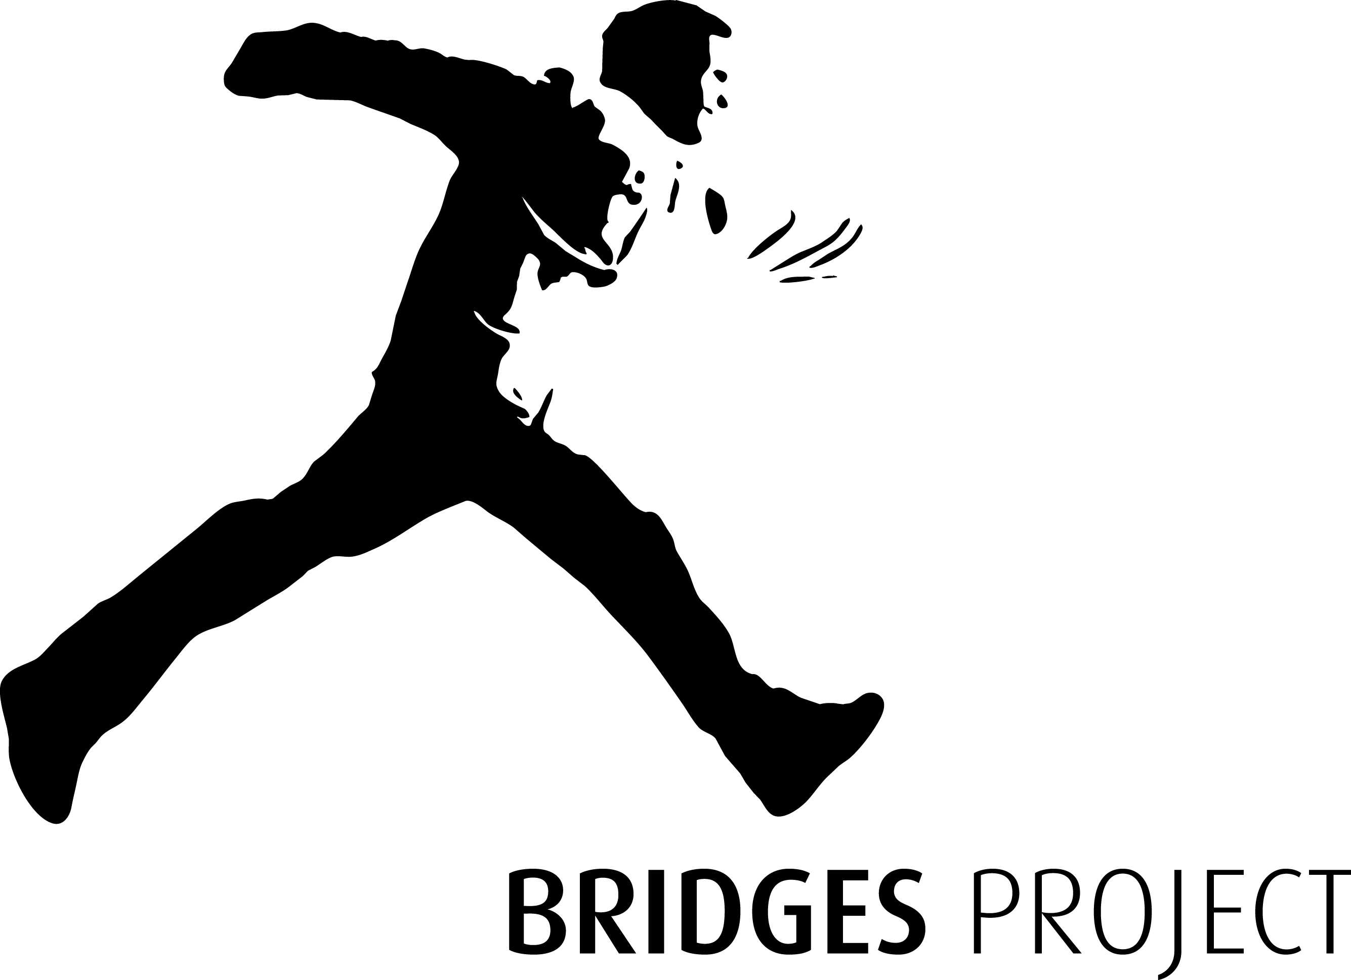

Equal Opportunities
Monitoring Form

Please indicate the job/s you are applying for:

Fundraiser 35 hrs

Bridges Project is striving to be an equal opportunities employer. In order to monitor the effectiveness of our policy in relation to employment legislation we would like you to fill in this form.

You are not obliged to fill it in, but we can assure you it will be treated in the strictest confidence. It will be detached from your application as soon as it is received, and it will not affect the selection procedure in any way.

You may send it under separate cover if you prefer.

Please tick the appropriate boxes, or leave blank if you prefer not to say

1. Age
 | 16-19 |  | 20-29 |  | 30-39 |  | 40-49 |  | 50-59 |  | 60+
2. Gender
 |  |  |  |  | Male |  |  | Female
3. Marital status
 | Single |  |  | Living with partner/ married/ civil partnership |  |  |  | Divorced/dissolved
4. Nationality
 | Please write in: _____________________________________________

Continued overleaf:

5. Ethnic Origin
A. | White
 | Scottish |  |  | Irish |  |  |  |  | Other British |  |  | Other White
B. | Mixed |  |  | Please write in: _______________________________________
C. | Asian or Asian British
 | Indian |  | Bangladeshi |  |  |  |  | Pakistani |  | Chinese |  |  |  | Other Asian background
D. | Black or Black British
 | Caribbean |  |  |  |  |  | African |  |  |  | Other Black background
E. | Other ethnic group |  |  |  |  | Please write in: __________________________________
6. Religion
 | My religion is (please specify): _______________________ |  |  |  |  |  |  |  |  |  |  |  | I do not have a religion
7. Disability
 | Have you a disability as defined under the terms of the Disability Discrimination Act 2005 and the Equality Act 2010?
 | Please specify: __________________________________________________________
8. Sexual Orientation
 |  | Heterosexual |  |  | Lesbian Bisexual |  |  |  |  |  | Gay |  |  |  | Transgender

Thank you for completing this form.

Please return it to:

Bridges Project, Bogpark Road, Musselburgh, EH21 6RT

Please mark envelopes ‘Strictly Confidential’

