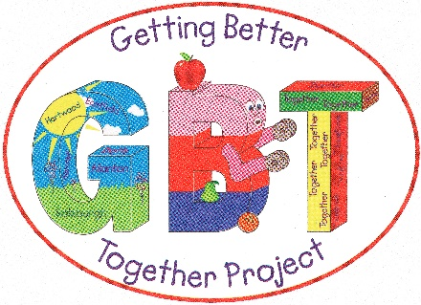

**Job title:** Radio Development Worker (Funded by Young Start for two years)

**Salary:** £12,000 per annum (£21,000 pro-rata)

**Hours of Work:** 20 hours per week (evening work expected)

**Location/Base:** Getting Better Together Ltd,Shotts Healthy Living Centre, Kirk Rd, Shotts, ML7 5ET

**Reporting to: Youth Development Worker**

**Managed by: Executive Manager**

**Main Purpose:**

To work as part of the Getting Better Together team supporting a 2-year youth radio project.

The post will specifically support the development of a youth-led radio station within the Fortissat Ward of North Lanarkshire, creating a community asset accessible to all community members with local young people taking the lead.

You will be working closely with the Youth Support Worker and Youth Development Worker and will communicate with a variety of holders including; schools, community groups, sports groups and community members.

The **Radio** **Development Worker** will oversee the development of the community radio station. Supporting the inclusion of volunteers and training, who in turn will support the running and output of the station. The post holder will work with the Youth Development Worker and Youth Support Worker to create schedules, policies and procedures, marketing materials, and organise administration work, involving supporting volunteers wherever possible. The successful candidate will also play a leading role in the transition to an FM station within the life time of the post.

The project requires a motivated individual who has experience in media and working with communities.

Experience of audio content creation is essential.

Experience in radio(online or otherwise) would be advantageous.

The role requires exceptional organisational and communication skills as well as the ability to work to your own initiative and be able to work well within a team setting.

**Key Responsibilities**

* **To** support disadvantaged young people to take part.
* **To** support other community members to take part.
* **To** create an inclusive atmosphere for volunteers to get involved.
* **To** lead the development of the station.
* **To** safely operate the organisations assets.
* **To** work with the Youth Support worker in content creation.
* **To** work with other Getting Better Together staff who deliver youth and other programmes.
* **To** work with partner agencies to ensure a multi-agency approach is being achieved within all aspects of the projects work.
* **To** work with the Youth Development Worker to devise suitable monitor project outcomes, which clearly demonstrate the projects effectiveness to funders, users and partner organisations.
* **To** attend staff training, staff meetings and undertake training courses pertinent to the role where required and directed by the organisation.
* **To** ensure that all activities, outings and workshops comply with Health and Safety, Risk assessments, Standard Operating Procedures and Child Safeguarding requirements.]
* **To** undertake any other tasks suitable to the level and nature of the post as deemed appropriate by the Executive Manager.
* To carry out other duties, which may reasonably be required in light of the main purpose of the job

**Person Specification**

*Essential*

* Qualification to at least HND level in a related subject to the position
* At least two years experience in Community work or similar field.
* Understanding of working in the voluntary and charitable sector.
* A knowledge of radio/audio production.
* Excellent organisational skills and an ability to communicate at all levels both orally and in writing.
* Excellent time management skills.
* Ability to inspire and relate to challenging client groups.

*Desirable*

* Experience in community/online radio.
* Knowledge of creating online content.

