

We have several rooms for hire, including IT suite and a fully fitted kitchen - suitable for small to medium

community groups.

Charges very according to size.

Call us to discuss your needs.



**Room Hire**

**Want to find out more?**

**Call us on 01698 888893**

**Email:** [**admin@ldvg.org.uk**](mailto:admin@ldvg.org.uk)

**Registry House**

**55 Victoria St**

**Larkhall**

**ML9 2BW**

**www.ldvg.org.uk**

Larkhall & District Volunteer Group

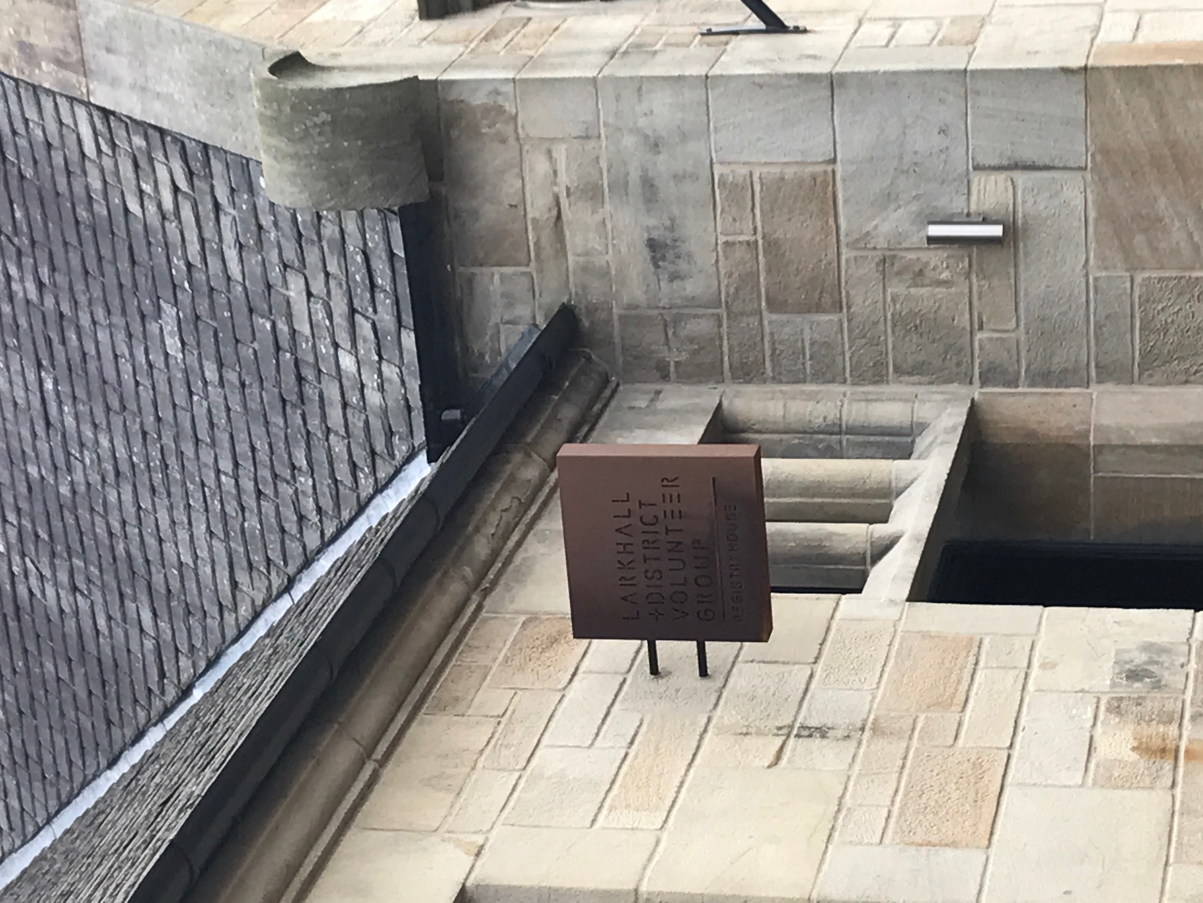



We have minibuses available for hire with driver/self drive.

Call for more information.

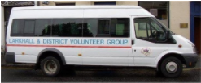

**Bus Hire**

Registered Charity SCO 28557





**Larkhall & District Volunteer Group**





**Room Hire**



Larkhall & District Volunteer Group is a voluntary organisation formed in 1994 as Avondale Careline to provide a friendly chat on the phone to elderly, disabled and housebound

**Services** have expanded and now include:

≠ Transport

≠ Call Line

≠ Handyperson service

≠ Lunch Clubs

≠ IT Groups

≠ Keep Fit

≠ Gardening Group

≠ Walking Group

≠ Genealogy Group

≠ Football Classics

≠ Monthly Tea Dance

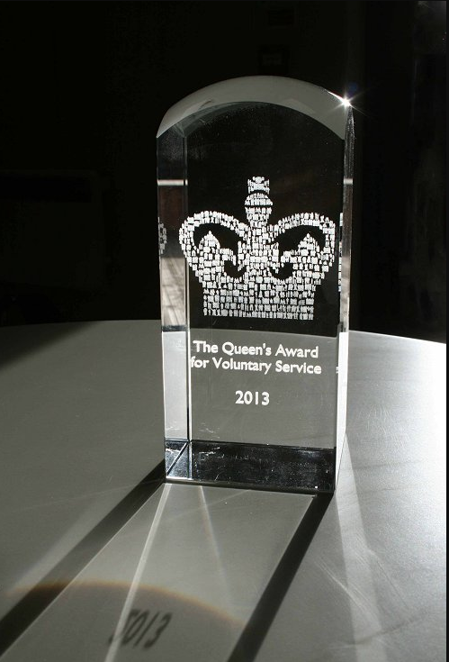





With our volunteers, we work to provide services for people in Larkhall and surrounding areas, particularly people who are feeling isolated.

We offer a range of activities and social events and are always keen to develop our services.



We also have a range of volunteering opportunities including:

**Drivers**

**Escorts**

**Handypersons**

**Telephone befrienders**

**Admin assistants**

**Lunch club assistants**

**Interested in joining us?**

**Call: 01698 888893**

**About Us**

