**Community Capacity Building and Carer Support**

**End of Year Report - 2018/2019**

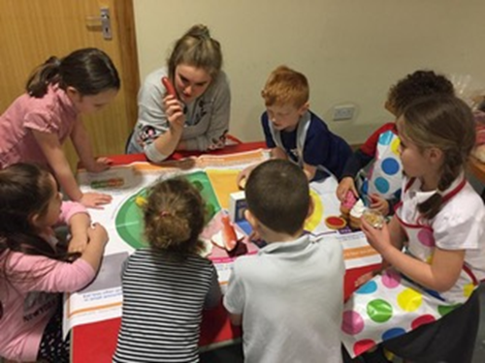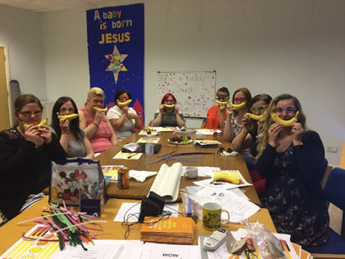

**Date: May 2019**

**Period Covered: 1st April 2018 – 31st April 2019**

**Author: Jacqui Melville**

**Contact: Jacqui Melville Jacqui.melville@vanl.co.uk**

**CONTENTS**

**Introduction**

**Background**

**Quantative Outcomes**

**Delivery Update**

**Strategic Update**

**Conclusion and Analysis**

**Next Steps**

**Recommendations**

**List of Appendices**

**1 Organogram**

**2 Budget**

**3 Outcomes by Theme**

**4 Outputs by Theme**

**5 LAP Spend**

**7 Case Studies**

**INTRODUCTION**

Community Capacity Building and Carer Support (CCB&CS) is Health and Social Care North Lanarkshire’s Third Sector delivery branch (structure included as appendix 1). Through the CCB&CS Strategy the Third Sector’s contribution is co-ordinated, robustly monitored and works to the regional logic model based on a series of programme outcomes. The CCB&CS work is based on co-production (which includes co-commissioning at a community level); giving people choice and control and connecting people to their communities.

Using nine thematic leads to guide best practice and 6 locality host organisations to ensure a truly community led approach, a devolved budget of £1.14 million is directly invested in organisations and community groups with countless others receiving support from other means. Investment ranges from micro-investment and matched funds to strategic investment in thematics of up to £75,000. Our programme approach ensures that all activity links to programme outcomes and that best value is achieved. Additionally, the programme is able to use its budget to leverage a significant although variable amount of additional funding and in-kind contributions. In 2018/2019 a conservative estimate of in-kind of contributions totalled £62,775 with £485,000 additional income leveraged.

Our approach has been recognised nationally and internationally as a model of best practice to achieve outcomes for citizens and get best value from the Third Sector. This report details the activity and outcomes for the first quarter of 2018/19.

**BACKGROUND**

It is widely recognised that a key component of managing future demand in terms of health and social care is prevention. It is also recognised that the health and wellbeing of the population can be negatively impacted upon by issues such as lack of physical activity, poor nutrition, poverty and inequality and more recently, evidence has been growing on the negative impacts on physical and mental health of isolation and loneliness.

The Community Capacity Building and Carers’ Support programme and its 5 year strategy focus on supporting the prevention agenda. The programme is built around a personal outcomes based approach which looks at the individual and their strengths and seeks to improve lives by reconnecting people with their own networks, communities and community assets. This approach also recognises the key contribution of carers and the importance of supporting them in their role and improving their personal outcomes.

By having the overarching aims of preventing isolation and loneliness and addressing inequalities; by moving away from defining people by age or condition; by reconnecting people with their communities; and by looking at innovative approaches which support people to be more active and to have a better diet, we can significantly improve the health and wellbeing of the population. This approach will also build more inclusive, cohesive and resilient communities thereby reducing future reliance on statutory agencies and services.

**PROGRAMME OUTCOMES**

The graph below shows the aggregated programme outcomes which were achieved in the year 2018/2019. This is broken down by theme in appendix 3. Details of the outputs employed to achieve these outcomes are detailed by theme in appendix 4.

**DELIVERY UPDATE**

**LOCALITY PARNTERSHIP DEVELOPMENT PROGRAMME (LPDP)**

The LPDP forms the backbone of the CCB&CS structure and ensures that the principles of co-  
production and needs led activity is adhered to at all times. The model enables co-designing, co-  
delivery and co-commissioning at a local level.

*I couldn’t leave the house at one time following a nervous breakdown … I could barely talk to people before and now here I am leading a project and have become treasurer so it just goes to show how much my confidence has increased and I’d encourage any men who are in similar circumstances to give it a go.*

Bellshill Locality Feedback

The commissioning process is enabled through the Locality Activity Fund (LAF) whereby £30,000 is  
allocated per locality to be managed and distributed as a micro fund via the Locality Consortia.

The LPDP use the Locator Tool (North Lanarkshire’s Third Sector information tool) to  
provide information about community supports for people living and working in North Lanarkshire. It  
includes details on community groups; activity groups; peer support groups and advisory  
organisations. These groups cover a broad range of supports from physical activity, crafts, Bookbug, to singing groups, historical interest groups and many more.

Crucially, Locator is embedded within Making Life Easier (MLE) the on-line self-management tool developed by NLC. Locator also has a link to MLE making this a two way support.

Together, they support the 3 key principles of the CCB&CS approach which are the promotion of:

* Community Connectors - whereby all third sector staff and volunteers are enabled to  
  'connect' people beyond one support or service to their own community, avoiding  
  the creation of additional dependence
* Self-Management - whereby all third sector staff and volunteers are able to signpost and  
  where appropriate support people to use MLE and the supports, services and adaptations  
  therein and;
* Promoting independence and developing resilience in individuals and communities.

**Airdrie**

Airdrie Consortium funded twelve different projects through the Locality Activity Fund offering 240 reports of reduced isolation and loneliness and 105 reports of better wellbeing for children and families. This included through the ‘Getting Ahead Group’ which worked with six new mums who were being supported by the community mental health team. The funding allowed a crèche to look after the baby whilst mum took part in the Cognitive Behavioural Therapy based workshops. The outcomes showed that the mums noted improved bond with their baby, improvement in their mental health and better links with community supports in their area in both 3rd and statutory sectors. All of those attended were discharged from the CMHT and required less support from their Public Health Nurse. The project evolved through partnership with the LPG and agreement to use LAF funding as a test of change. Due to successful evaluation, supported by the consortium and links with the children and families network lead, it has now been decided that H&SC will reinvest in the group going forward.

Additionally, the consortium funded the Time for Us project which is a 3 phase project that started in the summer in 2018. Engaging families from Plains, Central Airdrie & Caldercruix who all have children who have additional support needs in a mix of mainstream and ASN Education, the project targetted parent carers who struggled with their caring role during school holiday periods. Working in partnership with CLD, VANL, NHS Health Improvement, Hope for Autism and a wide range of 3rd sector support organisation to provide a 2 week summer programme, breaks from their caring role were provided to parents and included training to manage some of the issues affecting their children such as sleep workshops and food and nutrition workshops.

Phase 2 looked at supporting bonding and attachment and parenting with the families by providing craft activities for parent and child to work together, again this was fully supported by a partnership approach and many of the parents reported that this helped them reconnect with their child in a way that is often lost within their caring role.

Phase 3 was expected to take some time to develop and this was to look at the development of a peer support networking group from the previous 2 phase project. However, it became apparent quickly that the parents had made connections and friendships with each other, they had already developed a safe space to share their worries and issues in a judgement free environment. Co-Production again helped establish a venue within St Philips school that the group now meet weekly, planning activities, developing coping mechanisms and natural supports. The group have continued to go from strength to strength and are now at the stage were they could potentially, with some support from CLD and CCB&CS, become formally constituted and access funding to continue their development. Links with the group are good and they have also recently taken part in a project looking to test change within children and young peoples mental health services, by ensuring preventative and low level support is available whilst people wait for assessment and support from statutory services.

**Bellshill**

Bellshill locality have funded 27 projects many of which continue to deliver into 2019/2020 with a targeted reach of 1100 participants. This ranges from ‘Lingo Flamingo’ for those living with dementia to their Men’s and Women’s Sheds which are now well established and continue to grow.

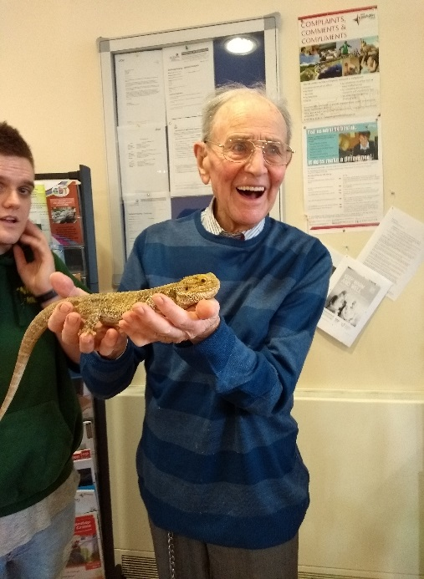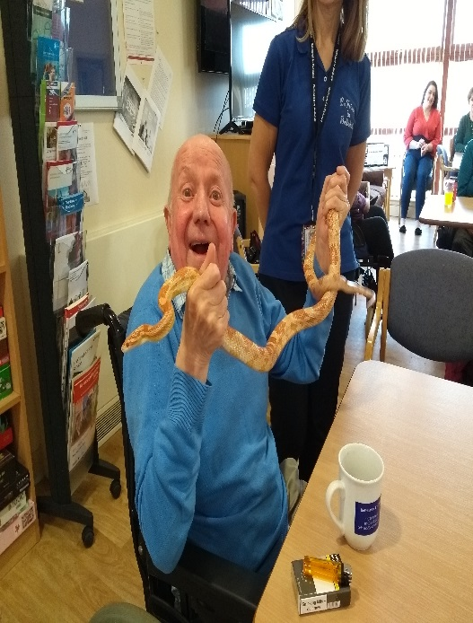

A new investment this year was in VIP Group to focus on the mental health and wellbeing of children and young people. The project aimed to offer a safe place to create calm confident kids in chaotic times by helping them manage stress and anxiety and to build positive self-esteem. VIP use *Relax Kids* which is a planned and structured programme which enables children and young people to complete a seven step system programme to take children and young people from a high energy levels to a relaxed state.

It teaches children and young people about mindfulness and how to feel calm relaxed and focused.

The outcomes are not noted in the end of year return but the the mid-point evaluation (based on 61 children P5 /6 /7 and after school mixed ages and three teachers) offers reports from children and young people on their learning as they note that ‘learned how to calm the meerkat’; that ‘I control the meerkat’ and that hey now knew ‘how to feel their energy using the energy ball’.

Through learned how (and why) controlled breathing support their wellbeing and many reported that it helped them to sleep better at night and that they ‘learned to breathe and not to panic’ and to ‘chill’ by deep breathing.’ One participant stated that it helped them to ‘not worry worry worry’.

The teachers from the three classes were asked if they had noticed any impact Relax kids was having on the children:

*I found the class to be generally very happy and upbeat after the sessions. I could tell they really enjoyed them. During the sessions children who normally find it difficult to be still and quiet were very calm and settled.*

*Children looked forward to go to each session after school .Children who initially found it difficult to go and be still in session 1 had made progress and were a lot calmer towards their last session*

When Relax kids was offered as an after school activity 51 children wished to attend and the sessions had to be split in to 2 x four week blocks to allow all children to participate .It was noted by the school that there had never been such a large amount of children signing up for After school activities and there has been some interest in parents attending a session with their child/ren to understand what Relax Kids is about and integrate learning in to the home

**Coatbridge**

Coatbridge Locality funded 18 projects evidencing 242 reports of reduced isolation and loneliness. The impact that this work is well demonstrated through a participant of the Alternatives to Violence Programme:

*On the Friday night I had no hope, and now I see there are other people like me and there is hope to change.*

As well as working in capacity building at a local level, Coatbridge made links with the Community Connectors. The Community Connectors are funded through the CCB&CS bid to Inspiring Scotland to drive forward support for those assessed as not being entitled to an individual budget at this time demonstrating the Partnership’s commitment to widespread support and promotion of self-management.

To this end, Coatbridge hosted an event to raise awareness of self-directed support (in its widest sense); evaluate the community’s current understanding of the guided self-assessment process and seek intelligence on what the community can do to enhance and support this.

There were over 50 attendees with 49 service users completing an evaluation on the day. Of that:

* 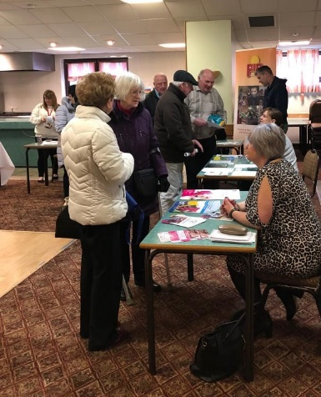45 people said that they felt more informed about supports within their local community as a result of attending
* 7 respondents felt more informed about the guided self-assessment process
* 12 individuals advised that their attendance at the event had influenced their decision around accessing a social care assessment
* 11 respondents reported that they were carers, with all of them advising that the advice that they had received would help them in their caring role.
* 10 carers also felt better linked with carer support and health and wellbeing services as a result of the information that they received
* 10 respondents felt more able to manage their caring role as a result of attending the event.

General feedback from evaluations indicated that the public would like to see more health, (including mental health) information at future events. This feedback will be considered in the planning and organisation of future events.

Further feedback from the event included the following comments from individuals:

*Information from Financial Inclusion team was very helpful.*

*A brilliant event, well organised and very welcoming.*

*Lots of information for people with disabilities - very helpful.*

*Practical Assistance for everyday living and advocacy info very interesting.*

**Cumbernauld and the North**

Cumbernauld locality activity fund has demonstrated impact resulting in 475 reports of enhanced use of information, advice and education. This has included in the ‘Living Life to the Full’ programme where a mother to a teenaged daughter reported the impact that being in prison has had on her and her daughter’s life. She spoke of ‘despairing lows’ and her ‘life taking a direction she never thought it would.’ She described her custodial sentence as ‘humbling experience’ but notes that ‘managing daily life as single parent and coping with the stigma of having been in prison’ was touch and resulted in stress, anxiety and depression to ‘levels that she had never had in her life before’ and which she found ‘frightening and distressing’. Despite the reservations, she noted:

*It dawned on me that I was amongst a group of ordinary people who each were facing their own challenges and who wanted to be supportive and non-judgemental. It had been so long since I had felt that kind of warmth and compassion, and it really touched me that people seemed genuinely interested in what I had to say and offer. I felt there was a strength in the room and a sense of peace and acceptance.*

The woman is now attending a summit in London for women who have served a custodial sentence and whilst she says that ‘everything in her life isn’t perfect, [she’s] been able to view things for a different angle’.

The range of work that the consortium is leading on and developing to meet their local needs also included in working with One Parent Families Scotland on a Single Dads Parent Community Hub; and supporting wider community engagement. Feedback from their funding of respitality breaks to Lanarkshire Carers’ Centre sums up the critical importance these community supports have on citizens and their carers:

*You’ve helped me stay sane.*

**Motherwell**

Motherwell Consortium have funded 19 projects through the locality activity programme evidencing 668 reports of reduced isolation and loneliness and 227 carers with optimised health and wellbeing.

Projects include ‘Chix with Stix’ which is a knitting group which facilitates work on behalf of the consortium including in the second hand smoke initiative where they knitted puppets for the ‘Jennie and the Bear Story’. However latterly the group have piloted creating trauma teddies which are distributed in partnership with Women’s Aid and Linus Quilts.

The Consortium also fund the Muirhouse Lunch Club which the Older people in the Muirhouse area of Motherwell had highlighted a need for this project based on attending a previous lunch club project within Isa Money Community Centre. 50+ older people used the previous lunch club, mostly 4 days a week and sometimes 5 days a week, over a 50-weeks per year period.

Lunches are now provided by North Lanarkshire Council and the group will be generating income by charging an extra 50p per meal which will help fund additional social activities for participants. Older people have stated that the lunch club is a vital activity for helping combat social isolation and ensuring establishing of social networking opportunities with other older people on a regular and ongoing basis.

Without the lunch club participants have said their mental and physical health would suffer as this group is a lifeline for them and would be isolated without this. For example, several members of the group have ongoing mental health issues and attending the lunch club has been beneficial in improving feelings of anxiety and nervousness as they have been able to regularly interact with people of a similar age and share similar experiences. Some also have caring roles, while others are in the early stages of caring.

**Wishaw**

Over the year, Wishaw have funded 18 projects and supported a number of initiatives ranging from autism awareness to suicide prevention; intergenerational projects to work with kinship carers. Two events were delivered promoting health and wellbeing through cycling.

The events were organised in partnership with the consortium and Cycle Scotland linking with the Scottish Government strategy to encourage more cycle use and reduce carbon emissions. The program linked with the Consortium Development plan aims to;

* Increase Physical Activity across generations
* Improve air quality reducing impact on COPD and other LTCs
* Provide access trails for all ability bikes.

The events attracted over 100 people try out alternative bikes and encouraged older people to re- engage with the sport. The event also targeted younger women to try out cycling as an activity.

One of the successes from this event came from the Nursing Homes. Both Nursing homes in the Shotts Locality attended with a number of clients. All tried ‘a wee road trip’ on an accessible bike and enjoyed them to the extent the nursing homes are enquiring about joining a cycle group who has access to these bikes. The program possibly identified a gap in locality provision and one which requires match funding to be sought.

12 under 5s practiced on balance cycles, four of whom went onto cycle unsupported.

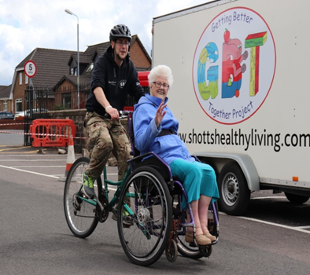

**Case Study** -Jeanie is 86 years of age living in a local nursing home. She attended the Big Bike Revival with the help of support workers. She was brought down to the event as she had shown interest in cycling. Jeanie often reminisced about cycling to work at Kingshill Pit Allanton 60 years ago. She started cycling for two reasons 1. To save her bus fare – she was planning on getting married and needed to save for a wedding breakfast. 2. She was bigger than her older sister so needed to slim down to get into her wedding dress! Jeanie ‘held court’ with the younger attendees listening to her every word when she recalled having to cycle to work. Jeanie ‘road tested’ the assisted bike. Away for a good 20mins Jeanie returned revitalised advising her charges that this was what she needed....’ to feel the wind in my hair again !’. The Nursing Home staff were not aware of the types of accessible bikes on the market and this event offered opportunity for people to try out types of cycles which suited them best. As a result the staff are now thinking of fundraising to buy two accessible bikes to give resident the opportunity to participate in a past activity

**Advocacy**

Preventative Advocacy continues to be promoted and delivered across the six localities building strong links with the statutory, private and voluntary sectors in efforts to build capacity for all citizens and carers ensuring that their quality of life is enhanced within local communities. This is being achieved by carrying out a programme of outreach work including 1:1 advocacy support, information stands, surgeries, talks and presentations.

The purpose of utilising outreach work is to ensure that members of the community have increased access to relevant information, knowledge and support which will allow them to make informed choices and decisions in relation to their lives and have a greater sense of control regarding their future, also improving confidence and general wellbeing.

A Preventative Advocacy Programme aimed at all North Lanarkshire Sheltered Housing Complexes in collaboration with NLC Housing Department has been developed with the aim of delivering future planning talks to all residents. To date there have been eleven sessions scheduled with a further twenty three to take place.

The one to one preventative advocacy – which complements the statutory provision – continues o have an impact:

Before Advocacy: *I feel a bit overwhelmed and not sure who to talk to. My grandson finds it difficult to make friends of out of school but they don’t live near us and I don’t drive. He also needs a new school uniform and finances are tight this worries me.*

With Advocacy and Connections: *I feel so much more positive about the future. My grandson will be able to make new friends in his new club. I can go along with him and have a cup of tea and a chat. Having the extra kinship money will make all the difference, and the £100 will enable us to go the Christmas panto and have a day in Edinburgh.*

**Community Based Palliative Care**

The community based palliative care project continues to run taking a person-centred approach (case study as appendix 7) and based around an initial assessment completed by a Community Nurse and in the patients’ home. It identifies goals and puts a plan in place to support outcomes for patients and carers. They support a wider community team which includes 51 volunteers who access a huge range of training and supports themselves.

From this project:

* 318 people have been assessed by the community nurse
* 248 people are accessing complementary therapy
* 265 people (including carers) are accessing befriending support
* 242 reports of reduced isolation
* 177 reports of increased information
* 207 people with increased independence

With a key focus and impact on carers:

* 127 short breaks have been accessed
* 137 reports of increased ability to manage their caring role
* 135 reports of better wellbeing

Using the above as evidence of the efficacy of the approach, St Andrews Hospice are part of a partnership bid to Big Lottery to continue the work in 2019/2020 onwards with confirmation expected in June 2019.

**Community Food**

The Community Food Project – led by Lanarkshire Community Food and Health Partnership – delivered 114 healthy cooking sessions to 339 locality participants across North Lanarkshire. These sessions were tailored to meet the needs of the localities and targeted specific long term conditions or vulnerable groups and resulted in 146 reports of reduced isolation and loneliness; 65 carers having a short break from their caring role and 115 family reports of increased sense of wellbeing.

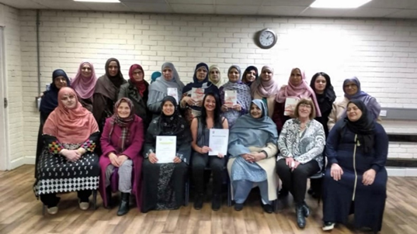

This a included a pre-diabetes course which was delivered following a review of the current services in North Lanarkshire which showed that there is a course called Diabetes Self-Management Type 2 Education Programme (STEP) and a Pre-Diabetes programme in Cumbernauld that has been running for around ten years. Additionally, a weight management programme called the Weigh to go is also free at Sports Centres. However, neither of these included healthy cooking, which is an important factor for health and life skills. It was also highlighted that there was a gap in services for people with pre-diabetes based on consultations with NHS Lanarkshire specialist diabetes team.

Two tailored courses were delivered in Airdrie and Coatbridge:

* A course targeting individuals with symptoms of metabolic syndrome (for instance, high cholesterol, high triglycerides, hypertension and/or elevated blood glucose/diabetes etc)
* Two courses targeting individuals with pre-diabetes and diabetes (both included carers)

These courses were designed to support people in the community by helping them to make informed food choices and motivating them to cook quick, nutritious meals in class and at home. Additionally, each course is tailored to meet the needs of the group, with focused advice on diabetes, healthy eating and cooking. All courses were flexible and person-centred to meet health and social outcomes.

*I have been able to support my husband in reducing his sugar intake and I am also more aware of increasing fibre in our diet which helps with bowel movement and blood sugar*

A course was also in Viewpark in partnership with NHS First Steps workers which was tailored to meet the needs of women who had experience trauma in early years parenting and / or domestic abuse and who had suffered mental ill health as a result. From this, the following feedback was gathered:

*I enjoy coming to the class as it provides some ‘me time’, something I don’t really get in the house.*

*I look forward to Monday as I know I have the cooking class [and] it’s good to get out of the house.*

*I’m glad the class was small as I’m trying to build my confidence.*

Additionally, Big Chef; Little Chef was run for those parents who wanted to learn to cook with their children and building of the benefits of a shared activity; confidence building (for both) and healthy eating:

*I can’t believe she’s trying peppers and wholemeal pitta bread; the pizza faces as so easy to make.*

*My son is sleeping within seconds after his mug of hot milk; I can’t believe it*

*I’ve still not bought a sausage roll and I don’t plan to. My son is never getting one again.*

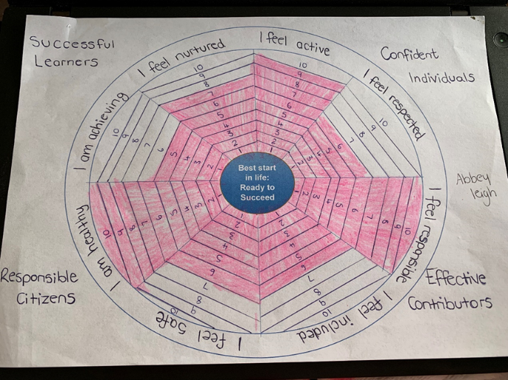

**Community Transport**

Over the year 21,549 passenger journeys were provided of which 3172 were provided by volunteer drivers, 625 were through the NHSL Hub transport bookings and a further 17101 covered all of the North Lanarkshire Community Transport providers. The geography of the volunteer driver service (to December 2018) is included below:

The impact of volunteer driving can not be underestimated since it is key to supporting participation and preventing loneliness. Mr A, a resident of a local care home and a non-transferable wheelchair user. Over the festive season of 2018, the family tried in vain to Mr A to the family Christmas and New Year’s day celebrations which he had not been able to attend for several years. However, every option was cost-prohibitive. GBT however, organised the transport for Mr A enabling him to participate fully in the family festivities. Another local family heard about the service and arranged for GBT to do the same for their mother – Mrs Z. Mrs Z was able to be with her family on Christmas Day for the first time in four years

.

3172 total journeys

1163 Vol Driver journeys

3995 volunteering hours

47,305 miles covered

**Dementia**

The dementia project has continued to raise awareness and education around those with living dementia both working with those directly affected and raising capacity of communities.

The Lingo Flamingo session were launched in Coatbridge and Glenboig where people with dementia and carers can engage in therapeutic language classes which aim to build self-management and reduce isolation. It also creates the opportunity for more people to engage in rural activities and gave participants the opportunities to engage in activities they hadn’t accessed before. It is hoped that these classes will enable people to forge relationships and help them engage in their wider community.

Additionally, work continues is raising awareness of the condition including dementia friendly sessions to groups such as Bonkle Church, Forgewood Community Centre, Sporting Memories, Culture NL. In Airdrie, a session was delivered to those with additional support needs demonstrating the commitment to engaging the whole community in widest possible awareness.

**Hospital Discharge**

In the year, 531 people were supported through the sharing of information from the Hospital Discharge project, with 353 referrals being made as well as 175 carer sign posts and 107 direct carer referrals. From this, there were 246 reports of reduced isolation and loneliness; 139 carers better able to cope with their caring role and 18 short breaks for carers reported.

The impacts of this on supporting the statutory sector (as well on enhancing partnership relationships) are demonstrable as below:

*As part of an integrated team, the role is invaluable. We often screen people who do not require home care, as their main issues are social isolation and loneliness. Having you around means that we have another option to consider, this is beneficial given the current pressure on the social care arena.*

*Being co-located with us within the hub makes the referral process to you seamless, and again allows cohesion of information between different services. With the ultimate aim of getting people home with the right support.*

*Discharge Facilitator*

More importantly, this has supported those people who are discharged from hospital in a variety of ways:

*The days can seem very long between home care visits; it would be nice to speak with other people*

*I am afraid I am losing my independence and contact with the community.*

*I lack motivation as I feel that I do not have something to look forward to. As a result, I do not manage my diabetes. I hope your referral can help me.*

*I am anxious about going home and the progression of my cancer treatment. Thank you for linking me with the Community Palliative Care Support.*

*Thank you for considering my role as a carer.*

*I have never considered any support for myself as a carer. I have always felt this was my duty and the importance lay with getting support for my Dad.*

**Community Alarms**

During the year, a total of 536 visits were completed and 808 telephone contacts made. In the vast majority of visits a complete review has been completed including an alarm test and a discussion around community support.

A high percentage of these visits have been a 6-week review which is conducted following a new Community Alarm installation. The aim of this visit is to remind the user how the alarm works, check contact details and discuss any potential support needs. This type of visit is valuable as often the community alarm is installed along with a number of other supports arranged on discharge from hospital. This can be busy time, which can make it difficult to retain all the information that is being delivered at that time.

With regards to the signposting carried out, the information is varied. This has included information on Health and Social Care Supports such as Making Life Easier as well as 3rd Sector options. During home visits the Community Alarms Team facilitates a personal outcomes conversation to identify any further support needs that can be met by the 3rd sector. The advice and support provided varies depending on the needs and wishes of the individual and their carers. As well as signposting to community support, the Community Liaison Officer will also make direct referrals to a range of key community referral partners. There has also been information provided and requested for local services such as a gardener and podiatrist.

**Physical Activity**

Co-ordinating and reporting on the combined investment in physical activity to include ‘Active Health’; ‘Weigh to Go’ and the ‘Macmillan Programme’, through CCB&CS 1773 people were referred to specialist health classes; 4608 were referred to the Active Health Programme and 318 to Weigh to Go. From this, there were 3350 reports of improved independence and wellbeing.

The following demonstrates the individual impact and move to better physical and mental health that these classes have:

*Look forward to the class each week. Its happy and enjoyable place to be. Good company, instructor advice from teach – having been attending for a few weeks I feel I’ve made new friends and am more mobile, thank you.* MK 87 Kilsyth

*More confident out of doors and on stairs. Have not had any falls since starting the class. Stretching exercises have helped with leg and back pain and stiffness. Drastic reduction in muscle cramps. Feeling healthier and better able to cope with activities of daily living.* HM 70 Chryston

*Having had regular access to the class has helped a lot. I can now do things without getting as exhausted. I can do things I could hardly do before without assistance. I enjoy this class and meeting the other people who attend. Great.* CT 64 Cumbernauld

*I won’t pretend it wasn’t hard sometimes and it took quite a while to get back to being fitter but I found the whole experience to be so inspirational that I took another leap and underwent training to become a Gentle Movement Instructor myself. Now I lead Gentle Movement Classes and the opportunity to help others and give something back has been a brilliant thing to do*

**Volunteer Development**

In the year, 158 volunteers were trained in a variety of courses which included: befriending; conflict resolution; equality and diversity; introduction to volunteer management; Making Life Easier; the Locator Tool; New technologies in volunteering; Moving in Volunteering (volunteering and employability); Personal development; communication and a number of others.

The project particularly aims to build capacity and as such there is ongoing focus on using the ‘Volunteer Friendly’ award to recruit, retain and recognise their own volunteers thereby building a sustainable programme of development. In the year, there were 15 organisations supported through the accreditation process.

Additionally, the majority of training aims to focus on promotion of self-management and community connections thereby ensuring a professional volunteer force who support the partnership’s ambitions (using MLE and wider community supports) to ensure that people live healthier more independent lives, with choice and control.

**STRATEGIC UPDATES**

**Carers**

The Carer Network Lead continues to attend the LPGs and support carer representation by meeting with carers to provide updates. It is anticipated that there will be a carer representative at all LPGs and this has been tested in the year. However, identifying carers, and indeed services users, who are willing and able to give their time to attend LPG’s, can be a challenge given both the number of meetings, the complexities that exist in relation to understanding the professional agenda and the demands on carers’ time. With direction from North Lanarkshire Carers Together (the lead organisation for carer representation, The CNL will be meeting with the service user lead and the lead for the third sector, to discuss ways in which we can progress more meaningful and effective representation, which truly represents the views and voices of carers and service users. NLCT is currently revising its model of carer representation and engagement in line with developments in the participation and engagement sub group and will inform the Strategy and Framework for participation which will be drafted for IJB approval in May 2019.

The Carer Network Lead met with the newly appointed Carer Coordinator within Wishaw General to discuss current and future carer support within the hospital setting and what needs to be developed to improve support for carers, with a particular focus on carer’s involvement in hospital discharge. Discussion took place around what is currently provided through the Community Liaison Service, Triangle of Care which NLCT have supported and NLCT’s quarterly information stands. The Carer Coordinator has also met with the Health and Social Care Partnership Carer Lead to discuss the ways in which developments within the acute setting link to wider strategic carer developments in relation to the New Strategy for Carers and the implementation of the Carers Act. The Carer Coordinator has become a member of the CSN and will provide members with updates on any likely developments and the ways in which they can be supported by the CSN.

A number of meetings have taken place with key partners to discuss and agree the use of the Carers Journey (CJ) within Equals Advocacy. It was agreed that the CJ engagement tool be reviewed in order to avoid confusion or indeed duplication of available support provided as a result of the completion of an Adult Carer Support Plan (ACSP). This work will be taking place over the next few months and an update on progress will be provided at the next CSN in July.

**Children and Families**

The Third Sector Children and Families Network continues to grow and flourish providing a key link to HSCNL priorities for children and families and the Third Sector who are often well placed to support and innovate around this work. As a result of liking with the Network with consortia, a number of tests of change have been funded ranging from work with the Dollywood Foundation (using books to build attachment); work with Homestart; Positively Growing with VIP (Bothwell) and a multi-agency transition project with St Philips.

The Network has also enable a mandated and consistent link with strategic developments including a well received input at the Lanarkshire Peri-Natal Mental Health Conference; input to the Neuro-developmental pathway work and links to the nutritional toolkit.

As the network evolves, it continues to link to priorities around ACEs; nurture and the promotion and support of breastfeeding. Regarding the latter, it is hoped that ongoing work with the ‘Community Mums’ model with build on the feedback that mums want someone they can contact by test any time and with whom they can build a relationship. Additionally, building on the success of the community bookbug work (including with the deaf community; with Syrian resettlement project and with the Polish community), bookbug is now being investigated for the antenatal units in the acute hospitals.

The Network lead has also delivered training to 79 on child protection and promoted attendance at multi-agency events and training creating a genuine partnership between the third and statutory sector to make North Lanarkshire the best place in the world to grow up.

**CCB&CS Improvement Service Review**

Review of the CCB&CS Programme was a Commissioning Intention in 2018/2019. In order to do this, the Improvement Service were engaged to lead on the work. As part of its role, the Improvement Service undertakes work with a variety of Community Planning Partnerships, Health and Social Care Partnerships, Integrated Joint boards, Child Protection and Adult Protection Committees across Scotland. This review was the first of its kind to review a Third Sector Strategy and was to consider how stakeholders felt that the CCB&CS had been performing in terms of the following areas which are derived from good practice concerning what makes for effective, outcome-focused partnership working. The areas reviewed were:

* Community Engagement and Participation
* Strategic Planning
* Focus on Outcomes
* Leadership and Relationships
* Governance
* Use of Resources
* Performance Management
* Reporting Impact

The Improvement Service described the findings of the review as very positive with the highest scoring three statements (noted below) demonstrating that outcomes are being achieved and endorsing the efficacy of the strategic, partnership approach:

* **Focus on Outcomes:** The CCB&CS programme outcomes link to the 9 national outcomes.
* **Impact:** By working together, the CCB&CS has delivered improvements which would not have been delivered by individual organisations.
* **Strategic Planning:** The CCB&CS strategy demonstrates an understanding of local needs and opportunities.

The following feedback was also offered in the comments section of the Checklist:

*Almost at every meeting, there are examples discussed that indicate strong partnership links and good working relationships - the wide-ranging remit of the CCB&CS encourages partnerships to develop that might not have otherwise happened.*

*The CCB&CS actively seeks to ensure its membership includes those who are able to articulate the communities they represent. Regular reviews of this are undertaken.*

*The people in the consortia contribute valuable local knowledge and understanding that cannot be gained from data and profile information*

*The CCB&CS is strategically placed between local communities and HSCNL partnership providing a two-way platform for discussing both strategic and local issues*

The review process has highlighted a number of strengths in terms of the areas covered in the Checklist, with the Improvement Plan focusing on how CCB&CS can further enhance its performance.

Four improvement areas and associated action plans were agreed. These are:

* The CCB&CS should improve the use of localised data in identifying key challenge and particular needs for localities. This includes refreshing how data is currently used and working with HSCNL to work with CCB&CS to better enable the Third Sector to inform data to build a more a holistic picture of community including using CCB&CS’ feedback from stakeholders and local knowledge.
* Consider how the process of funding the CCB&CS can be improved to support more effective strategic planning to meet the outcomes of the strategy. This includes looking at longer term funding; ensuring that prevention and early intervention and prevention remain a priority; and working to the strategic plan which aims to realign existing Third Sector Investment through CCB&CS to get better value and better outcomes.
* Identify more innovative and accessible ways to share information including performance governance and key messages including in branding CCB&CS better.
* Explore how CCB&CS can better market and celebrate their achievements across North Lanarkshire including developing a clear comms strategy (linked to above) and investing in a dedicated comms officer.

**CONCLUSIONS AND ANALYSIS**

This report demonstrates continued evidence of strong performance within the CCB&CS Programme as confirmed with the engagement with the Improvement Service which demonstrated strength in strategy, in outcomes and in impact.

Activity targets have consistently been met or exceeded and the type, style and content of the programme have evolved year on year to ensure effective delivery and fitness for purpose. Our ambition for ongoing support, development and training for the volunteer workforce in line with key priorities and principles of HSCNL (promotion of self-management and MLE; public protection; community connectedness and living more independent lives) ensures that their input is relevant adaptable and of high quality as would be expected of HSCNL staff.

More generally, the strategy sets out how the contribution of the programme can be grown through increased commissioning of Third Sector interventions supported by a more strategic approach to funding and investment.

The programme has also been very successful in recognising the importance of enablers such as community transport. These vital services keep people connected to friends and family, community assets, leisure facilities etc. in support of the programme outcomes. These services also support partners, by allowing communities to access their services, by reducing wasted appointments and by supporting hospital discharge.

Continuation and further growth of our personal outcomes and strengths-based approaches will see more prevention; more people enabled to self-manage by connecting with mainstream community resources; the emergence of more resilient communities; and fewer people seeking service solutions.

**NEXT STEPS**

In line with the five year strategy and associated commission plan, the next three years will ensure that the community and voluntary sector are enable to take cognisance and support action around key policy including but not exclusively the Carers Act, The Children and Young People’s Act and Self Directed Support legislation. Additionally, local priorities including promotion of ‘Making Life Easier’; self management and SDS; High Health Gain Individuals; addresssing inequalities and reducing isolation and lonelieness will be key to informing the delivery targets and work in the forthocming years.

Specifically, this will include:

* Supporting work on High Resource Users using test of change methodology
* Building on the work around the Inspiring Scotland funded (£246,000 over 2.5 years) collaborative bid from CCB&CS to test third sector to SDS process targeting those not entitled to an individual budget at this time
* Ongoing discussion on how to build and evolve the shopmobility service into a more holistic community connections model
* Responding to findings on work on social prescribing
* An investment of £190,000 in a consortium home-visiting and befriending project backed by £400,000 match-funding from a variety of sources and organisations
* The building of a management information system which will enhance programme reporting and inform future commissioning and impact in a way which is robust, proportionate and focussed on personal outcomes

Critically, a more strategic approach to investment will be outlined and implemented to ensure that the ambition of the strategy can be met in a way which is co-ordinated, sustainable and has the highest impact.

**RECOMMENDATIONS**

* To note the contents of the report

**ASSOCIATED DOCUMENTS**

* CCB&CS Five Year Strategy
* CCB&CS Commissioning Plan
* CCB&CS Improvement Service Report

Appendix 1 – Organogram

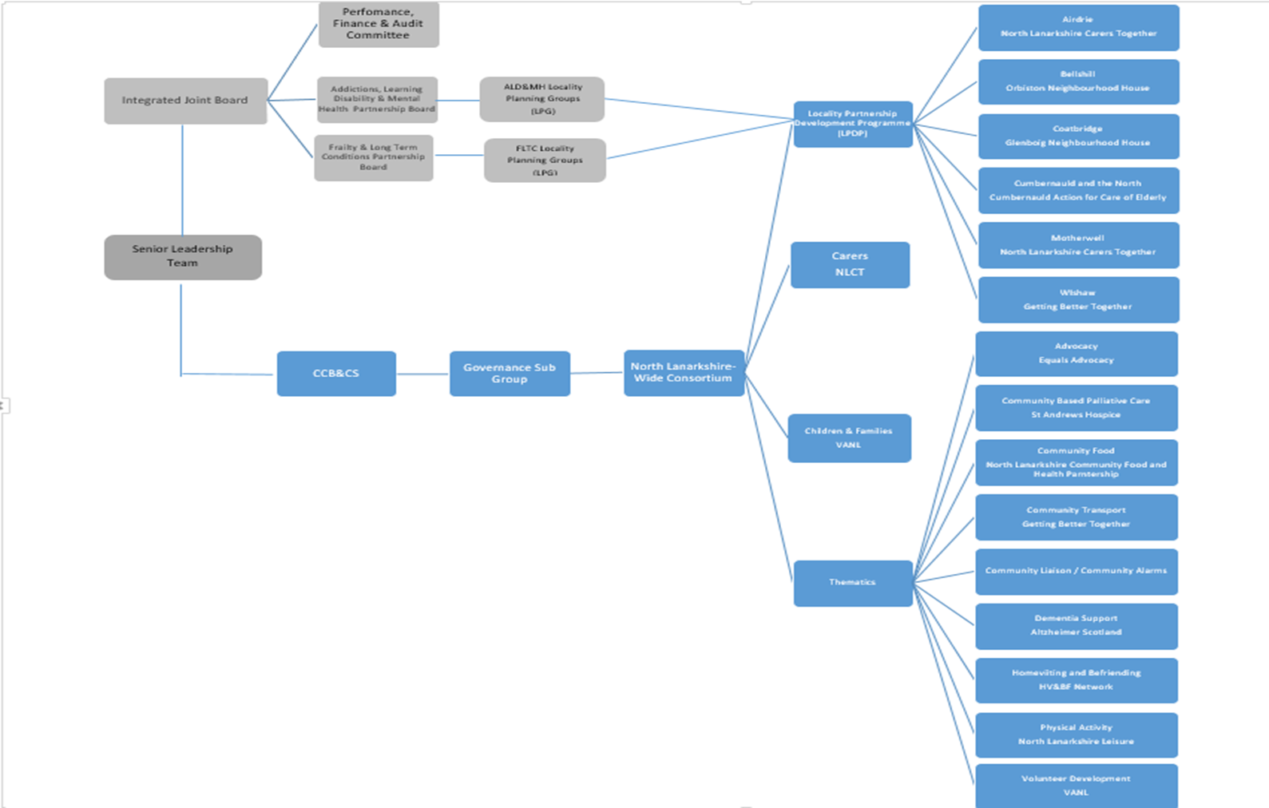

**Appendix 2- End of Year Budget**



**Appendix 3 – Outcomes by Project**

**Citizens**

|  |  |  |  |  |
| --- | --- | --- | --- | --- |
|  | 2018/2019 | | | |
|  | April – Jun | April - Sep | April – Dec | April - Mar |
| **Outcome: A reduction in isolation and loneliness** | **Total** | **Total** | **Total** | **Total** |
|
| Community Alarms |  | 7 | 9 | 13 |
| Advocacy | 8 | 18 | 23 | 43 |
| Community Based Palliative Care | 68 | 150 | 201 | 242 |
| Community Food | 30 | 63 | 145 | 202 |
| Community Liaison | 65 | 147 | 199 | 246 |
| Dementia Support | 150 | 240 | 340 | 420 |
| Physical Activity | 1493 | 3653 | 4880 | 3350 |
| Volunteer Development | 26 | 50 | 84 | 100 |
| Locality Activity Programme |  |  |  | 2607 |
| **Total** | **1840** | **4328** | **5881** | **7223** |
|  |  |  |  |  |
|  |  |  |  |  |
|  |  |  |  |  |
|  | 2018/2019 | | | |
|  | April – Jun | April - Sep | April – Dec | April - Mar |
| **Outcome: Enhanced use of information, advice and education** | Total | Total | Total | Total |
|
| Community Alarms | 152 | 475 | 792 | 1060 |
| Advocacy | 8 | 18 | 23 | 43 |
| Community Based Palliative Care | 56 | 88 | 120 | 177 |
| Community Food | 30 | 63 | 145 | 202 |
| Community Liaison | 64 | 147 | 199 | 246 |
| Dementia Support | 150 | 240 | 340 | 420 |
| Physical Activity | 1493 | 3653 | 4880 | 3350 |
| Volunteer Development | 47 | 85 | 143 | 176 |
| Locality Activity Programme |  |  |  | 2673 |
| **Total** | **2000** | **4769** | **6642** | **8347** |
|  |  |  |  |  |
|  |  |  |  |  |
|  |  |  |  |  |
|  | 2018/2019 | | | |
|  | April – Jun | April - Sep | April – Dec | April - Mar |
| **Outcome: Improved independence and well-being** | Total | Total | Total | Total |
|
| Community Alarms | 83 | 169 | 223 | 283 |
| Advocacy | 8 | 18 | 23 | 43 |
| Community Based Palliative Care | 68 | 109 | 159 | 207 |
| Community Food | 30 | 63 | 145 | 202 |
| Community Liaison | 65 | 148 | 200 | 247 |
| Dementia Support | 150 | 240 | 340 | 420 |
| Physical Activity | 1493 | 3653 | 4880 | 3350 |
| Volunteer Development | 27 | 44 | 94 | 146 |
| Locality Activity Programme |  |  |  | 2188 |
| **Total** | **1924** | **4444** | **6064** | **7086** |
|  |  |  |  |  |
|  |  |  |  |  |
|  |  |  |  |  |
|  | 2018/2019 | | | |
|  | April – Jun | April - Sep | April – Dec | April - Mar |
| **Outcome: People feel included, connected and safe** | Total | Total | Total | Total |
|
| Community Alarms | 14 | 28 | 58 | 70 |
| Advocacy | 8 | 18 | 23 | 43 |
| Community Based Palliative Care | 53 | 96 | 133 | 179 |
| Community Food | 0 | 0 | 0 | 0 |
| Community Liaison | 64 | 147 | 199 | 246 |
| Dementia Support | 150 | 240 | 340 | 420 |
| Physical Activity | 1493 | 3653 | 4880 | 3350 |
| Volunteer Development | 35 | 64 | 137 | 158 |
| Locality Activity Programme |  |  |  | 2613 |
| **Total** | **1817** | **4246** | **5770** | **7079** |
|  |  |  |  |  |
|  |  |  |  |  |
|  |  |  |  |  |
|  | 2018/2019 | | | |
|  | April – Jun | April - Sep | April – Dec | April - Mar |
| **Outcome: Citizens have greater access to health & wellbeing supports & services** | Total | Total | Total | Total |
|
| Community Alarms | 8 | 24 | 35 | 49 |
| Advocacy | 8 | 18 | 23 | 43 |
| Community Based Palliative Care | 56 | 134 | 181 | 200 |
| Community Food | 30 | 63 | 145 | 202 |
| Community Liaison | 65 | 148 | 200 | 247 |
| Community Transport |  |  |  |  |
| Dementia Support | 150 | 240 | 340 | 420 |
| Physical Activity | 1493 | 3653 | 4880 | 3350 |
| Volunteer Development | 19 | 60 | 99 | 158 |
| Locality Activity Programme |  |  |  | 2059 |
| **Total** | **1829** | **4340** | **5903** | **6728** |

**Outcomes by Project – Carers**

|  |  |  |  |  |
| --- | --- | --- | --- | --- |
|  |  |  |  |  |
|  | Apr - Jun 18 | Apr - Sep 18 | Apr - Dec 18 | Apr - Mar 19 |
| **Outcome: Carers have accessed a short break from their cairng** | Total | Total | Total | Total |
|
| Community Alarms |  |  |  |  |
| Advocacy | 0 | 0 | 0 | 1 |
| Carer Support | 102 | 243 |  |  |
| Community Based Palliative Care | 37 | 66 | 96 | 127 |
| Community Food | 17 | 28 | 47 | 65 |
| Community Liaison | 3 | 6 | 16 | 18 |
| Community Transport |  |  |  |  |
| Dementia Support | 100 | 220 | 310 | 380 |
| Physical Activity | 15 | 34 |  | 66 |
| Volunteer Development | 6 | 9 | 10 | 12 |
| Locality Activity Programme |  |  |  | 1021 |
| **Total** | **280** | **606** | **479** | **1690** |
|  |  |  |  |  |
|  |  |  |  |  |
|  |  |  |  |  |
|  |  |  |  |  |
|  |  |  |  |  |
|  | Apr - Jun 18 | Apr - Sep 18 | Apr - Dec 18 | Apr - Mar 19 |
| **Outcome: Carers have increased ability to manage or cope with their caring role** | Target | Target | Target | Target |
|
| Community Alarms | 50 | 106 | 144 | 188 |
| Advocacy | 5 | 9 | 13 | 21 |
| Carer Support | 102 | 189 |  |  |
| Community Based Palliative Care | 48 | 90 | 117 | 137 |
| Community Food | 17 | 28 | 47 | 65 |
| Community Liaison | 37 | 94 | 120 | 139 |
| Community Transport |  |  |  |  |
| Dementia Support | 100 | 220 | 310 | 380 |
| Physical Activity | 15 | 34 |  | 66 |
| Volunteer Development | 30 | 33 | 34 | 37 |
| Locality Activity Programme |  |  |  | 901 |
| **Total** | **404** | **803** | **785** | **1934** |
|  |  |  |  |  |
|  |  |  |  |  |
|  |  |  |  |  |
|  |  |  |  |  |
|  | Apr - Jun 18 | Apr - Sep 18 | Apr - Dec 18 | Apr - Mar 19 |
| **Outcome: Carers health and wellbeing is optimised** | Target | Target | Target | Target |
|
| Community Alarms | 91 | 191 | 266 | 330 |
| Advocacy | 5 | 9 | 13 | 21 |
| Carer Support | 86 | 159 |  |  |
| Community Based Palliative Care | 69 |  | 114 | 135 |
| Community Food | 17 | 28 | 47 | 65 |
| Community Liaison | 37 | 94 | 120 | 139 |
| Community Transport |  |  |  |  |
| Dementia Support | 100 | 220 | 310 | 380 |
| Physical Activity | 15 | 34 |  | 66 |
| Volunteer Development | 39 | 42 | 43 | 46 |
| Locality Activity Programme |  |  |  | 986 |
| **Total** | **459** | **777** | **913** | **2168** |
|  |  |  |  |  |
|  |  |  |  |  |
|  |  |  |  |  |
|  | Apr - Jun 18 | Apr - Sep 18 | Apr - Dec 18 | Apr - Mar 19 |
| **Outcome: Carer have been referred to direct carer support services** | Target | Target | Target | Target |
|
| Community Alarms | 1 | 2 | 3 | 5 |
| Advocacy | 1 | 1 | 1 | 1 |
| Carer Support | 195 | 394 |  |  |
| Community Based Palliative Care | 11 |  | 29 | 39 |
| Community Food | 17 | 28 | 47 | 65 |
| Community Liaison | 13 | 41 | 85 | 107 |
| Community Transport |  |  |  |  |
| Dementia Support | 100 | 220 | 310 | 380 |
| Physical Activity | 15 | 34 |  | 0 |
| Volunteer Development | 9 | 12 | 13 | 16 |
| Locality Activity Programme |  |  |  | 419 |
| **Total** | **362** | **732** | **488** | **1032** |
|  |  |  |  |  |
|  |  |  |  |  |
|  |  |  |  |  |
|  | Apr - Jun 18 | Apr - Sep 18 | Apr - Dec 18 | Apr - Mar 19 |
| **Outcome: Carer have been signposted to direct carer support services** | Target | Target | Target | Target |
|
| Community Alarms | 50 | 106 | 146 | 44 |
| Advocacy | 5 | 9 | 13 | 21 |
| Carer Support |  |  |  |  |
| Community Based Palliative Care | 22 |  | 59 | 73 |
| Community Food | 0 | 1 | 3 | 4 |
| Community Liaison | 41 | 83 | 123 | 175 |
| Community Transport |  |  | 310 | 380 |
| Dementia Support | 100 | 220 | 340 | 66 |
| Physical Activity | 15 | 34 |  |  |
| Volunteer Development | 11 | 14 | 15 | 18 |
| Locality Activity Programme |  |  |  | 804 |
| **Total** | **244** | **467** | **1009** | **1585** |
|  |  |  |  |  |
|  |  |  |  |  |

**Outcomes by Project – Children and Families**

|  |  |  |  |  |  |  |  |  |
| --- | --- | --- | --- | --- | --- | --- | --- | --- |
|  | **Apr - Jun 18** | | **Apr - Sep 18** | | **April - Dec 18** | | **Apr 18 - Mar 19** | |
| **Outcome: Sense of wellbeing is increased** | **Total** | | **Total** | | **Total** | | **Total** | |
|
| **Community Alarms** |  | |  | |  | |  | |
| **Advocacy** | 0 | | 0 | | 0 | | 0 | |
| **Carer Support** |  | |  | |  | |  | |
| **Community Based Palliative Care** |  | |  | |  | |  | |
| **Community Food** | 4 | | 38 | | 79 | | 115 | |
| **Community Liaison** |  | |  | |  | |  | |
| **Community Transport** |  | |  | |  | |  | |
| **Dementia Support** |  | |  | |  | |  | |
| **Physical Activity** | 13 | | 57 | | 84 | | 124 | |
| **Volunteer Development** | 41 | | 88 | | 146 | | 184 | |
| **Locality Activity Programme** |  | |  | |  | | 1872 | |
| **Total** | **58** | | **183** | | **309** | | **2295** | |
|  |  |  |  |  |  |  | |  | |  |
|  |  |  |  |  |  |  | |  | |  |
|  | **Apr - Jun 18** | | **Apr - Sep 18** | | **April - Dec 18** | | **Apr 18 - Mar 19** | |
| **Outcome: Mental Health is optimised** | **Total** | | **Total** | | **Total** | | **Total** | |
|
| **Community Alarms** |  | |  | |  | |  | |
| **Advocacy** | 23 | | 23 | | 30 | | 30 | |
| **Carer Support** |  | |  | |  | |  | |
| **Community Based Palliative Care** |  | |  | |  | |  | |
| **Community Food** | 4 | | 38 | | 79 | | 115 | |
| **Community Liaison** |  | |  | |  | |  | |
| **Community Transport** |  | |  | |  | |  | |
| **Dementia Support** |  | |  | |  | |  | |
| **Physical Activity** | 13 | | 57 | | 84 | | 124 | |
| **Volunteer Development** | 72 | | 110 | | 156 | | 137 | |
| **Locality Activity Programme** |  | |  | |  | | 1797 | |
| **Total** | **89** | | **205** | | **349** | | **2203** | |
|  |  |  |  |  |  |  | |  | |  |
|  |  |  |  |  |  |  | |  | |  |
|  | **Apr - Jun 18** | | **Apr - Sep 18** | | **April - Dec 18** | | **Apr 18 - Mar 19** | |
| **Outcome: Parental / Carer Attachment is improved** | **Total** | | **Total** | | **Total** | | **Total** | |
|
| **Community Alarms** |  | |  | |  | |  | |
| **Advocacy** | 0 | | 0 | | 0 | | 0 | |
| **Carer Support** |  | |  | |  | |  | |
| **Community Based Palliative Care** |  | |  | |  | |  | |
| **Community Food** | 8 | | 22 | | 79 | | 115 | |
| **Community Liaison** |  | |  | |  | |  | |
| **Community Transport** |  | |  | |  | |  | |
| **Dementia Support** |  | |  | |  | |  | |
| **Physical Activity** | 0 | | 0 | | 0 | | 0 | |
| **Volunteer Development** | 62 | | 103 | | 182 | | 250 | |
| **Locality Activity Programme** |  | |  | |  | | 1853 | |
| **Total** | **70** | | **125** | | **261** | | **2218** | |

|  |  |  |  |  |  |  |  |  |
| --- | --- | --- | --- | --- | --- | --- | --- | --- |
|  | **Apr - Jun 18** | | **Apr - Sep 18** | | **April - Dec 18** | | **Apr 18 - Mar 19** | |
| **Outcome: Resilience is improved** | **Total** | | **Total** | | **Total** | | **Total** | |
|
| **Community Alarms** |  | |  | |  | |  | |
| **Advocacy** | 23 | | 23 | | 30 | | 50 | |
| **Carer Support** |  | |  | |  | |  | |
| **Community Based Palliative Care** |  | |  | |  | |  | |
| **Community Food** | 4 | | 38 | | 79 | | 115 | |
| **Community Liaison** |  | |  | |  | |  | |
| **Community Transport** |  | |  | |  | |  | |
| **Dementia Support** |  | |  | |  | |  | |
| **Physical Activity** | 13 | | 57 | | 84 | | 124 | |
| **Volunteer Development** | 90 | | 158 | | 243 | | 263 | |
| **Locality Activity Programme** |  | |  | |  | | 1679 | |
| **Total** | **107** | | **253** | | **436** | | **2231** | |
|  |  |  |  |  |  |  |  |  |
|  |  |  |  |  |  |  |  |  |
|  | **Apr - Jun 18** | | **Apr - Sep 18** | | **April - Dec 18** | | **Apr 18 - Mar 19** | |
| **Outcome: Physical Activity Is Increased** | **Total** | | **Total** | | **Total** | | **Total** | |
|
| **Community Alarms** |  | |  | |  | |  | |
| **Advocacy** |  | |  | |  | |  | |
| **Carer Support** |  | |  | |  | |  | |
| **Community Based Palliative Care** |  | |  | |  | |  | |
| **Community Food** | 4 | | 38 | | 79 | | 115 | |
| **Community Liaison** |  | |  | |  | |  | |
| **Community Transport** |  | |  | |  | |  | |
| **Dementia Support** |  | |  | |  | |  | |
| **Physical Activity** | 13 | | 57 | | 84 | | 124 | |
| **Volunteer Development** | 23 | | 97 | | 129 | | 184 | |
| **Locality Activity Programme** |  | |  | |  | | 1921 | |
| **Total** | **40** | | **192** | | **292** | | **2344** | |

**Appendix 4 – Outputs by Project**

|  |  |  |  |
| --- | --- | --- | --- |
|  |  | **END OF YEAR FIGURE** | |
| **Theme** | **Outputs** | **Target** | **Actual** |
| Advocacy | Number of new referrals | 80 | 43 |
| Advocacy | Case load worked with in quarter (incl referrals from previous quarter not closed) | 45 | 18 |
| Advocacy | Training sessions delivered | 24 | 11 |
| Advocacy | Number of people attending training sessions | 240 | 186 |
| Advocacy | Surgeries held | 24 | 32 |
| Advocacy | Number of people attending surgeries | 80 | 671 |
| Advocacy | Stands hosted | 24 | 13 |
| Advocacy | Number of people attending stands | 300 | 1116 |
| Community Food | Locality Healthy Eating Sessions (Tailored to Locality) @ 16 sessions per six locality over the year (96 sessions in total) | 96 |  |
| Community Food | Locality Participants (targets based on 8 people attending each course lasting 4-8 wks long). Food demos can included a higher number. | 128 |  |
| Community Food | Healthy Eating Champions |  |  |
| Community Food | Recruited and/or in training | 12 |  |
| Community Food | Trained and Delivering | 24 |  |
| Community Alarms | Number of Visits/Reviews |  | 536 |
| Community Alarms | Number of Clients Contacted |  | 808 |
| Community Alarms | Number of direct referrals made for support |  | 10 |
| Community Alarms | Number of Clients/Carers Signposted |  | 322 |
| Community Alarms | Number of Direct Referrals made for Carers |  | 1 |
| Community Alarms | Number of Amendments to records |  | 595 |
| Community Liaison | Number of people supported for Information Received by the HDSP | 580 | 531 |
| Community Liaison | Numbers of referrals made by HDSP for Community Based Support | 300 | 353 |
| Community Liaison | Number of Carers Signposted for support by the HDSP | 280 | 175 |
| Community Liaison | Number of Carers referred for support or supported by the HDSP | 100 | 107 |
| Community Transport | Total Passenger Journeys |  | 21549 |
| Community Transport | Volunteer Driver passenger journeys |  | 3172 |
| Community Transport | GBT/SPT/NHSL Hub transport bookings |  | 625 |
| Community Transport | GBT CT  covering all CT members and GBT services |  | 17101 |
| Dementia Support | Deliver Dementia Friends sessions to staff and Families in Care Homes (Sessions) | 12 | 12 |
| Dementia Support | Work with care homes to share practice of activities for people with dementia. | 20 | 24 |
| Dementia Support | Support access to activities for people with dementia in care homes and for staff/families supporting them. | 20 | 24 |
| Dementia Support | Support groups in developing Dementia Friendly Communities through use of DFC Toolkit. | 40 | 20 |
| Dementia Support | Number of volunteers and participants of community groups involved in awareness and/or Dementia Friends sessions. | 160 | 180 |
| Dementia Support | Develop community activities in the rural areas to promote self management e.g Lingo Flamingo sessions. | 4 | 3 |
| Dementia Support | Establish a local Dementia Working Group where people with dementia and carers can feedback on engagement with dementia friendly communities. | 1 | 0 |
| Dementia Support | Number of people engaged with Rural Activities. | 40 | 35 |
| Dementia Support | Work with businesses to gain DFC commitment and recognition. | 20 | 20 |
| Dementia Support | Work with local business to raise awareness of issues and support for employees affected by dementia. | 40 | 28 |
| Dementia Support | Number of staff part of Dementia Friends/awareness sessions. | 200 | 230 |
| Dementia Support | Deliver awareness/ Dementia Friends sessions to BME groups that meet their cultural needs. | 120 | 100 |
| Dementia Support | Work with local churches to develop an engagement plan with people with dementia and carers to encourage people to continue going to church. | 12 | 15 |
| Dementia Support | Deliver awareness/ Dementia Friends sessions to groups who are affected by physical and learning disability. | 80 | 60 |
| Dementia Support | Work with partner agencies who support people with physical and learning disabilities to raise awareness of dementia. | 12 | 8 |
| Dementia Support | Deliver awareness raising/risk reduction events in partnership with health improvement and local consortia leads. | 4 | 1 |
| Volunteer Development | Volunteer Friendly Awards & Reaccreditations | 12 | 15 |
| Volunteer Development | Volunteers Trained Courses Various (as required but will be detailed in quarterly reports) | 100 | 158 |
| Volunteer Development | Promotion / Co-ordination to Multi Agency Training | 100 | 0 |
| Volunteer Development | Volunteer Together Events Consultation | 4 | 4 |
| Volunteer Development | Volunteer Together Events | 4 | 0 |
| Volunteer Development | Volunteer Together Attendees | 60 | 0 |
| Volunteer Development | Locator Tool Review and revamp | 1 | 4 |
| Volunteer Development | Locator Tool Launch Event | 1 | 0 |
| Volunteer Development | Community Connector Review and revamp | 1 | 3 |
| Volunteer Development | Community Connector Launch Event | 1 | 0 |
| Community Based Palliative Care | Total No of referrals assessed by Community Nurse | 248 | 318 |
| Community Based Palliative Care | No. of people accessing Comp Therapy (Inc Carers) | 300 | 248 |
| Community Based Palliative Care | No.of people benefitting from Vol Befrienders (Inc carers) | 188 | 265 |
| Community Based Palliative Care | No. of active Befrienders | 40 | 51 |
| Community Based Palliative Care | No. of Vol befrienders training sessions accessed | 100 | 117 |
| Children and Families | Strengthening of Children & families network ( membership) | 11 | 11 |
| Children and Families | Mapping service & input into locator | 22 | 23 |
| Children and Families | Meet with CLPG 3rd Sector reps on a regular basis | 3 | 3 |
| Children and Families | Embed access to Child Protection Training into core training delivered. | 4 | 4 |
| Children and Families | Co coordinating pieces of improvement work & develop appropriate Tests of change | 10 | 11 |
| Children and Families | Sleep Scotland Parent Workshop | 3 | 3 |
| Children and Families | Work with colleagues on breast feeding action group to increase rates | 5 | 5 |
| Physical Activity | Increase in the number of people being referred to the Specialist Health Class Programme | 1200 | 1773 |
| Physical Activity | Increase in the number of people being referred to the Active Health Programme | 2600 | 4608 |
| Physical Activity | Increase in number of people being referred to Weigh to Go | 350 | 318 |
| Physical Activity | Increase in number of people being referred to Macmillan’s Move More Progamme | 100 | 139 |
| Physical Activity | Increase in umbers of 12-16 year olds taking up the Get Active Teen programme | 100 | 124 |

**Appendix 5 - Locality Activity Programme Investment**

|  |  |  |  |
| --- | --- | --- | --- |
| **ORGANISATION** | **PROJECT** | **LOCALITY** | **GRANT AMOUNT** |
| Airdrie CAB | Airdrie Citizens Advice Redecoration | Airdrie | 300.00 |
| Fool On | Recovery Through Performing Arts | Airdrie | 3,944.00 |
| Health and Wellness Hub | Time for Us | Airdrie | 3,995.00 |
| Lanarkshire Carers Centre | Short Breaks Carers Information Service (Respitality) | Airdrie | 500.00 |
| Lanarkshire Carers Centre | Short Breaks Carers Information Service (Vouchers) | Airdrie | 500.00 |
| Love n Light Recovery Org | Understanding Addiction - The Root Causes | Airdrie | 3,000.00 |
| NHS Lanarkshire - Community Mental Health Team | Getting Ahead of Postnatal Depression | Airdrie | 1,119.00 |
| North Lanarkshire Carers Together | Time for Us | Airdrie | 650.00 |
| North Lanarkshire Council Childrens Carer Centre | Foster Carers Coffee Morning | Airdrie | 225.00 |
| St Andrews Hospice | Compassionate Communities (co-co) | Airdrie | 5,000.00 |
| The Health and Wellness Hub | Time for Us | Airdrie | 1,000.00 |
| VIP Arts & Sports Academy | Insane Dance & VIP | Airdrie | 8,586.00 |
| Wellwynd Art Group | Wellwynd Art Group | Airdrie | 2,381.00 |
| Alzheimer Scotland/CLD Lawmuir | Generation Garden | Bellshill | 440.00 |
| Befriend in Bellshill | Group Befriending and Development | Bellshill | 2,280.00 |
| Bellshill West Parish Church | West Fix | Bellshill | 1,500.00 |
| Flipside | Flipside Activities | Bellshill | 1,245.00 |
| Fool On | Mental Health Support - Performing Arts | Bellshill | 4,800.00 |
| Homestart | Walk, Talk & Play Pilot | Bellshill | 6,700.00 |
| Lanarkshire Carers Centre | Short Breaks Information Service - Meals | Bellshill | 500.00 |
| Lanarkshire Carers Centre | Short Breaks Information Service - Respitality | Bellshill | 500.00 |
| Lanarkshire Community Food & Health Partnership | Community Food | Bellshill | 1,920.00 |
| Utheo Ltd | Men's Group Development | Bellshill | 1,720.00 |
| VIP Arts & Sports Academy | VIP Positively Growing with VIP | Bellshill | 750.00 |
| VIP Arts & Sports Academy | VIP Relax Kids | Bellshill | 3,825.00 |
| Bellshill West Parish Church | West Flix (2) | Bellshill | 400.00 |
| Bellshill West Parish Church | West Table Tennis Club | Bellshill | 520.00 |
| Utheo Ltd | ONC Digital | Bellshill | 1,780.00 |
| Utheo Ltd | Bellshill Activity Programme | Bellshill | 1,820.00 |
| Alternatives to Violence Project Scotland | Alternatives to Violence Project | Coatbridge | 2,500.00 |
| Alzheimer Scotland | Lingo Flamingo | Coatbridge | 950.00 |
| Alzheimer Scotland | Lingo Flamingo | Coatbridge | 100.00 |
| Bazooka Arts | Bazooka Arts Community Workspace | Coatbridge | 750.00 |
| Buchanan High ASN School | Go Glenboig - Bikeability | Coatbridge | 2,000.00 |
| Coatbridge Kinship Carers | Strong Together | Coatbridge | 2,750.00 |
| Coatbridge Men's Shed | Coatbridge Men's Shed | Coatbridge | 1,130.00 |
| Coatbridge Men's Shed | Coatbridge Men's Shed | Coatbridge | 292.53 |
| Glenboig Development Trust | Senior Care Project | Coatbridge | 598.51 |
| Glenboig Development Trust | Jelly Bean | Coatbridge | 5,400.00 |
| Glenboig Development Trust | Connecting at Christmas | Coatbridge | 520.00 |
| Glenboig Neighbourhood House | Parent Carers Event | Coatbridge | 479.00 |
| Kirkshaws Neighbourhood Centre | Cooking for the Community | Coatbridge | 2,859.96 |
| Kirkshaws Neighbourhood Centre | Angels and Aeroplanes | Coatbridge | 1,452.00 |
| Lanarkshire Carers Centre | Short Breaks Carers Information Service (Creative) | Coatbridge | 500.00 |
| Lanarkshire Carers Centre | Short Breaks Carers Information Service (Respitality) | Coatbridge | 500.00 |
| Lanarkshire Community Food & Health Partnership | Community Food | Coatbridge | 1,810.00 |
| Lanarkshire Community Food & Health Partnership | Community Food | Coatbridge | 800.00 |
| Lanarkshire Community Food & Health Partnership | Community Food | Coatbridge | 700.00 |
| Monklands Elderly Asian Group | Monklands Elderly Asian Group | Coatbridge | 1,162.00 |
| NL Muslim Women and Family Alliance | Coatbridge Healthy Curry Club | Coatbridge | 1,696.00 |
| The Safety Zone | The Safety Zone | Coatbridge | 150.00 |
| The Safety Zone | Friday Night Takeaway | Coatbridge | 900.00 |
| CACE | Thrive with Us - New Activities Group | Cumbernauld | 2,400.00 |
| CACE | North Locality Information Fair | Cumbernauld | 1,000.00 |
| CACE | Alternatives to Violence Project | Cumbernauld | 1,507.00 |
| CACE | North Locality Activity Library 2018-2019 | Cumbernauld | 132.94 |
| Community Learning and Development | North Family Summer Programme | Cumbernauld | 1,796.50 |
| ConnectionS | ConnectionS - Integrational Pilot | Cumbernauld | 2,193.35 |
| Cornerstone House Centre | Family Hub Project | Cumbernauld | 1,302.22 |
| Cornerstone House Centre | Healthier Generations | Cumbernauld | 2,600.00 |
| Cornerstone House Centre | Lets Play with Bookbug - Family Hub | Cumbernauld | 246.99 |
| Cornerstone House Centre | Family Hub Project | Cumbernauld | 256.00 |
| Cumbernauld YMCA | Cumbernauld YMCA YMates | Cumbernauld | 450.00 |
| Friends of Cumbernauld & Croy Stations | Station Adopters' Enhancements for Commuters and Residents of Cumbernauld | Cumbernauld | 900.00 |
| Friends of Gartcosh | Saturday Social | Cumbernauld | 3,640.00 |
| Kilsyth Civic Week | Kilsyth Civic Week Tea Dance | Cumbernauld | 1,000.00 |
| Lanarkshire Carers Centre | Short Breaks Carers Information Service (Respitality) | Cumbernauld | 500.00 |
| Lanarkshire Carers Centre | Short Breaks Information Service (Meals) | Cumbernauld | 500.00 |
| Lanarkshire Community Food & Health Partnership | Community Food | Cumbernauld | 1,520.00 |
| Love n Light Recovery Org | Understanding Addiction | Cumbernauld | 1,150.00 |
| NHS Lanarkshire | Clyde United | Cumbernauld | 654.00 |
| Not on your own at Christmas | Not on your own at Christmas | Cumbernauld | 1,200.00 |
| One Parent Families Scotland | Parenting Alone Single Dads | Cumbernauld | 1,500.00 |
| The Meeting Place and Café | The Meeting Place and Café | Cumbernauld | 1,440.00 |
| The Silver Singers | Senior Citizens Singers | Cumbernauld | 420.00 |
| Uemployed Workers Centre | Improving Independence | Cumbernauld | 1,191.00 |
| Westfield Friendship Group | Westfield Frienship Group | Cumbernauld | 500.00 |
| Ailsa Family Learning Centre | Aisla Family Learning Centre | Motherwell | 454.00 |
| Chix with Stix - Motherwell South Parish Church | Linus Quilts & Trauma Teddy's | Motherwell | 1,000.00 |
| Community Action Newarthill | Newarthill Healthier Living Programme | Motherwell | 2,000.00 |
| Elim Befriending Service | Elim Befriending Service Development Project | Motherwell | 5,000.00 |
| Fool On | Mental Health Support - Performing Arts | Motherwell | 1,420.00 |
| Health and Wellness Hub | Butterfly Project | Motherwell | 1,200.00 |
| Knitty Knatter Club | Knitty Knatter Club | Motherwell | 750.00 |
| Lanarkshire Carers Centre | Short Breaks Information Service - Respitality | Motherwell | 500.00 |
| Lanarkshire Carers Centre | Short Breaks Information Service - Vouchers | Motherwell | 500.00 |
| Lanarkshire Deaf Club | Fitness & Gym Sessions | Motherwell | 2,000.00 |
| Love & Light Recovery Org | Understanding Addiction - The Root Causes | Motherwell | 1,150.00 |
| Motherwell Youth Voice | Motherwell Youth Voice | Motherwell | 1,000.00 |
| Muirhouse Lunch Club | Muirhouse Lunch Club Project | Motherwell | 1,000.00 |
| Muirhouse Primary Parent Council | Muirhouse After School Project | Motherwell | 2,000.00 |
| North Lanarkshire Carers Together | Motherwell Locality Community Connections Project 18/19 | Motherwell | 3,936.00 |
| PDA Awareness Support Group | PDA Awareness Support Group | Motherwell | 990.00 |
| St Brendans Primary | Beats of Brazil Learning Festival | Motherwell | 600.00 |
| The Health and Wellness Hub | Health and Wellness Hub Tai Chi Programme | Motherwell | 2,000.00 |
| Windmills Café | Windmills Café Community Hub | Motherwell | 2,500.00 |
| Clyde Valley Campus Community Sports Hub | Gowkthrapple Activity Club | Wishaw/Shotts | 2,096.00 |
| Coltness Community Council | Pop Up Café Coltness | Wishaw/Shotts | 1,572.00 |
| Getting Better Together | Park'ed Lunch Project | Wishaw/Shotts | 1,500.00 |
| Getting Better Together | Bike Revival - Gowkthrapple | Wishaw/Shotts | 1,350.00 |
| Getting Better Together | WMF Cycling Development Programme | Wishaw/Shotts | 2,800.00 |
| Getting Better Together | Bike Revival - Shotts | Wishaw/Shotts | 1,350.00 |
| Getting Better Together | Willows to Mighty Oaks | Wishaw/Shotts | 1,000.00 |
| Getting Better Together | WMF Consortium Carers & Service User Event | Wishaw/Shotts | 1,000.00 |
| Getting Better Together | WMF Library | Wishaw/Shotts | 1,602.00 |
| Getting Better Together | Carers Self Directed Support Event | Wishaw/Shotts | 1,000.00 |
| Getting Better Together | Positive Affirmation | Wishaw/Shotts | 696.00 |
| Getting Better Together/Fotissat Community Action | Positivity Café | Wishaw/Shotts | 629.56 |
| Getting Better Together/GraveDodgers | Music for Health | Wishaw/Shotts | 500.00 |
| Gowkthrapple Organisation for Leisure and Development | Gaming Against Isolation | Wishaw/Shotts | 4,428.00 |
| Hands Across Shotts | Hands Across Shotts | Wishaw/Shotts | 4,646.00 |
| Lanarkshire Links | Chat Café | Wishaw/Shotts | 1,500.00 |
| Little Guys and Dolls | Little Guys and Dolls | Wishaw/Shotts | 2,030.00 |
| WMF Forum | WMF Forum | Wishaw/Shotts | 300.00 |
|  |  |  |  |
|  |  |  |  |
|  |  | Total Spent | 181,899.56 |
|  |  | Total Allocated | 180,000.00 |
|  |  | Add Underspends | 1,900.00 |
|  |  | Total Left | **0.44** |

Appendix 7 - Case Studies

|  |  |
| --- | --- |
| **Name of Project** | **Equals Advocacy Partnership** |

1. **Summary**

*Please summarise the case study in one paragraph of no more than 100 words.*

|  |
| --- |
| The client is a kinship carer for her two teenage grandchildren (they are the children of the client’s foster daughter) and carer for her husband who has Parkinson’s Disease. The client’s husband has an SDS package which is meeting his needs. The client was worried about finances and what benefits she would be entitled to as a kinship carer and unsure who to talk to. The client also wanted to know about kinship carers support groups and POA. The clients two older children were both married and had families. Whilst they were supportive of their father and would help out if required to give their mother some respite they did not approve of their mother taking on kinship care and would not help out with the children. |

1. **What was the issue you were addressing or working on?**

|  |
| --- |
| Advocacy support to source kinship carer’s specific benefits advice, kinship carers support groups and POA. |

1. **What did the project do?**

|  |
| --- |
| The advocate met with the client and discussed the POA process and left information and contact numbers for local solicitors and Solicitors for Older People Scotland (SOPS). The advocate also agreed to find out about local kinship carers support groups, 1-1 support and benefits advice. The advocate arranged to meet up again with the client with the above information.  The advocate through Nurture Scotland was given the name and contact number of the C.A.B Kinship Care Specialist who could assist the client with benefits advice and filling in any relevant paperwork. The advocate with the client’s permission arranged for a worker from Nurture Scotland to contact the client for 1-1 support and to join a local support group. |

**What were the outcomes/benefits or otherwise?**

*(What happened and what was gained or lost from this? When were the benefits realised? Would you do anything differently? What is/was your timeline?)*

|  |
| --- |
| The client received kinship care money which was also backdated. The client received 1-1 support from a Nurture Scotland Worker who was able to advise her about a local kinship care support group which the client joined. She also advised her about other grants she could access as well as community groups for her grandchildren especially through the long summer holidays. The client arranged for a home visit from SOPS as her husband had difficulty with his mobility. Due to her husbands Advanced Parkinson’s Disease affecting his capacity they were advised that a Guardianship was the best option. This was applied for and they received legal aid. The client also made a POA and her two older children were attorneys for her. |

|  |  |
| --- | --- |
| **Name of Project** | **Community based palliative care** |

1. **Summary**

|  |
| --- |
| Received a referral from a CNS at a local acute hospital for a COPD patient who lives on her own and has had numerous admissions to hospital due to increased SOB/ exacerbation/ increased anxiety due to disease progression. CNS referred the patient to the project as she felt that if she could receive relaxation therapy and/or befriending this would help relax the patient with her breathing and how to control the symptoms better rather than phone 999 for an ambulance depending on symptoms. On speaking with the CNS she reassured me that patient was being admitted every 1 or 2 weeks for same symptoms and she felt this could be better managed with the help of the team. I agreed to go and visit the patient at home in which I contacted the patient and her son for consent. The date and time was agreed with all. |

1. **What was the issue you were addressing or working on?**

|  |
| --- |
| I was working with the hospital based CNS to identify if there were alternative measures that could be put in place that would decrease the admissions to hospital for the patient, as she had all resources at home for SOB/ Exacerbation/ anxiety. |

1. **What did the project do?**

|  |
| --- |
| As CNS of the project I went to visit patient at home and on speaking to the patient she was very anxious and SOB. I reassured the patient not to speak to me until she felt she could do so without exacerbation of her breathlessness. I would sit there and wait until she felt she could talk. Firstly I noticed that the patient smiled and I smiled back. After approx. 10 mins patient took the nebuliser mask off and we had a chat. She agreed to having complementary therapies and befriending service.  These services are now in place. This appears to be the longest period the patient has had at home, without acute hospital admission for some considerable time.  Will continue to observe this, patient enjoying therapy and befriending service. |

1. **What were the outcomes/benefits or otherwise?**

|  |
| --- |
| The therapies have started recently along with befriending service,  A benefit is the patient is enjoying both services, there has been decrease with hospital admissions for patient.  Respite for her son who is the main carer.  Will evaluate as we continue with the service. |