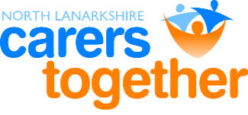
North Lanarkshire CARERS TOGETHER
Carers Centre
51 Hope Street
MOTHERWELL ML1 1BS

T: 01698 404055
“Working for You”
Scottish Charity No: SC033795

E: admin@carerstogether.org
W: www.carerstogether.org

15th April 2020

Dear Applicant

POST OF COMMUNITY LINK WORKER

Thank you for showing an interest in the above post. Please complete the application form provided as CV’s will not be accepted.

Completed applications should be emailed to myself at allison@carerstogether.org

The closing date for applications is 29th May. Interview dates will be advised to those applicants who have been shortlisted. North Lanarkshire Carers Together does not inform applicants who have been unsuccessful at this stage.

Kindest Regards

Allison M Smith

Allison M Smith
Advisor to the Board

