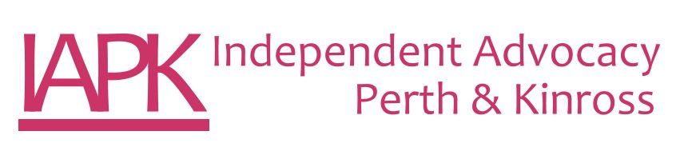

JOB DESCRIPTION

Post Title: Peer Independent Advocacy Worker – Drug & Alcohol

Salary: £19,710 per annum
Auto Enrolment Pension Scheme (currently Employer 3% & Employees 5%)

Hours of work: 28 hours per week – normal working hours are within Monday to Friday 9am to 5pm. This post may entail some evening and
weekend work.

Qualifications: Lived Experience of recovery from substance or alcohol dependency (your own or someone close to you)
An understanding of social care or health sectors
An understanding of Independent Advocacy

Job Purpose

To focus on improving access to and delivering rights based peer independent advocacy for people affected by alcohol and substance dependency in line with the Scottish Government Strategy: Rights, Respect and Recovery. This post is classed as Regulated Work and requires the successful candidate to apply for membership of the PVG Scheme.

Duties and Responsibilities

- To deliver rights based independent advocacy ensuring that the highest standards are maintained and evidenced as appropriate.
- To focus on raising awareness of the rights-based approach to the Health & Social Care Partnership in Perth and Kinross.
- To undertake the Rights Based Advocacy SQA as part of the National Recovery Advocacy Network.
- To work within the Principles, Standards & Code of Best Practice for Independent Advocacy (SIAA 2019).
- To work to clearly defined objectives and specified targets, be familiar with work planning and effective time management.
- To work as an individual, but also as part of a team
- To be able to work within clear codes of confidentiality.
- To communicate well and use positive and inclusive communication underpinned by the Social Model of Disability and Human Rights Based Approach
- To function at a high level of IT proficiency.

- To be able to work with a case management system to maintain accurate and up to date written information and records, providing IAPK with monitoring outcomes and information - both qualitative and quantitative.
- To seek feedback from advocacy partners on their experience of independent advocacy and its impact on their situation.
- To report regularly to, and receive ongoing support and supervision from the Advocacy Manager.

Self Management

- Adhere to and take responsibility for implementing policies, procedures and protocols of IAPK.
- Develop resilience strategies
- Take responsibility for personal safety in and out of the office according to IAPK’s procedures
- Present a positive image of Independent Advocacy and IAPK at all times
- Critically reflect on practice and participate in team practice discussions.
- Take ownership of own learning and development
- Work within the ethos and values of the organisation
- Undertake any other duties as reasonably requested by Management.

Training, support & supervision

The Advocacy Manager will provide ongoing support. This post requires the post holder to complete a SVQ in Rights Based Advocacy SQA as part of the National Recovery Advocacy Network. The post holder will identify their own learning needs and participate in identified learning opportunities when required.

Other duties

This job description is a broad picture of the post at the date of presentation. It is not an exhaustive list of possible duties, and it is recognised that posts change and evolve over time. Consequently, this is not a contractual document, and the post holder will be required to carry out any other duties to the equivalent level that are necessary to fulfil the purpose of the post.

