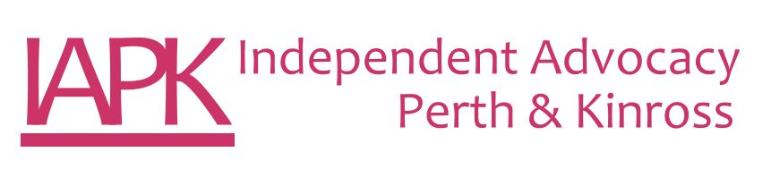
Peer Independent Advocacy Worker – Drug & Alcohol

Person Specification

CATEGORY | ESSENTIAL | DESIRABLE
EXPERIENCE AND UNDERSTANDING | - To have lived experience of addiction recovery – either personally or with someone close.  - Knowledge and understanding of the Rights, Respect and Recovery Strategy (Scottish Government 2018)  - An understanding of social care or health sectors  - Knowledge and understanding of Independent Advocacy  - Experience of working with people who face barriers and discrimination through disability, illness or life circumstances.  - Demonstrable understanding of the Principles, Standards & Code of Best Practice of Independent Advocacy  - Experience of multi-agency networking with Health and Social Care Partnership, and other third sector organisations. | Previous advocacy experience  Experience in the Child Protection and Children’s Hearing systems and Mental Health Tribunal system  Understanding of:  - Mental Health (Care & Treatment) (Scotland) Act 2003  - Adults with Incapacity (Scotland) Act 2000  - Adult Support & Protection (Scotland) Act 2007  - Carers (Scotland) Act 2016  - Education (Additional Support for Learning) (Scotland) Act 2004  - National Care Standards
GENERAL SKILLS | - Effective communication skills, both written and oral  - IT skills, particularly Microsoft Office.  - To be able to work with a cloud based case management system to maintain accurate and up to date written information and records.  - To be highly motivated enthusiastic, flexible in order to demonstrate a positive commitment to the values of IAPK
EDUCATION AND QUALIFICATIONS | - Good overall higher education  - Current Driving Licence and sole use of a car | - Relevant qualification – e.g. social work, counselling,
INTERPERSONAL SKILLS | - Ability to work in a team  - Sensitivity/empathy to the needs of others  - Ability to prioritise and demonstrate good time management  - Ability to liaise with professionals at all levels in appropriate manner  - Ability to work with people who are experience difficulty with engagement or have difficulty in communicating due to barriers in society.  - Proactive approach to dealing with issues  - Listening Skills  - Non Judgemental attitude  - Flexibility  - Approachability and Openness

As this post is considered regulated work, it requires the successful candidate to apply for PVG membership. IAPK will cover the cost of this application.

